Project Report
(Submitted for the Degree of B.com Honours in Accounting & Finance under the University of Calcutta)

Study on Goods and Services Tax (GST)
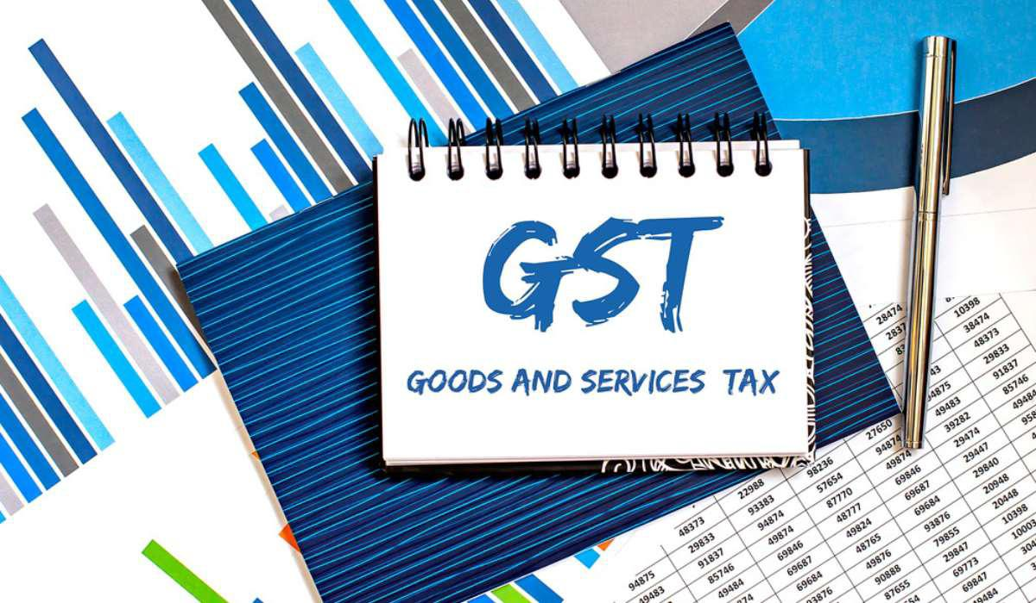
- Submitted by:-
- Name of the Candidate:- Neha Shaw
- C.U Registration No:- 144-1211-0872-20
- C.U Roll No.:- 201144 -11- 0115
- College Roll No.:
- Name of the College:- BANGABASI MORNING COLLEGE

- Supervised by:-
- Name of the Supervisor:- Dr.Moumita Sarkar(Samanta)

- Month & Year of Submission:- May - 2023

Annexure I
Supervisor’s Certificate

This is to certify that Mrs. Neha Shaw a student of B.com. Honours in Accounting & Finance of BANGABASI MORNING COLLEGE under the University of Calcutta has worked under my supervision and guidance for his project work and prepared a project Report with the title study on Goods and Services Tax (GST) which she is submitting, is her genuine and original work to the best of my knowledge.

Signature: ………………..
Name:-Dr.Moumita Sarkar (Samanta)
Designation:- Associate Professor
Name of College: - BANGABASI MORNING COLLEGE

Place:- Kolkata
Dated:-

Annexure-II
Student’s Declaration

I hereby declare that the project work with the title study on Goods and Services Tax (GST) submitted by me for the partial fulfillment of the degree of B.com. Honours in Accounting & Finance under the University of Calcutta is my origin and has not been submitted earlier to any other University/Institution
for the fulfillment of the requirement for any course of study.

I also declare that no chapter of this manuscript in whole or in part has been incorporated in this report from any earlier work done by others or by me. However, extracts of any literature which has been used for this report has been duly acknowledge providing details of such literature in the references.

Signature:-…………….
Name: - Neha shaw
Registration No: - 144-1211-0872-20
Roll No: - 201144 -11- 0115

Place:- Kolkata
Date:-

ACKNOWLEDGEMENT

I express my thanks towards my professors and faculty members of “BANGABASI MORNING COLLEGE”, Department of Commerce. A Debt gratitude towards my guide, Dr.Moumita Sarkar (Samanta), for patiently hearing me out and for giving valuable inputs on my research project.

I would like to make special thanks to my teachers, without whose blessings, this project would not be possible.

CONTENTS

CHAPTER | TOPIC | PAGE
- Introduction. | 1.1 Background | 6-8
 | 1.2 Rationale | 8
 | 1.3 Review of literature | 9
 | 1.4 Objectives of the GST | 9-10
 | 1.5 Reserch Methodology | 10
2.Conceptual Framework | 2.1 Concept of GST | 10-15
 | 2.2 National & international Scenario of GST | 16-21
3.Presentations, Analysis, Finding, & Recommendations  4.Conclusions | 3.1 Data Presentation | 22-25
 | 3.2 data Analysis | 25-30
 | 3.3Finding & Recommendations | 31-36
 | 4.1 Conclusion | 37
 | Bibliography | 37

Chapter (1):- INTRODUCTION

1(1) Background:-
The Goods and Services Tax (GST) is a comprehensive value added tax on Goods & Services. It is a vast concept. GST will be help to enhancing & supporting the economic growth of a country.

In India, the idea of adopting GST was first suggested by the “Atal Bihari Vajpaye” Government in 2000. To the “Norendra Modi’s” Government in 2014, India’s new Finance Minister Arun Jaitley was submit 122nd Constitution Amendment Bill in the 16th Lok Sabha on 19th December 2014. The opposition demanded that the bill be sent for discussion to the standing committee. Then Government of India has appointed various committess, task force to give their views to introduce a vibrant and modern Indirect Tax structure in India.

Finally in August 2016, The Constitution Amendment bill was passed in the parliament & 18 states ratified The Constitution Amendment Bill & The President “Pranab Mukherjee” gave his assent to it.

GST council has also recommended four – tier GST rate structure & thresholds.

GST council approved the Central Goods & Services Tax Bill 2017 (The CGST Bill), The Integrated Goods & Services Tax Bill 2017 (The IGST Bill), The Union Territory Goods & Services Tax Bill 2017 (The UTGST Bill), The Goods & Services Tax (Compensation to the states) Bill 2017 The Compensation Bill, these Bills were passed by the Lok sabha on 29 march 2017. The Rajya sabha passed these Bills on 6th April 2017.

The GST was implemented at midnight on 1st July 2017 by president of the India, “Pranab Mukherjee” & the government of India. The Jammu & Kashmir state legislature passed its GST act on 7 July 2017.

1(2)The rationales behind moving from current tax structure to GST is explained below:-

- The indirect tax Regime where taxes under various headings are levied on goods and services would be replaced with one common tax module. this will encourage national market due to uniformity in tax structure across the states.
- Taxes levied at multiple levels mean extra burden on consumers and businesses due to cascading effect. Implementation of GST would mean relief from excess taxing at different levels.
- Earlier taxes for goods and services were separate, but clearly distinguishing between goods and services have become difficult with lot of innovation and technological advancement. GST will remove this problem too.
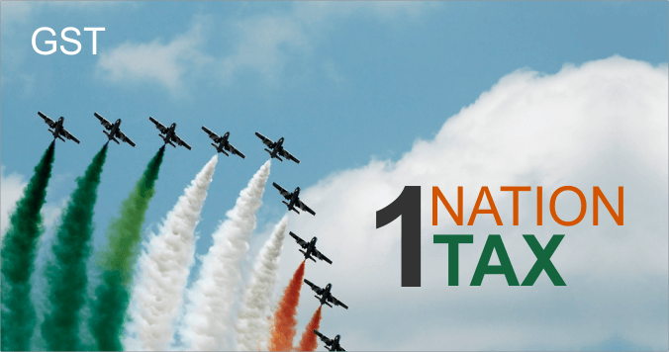

1(3) Review of Literature:-

Halakhandi, (2007)
GST was supposed to be introduced in India way back in 2010. It has been getting postponed due to various reasons major one being getting to a consensus between the various states and the centre for compensation. The author in the paper has discussed the existing laws in India for indirect taxes, the VAT laws in various states with their advantages and disadvantages, the impact of the proposed GST, the compliances under the proposed GST etc. The author has also used various numerical examples to demonstrate how GST is cost effective.

Eva, (2008)
The author in his paper has examined the cost of complying with the indirect tax laws in the Slovak Republic by doing research of small, medium and large businesses through a questionnaire and concludes that businesses especially the small ones are not able to and do not make efforts to quantify the cost of compliance which is quite high due to the complex laws.

Eugen, (2011)
The authors have examined the various methods adopted by assessees to evade VAT especially in intra country transactions in Romania. The authors have also recommended the documentation and returns which could be relied upon by both the authorities and the assessees to ensure that there is no tax evasion.

Mansor, (2013)
GST has always been considered as a tool in the hands of any Government to increase revenue. The Malaysian Government introduced the said tax in Malaysia in order to reduce its budget deficit. The authors in the paper have discussed the readiness of the Malaysian economy in adopting the said newly introduced GST along with the reactions of various sections of the society.

1(4) Objective of the GST:-
- One Country – One Tax.
- Consumption based tax instead of Manufacturing.
- Uniform GST Registration, payment and Input tax Credit
- To eliminate the cascading effect of Indirect taxes on single transaction
- Subsume all indirect taxes at Centre and State Level under
- Reduce tax evasion and corruption
- Increase productivity
- Increase Tax to GDP Ratio and revenue surplus
- Increase Compliance
- Reducing economic distortions

1(5) Reserch Methodology:-

The study is based on secondary data collected from various referred books, National and international journals, government reports, applications from various websites which focused on various aspects of goods and service tax.

The Researchers used an exploratory research technique based on past literature from respective journals, annual reports, newspapers and magazines covering wide collection.

- Some list of countries by GDP (World Bank 2017)
COUNTRY | GDP (WORLD BANK 2017)
INDIA | 2,597,491
UNITED STATES | 19,390,604
JAPAN | 4,872,137
CHINA | 12,237,700
GERMANY | 3,677,439
UNITED KINGDOM | 2,622,434
RUSSIA | 1,530,751
FRANCE | 2,582,501

LIMITATION OF THE STUDY

CHAPTER PLANNING

Chapter (2):- Conceptual Framework

2(1) Concept of GST:-
The Act came into effect on 1st July 2017; Goods & Services Tax Law in India is a comprehensive, multi-stage, destination-based tax that is levied on every value addition. In simple words, Goods and Service Tax (GST) is an indirect tax levied on the supply of goods and services.
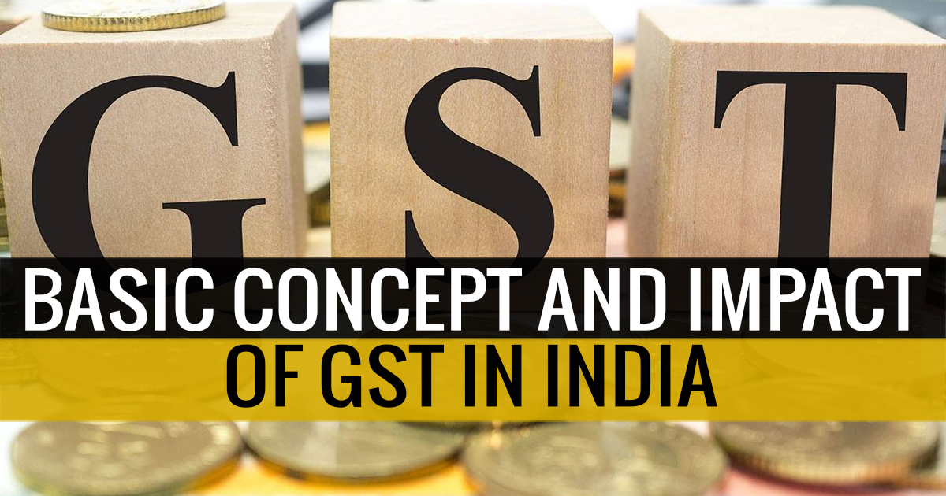

- Who shall pay? | - Taxable person- sch III
- On what GST shall be paid? | - Supply of Goods and services Section 7
- When GST shall be paid? | - Point of Supply
- Where shall GST be paid? | - Place of supply
- To whom shall would be paid? | - Respective Government
- How to pay? | - Cash / Credit

Types of GST:-
There are three kinds of taxes under the GST.

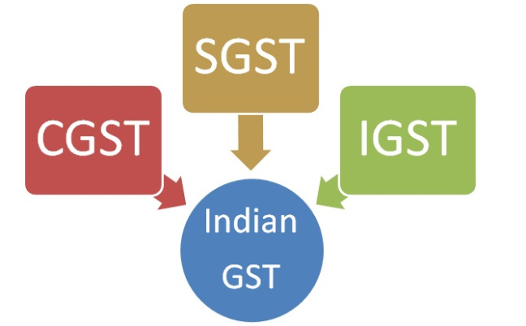

SGST, CGST & IGST

1. SGST:-
SGST means State Goods and Service Tax. It is covered under State Goods and Service Tax Act 2016. A collection of SGST will be the revenue for State Government. After the introduction of SGST all the state taxes like Value Added Tax, Entertainment Tax, Luxury Tax, entry Tax etc. will be merged under SGST. For example, if goods are sold or services are provided within the State then SGST will be levied on such transaction.

2. CGST:-
CGST means Central Goods and Service Tax. CGST is a part of goods and service tax. It is covered under Central Goods and Service Tax Act 2016. Taxes collected under Central Goods and Service tax will be the revenue for central Government. Present Central taxes like Central excise duty, Additional Excise duty, Special Excise Duty, Central Sales Tax, Service Tax etc. will be subsumed under Central Goods And Service Tax.

3.IGST:-
IGST means Integrated Goods and Service Tax. IGST falls under Integrated Goods and Service Tax Act 2016. Revenue collected from IGST will be divided between Central Government and State Government as per the rates specified by the government. IGST will be charged on transfer of goods and services from one state to another state. Import of Goods and Services will also be deemed to be covered under Inter-state transactions so IGST will be levied on such transactions. For example, if Goods or services are transferred from Rajasthan to Maharashtra then the transaction will attract IGST.

Tax Rates under GST:-
GST rates are divided into five categories which are 0%, 5%, 12%, 18%, 28%.
All the basic need requirement good are pleased in 0% category like food grains, bread, salt, books etc. Goods like paneer packed food, tea coffee etc are placed under 5% category. Mobiles, sweets, medicine are under 12%. All types of services are under18% category. All other remaining luxury items are placed under the last head of 28%.

List of rate changes at 31st GST Council Meeting:-
SL.no | List of Goods/Services | Changes in Tax Rate
1 | Vegetables provisionally preserved but unsuitable for immediate consumption | 5% to Nil
2 | Vegetables cooked/uncooked via steamed, frozen or boiled (branded) | 5% to Nil
3 | Music Books | 12% to Nil
4 | Parts for manufacturing renewable energy devices falling under chapter 84, 85 of tarrif | 5%
5 | Natural cork | 12% to 5%
6 | Fly ash blocks | 12% to 5%
7 | Walking sticks | 12% to 5%
8 | Marble rubble | 18% to 5%
9 | Agglomerated cork | 18% to 12%
10 | Cork roughly squared or debugged | 18% to 12%
11 | Articles of Natural cork | 18% to 12%
12 | Movie Tickets < or = Rs 100 | 18% to 12%
13 | Premium on Third party insurance on Vehicles | 18% to 12%
14 | Accessories for Handicapped Mobility Vehicles | 28% to 5%
15 | Power banks | 28% to 18%
16 | Movie Tickets > Rs 100 | 28% to 18%
17 | Video game consoles, equipments used for Billiards and Snooker and other sport related items of HSN code 9504 | 28% to 18%
18 | Retreated & used pneumatic Rubber Tyres | 28% to 18%
19 | Colour Television Sets & monitors up to “32 Inches | 28% to 18%
20 | Digital & Video Camera recorders | 28% to 18%
21 | Pulleys, transmission shafts, cranks and gear boxes under HSN 8483 | 28% to 18%
22 | Tax rate on Air travel of pilgrims reduced* | 28% to 18%

Composition scheme under GST:-
Any taxable person whose aggregate turnover in the preceding financial year is less than Rs. 1.5 Crores and less than Rs. 75 lakhs for North Eastern States can opt for a simplified composition scheme where tax will payable at a concessional rate on the turnover in a state without the benefit of Input Tax credit.The floor rate of tax for CGST and SGST shall not be less than 1%. A tax payer opting for composition levy shall not collect any tax from his customers. Tax payers making inter-state supplies or paying tax on reverse charge basis shall not be eligible for composition scheme.
Features of registration process:-
- Existing dealers: Existing VAT/Central excise/Service Tax payers will not have to apply afresh for registration under GST.
- New dealers: Single application to be filed online for registration under GST.
- The registration number will be PAN based and will serve the purpose for Centre and State.
- Unified application to both tax authorities.
- Each dealer to be given unique ID GSTIN.
- Deemed approval within three days.
- Post registration verification in risk based cases only.

2(2) National & International scenario of GST:-
The National Scenario:-
At midnight of 30th June 2017, India became one of the 160 countries to launch GST. The GST is a target based unified indirect tax and will remove all other indirect taxes. It is collected and levied on the value added at each stage. GST will be operated at both state (SGST- State collected GST) and central level (CGST- Central collected GST). Besides, the center will also collect Integrated Goods and Services Tax (IGST) in case of inter-state transactions. GST is a consumption-based tax and is regressive. The ultimate burden of this tax is on the final consumer of goods and services. So, whether your income is thousand, hundred or nothing you have to pay this tax, as long as you buy some commodity. There is uniformity in the tax between the rich and the poor. GST aims at unifying the country’s population under a single tax regime expressing the principle of one nation, one tax, and one market. GST will be collected under five tax braces of 0 percent, 5 percent, 12 percent, 18 percent and 28 percent. India is a developing country where 21.9 per cent of the population still lives below the National Poverty Line (Basic Statistics 2017). United Nations Development Programme’s report shows that 55.3 percent of India’s population is living under multidimensional poverty and Human Development Index (HDI) for the country stands at 0.624 (0.454 only when adjusted for inequality). HDI Report 2016 placed India at 131st rank in a list of 188 countries. World Bank’s report on world development indicators also placed India at much lower levels than the global average (World Bank 2016). The public health expenditure in India is only 1.40 percent of Gross Domestic Product (the year 2014).

In development scenario India is much behind than countries like Japan, United Kingdom, France, United States, etc. but still having the highest GST in the world. However, the developed countries have set much lower rates of GST than India and are growing at faster rates, with almost nil amounts of poor people. Has the government gone through above economic indicators before implementing GST? Was it necessary for India to set the highest tax rates in the world? Someone analyzed that countries where tax rates moved higher, GDP growth pushes up, after following a temporary negative impact in initial years. The Reserve Bank of India in its research report named ‘GST: A Game Changer’ also showed the good performance of countries like New Zealand, Canada, Singapore, Malaysia after implementation of GST. One thing that is missing is the background of a nation. Every policy is based on the previous experience of the economy. India is a country where more than 25 lakh people die of hunger every year (Hunger Facts 2017). A large number of people are engaged in agricultural pursuits. They are earning less and living hard and as a result, farmers are committing suicides. National Crime Records Bureau of India reported 13,755 farmer suicides in 2012. How can the government expect these people as the bearers of tax? Besides, the economy is already facing disturbances due to demonetization. Imposing GST in such an economy and at this time will simply increase the inequality between the rich and the poor. International Monetary Fund (2001) on tax policy for developing countries suggested that consumer taxes play a diminished role in these economies. Therefore, the possibility that the government will impose high tax levels is virtually excluded.
The international scenario:-
GST!!! A pathway towards unified taxation regime eventually leading towards betterment of economy!!! GST has been practiced in around 160 countries around the globe. Legal instincs through this article bring before its readers the scenario of GST/VAT around the globe, its implementation and its impact on respective economies.
(1) United Kingdom(UK):-
Name: Value Added Tax
Date of introduction: 01.04.1973

Scope:
- Supply of goods or services madein the UK.
- Intra community procurements from EU Members.
- Importation of Goods & Services
Standard Rate: 20 %
Reduced Rate: 5 % and exempt and zero-rated
Threshold exemption limit: £ 73,000
Liabilities arises on:
1.Accrual Basis: On raising of invoice or receipt of consideration or supply (of goods or services), whichever is earlier.
2. Cash Basis: (if turnover is below £1.35 million): On receipt of considerations
Payment: Usually quarterly returns. However, a small business can opt for annual returns filing.
Export: Exports are ‘Zero’ rated.
Exempt Services:
1. Medical and education
2. Finance, insurance, postal services
Innovative Concept: To ease the VAT administration, the assessee is informed at the time of registration itself as to which of the three quarterly cycle it should follow for filling the VAT returns.
(2) Canada:-
Name: Federal Goods and Service Tax & Harmonized Sales Tax
Date of introduction GST: 01.01.1991 & HST 01.04.1997
Scope: Taxable supplies of goods and services
Standard Rate: GST 5% and HST varies from 0% to 15%
Reduced Rates: Exempt and Zero-rated
Threshold exemption limit: Canadian $ 30,000
Liability arises on: On accrual (date of invoice, date of issue of invoice) or receipt of consideration, whichever is earlier.
VAT returns and payments: Depending on the turnover, tax needs to be deposited either monthly, quarterly or annually.
Reverse charge mechanism: Reverse charge applies to the importation of services and intangible properties.
Export: Exports are ‘Zero’ rated.
Exempt services:
1. Supply of real estate
2. Financial Services and residential renting
3. Supplies by charities
4. Health, education services
Innovative concept: A group concern can supply to another group concern at zero-rated.
(3) Australia:-
Name: Goods and Service Tax
Date of introduction: 01.07.2000
Scope:
• Taxable supplies of goods and services made which are connected with Australia and made for a consideration by a registered (or required to be registered) person in the course of business enterprises Importation of goods
Standard Rate: 10 %
Reduced Rate: 0 %
Threshold exemption limit: $ 75,000
Liability arises on:
• Accrual basis: On the raising of invoice or receipt of consideration, whichever is earlier.
• Cash basis: [an option available to assessee having turnover below $ 2 million]: On receipt of consideration.
Payment: Depending on the turnover, the tax needs to be deposited either monthly, quarterly or annually. The due date for payment Tax needs to be deposited on 21st day following the end of the month/quarter/year.
Reverse Charge Mechanism: Reverse charge applies to supplies made by non-residents
Export: Exports are ‘Zero’ rated.
Exempt Services:
1. Government supplies such as water services, drainage services etc.
2. Health, education, religious supplies Financial Services and residential renting
3. Vegetable, fruit, meat
Innovative Concept: ‘Group registration’ wherein a single consolidated return for the group can be filed.
(4) New Zealand:-
Name: Goods and Service Tax
Date of introduction: 01.10.1986
Scope:
• Supply of goods or services made in New Zealand by a registered person
• Importation of goods
Standard Rate: 15 %
Reduced Rate: Zero-rated and exempt
Threshold exemption limit: NZ$ 60,000
Liability arises on: On raising of invoice or receipt of consideration, whichever is earlier.
Returns: Depending on the turnover it is either monthly, bi-monthly or six-monthlyDue date for returns and payment On 28th day following the end of the month or bi-month or six-month.
The due date for returns and payment: On the 28th day following the end of the month or bi-month or six-month. However, a different date for the certain periods.
Reverse charge mechanism: Reverse charge applies to the supply of services made by non-residents.
Export: Exports are ‘zero’ rated.
Exempt services:
1. Real estate
2. Financial services
3. Residential rental
Innovative concept: The headline price in advertisement and stores must be always GST inclusive except when supplies are to wholesale clients.
(5) Singapore:-
Name: Goods and Service Tax
Date of introduction: 01.04.1994
Scope:
• Supplies of goods and services in Singapore by a taxable person in the course or furtherance of a business
• Importation of goods
Standard Rate: 7 %
Reduced Rate: Zero-rated and exempt
Threshold exemption limit: Singapore $ 1 million
Liability arises on: On raising of invoice or receipt of consideration or supply (of goods or services), whichever is earlier.
Returns: Usually quarterly returns. However, a business can opt for monthly returns.
The due date for returns and payment: Last day of the month following the end of the month or quarter.
Reverse charge mechanism: Reverse charge applies to the supply of services
Export: Exports are ‘zero’ rated.
Exempt services: Real estate, Financial services, Residential rental
Innovative concept: Divisional registration wherein if an assessee has several divisions he may register the said divisions separately. Each such division should submit its own return. The supplies between the divisions are ignored for GST purposes.

Chapter (3):- Analysis, Finding & Recommendation
3(1) Data presentation Impact of GST on retail industry
After the implementation of the GST, we can see both its positive and negative effects on different industries. Many sectors like manufacturing, electronics, telecom, FMCG, education, banking, jewellery, tourism, logistics, IT etc. are the important part of the Indian economy. The positive impact of the GST on such sectors in seen in the form of electronic development of the country .
How will GST Shape retail industry ?
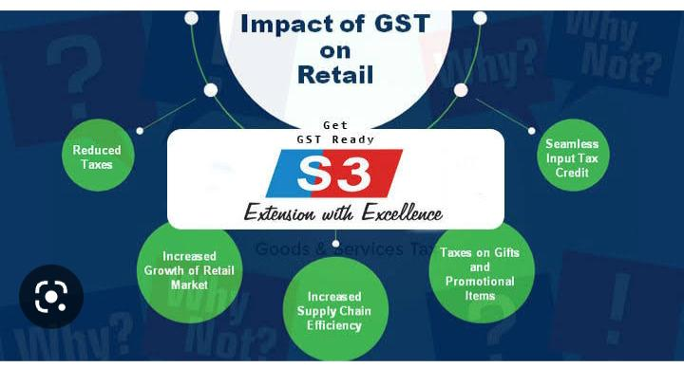
Below five factors will significantly change the dynamics of the retail sector in India:
A. Reduced taxes – he main impact of GST on retailers will be a significant reduction of the tax burden on the retailers.
B. Seamless Input tax credit – GST will make an impact by eliminating the cascading effect of taxes thereby reducing the total tax burden on the retail sector.
C. Increased Supply chain efficiency – The impact of GST will be evident on supply chains, as their designs would be efficiency-oriented and not in alignment with the taxation system.
D. Tax on gifts and promotional items – As per the model GST law, any supply without any consideration will attract tax.
E. Better Opportunities & Growth of Retail Market – Upon implementation of GST, analysts predict unification of markets.

TREND ANALYSIS OF GST GROSS COLLECTION IN INDIA
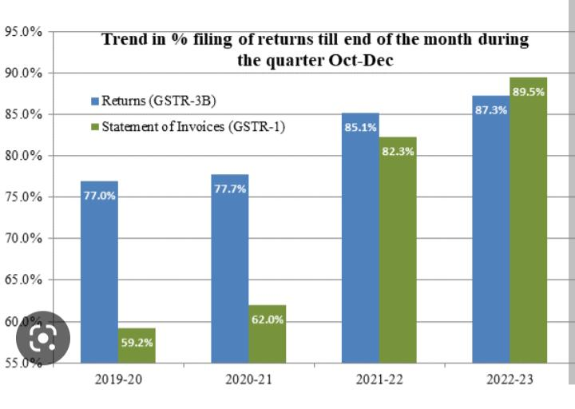
Analysis :-
The gross GST revenue collected in the month of March 2023 is ₹1,60,122 crore of which CGST is ₹29,546 crore, SGST is ₹37,314 crore, IGST is ₹82,907 crore (including ₹42,503 crore collected on import of goods) and cess is ₹10,355 crore (including ₹960 crore collected on import of goods). It is for the fourth time, in the current financial year that the gross GST collection has crossed ₹1.5 lakh crore mark registering second highest collection since implementation of GST. This month witnessed the highest IGST collection ever.
The government has settled ₹33,408 crore to CGST and ₹28,187 crore to SGST from IGST as regular settlement. The total revenue of Centre and the States in the month of March 2023 after IGST settlement is ₹62,954 crore for CGST and ₹65,501 crore for the SGST.
The revenues for the month of March 2023 are 13% higher than the GST revenues in the same month last year. During the month, revenues from import of goods was 8% higher and the revenues from domestic transaction (including import of services) are 14% higher than the revenues from these sources during the same month last year. The return filing during March 2023 has been highest ever. 93.2% of statement of invoices (in GSTR-1) and 91.4% of returns (in GSTR-3B) of February were filed till March 2023 as compared to 83.1% and 84.7%, respectively same month last year.
The total gross collection for 2022-23 stands at ₹18.10 lakh crore and the average gross monthly collection for the full year is ₹1.51 lakh crore. The gross revenues in 2022-23 were 22% higher than that last year. The average monthly gross GST collection for the last quarter of the FY 2022-23 has been ₹1.55 lakh crore against the average monthly collection of ₹1.51 lakh crore, ₹1.46 lakh crore and ₹1.49 lakh crore in the first, second and third quarters respectively.
The chart below shows trends in monthly gross GST revenues during the current year. The table shows the figures of GST collected in each State during the month of March 2023 as compared to March 2022.

3(2) Data analysis of GST:-
The Prime Minister approved the Constitution Amendment Bill for goods and service tax”( GST) in the parliament Session ( Rajya Sabha on 3 August 2016 and Lok Sabha on 8 August 2016) along with the ratification by 50% of the state legislatures. Thus, the current indirect taxes levied by state and Centre are all set to be replaced with proposed implementation of GST by April 2017.This would be the biggest tax Reform since Independence and a boon to the economy as it will eradicate the shortcomings of the current tax structure and provide a single tax on supply of all goods and services.

Benefits of GST:-
- Removal of bundled indirect taxes such as VAT, CST, Service tax, CAD, SAD, and Excise.
- Less tax compliance and a simplified tax policy compared to current tax structure.
- Removal of cascading effect of taxes i.e. removes tax on tax.
- Reduction of manufacturing costs due to lower burden of taxes on the manufacturing sector. Hence prices of consumer goods will be likely to come down.
- Lower the burden on the common man i.e. public will have to shed less money to buy the same products that were costly earlier.
- Increased demand and consumption of goods.
- Increased demand will lead to increase supply. Hence, this will ultimately lead to rise in the production of goods.
- Control of black money circulation as the system normally followed by traders and shopkeepers will be put to a mandatory check.
- Boost to the Indian economy in the long run.

Goods and Services Tax (GST) Forms for Registration & Cancellation:-
Sr.No | Form Number | Description
1. | REG-01 | Registration Application u/s 19(1) GST Act, 20
2. | REG-02 | Acknowledgement
3. | REG-03 | Information regarding Registration / Amendments / Cancellation Notice
4. | REG-04 | Filing application for clarification Registration / Amendment / Cancellation / Revocation of Cancellation
5. | REG-05 | Order application for rejection for Registration / Amendment / Cancellation / Revocation of Cancellation
6. | REG-06 | Issued registration certificate u/s 19(8A) of the GST Act, 20
7. | REG-07 | Application for Registration as TDS or TCS u/s 19(1) of the GST Act, 20
8. | REG-08 | Order of Cancellation of Application for Registration as TDS /TCS u/s 21 of the GST Act
9. | REG-09 | Non-Resident Taxable Person Application for Registration
10. | REG-10 | Person supplying online information and database access or retrieval services from a place outside India to a person in India, other than a registered person Application for registration
11. | REG-11 | Amendment in Particulars subsequent to Registration Application
12. | REG-12 | Temporary Registration/ Suo Moto Registration Order of Grant
13. | REG-13 | Grant of Unique Identity Number (UIN) to UN Bodies/ Embassies /others Application/Form
14. | REG-14 | Application for Cancellation of Registration under GST 20
15. | REG-15 | Amendment Order
16. | REG-16 | Cancellation of Registration Application
17. | REG-17 | Cancellation of Registration Show Cause Notice
18. | REG-18 | Show Cause Notice issued for Cancellation Reply
19. | REG-19 | Cancellation of Registration Order
20. | REG-20 | Dropping the proceedings for cancellation of registration Order
21. | REG-21 | Revocation of Cancellation of Registration Application
22. | REG-22 | Order for revocation of cancellation of registration
23. | REG-23 | Show Cause Notice for rejection of an application for revocation of cancellation of registration
24. | REG-24 | Reply to the notice for rejection of an application for revocation of cancellation of registration
25. | REG-25 | Provisional Registration Certificate
26. | REG-26 | Existing Taxpayer Application Enrolment
27. | REG-27 | Provisional registration Show Cause Notice cancellation
28. | REG-28 | Provisional registration Order Cancellation
29. | REG-29 | Provisional registration Application cancellation
30. | REG-30 | Field Visit Report Form

Goods and Services Tax (GST) Forms for Composition
Sr.No | Form Number | Description
1. | CMP-01 | Notification for the payment of taxes under section 10 (composition scheme)  (Concerning taxpayers registered under the present regime migrate on the elected day)
2. | CMP-02 | Notification for the payment of taxes under section 10 (composition scheme)  (Concerning Taxpayers registered under the Act)
3. | CMP-03 | Notification of stock details from the date of opting composition scheme  (Concerning taxpayers registered under the present regime migrate on the elected day)
4. | CMP-04 | Notification/ Application to opt out from the composition scheme
5. | CMP-05 | Notification of denial option for the payment of tax under composition scheme
6. | CMP-06 | Responding to the notification to show cause
7. | CMP-07 | Reply order to accept or reject concerning show cause notice

List of forms for a GST Practitioner

Forms for GST-Practitioner
Form | Purpose of Form
FORM GST PCT-1 | Application to become a practitioner
FORM GST PCT-2 | Certificate of Registration for a GST-Practitioner
Form GST PCT-3 | Notice seeking additional information on application for enrollment or show cause notice issued to GST practitioner for misconduct
Form GST PCT-4 | Order of rejection of application for enrollment or disqualification of a GST practitioner found guilty of misconduct
Form GST PCT-5 | List of enrolled GST practitioners maintained on the Common portal
Form GST PCT-6 | Authorisation of a GST practitioner by a taxable person on the Common Portal
Form GST PCT-7 | Withdrawal of authorisation of a GST practitioner by a taxable person

List of Forms for Input Tax Credit (ITC) under GST

ITC Forms
Form | Purpose of Form
Form GST ITC – 1 | Declaration for claim of input tax credit under sub-section (1) of section 18.
Form GST ITC – 2 | Declaration for transfer of ITC in case of sale, merger, demerger, amalgamation, lease or transfer of a  business under sub-section (3) of section 18.
Form GST ITC – 3 | Declaration for intimation of ITC reversal on inputs, inputs contained in semi-finished and finished  goods and capital goods in stock under sub-section (4) of section 18.
Form GST ITC – 4 | Details of goods/capital goods sent to job worker and received back.

List of Form for Tax payment under GST

Form | Purpose of Form
Form GST PMT-01 | Electronic Liability Register of registered person  (Part–I: Return related liabilities  Electronic Liability Register of taxable person  (Part–II: Other than return related liabilities)
Form GST PMT-02 | Electronic Credit Ledger
Form GST PMT-03 | Order for re-credit of the amount to cash or credit ledger on  rejection of refund claim
Form GST PMT-04 | Application for intimation of discrepancy in Electronic  Credit Ledger/Cash Ledger/Liability Register
Form GST PMT-05 | Electronic Cash Ledger
Form GST PMT-06 | Challan For Deposit of Goods and Services Tax
Form GST PMT-07 | Application for intimating discrepancy in making payment

List of Tax Refund forms under GST

Refund forms under GST
Form | Purpose of Form
GST RFD-01 | Application for Refund
GST RFD-02 | Acknowledgement
GST RFD-03 | Deficiency Memo
GST RFD-04 | Provisional Refund Order
GST RFD-05 | Payment Advice
GST RFD-06 | Refund Sanction/ Rejection Order/Interest on delayed refund order (same as refund order)
GST RFD-07 | Order for complete adjustment of sanctioned Refund
GST RFD-08 | Notice for rejection of application for refund
GST RFD-09 | Reply to show cause notice
GST RFD-10 | Application for Refund by any specialize agency of UN or Multilateral Financial Institution and Organization, Consulate or Embassy of foreign countries, etc
3(3) Findings & Recommendation:-

Types of GST Returns:

S.No | Return | Particulars
1. | GSTR-1 | Details of outward supplies of taxable goods or services or both effected
2. | GSTR-2 | Details of inward supplies of taxable goods or services or both claiming input tax credit
3 | GSTR-3 | Monthly return on the basis of finalization of details of outward supplies and inward supplies along with the payment of amount of tax
4 | GSTR-4 | Quarterly Return for compounding taxable persons
5 | GSTR-5 | Return for Non-Resident foreign taxable persons
6 | GSTR-6 | Input Service Distributor return
7 | GSTR-7 | Return for authorities deducting tax at source
8 | GSTR-8 | Details of supplies effected through e-commerce operator and the amount of tax collected as required under sub-section (52)
9 | GSTR-9 | Annual Return
10 | GSTR-9A | Simplified Annual return by Compounding taxable persons registered under section 10

Due Dates for filing of Return in GST:
S.No | Return Form | Due Date
1. | GSTR-1  IFF OPTIONAL | 13th of Next Month
2. | GSTR-2 | After the 10th but before 15th of Next Month
3 | GSTR-3 | 20th of Next Month
4 | GSTR-4 | 18th from end of the Quarter
5 | GSTR-5 | 20th from end of the month or within 7 days after the last day of validity of registration whichever is earlier
6 | GSTR-6 | 13th of Next Month
7 | GSTR-7 | 10th of Next Month
8 | GSTR-8 | 10th of Next Month
9 | GSTR-9 | 31st December of Next Financial Year
10 | GSTR-9A | 31st December of Next Financial Year

The GST council has recommended changes in the GST rates on the followings goods:

Sl. No. | HSN | Description | Present  GST Rate | Recommended
1. | 0802 | Walnuts, whether or not shelled | 12% | 5%
2. | 0813 | Tamarind dried | 12% | 5%
3. | 2106 | Roasted Gram | 12% | 5%
4. | 2106 | Custard powder | 28% | 18%
5. | 2106 | Batters, including idli / dosa batter | 18% | 12%
6. | 2304,2305 | Oil cakes | Nil for | 5%
7. | 2306 | Cotton seed oil cake | Cattle feed 5% for other uses Nil for | [irrespective of end use]  Nil
8. | 33074100 | Dhoop batti, dhoop, sambhrani and | cattle feed  5% for  other uses12% | [irrespective of end use 5%
9. | 3926 | other similar items  Medical grade sterile disposable | 28% | 18%
10. | 3926 | Gloves of plastics  Plastic raincoats | 28% | 18%
11. | 4016 | Rubber bands | 28% | 12%
12. | 4016 | Rice rubber rolls for paddy de-husking | 28% | 18%
13. | 4907 | Machine  Duty Credit Scrips | 12% | 5%
14. | 50 to 55 | Khadi fabric, sold through Khadi and | 5% | Nil
15. | 5801 | Village industries Commission’s outlets | 12% | 5% [with no
16 | 5808 | Saree fall | 12% | Refund of ITC  5%
17. | 6501 | Textile caps | 18% | 12%
18. | 6912 | Idols made of clay | 28% | Nil
19. | 44,68,83 | Idols of wood, stone [including | 28% | 12%
20. | 7102 | Rough industrial diamonds including | 3% | 0.25%

Recommendation of GST:-
The major recommendations are as detailed below:
- Upper limit of turnover for opting for composition scheme to be raised from Rs. 1 crore to Rs. 1.5 crore. Present limit of turnover can now be raised on the recommendations of the Council.
- 2. Composition dealers to be allowed to supply services (other than restaurant services), for upto a value not exceeding 10% of turnover in the preceding financial year, or Rs. 5 lakhs, whichever is higher.
3. Levy of GST on reverse charge mechanism on receipt of supplies from unregistered suppliers, to be applicable to only specified goods in case of certain notified classes of registered persons, on the recommendations of the GST Council.
4. The threshold exemption limit for registration in the States of Assam, Arunachal Pradesh, Himachal Pradesh, Meghalaya, Sikkim and Uttarakhand to be increased to Rs. 20 Lakhs from Rs. 10 Lakhs.
5. Taxpayers may opt for multiple registrations within a State/Union territory in respect of multiple places of business located within the same State/Union territory.
6. Mandatory registration is required for only those e-commerce operators who are required to collect tax at source.
7. Registration to remain temporarily suspended while cancellation of registration is under process, so that the taxpayer is relieved of continued compliance under the law.
8. The following transactions to be treated as no supply (no tax payable) under Schedule III:
a) Supply of goods from a place in the non-taxable territory to another place in the non-taxable territory without such goods entering into India;
b) Supply of warehoused goods to any person before clearance for home consumption; and
c) Supply of goods in case of high sea sales.
9.Scope of input tax credit is being widened, and it would now be made available in respect of the following:
a) Most of the activities or transactions specified in Schedule III;
b) Motor vehicles for transportation of persons having seating capacity of more than thirteen (including driver), vessels and aircraft;
c) Motor vehicles for transportation of money for or by a banking company or financial institution;
d) Services of general insurance, repair and maintenance in respect of motor vehicles, vessels and aircraft on which credit is available; and
e) Goods or services which are obligatory for an employer to provide to its employees, under any law for the time being in force.
10. In case the recipient fails to pay the due amount to the supplier within 180 days from the date of issue of invoice, the input tax credit availed by the recipient will be reversed, but liability to pay interest is being done away with.
11. Registered persons may issue consolidated credit/debit notes in respect of multiple invoices issued in a Financial Year.
12. Amount of pre-deposit payable for filing of appeal before the Appellate Authority and the Appellate Tribunal to be capped at Rs. 25 Crores and Rs. 50 Crores, respectively.
13. Commissioner to be empowered to extend the time limit for return of inputs and capital sent on job work, upto a period of one year and two years, respectively.
14. Supply of services to qualify as exports, even if payment is received in Indian Rupees, where permitted by the RBI.
15. Place of supply in case of job work of any treatment or process done on goods temporarily imported into India and then exported without putting them to any other use in India, to be outside India.
16. Recovery can be made from distinct persons, even if present in different State/Union territories.
17. The order of cross-utilisation of input tax credit is brationalisrationalis

Chapter (4):- conclusion

4(1) conclusion of GST
Implementation of GST is one of the best decision taken by the Indian government. For the same reason, July 1 was celebrated as Financial Independence day in India when all the Members of Parliament attended the function in Parliament House. The transition to the GST regime which is accepted by 159 countries would not be easy. Confusions and complexities were expected and will happen. India, at some point, had to comply with such regime. Though the structure might not be a perfect one but once in place, such a tax structure will make India a better economy favorable for foreign investments. Until now India was a union of 29 small tax economies and 7 union territories with different levies unique to each state. It is a much accepted and appreciated regime because it does away with multiple tax rates by Centre and States. And if you are doing any kind of business then you should register for GST as it is not only going to help Indian government but will help you also to track your business weekly as in GST you have to make your business activity statement each week.

Bibliography:-
WEBSITES:-
- http://www.gst.gov.in (last accessed on 02-05-2023)
- http://www.taxmann.com (last accessed on 02-05-2023)
- http://www.icai.org (last accessed on 01-05-2023)
- ClearTax (2019): Impact of GST on the Indian Economy. https://cleartax.in/s/impact-of-gst-on-indian-economy
- Nayyar,A., Singh,I. (2018): A Comprehensive Analysis of Goods and Services Tax (GST) inIndia. Indian Journal of Finance , 12(2)
- Taxmann Goods and Services Tax (2020): Top stories and Updated on GST.https://gst.taxmann.com/
- The Economic Times (2020): GST updates. https://economictimes.indiatimes.com/topic/GST-

