PROJECT REPORT

(Submitted for the Degree of B.Com. Honours in Accounting & Finance
under the University of Calcutta)

Comparative Study of Online Banking & Traditional Banking System: a customer’s perspective

Submitted by

Name of the Candidate : Sreedipa Chakraborty

Registration No. 144-1211-0869-20

C. U roll no .: 201144-11-0114

Name of the College : Bangabasi Morning College

College Roll No. BH0439

Supervised by

Name of the Supervisor: Dr.Moumita Sarkar (Samanta)

Name of the College: Bangabasi Morning College

Month & Year of Submission : May 2023

Annexure- IA

Supervisor's Certificate

This is to certify that Miss Sreedipa Chakraborty a student of B.Com. Honours in Accounting & Finance Bangabasi Morning College under the University of Calcutta has worked under my supervision and guidance for her Project Work and prepared a Project Report with the title Comparative Study of Online Banking & Traditional Banking System: a customer’s perspective which she is submitting, is her genuine and original work to the best of my knowledge.

Signature
Place:Kolkata Name: Moumita Sarkar (Samanta)
Date: Designation: Assistant prof.
Name of the College
Bangabasi Morning College

Annexure- IB

Student's Declaration

I hereby declare that the Project Work with the title Comparative Study of Online Banking & Traditional Banking System: a customers perspective submitted by me for the partial fulfilment of the degree of B.Com. Honours in Accounting & Finance in Business under the University of Calcutta is my original work and has not been submitted earlier to any other University/Institution for the fulfilment of the requirement for any course of study.

I also declare that no chapter of this manuscript in whole or in part has been incorporated in this report from any earlier work done by others or by me. However, extracts of any literature which has been used for this report has been duly acknowledged providing details of such literature in the references.

Signature
Name: Sreedipa Chakraborty
Address:10/2C Asgar Mistry Lane Kolkata-700046
Registration No.144-121-0869-20

Place:Kolkata
Date:

ACKNOLEDGEMENT

Words are indeed inadequate to convey my deep sense of gratitude to all those who have helped me in completing this project to the best of my ability. Being a part of this project has certainly been a unique and a very productive experience of my part.

I would like to thank my mentor and my project supervisor Dr.Moumita Sarkar (Samanta) for assigning me a project of such a great learning experience and for their valuable guidance,time,help and suggestion and constant encouragement during my project work. This Project would not have been successful without the help of my college librarian.

Last but not the list I would like to thank all the employee of Banks who have directly or indirectly help me with their moral support for completion of my project.

However, I accept the sole responsibility for any possible error of omission and commission.
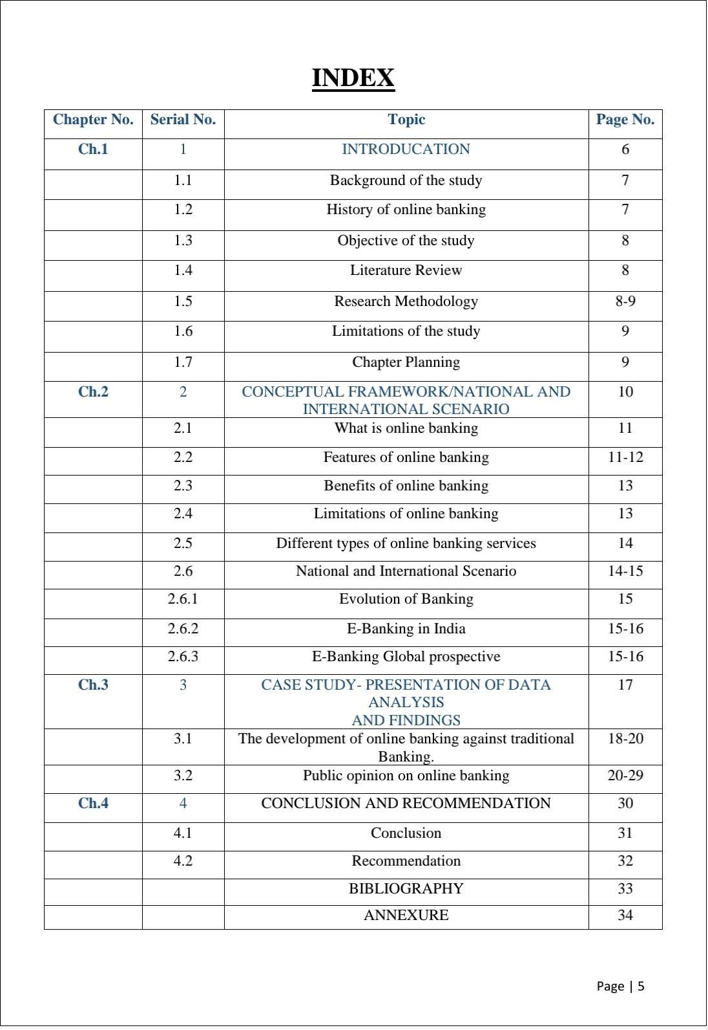

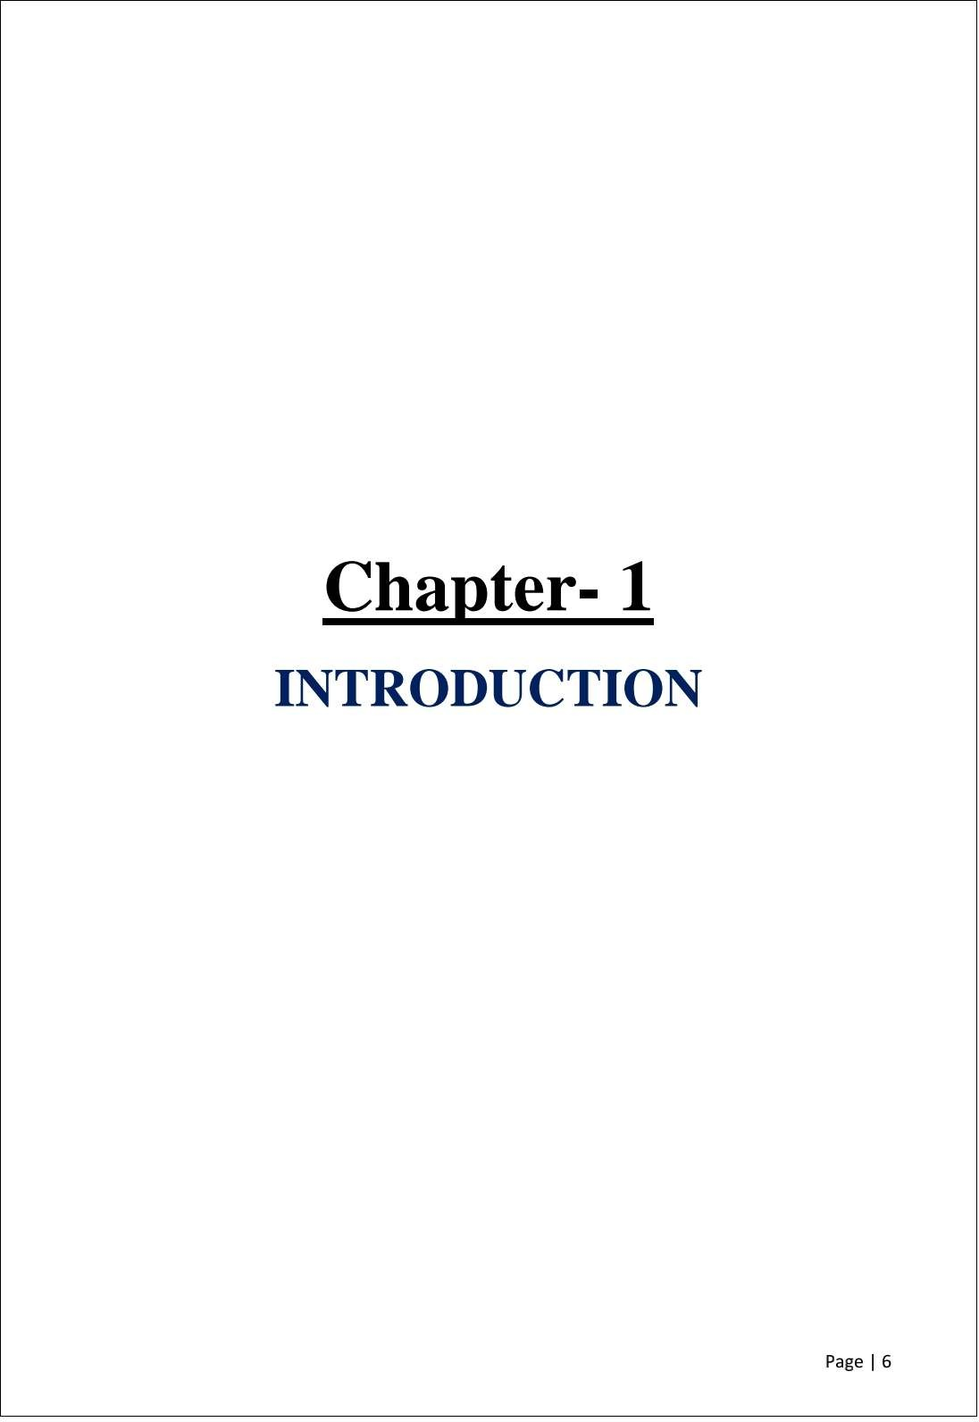

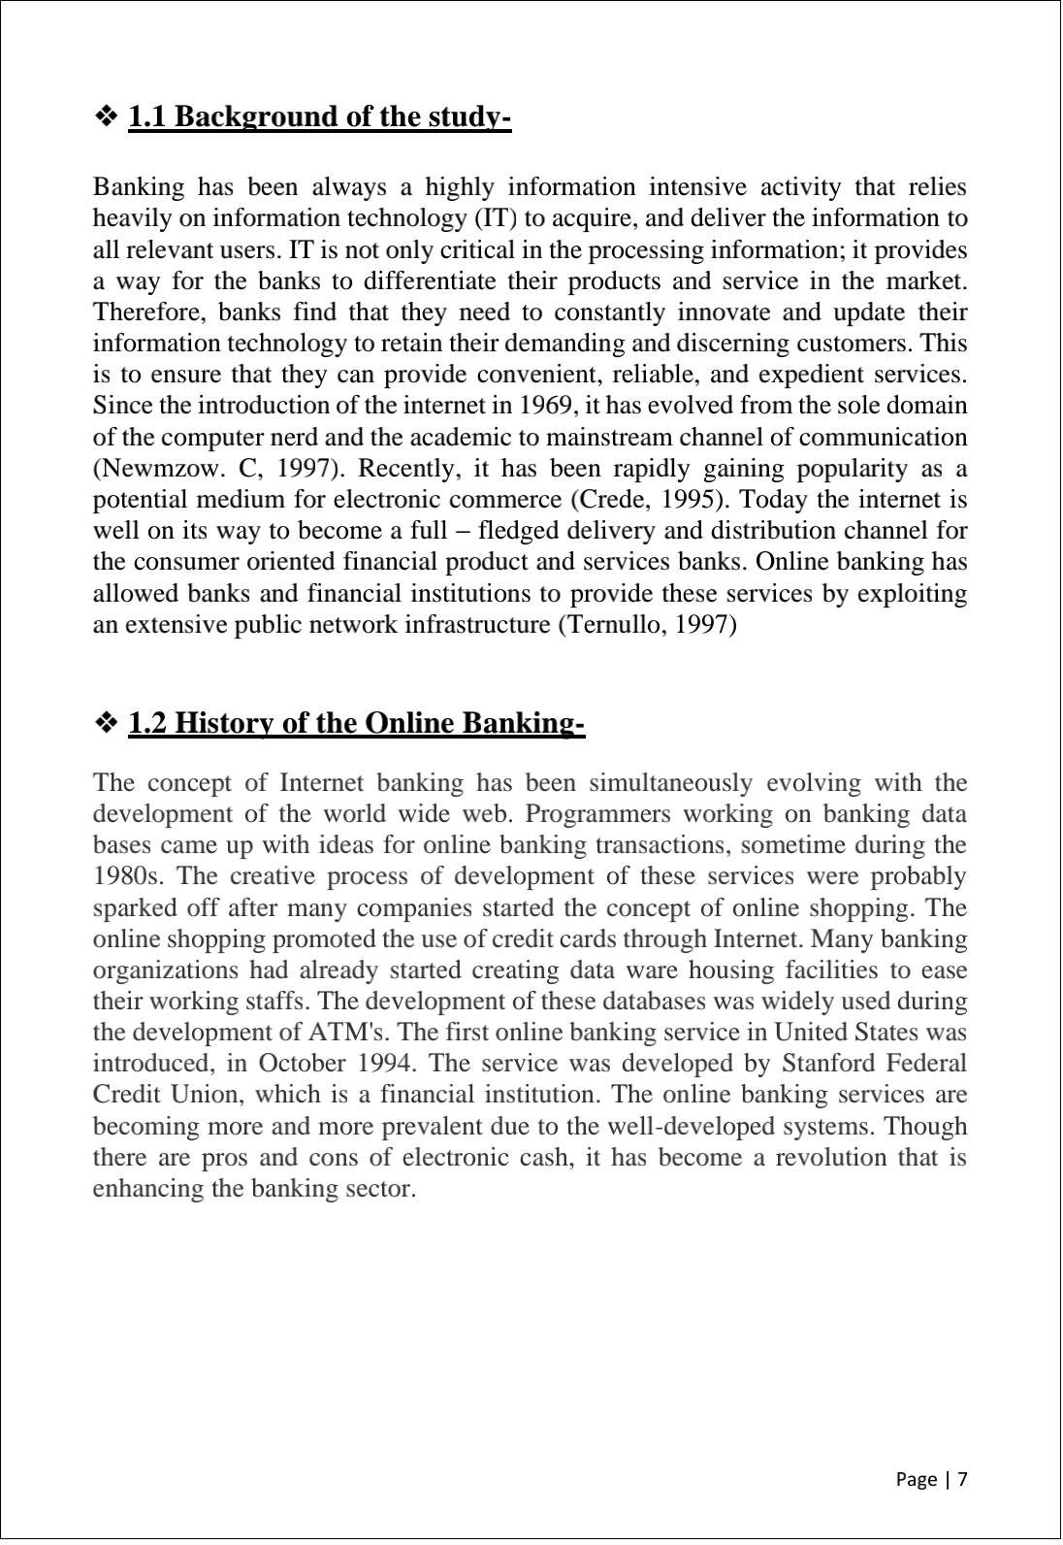

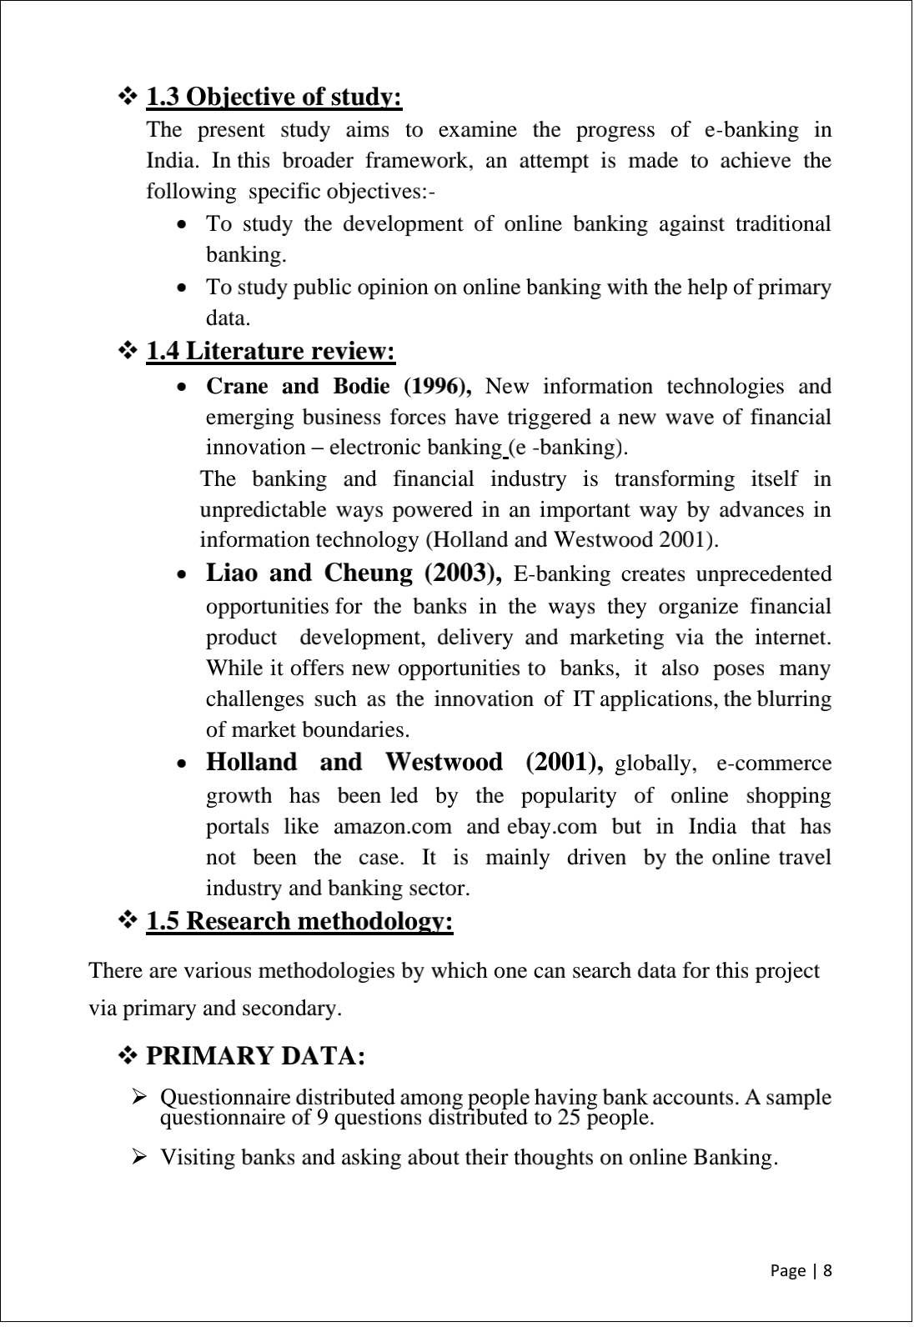

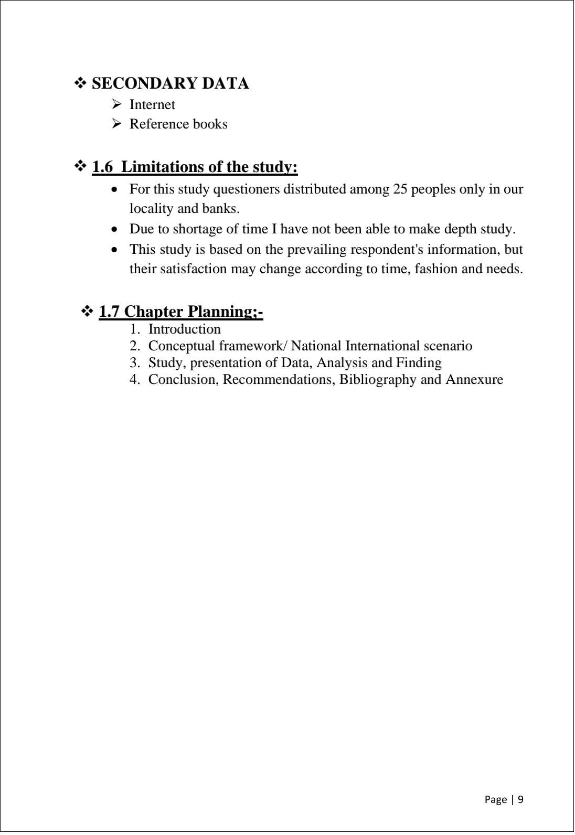

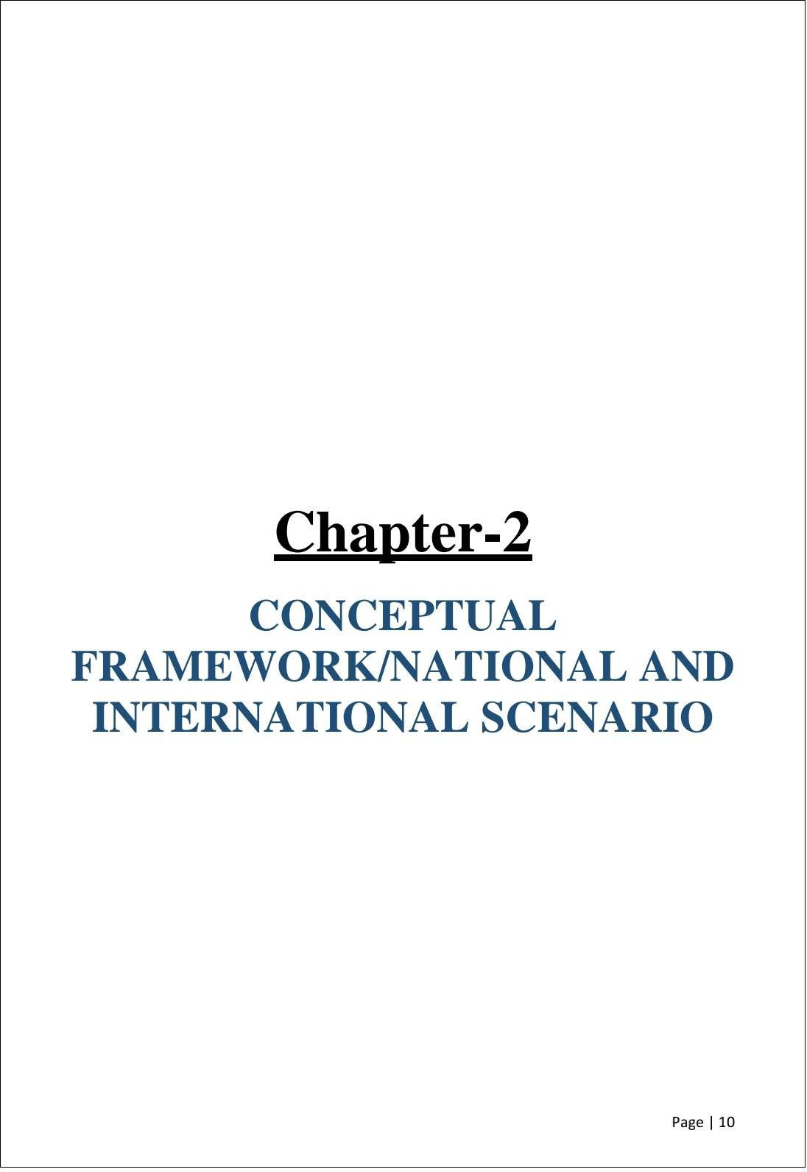

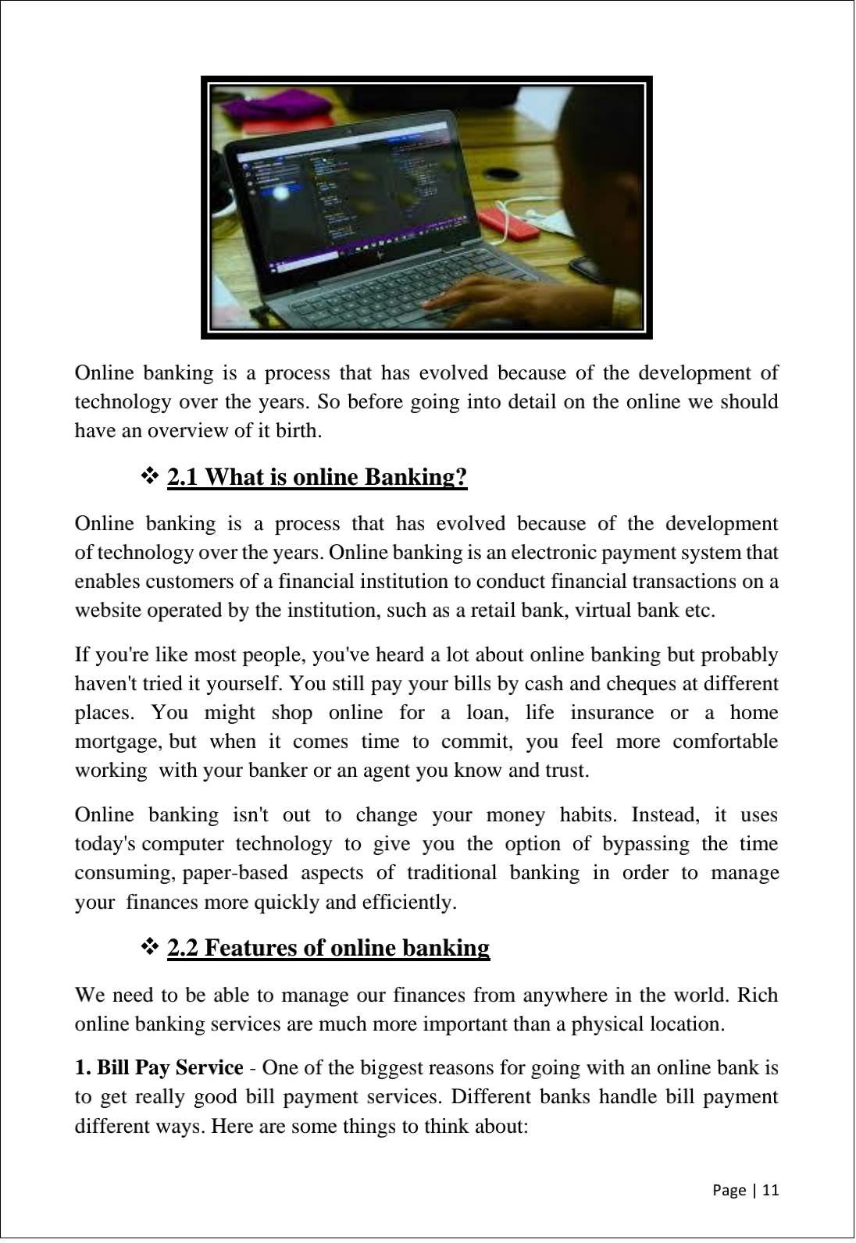

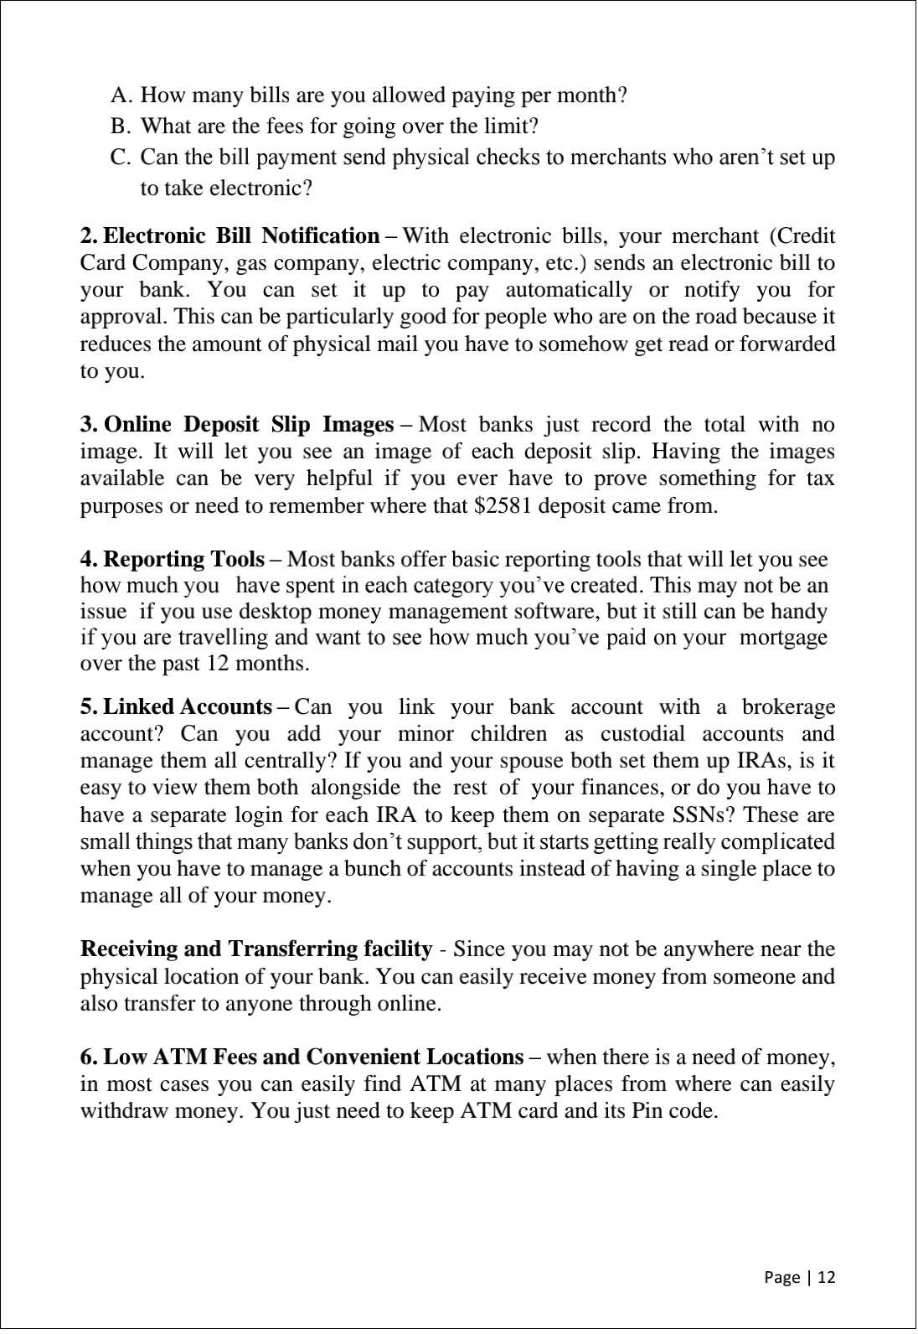

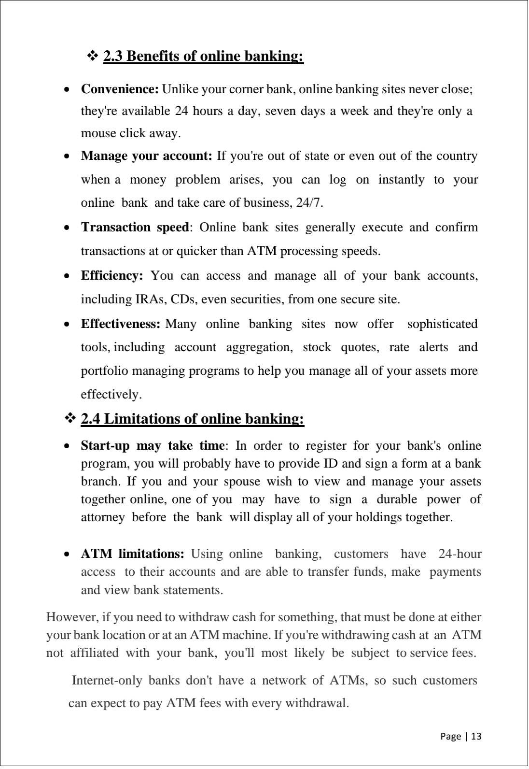

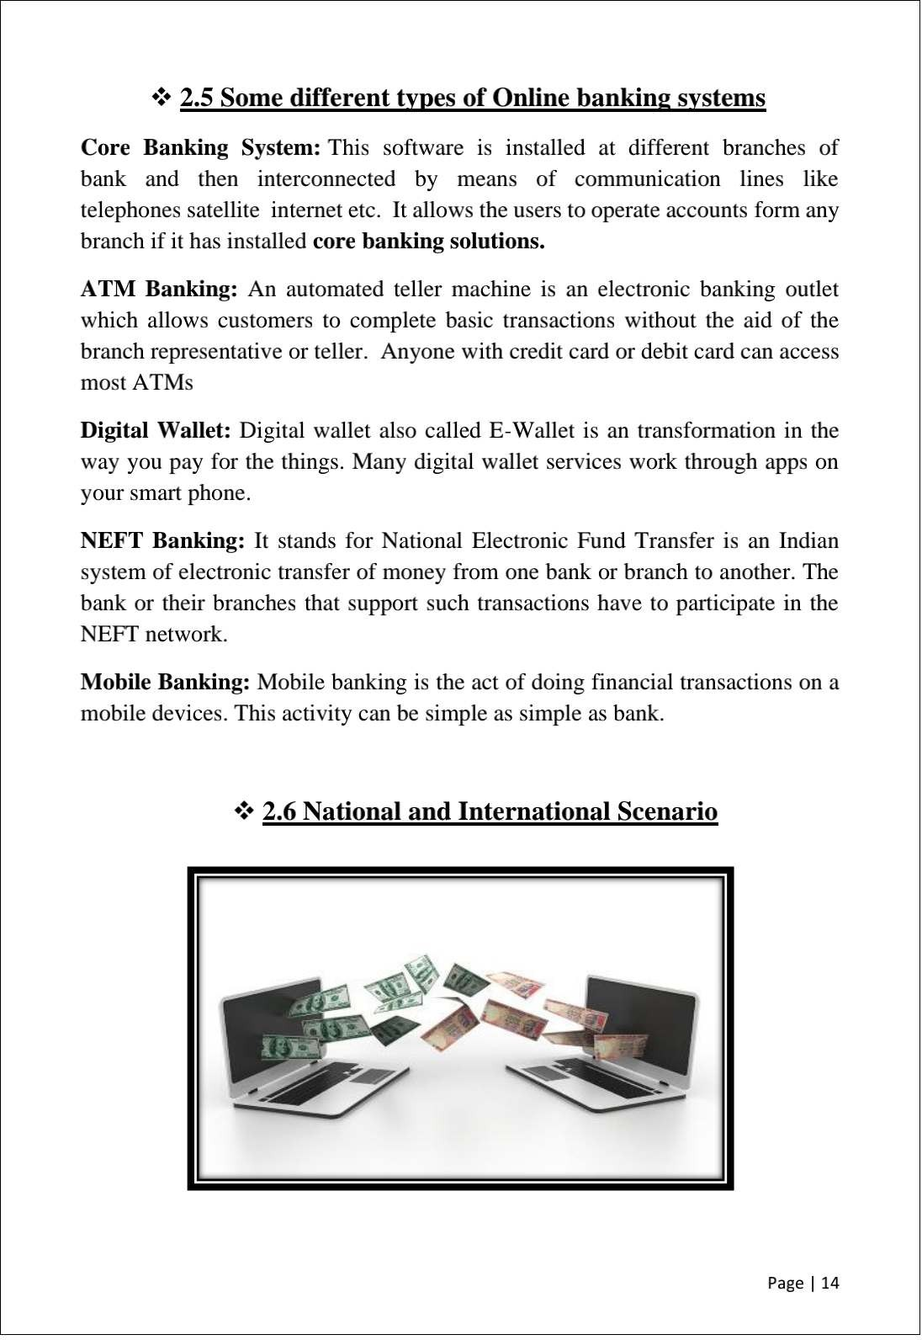

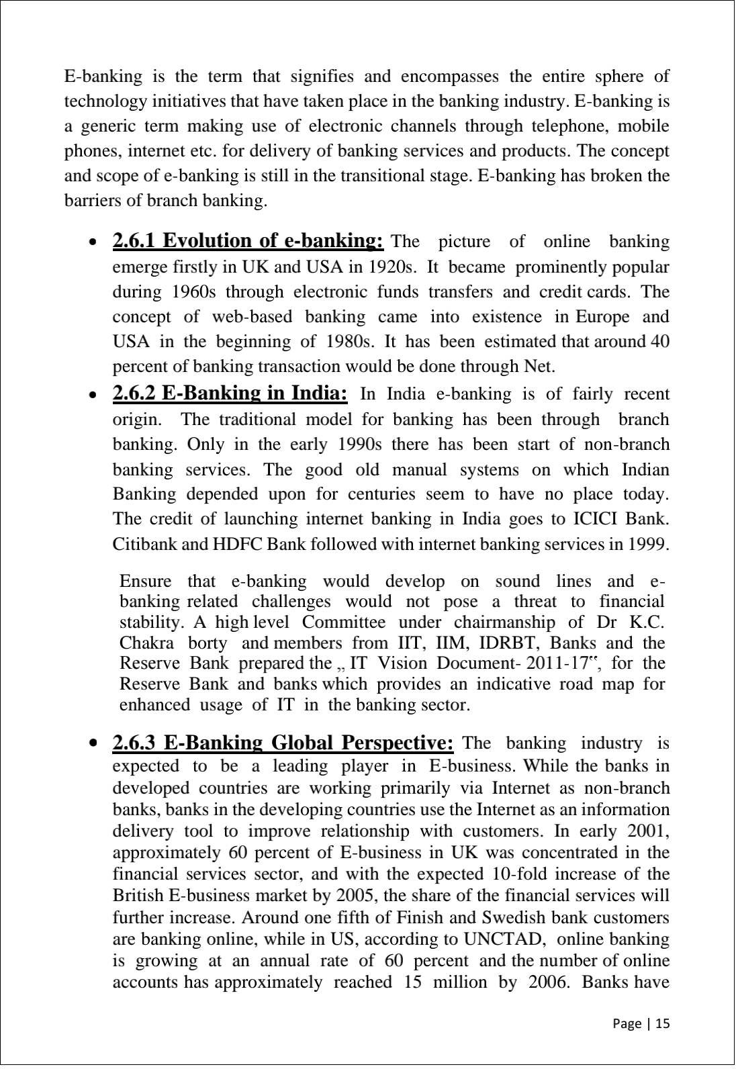

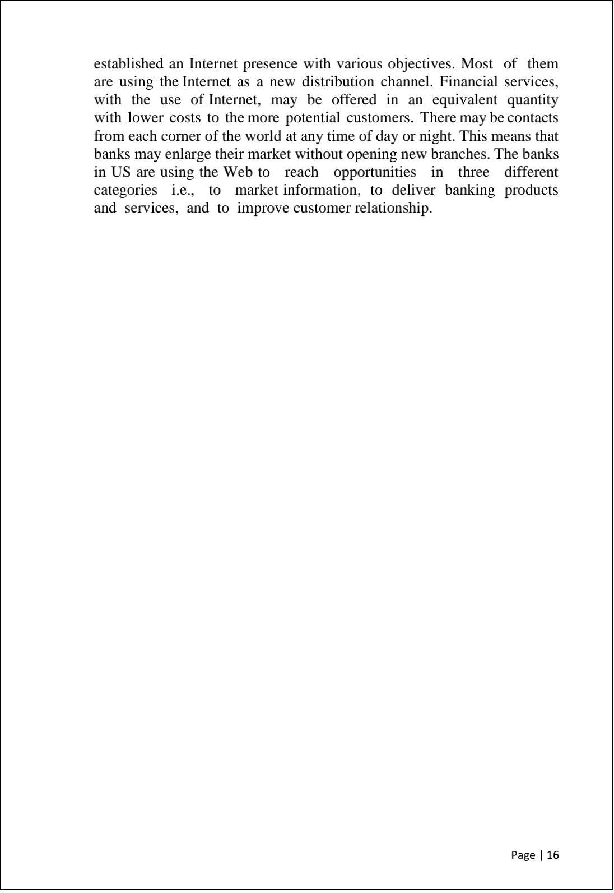

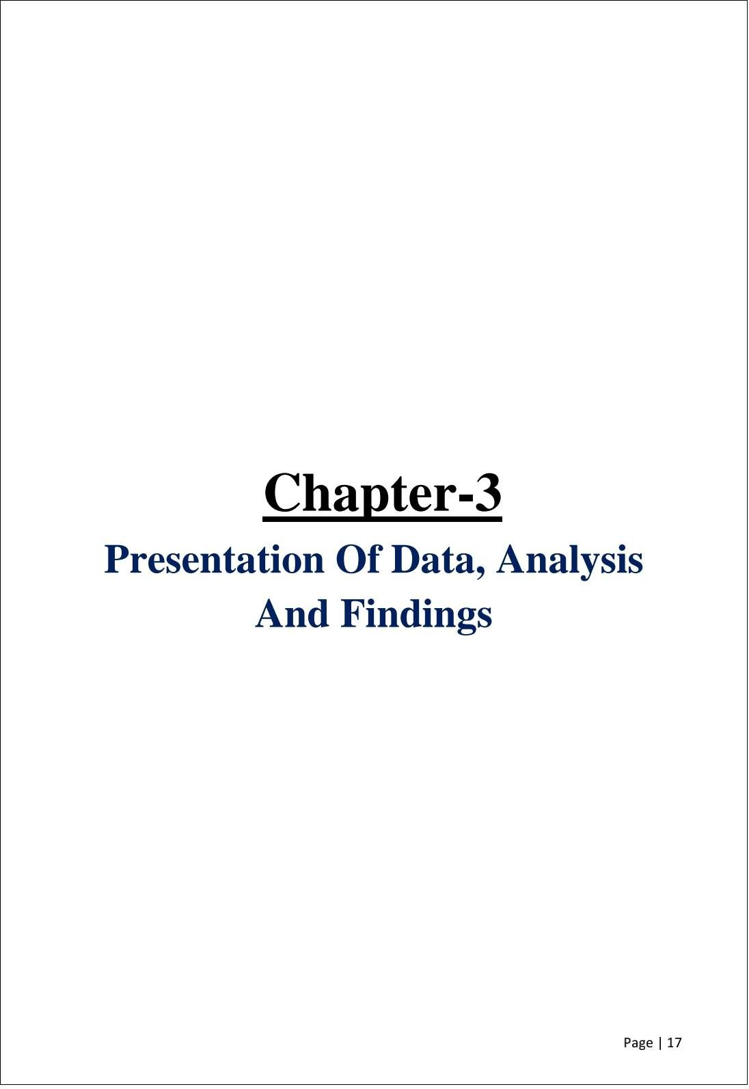

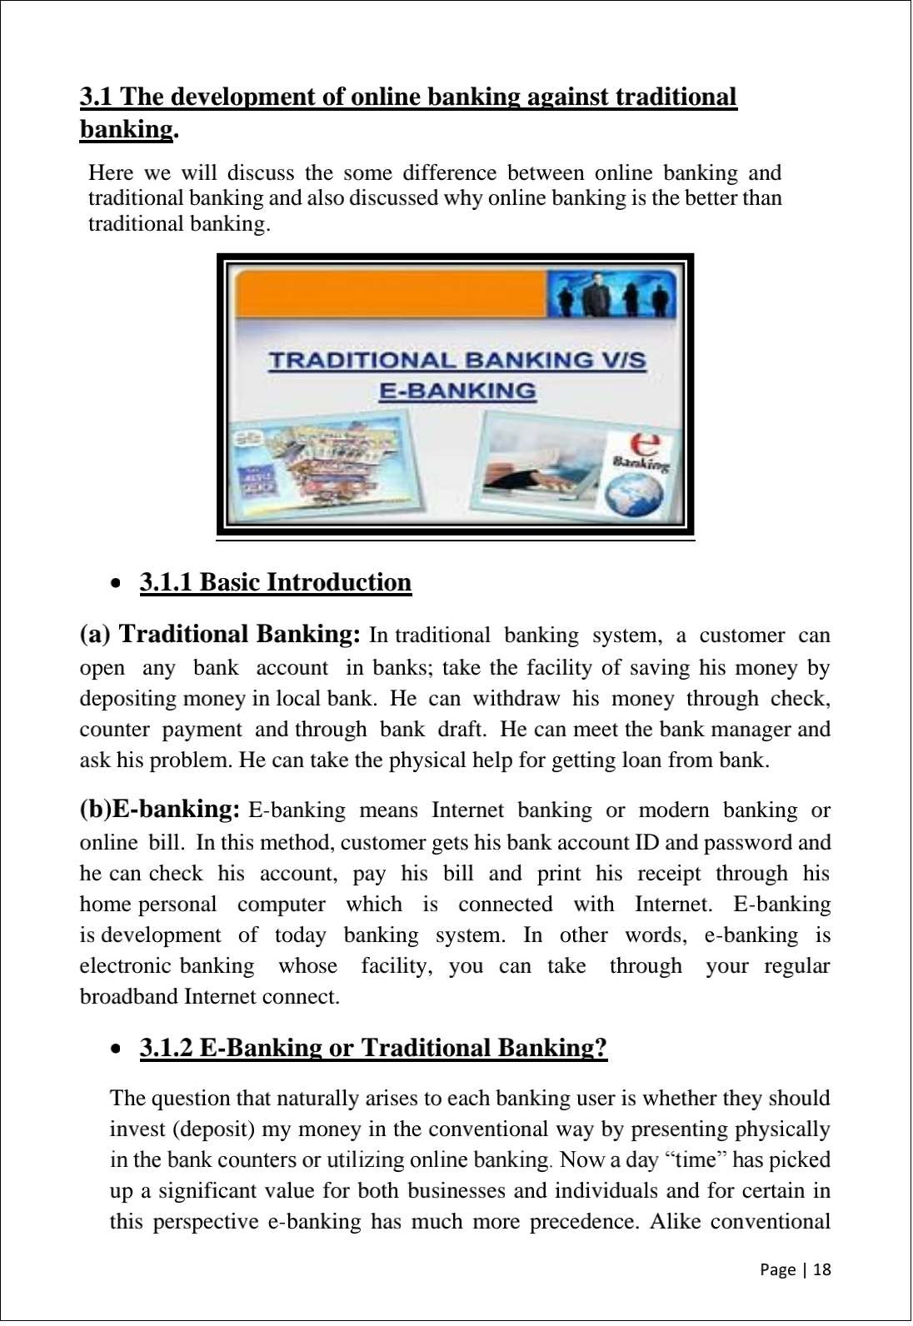

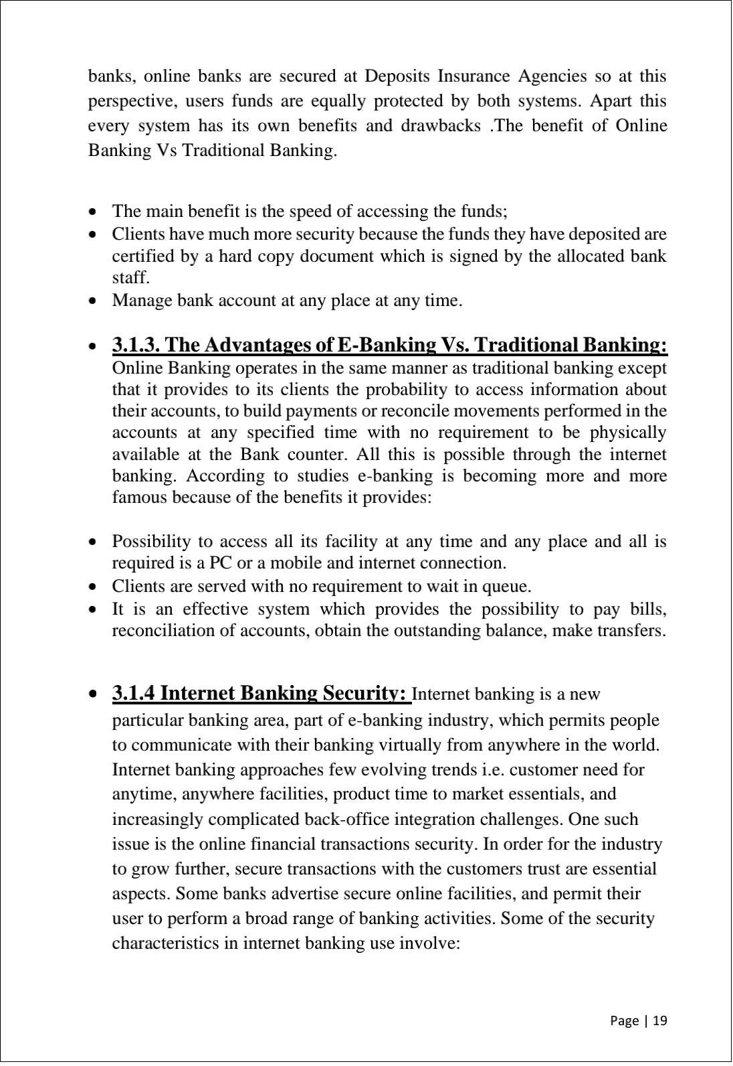

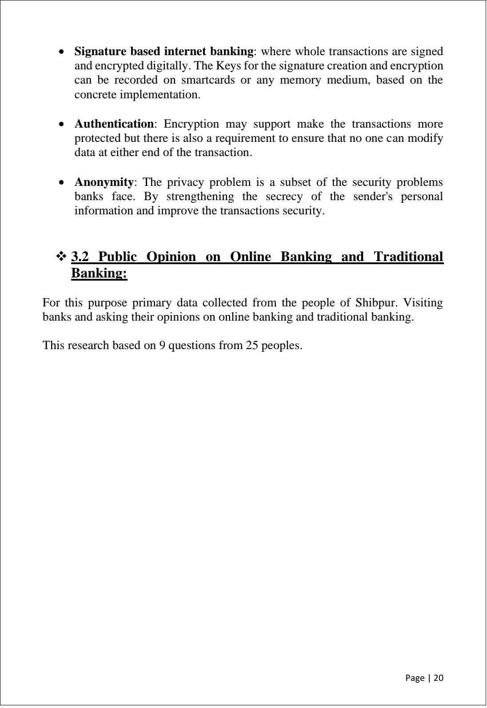

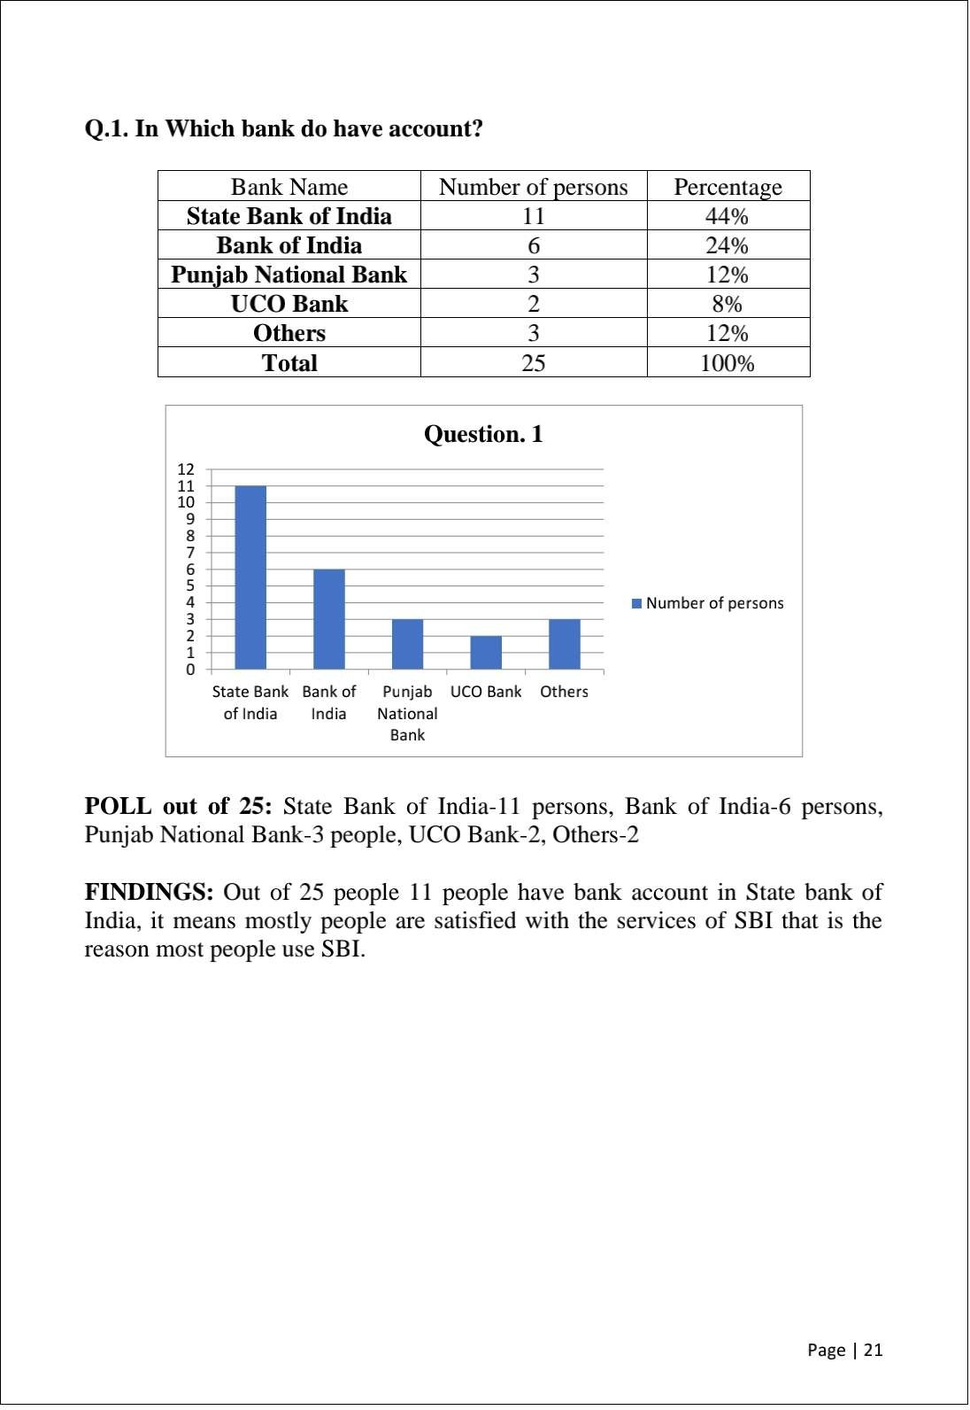

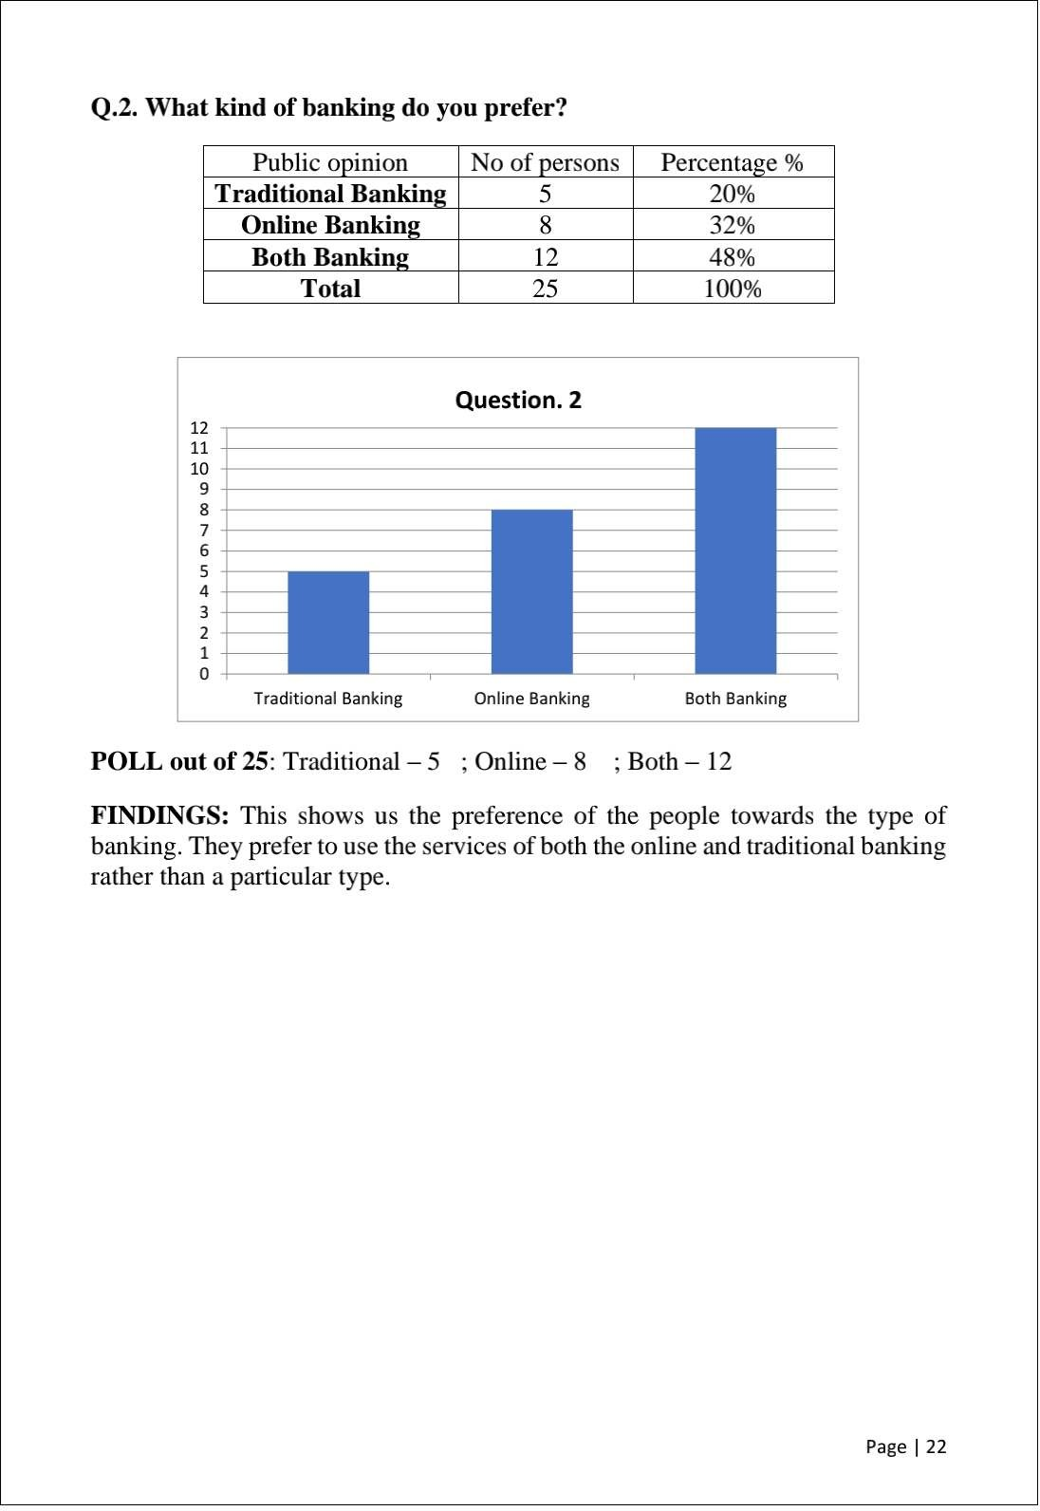

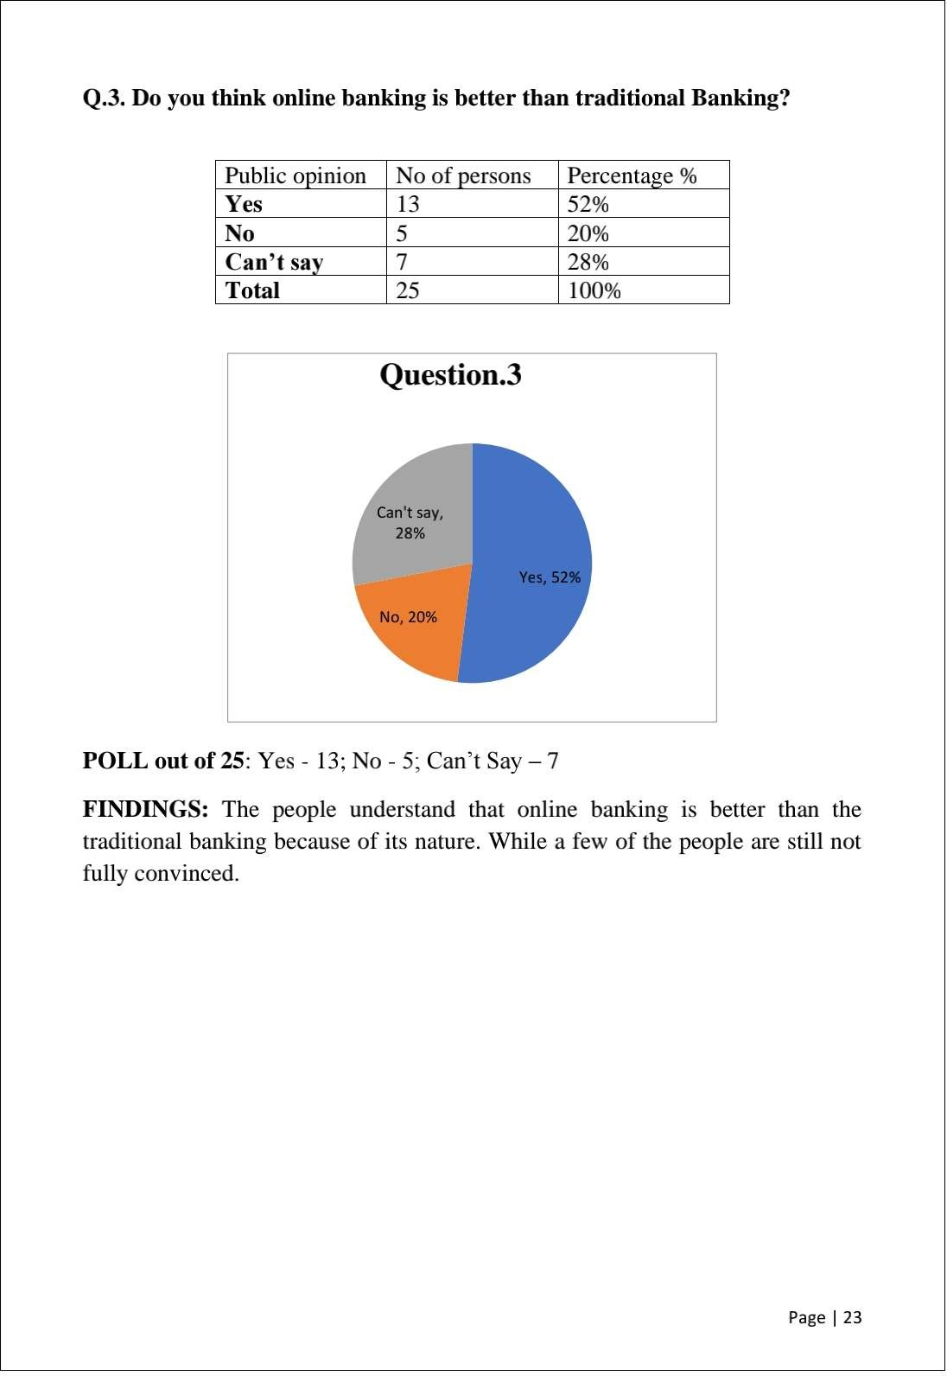

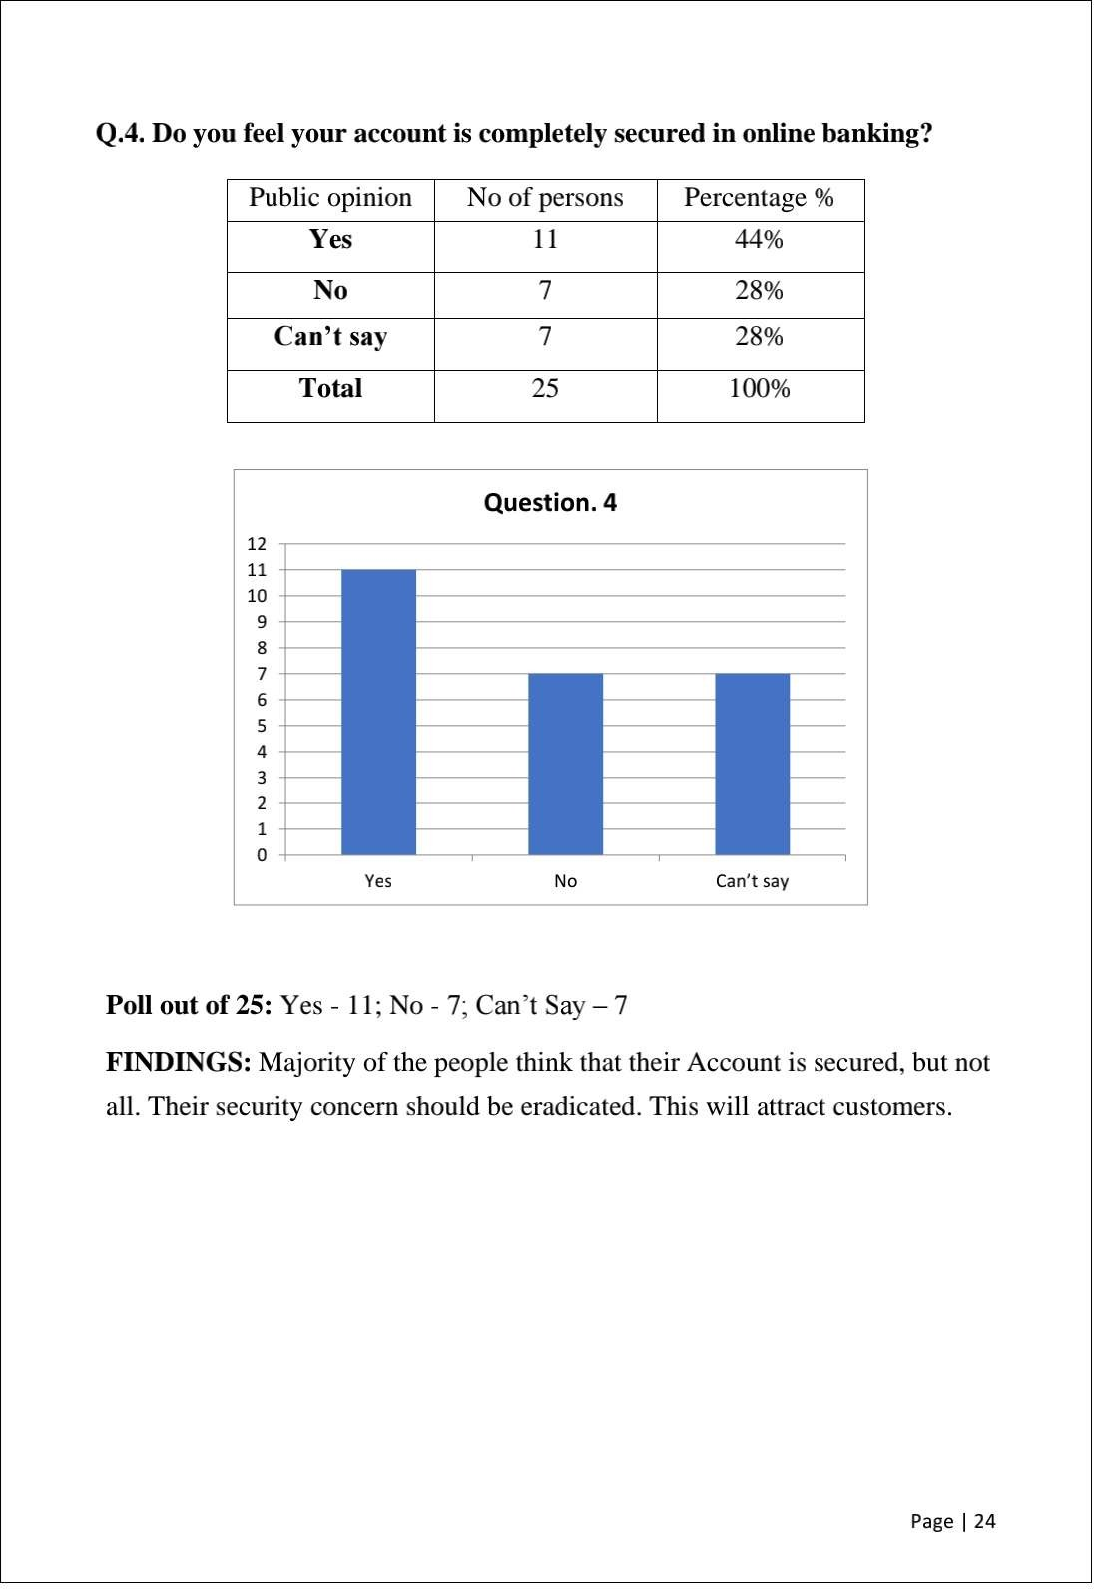

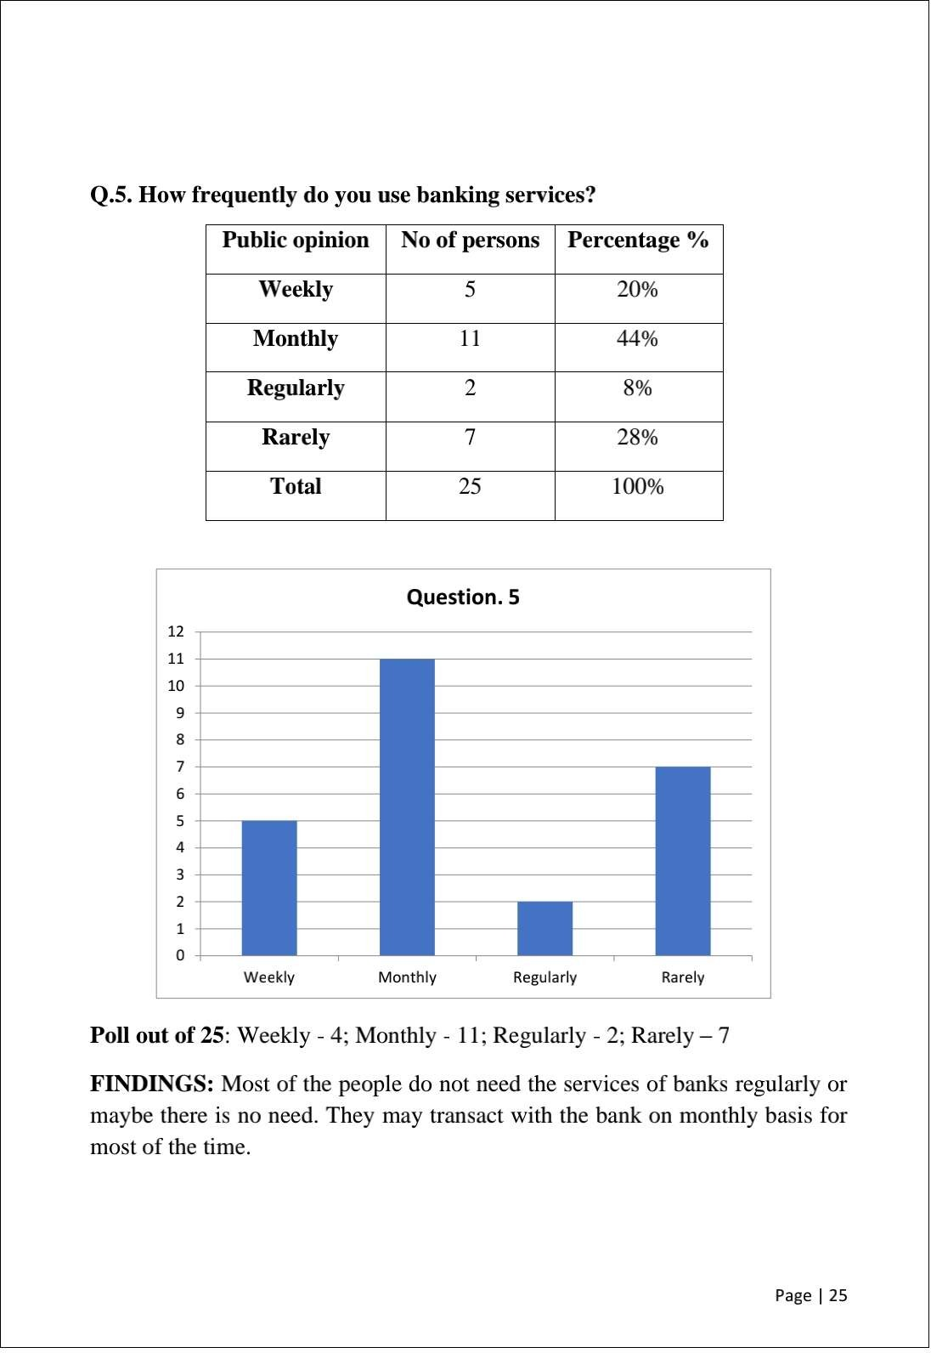

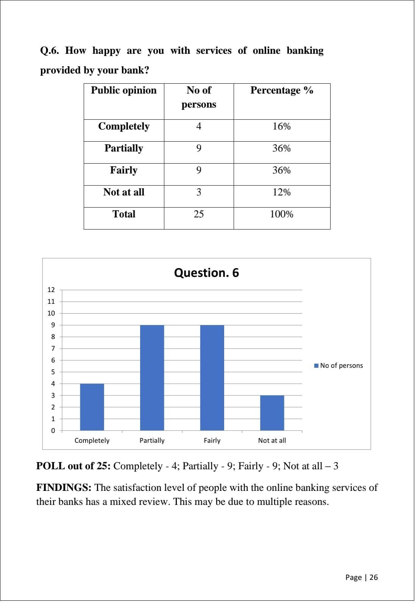

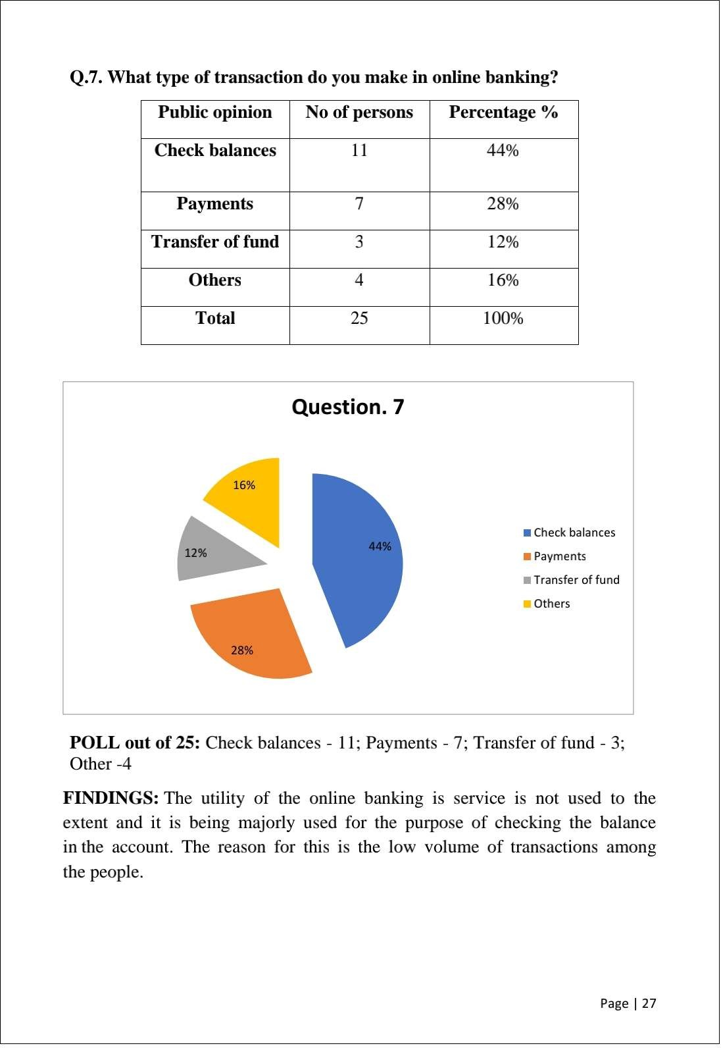

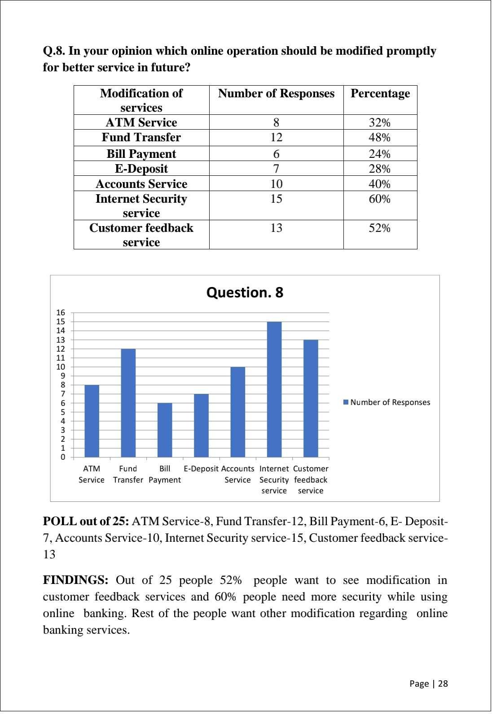

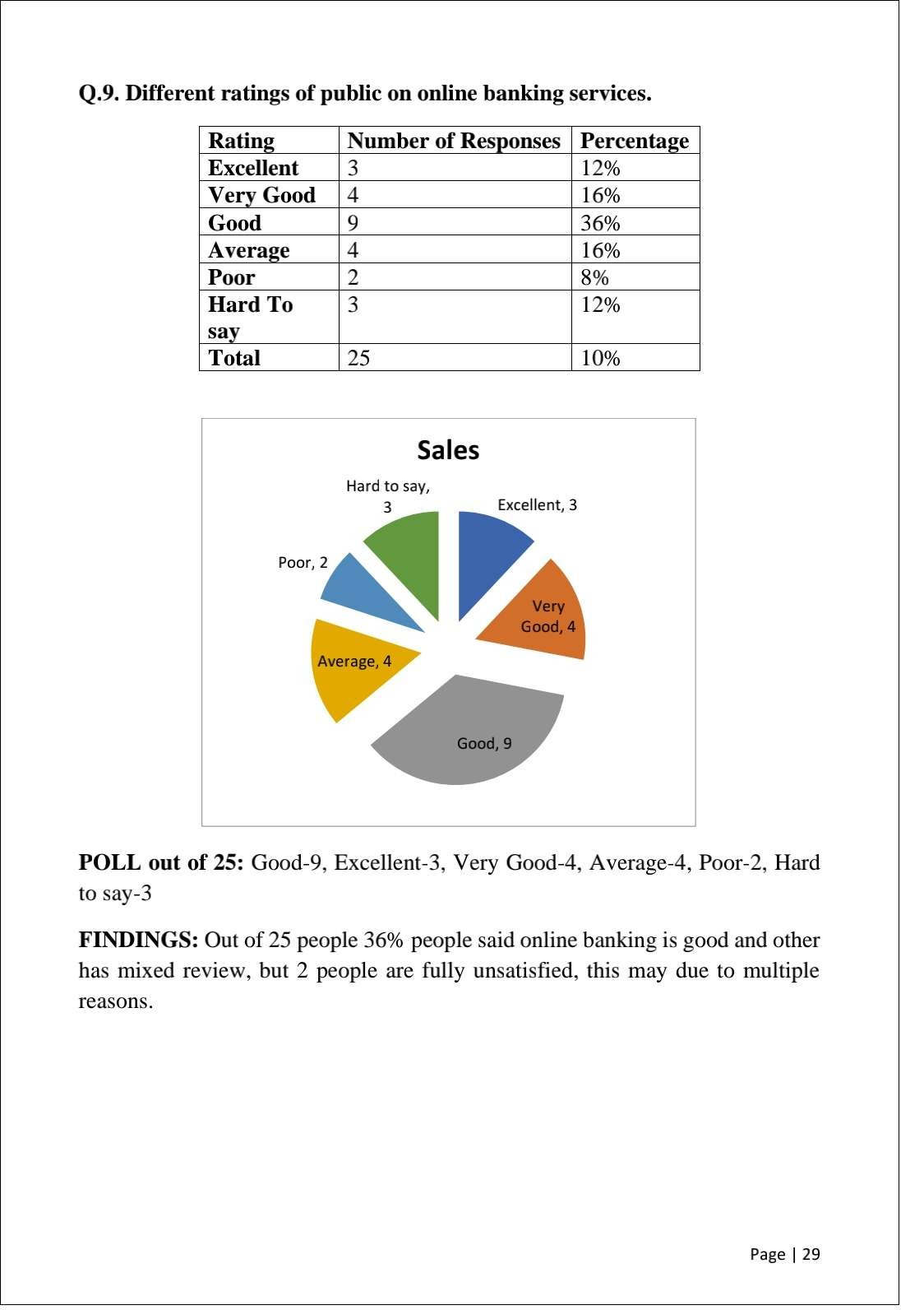

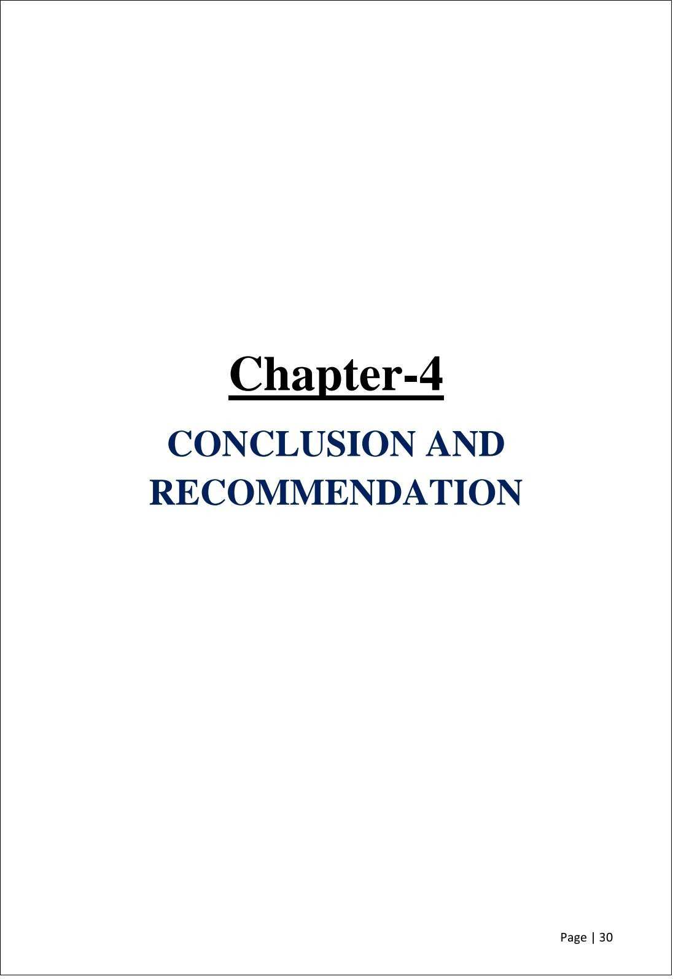

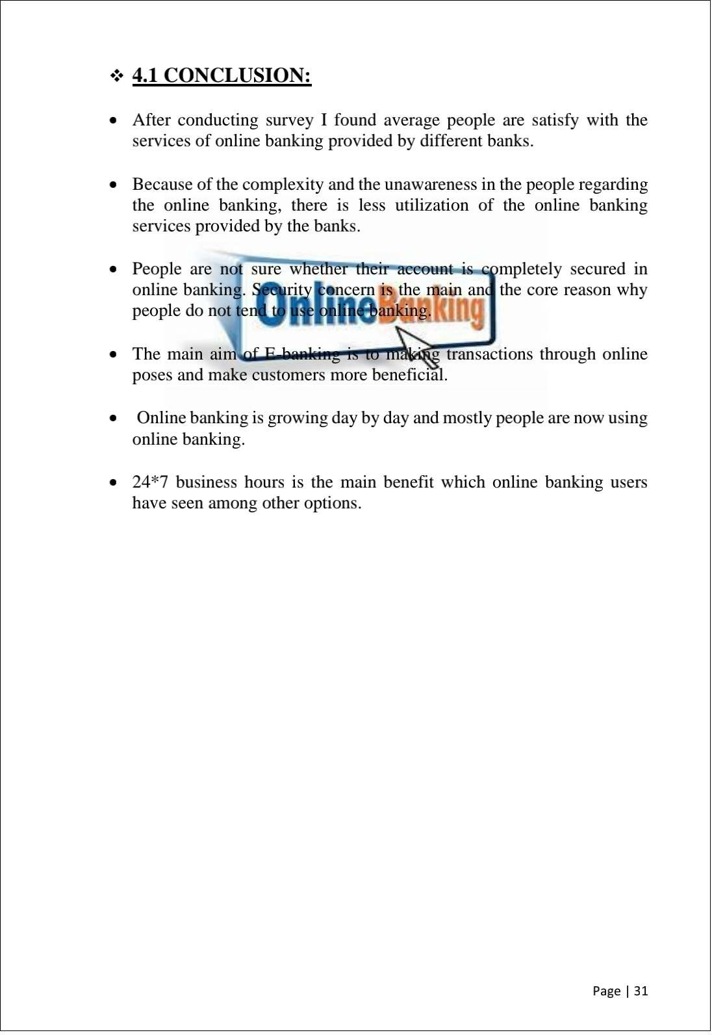

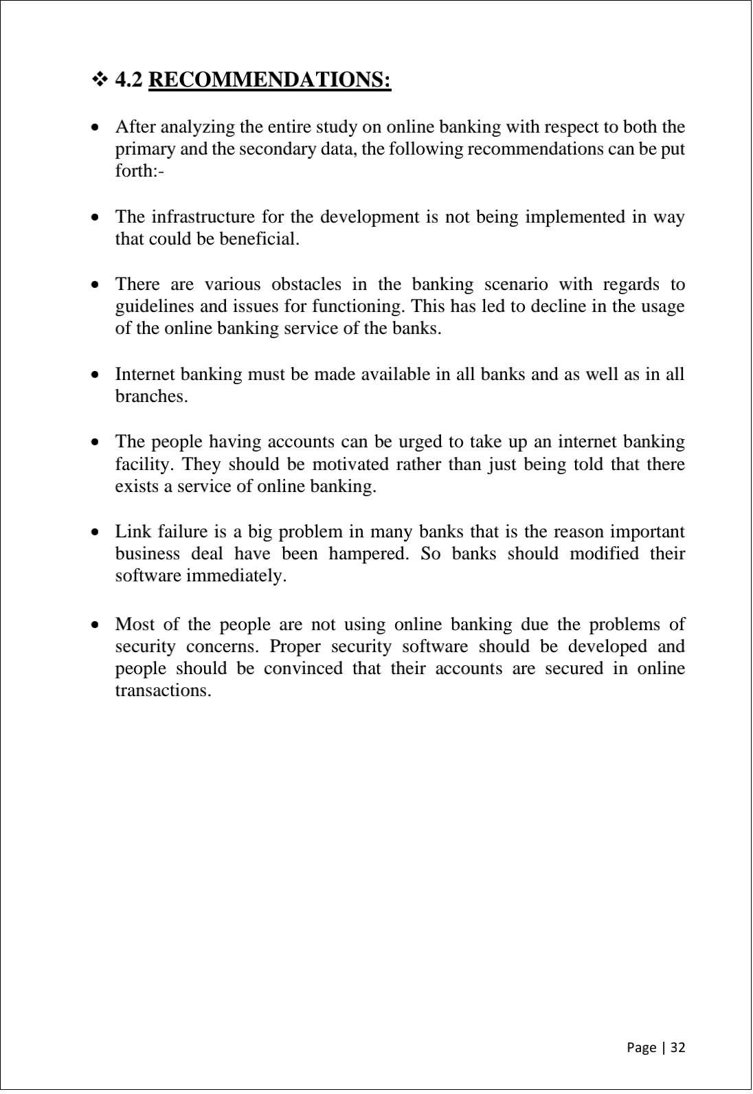

BIBLIOGRAPHY

JOURNALS
- Himani Sharma(2011), “Bankers’ Perspectives on E-Banking and Its Challenges: Evidence from North India” The IUP Journal of Bank Management, Vol. X, No. 4, 2011
- Nancy B, Lockett A, Winklhofer H and Christine E (2001), “The Adoption of Internet Financial Services: A Qualitative Study”, International Journal of Retail and Distribution Management, Vol. 29, No. 8, pp. 390-398.
- Sathye M (1999), “Adoption of Internet Banking by Australian Consumers: An Empirical Investigation”, International Journal of Bank Marketing, Vol. 17, No. 7, pp. 324-334.
- Nath R, Paul S and Monica P (2001), “Bankers’ Perspectives on Internet Banking”, e-Service Journal, Vol. 1, No. 1, pp. 21-36.
- Liao Z and Cheung M T (2002), “Internet-Based E-Banking and Consumer Attitudes: An Empirical Study”, Information & Management, Vol. 39, No. 4, pp. 283-295.
- Kaleem A and Ahmad S (2008), “Bankers’ Perceptions of Electronic Banking in Pakistan”, Journal of Internet Banking and Commerce, Vol. 13, No. 1

WEBSITES:
- www.onlinebanking.net/online-banking-services/

- www.thewisdomjournal.com/Blog/pros-and-cons-of-

- online-banking/www.onlinebanking.net/future-of-

- online-banking/

- www.banknetindia.com/banking/ibkg.htm

