PROJECT REPORT
(Submitted for the Partial fulfilment of the Degree of B. Com. Honours in Accounting & Finance under the University of Calcutta)

STUDY OF NEW AGE BANKING : A Case Study on SBI

Submitted By
Name of the Candidate : MAMTA SINGH
CU Registration No : 144-1211-0855-20
College Roll : BHO425
CU Roll No : 201144-11-0112
Name of the College : Bangabasi Morning College

Supervised By
Name of the Supervisor : Dr. Moumita Sarkar (Samanta)
Name of the College : Bangabasi Morning College

Month & Year of Submission
May’2023

Annexure-I
Supervisor’s Certificate

This is to certify that Ms. Mamta Singh a student of B.Com. Honours in Accounting & Finance of Bangabasi Morning College under the University of Calcutta have prepared a Project Report with the Study of New Age Banking in Respect of SBI, which she is submitting, is her genuine and original work to the best of my knowledge.

Date: Signature:
Place: Kolkata Name: Dr. Moumita Sarkar (Samanta)
Designation: Assistant Professor
Name of College: Bangabasi Morning College

Annexure-II

Student’s Declaration

I hereby declare that the Project work with the title STUDY OF NEW AGE BANKING IN RESPECT OF SBI submitted by me for the partial fulfilment of the degree of B.Com Honours in Accounting & Finance under the University of Calcutta is my original work and has not been submitted earlier to any other University/Institution fulfilment of the requirement for any course of study. I also declare that no chapter of this manuscript in whole or in part has been incorporated in this report from any earlier work done by others or by me. However, extracts of literature which has been used for this report has been duly acknowledged providing details of such literature in the references.

Date: | Signature:
Place: Kolkata | Name: Mamta Singh
CU Registration No: 144-1211-0855-20
CU Roll No: 201144-11-0112

TABLE OF CONTENT

CHAPTER | INDEX | PAGE NO.
1 | INTRODUCTION
1.1 | BACK GROUND OF THE STUDY | 5
1.2 | NEED FOR THE STUDY | 8
1.3 | OBJECTIVE OF THE STUDY | 9
1.4 | LITERATURE RIVIEW | 10
1.5 | RESEARCH METHODOLOGY AND DATA COLLECTION | 12
1.6 | LIMITATIONS OF THE STUDY | 13
1.7 | CHAPTERISATION | 13
2. | CONCEPTUAL FRAMEWORK
2.1 | NATIONAL SCENARIO | 14
2.2 | INTERNATIONAL SCENARIO | 21
3. | PRESENTATION OF DATA ANALYSIS
3.1 | DATA ANALYSIS AND FINDINGS | 22-30
4. | CONCLUSION AND RECOMMENDATION | 31-32
 | BIBLIOGRAPHY | 33
 | Annexure (Questionnaire) | 34-36

CHAPTER - 1
INTRODUCTION

1.1 Background of the Study:
Electronic banking (e-banking) is defined as the automated delivery of new and traditional banking products and services directly to customers through electronic, interactive communication channels.

Efficient implementation of supporting technology for allowing a variety of electronic banking has bought a new revolution for the delivery of banking facilities. With the increasing popularity and benefits of e-banking, a lot of banks have recognised the importance, competition and challenges carried out with this new technology and are adapting to this new-age banking.

Online Banking also known as “e-banking” or “Internet Banking” or “Virtual Banking” is defined as the automated delivery of new and traditional banking product and services directly to customer through electronic, interactive channels. Internet banking has become the self service channel that allows banks to provide information and offer services to their customers with more convenience via the web service technology.

The evolution of e-banking has fundamentally transformed information on financial products and services through a public or private network, including internet. Customers access e-banking services using and intelligent electronic device, such as Personal Computer (PC), Personal Digital Assistant (PDA) and Automated Teller Machine (ATM). Today e-banking has experienced phenomenal growth and has become one of the main avenues for banks to deliver their product and services.

Evolution of E-Banking:
The story of technology in banking started with the use it of punched card machines like accounting machines or ledger posting machines. The use of technology, at that time, was limited to keeping books of accounts. It further developed with the birth of online real time system and vast improvement in telecommunications during late 1970’s and 1980’s. It resulted in revolution of in the field of banking with “Convenience Banking” as a buzzword. Through the convenience banking, the bank is carried to the doorstep of the customers. The 1990’s saw the birth of distributed computing technologies and Relational Database Management System. The banking industry was simply waiting for these technologies. The intense competition has forced banks into reinvent and improves their product and services to make them more beneficial and cost effective. Technology in the form of e-banking has made it possible to find alternate banking practices at lower costs.
Since the 80’s there has been turbulence in the banking and finance industry worldwide as the pace of changes continues to accelerate. Changes are being driven, above all by competition, technology and customers demand. One of the strategic challenge faced by banking Institution in the growing and changing needs and expectations of customers with the increased educational level and growing wealth. The globalization process and the opening up of the Indian economy have given reason for the banking sectors to think it’s existing strategies. The penetration of customers and growth in internet usage is making the customers crave fir more services, more convenience. People want to put their PC to as many uses as possible; E-banking is one of such use.

The practice of online banking actually began in the 1980’s, although the concept didn’t take off until the mid - 90’s, as the internet truly took flight with customers signing up for internet connection. The STANFORD FEDERAL CREDIT UNION was the first financial Institution to offer online internet banking services to all of its members in October 1994. In October 1991, the presidential Savings Bank became the first bank in America to offer account over the internet. In India, ICICI bank was the first bank to offer this service. In 1996, other private sector banks like Citibank, HDFC, started offering internet services, in 1999, SBI launched it’s services in July 2001.

Internet Banking System:
Internet Banking System is a system that has been developed in order to help clients with the daily day-to-day transactions. Internet banking systems means that clients can now do banking at the leisure of their homes. Also known as online banking, the system allows both transactional and nontransactional features. Online banking or internet banking allows customers to conduct financial transactions on a secure website operated by the retail or virtual bank.

1.2 Literature Review:-
Singh, B. A. and Tandon, P. Affirmed that banking Sector plays a vital role in economic development of a country. The banking industry of Bharat is featured by a large network of bank branches, serving several types of financial services of the folks. The banking company of Bharat, popularly called SBI is one amongst the leading bank of public sector in Bharat. The study found that SBI is acting well and financially sound.
Kumbirai, M. and Webb, R. investigates the performance of South Africa’s business banking sector for the quantity 2005- 2009. cash ratios are utilized to measure the profit, liquidity, and credit quality performance of five big South African primarily based business banks. The study found that overall bank performance increased considerably among the initial two years of the analysis. A significant modification in trend is detected at the onset of the global cash crisis in 2007, reaching its peak throughout 2008-2009. This resulted in falling profit, low liquidity and deteriorating credit quality among the South African Banking sector.
Mohi-ud-Din Sangmi; Nazir, T. (2010) specific that sound financial health of a bank is that the guarantee not exclusively to its depositors but is equally necessary for the shareholders, employees and whole economy, nevertheless. As a sequel to the current maxim, efforts square measure created from time to time, to measure the cash position of each bank and manage it efficiently and effectively. Throughout this paper, a shot has been made to gauge the cash performance of the two major banks operative in northern Republic of India .This analysis has been done by practice hoofed mammal Parameters, the foremost recent model of financial analysis. Through this model, it's highlighted that the position of the banks beneath study is sound and satisfactory up to currently as their capital adequacy, and quality, Management capability and liquidity thinks about.
Mitra, R. and sitar player, R. (2008) aforementioned that a stable and efficient banking sector is a vital precondition to increase the economic level of a rustic.
Kamakodi et al. (2008) expressed that an extensive gap exists in human service in Indian banking while IT-based facilities are beyond the expectations.
Qureshi T M, Zafar M K and Khan M B (2008) evaluated the customer acceptance of online banking study concludes that majority of customers are accepting online banking culture because of favourable factors and usefulness, security and privacy.
Uppal R K (2010) expressed in his research, ATMs is the most effective while mobile banking does not hold a strong position in public sector banks, Mobile banking customers are also the highest in E-Banks which have a positive impact on net profit and business per employee.
Mishra (2011) delivered a useful advice to safeguard the safety of internet-based transactions (IBT). The customer of the banks should not reply to any SMS, calls or Emails, requesting for password and not to connect on any link for banks website. E-Banking has arisen from such an advanced improvement.
Zamdi et al (2013), studying 56 countries over 2008-12, calculate that USD 983 billion were added to their cumulative real GDP because of increased card usage. Among the emerging economies, India at a lower level of 0.047%. Dhananjay B and Suresh Chandra B (2015) expressed that retail electronic payment system has progressed in the recent years. The creation of NCPI set the stage for the development of Electronic payments. In this ratio of electronic clearing grew from one percent to three percent. Mukhopadhyay (2016) in their study of benefits from cashless society found that as more payments are directly credited to the account, cashless payments increase significantly.
Dr. Karunagupta, Mr. Ravindraarya, (2017) focused on emerging trends in the banking sector in India, he focused on the banking sector with reference to digitalization. The digitalization of banking system leads to a strong foundation in of economy and to ready to become cashless economy to transform the Indian banking industry.
The confirmation/disconfirmation paradigm views customer satisfaction judgments as the result of the consumer`s perception of the gap between their perceptions of performance and their prior expectations customer satisfaction in service industries has been approached differently by equity theory, attribution theory, the conformation and disconfirmation paradigm, and satisfaction as functional perception (Parker and mathews,2001). Increased research into customer satisfaction has been influenced dramatically by the variety of measurement scales used in customer satisfaction instruments tests (Devlin et al., 1991). The biggest technological advancement since the personal computer and the primary technological force causing all corporations to rethink their business model, the internet is a system of millions of interconnected networks that spans to the earth (Wilson, 1996).

1.3 Need for the Study:
In today’s scenario when the country is progressing towards technological development in
every aspect, online banking is considered one of the tools of such development. My main
motive behind choosing this topic is to show.

This study is needed to find out the working of Internet Banking of SBI and its importance to customer as well as to bank.
    - The details of online banking.
    - Acceptance and dependence of various services of online banking among various kinds of persons.
    - Measures to be taken for the improvement on the acceptance of online banking.
This paper investigates the acceptance of online banking and also the factors which are affecting the accepting the acceptance of e-banking services among the customers. It also indicates the level of concern regarding security and privacy issue.

1.4 Objective of the Study:
- To understand the concept of Internet banking and importance, to bank as well as customers.
- To get aware of various aspects of net banking
- To evaluate the awareness of E-banking among the customers of SBI
- To measure the customer satisfaction in E-banking services provided by SBI
- To Study the most preferred E-banking service offered by SBI.

1.5 Research Methodology:
Methodology basically means the selection of the various methods and techniques
In the research conducted. The various steps include:
1. Selection of sample
2. Application of various tools and techniques to obtain relevant information related to the case.
3. Collection of relevant data
4. Analysis and interpretation
5. Generation of final report

Data Collection: Both primary and secondary data are used.
Primary Data: Primary data are those data regarding the topic which is collected directly by interacting with the customers by using structured questionnaire and interview method.
- Questionnaire
Secondary Data: These are collected from the existing data sources, catalogues, internet and World Wide Web.

Sample Size: I did the survey on 60 people for my project report.

1.6 Limitations of the Study:
The study conducted and done is analytical subject to following some limitations.
- The study fully depends upon reliability of data information collected form the secondary source. it is not possible to collect the data on all detailed activities taken place over this year.
- There may be fractional differences in the calculated ratios and the overall performance is taken into consideration without taking into the account of individual values.
- Different definitions of capital employed may cause confusion. And insufficient time available for the study and submission of the project.
- Only last few years data are considered.
- Changes in external environment will affect the comparison and only the case study had been done for the project. Therefore, the conclusions drawn based on this may not be reflection of the entire industry.

1.7 Chapterisation:
The study is divided into four chapters with reference:
▪ Chapter- 1: INTRODUCTION
▪ Chapter- 2: CONCEPTUAL FRAMEWORK
▪ Chapter- 3: DATA ANALYSIS AND INTERPRETATION
▪ Chapter- 4: CONCLUTION AND RECOMMENDATIONS

CHAPTER - 2
CONCEPTUAL FRAMEWORK

2.1 National Scenario:
: STATE BANK OF INDIA:
State bank of India is the nation’s largest and oldest bank. Tracing its roots back some 200 years to the British East India Company (and initially established as the Bank of Calcutta in 1806), the bank operates more than 15,000 branches within India, where it also owns majority stakes in six associate banks. State Bank of India (SBI) has more than 80 offices in nearly 35 other countries, including multiple locations in the US, Canada, and Nigeria. The bank has other units devoted to capital markets, fund management, factoring and commercial services, credit cards, and brokerage services. The Reserve Bank of India owns about 60% of State bank of India.

WHERE SBI WAS?
- In early 1990‟s more than 7000 branches were using traditional manual procedures.
- These manual procedures were inherited from the Imperial Bank.
- Traditional procedures were evolved over decades
- Very few changes were brought in those procedures as per the need of time.
- In that time, mainframe or mini computers were used for MIS, RECONCILLATION & FUND SETTLEMENT PROCESS, or we can say that for backhand operations purpose.

SBI launched internet banking in 2001 and experienced good response. In general, internet banking saw an exponential rise in users.

Changes brought in Information Technology by SBI:-
- In the next decade internet facility was provided for individuals.
- All SBI branches were connected and ATM‟S were launched ➢ 2001 - KMPG appointed consultant for preparing IT Plan for the Bank.
- Later on Core banking proposed by the IT consultancy company.
- 2002 – All branches computerized but on decentralized systems, there the initiative of core banking took place
- 2008- more than 6500 branches (95% of business) on Core Banking Solution (CBS)
- Internet Banking facility for Corporate customers were also launched in early 2008
- More Interfaces developed with e-Commerce & other sites through alternate channels like ATM & Online Banking.
- All Foreign Offices were brought on Centralized Solution
- Large network is playing the role of backbone for connectivity across the country.
- Multiple Service Providers are providing the links – BSNL, MTNL, Reliance, Tata & reliance which are making the system errorless and provide high speed.
- Multiple Technologies to support the networking infrastructure – Leased
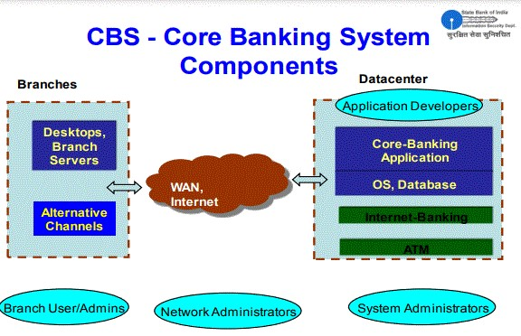
lines, Dialup, CDMA & VSAT.

(www.indianmba.com)
E-BANKING AND SBI:
Electronic-banking includes banking transactions electronically without visiting a branch or Banking without teller/bankers. In this there is a use of computers and telecommunications to enable banking transactions to be done by telephone or computer rather than through human interaction. One can use either phone or Internet to log-on to his/her personal account, which is protected with PIN code (Personal Identification Number).

There are different ways or tools of electronic banking -Plastic Money (ATM cum debit Card & SBI credit card), Mobile Banking services, Internet banking services.

For internet banking services SBI has special portal by the name “OnlineSBI”. The portal provides anywhere, anytime access to SBI accounts. It provide various services like Bill payment, E-Tax, Fund transfer, E-ticketing, RTGS/NEFT, Third party transfer Cheque Book/ Demand draft request, Account statements, E-Trading Account opening request, Transaction enquiry, Demat account, Global services(NRI services) etc.

Mobile banking services are offered by SBI through its tag line:
“State Bank FreedoM- Your Mobile Your bank”. It offers mobile banking services: over application/wireless application protocol (WAP), over SMS and Unstructured supplementary service data (USSD). It is offered to have convenient, simple, secure, anytime and anywhere banking. This service is available on java enabled mobiles phones (with or without GPRS) where the user is required to download the application on to the mobile handset. It performed various functions like: Funds transfer (within and outside the bank), Interbank Mobile Payment Services, Enquiry services (Balance enquiry/ Mini statement), Cheque book request, Demat Enquiry Service, Bill Payment (Utility bills, credit cards, Insurance premium), Donations, Subscriptions, Mobile Top up, M Commerce (Top up of Tatasky, BigTV, SunDirect, DishTV connections and receive recharge pins for Digital TV/Videocon d2h, SBI life insurance premium.

SBI offers plastic money-“SBI Card- Make life simple” to its customers. It has various types of plastic money like Premium cards, travel & shopping cards, classic cards, exclusive cards. It include various features like Cash Access across the World, Convenience @ the Speed of Technology, Estatements, SMS Alerts, SBI Card Online, Fuel Freedom, and Easy Bill Pay Facility at Zero Charge, Flexi-pay, and Balance Transfer at Low Interest Rates, Easy Money Facility, Credit Facility, Online Railway Tickets Booking, and Global Card. These features provide various benefits like 24X7 Priority Concierge Desk, Flower & Gift Delivery, Movie Tickets, Airline Ticket Reservation Assistance, Car Rental and Limousine Referral and Reservation Assistance, Hotel Referral and Reservation Assistance.
Internet banking in India:
The Reserve Bank of India constituted a working group on internet
banking. The group divided the internet banking products in India into 3 types based on the levels of access granted. They are:
- Information Only System: General purpose information like internet rates, branch location, bank products and their features, loan and deposits calculations are provided in the banks website. There exist facilities like downloading various types of application forms. The communication is normally done through e-mail. There is no interaction between the bank application system and the customers. There exists no possibility of any unauthorised person getting production system of the bank’s internet.
- Electronic information Transfer System: The system provides customer – Specific information in the form of account balances, transaction details, and statements of accounts. The information is still largely of the “read only” format. Identification and authentication of the customers is through password. The information is fetched from the banks application system either in batch mode or off line. The application system cannot directly access through the internet.
- Fully Electronic Transactional System: This system allows bi-directional capabilities. Transactions can be submitted by the customers for online update. This system requires high degree of security and control. In this environment the web server and application system are linked over secure infrastructure. It compromises technology covering computerization, networking and security, inter-bank payment gateway and legal infrastructure.
It includes the following.
  - Automated Teller Machine
  - Debit Card
  - Credit Card
  - Mobile Banking
  - Internet Banking

Online Banking Products:
- Credit Card
- Debit Card
- Smart Card
- Automated Teller Machine
- Electronic Fund Transfer
- Mobile Banking
- Internet Banking
- Telephone Banking, etc.
Credit Card: A credit card is an instrument of payment, which enables the card holder to obtain either goods or services from business houses where arrangements have been made to reimburse the businessman. The outstanding amount is paid by the card holder to the over a specified period which carries a fixed amounts of of interest also. Credit cards are most popular method for cyberspace consumer shopping today. Premium Credit card, Cash Back Credit cards, Silver Credit Card are some of the credit cards.
Debit Card: A debit card is a card that authorizes the EFT (Electronic Fund Transfer). A debit card is a way to pay now while a credit card is a way to pay later. When people use debit card, the amount is immediately dedicated from his/her account. It is an alternative to carry a cheque book or cash. The SBI debit card is also known as ATM card which can be used to withdraw money from the ATM machine with a maximum capping of Rs.15,000.
Smart Card: Smart cards are one kind of store value card system based on credit card sized plastic cards with embedded chips that store personal information that can be used to support wireless e-commerce payments. It can be used to pay for generally small ticket items by waving the card at a reader, or Passing it through a reader. There are two types of smart cards contact and contactless depending on the technology embedded. For contact cards to be read they must biophysically placed into a card reader, while contactless cards have a built in antenna that enables transmission of data without direct contact using RFID (Radio Frequency identification) technology.
Tele Banking Or Phone Banking: Telephone banking is relatively new banking product. However it is fastly becoming one of the most popular products. Customer can perform any number of transactions, from any where they have access to phone. They can do the following.
- Check balances and account information
- Transfer fund from one account to another
- Pay certain bills
- Order statements or cheque books
- Demand draft request
Mobile Banking: Mobile banking comes in as a part of the banks initiative to offer multiple channels banking providing convenience for it’s customers. A versatile multifunctional, free service that is accessible and viewable on the monitor of mobile phone. They are being used both as banking and other channel.
Internet Banking: The advent of the internet and the popularity of personal computer presented both opportunity and challenge for the banking industry. For years financial Institutions have used powerful computers to automate million of daily transactions. Today often they only paper record is the customers receipt at the point of sale. Now that their customers are connected to the internet via personal computers, bank envisions similar advantages by adopting those same internal electronic processes to home use. It helps to eliminate costly papers handling. In India first one to move into this area was ICICI Bank, in 1997.
Automated Teller Machine: ATM is a computerized telecommunication device that provides financial Institutions customers a method of financial transaction in a public space without the need of a human clerk or a bank teller. The customer identifies him or himself by inserting a plastic ATM card with a magnetic stripe or a plastic smart card with a chip that contains his or her card number and some security information, such as an expiration date. Security is provided by the customer entering personal identification number (PAN). Using an ATM customers. Can access their bank account in order to make cash withdrawals and check their account balance. Many ATM also allow people to deposit Cash or Cheques, transfer money between their bank accounts, pay bills etc.

2.2 International Scenario:

TOP 20 INTERNET COUNTRIES
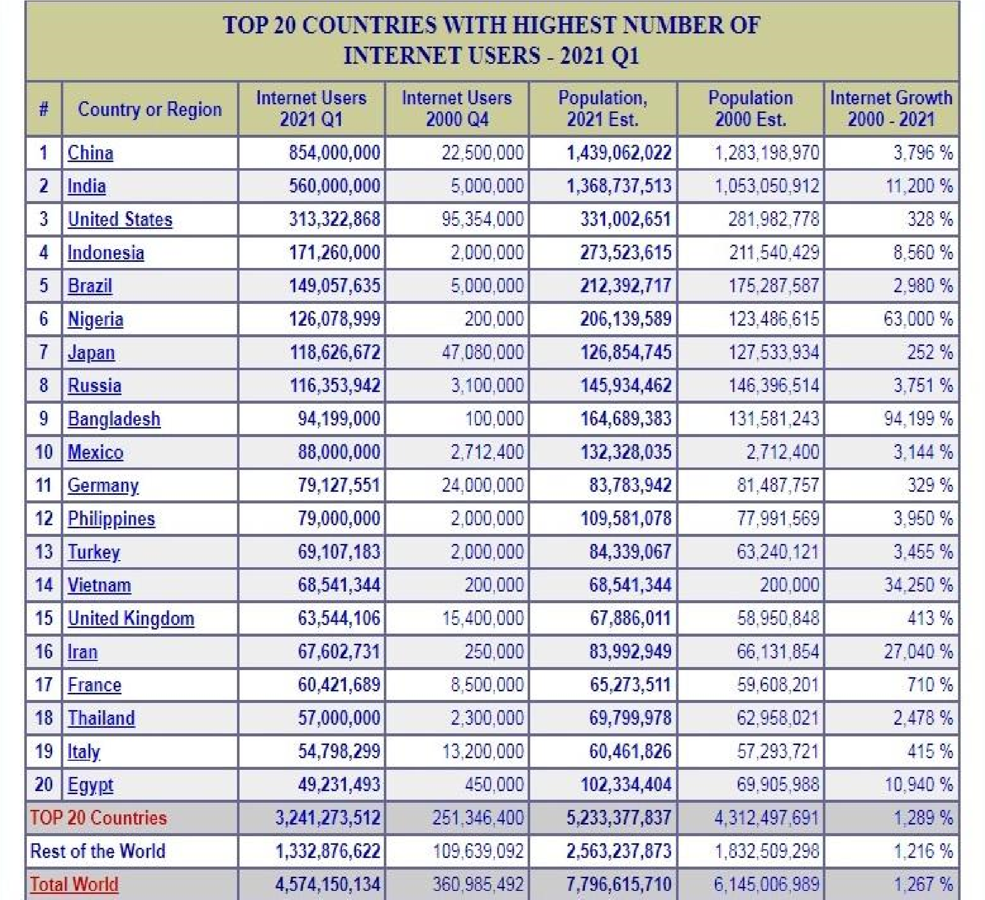
(www.ciol.com/enterprise/bfsi/feature.)
NOTES:
- Top 20 Internet Countries Statistics were updated for Dec 31, 2019.
- Growth percentage represents the increase in the number of Internet users between the years 2000 and 2020.
- The most recent user information comes from data published by Facebook, International Telecommunications Union, official country telecom reports, and other trustworthy research sources.

CHAPTER - 3
DATA ANALYSIS AND FINDINGS

3.1 Data Analysis:
Customers perspection on Online Banking and Traditional Banking
A survey was conducted on online banking in India for the primary data among 60 people. The analysis of this survey or data is as follows:-

Q1. Do you think online banking is better than traditional Banking?
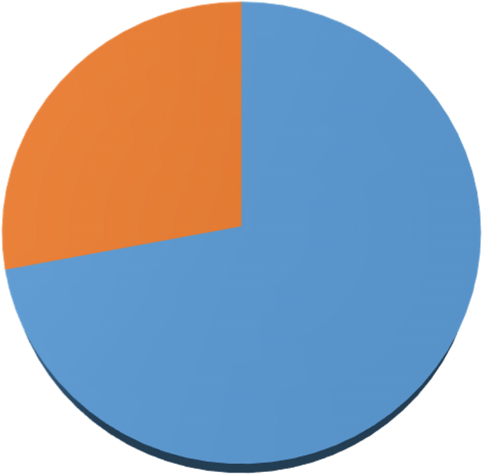

YES
72
%
NO
28
%
POLL out of 60: Yes – 72%; No- 28%
FINDINGS: The people understand that online banking is better than the traditional banking because of its nature.
Q2. Overall, how satisfied are you with our online banking service?
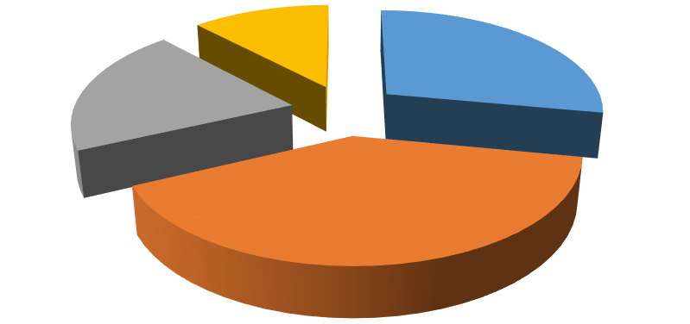

very satisfied
satisfied
neutral
unsatisfied

POLL OUT OF 60:very satisfied-28%; satisfied-40%; neutral-20%; unsatisfied-12%
FINDINGS:Majority of peoples are satisfied with online banking but some peoples are also very satisfied, neutral, unsatisfied.

Q3. Is Bank –a –net easy to use?

yes
no
POLL OUT OF 60: yes-60%; No-40%
FINDINGS: Majority of people understand that online banking is easy to use because they can save their time.
Q4. Do you trust the security of online banking service?
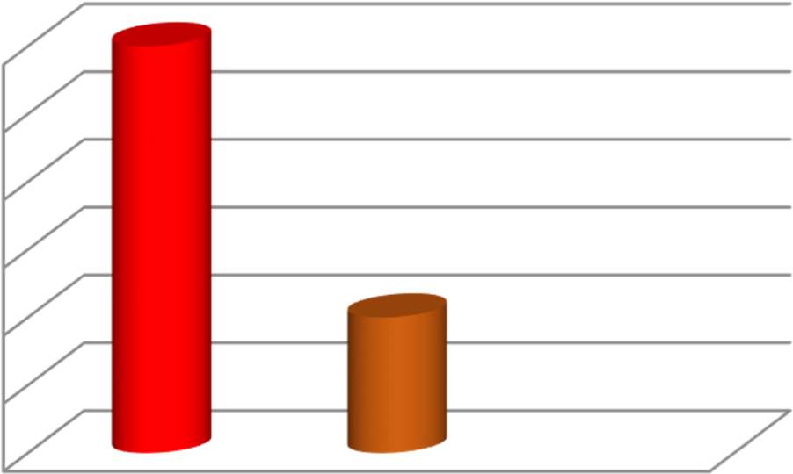

46
%
47
%
48
%
49
%
50
%
51
%
52
%
YES
NO
Poll out of 60: Yes –52%; No – 48%;
FINDINGS: Majority of the people think that their Account is secured, but not all. Their security concern should be eradicated. This will attract customers.
Q
5
. How often do you use online banking?

0
%
5
%
10
%
%
15
%
20
%
25
30
%
35
%
40
%
45
%
50
%
WEEKLY
MONTHLY
REGULARLY
RARELY
POLL out of 60: Weekly – 20%; Monthly – 44%; Regularly – 8%; Rarely – 28%
FINDINGS: Most of the people do not need the services of banks regularly or maybe there is no need. They may transact with the bank on monthly basis for most of the time.
Q6. What type of transaction do you make in online banking?

0
%
5
%
10
%
15
%
20
%
25
%
30
%
35
%
40
%
45
%
50
%
CHECK BALANCES
PAYMENTS
TRANSFER OF
FUNDS
OTHER
POLL out of 60: Check balances – 44%; Payments – 28%; Transfer of fund – 8%;other -20% FINDINGS: The utility of the online banking is service is not used to the extent is should be and it is being majorly used for the purpose of checking the balance in the account. The reason for this is the low volume of transactions among the people.
Q7.Are you aware of net banking services offered by the banks?

Yes
88
%
No
12
%
Awareness of internet banking services
POLL out of 60: Yes-88%; No-12%
FINDINGS: It is good for the banks as most of the respondents were aware of the internet banking and all the services provided under internet banking.
Q8.In which bank do you have your acccount?

POLL out of 60: HDFC banks-20%; PNB-24%; SBI-40%; Others-16%

SBI
40
%
PNB
24
%
HDFC
20
%
Others
16
%
Account in the respective bank
FINDINGS: It was witnessed that today public sector bank State bank of India has the largest customer base but the private banks are also catching up and after State Bank of India, PNB and HDFC has the highest customer base .Multi-national banks are also making their presence noticeable in the Indian scenario.
Q9.Are you aware of the methods which can be undertaken to make any kind of fraud?

POLL out of 60: Yes 32%; NO 68%
:

Yes
32
%
No
68
%
Awareness of methods of fraud
FINDINGS: It’s pretty tragic but most of the respondents are unaware of the techniques which can be taken up for any type of fraud.
Q10.Does your bank educate you about the internet banking services being offered?
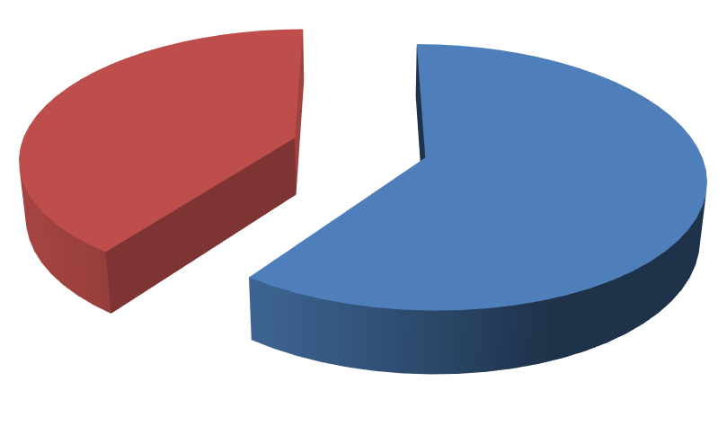

Yes
60
%
No
40
%
Educating about internet banking
POLL out of 60: Yes-60%; No-40%
FINDINGS: Most of the respondents felt that they are not properly educated of internet banking and its benefits to them.
Q11. What benefits do you see in internet banking?
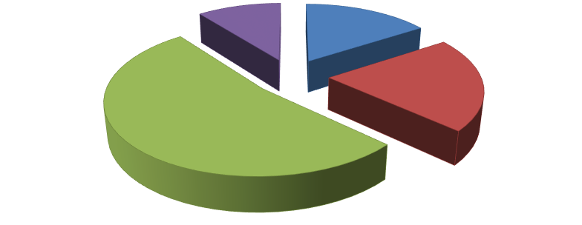

Convenience
16
%
Speed
21
%
Transparency
53
%
Time
10
%
benefits seen by customers
POLL out of 60: Convenience-16%; Speed-21%; Transparency-53%; Time-10%
FINDINGS:.Most of the respondents felt that the transparency provided by internet banking is the highest motivating factor for an individual to use internet banking; rest speed convenience and time are also the other motivating factors.

Q12.Would you prefer using net banking instead of visiting your bank every now and then?

Yes
88
%
No
12
%
Prefer using net banking
Poll out of 60: Yes-88%; No-12%
Findings: It was witnessed that most of the respondents preferred using internet banking over there conventional banking system. Thus, internet banking has a bright future ahead.
Q13.Are you aware of the benefits of net banking which are available?
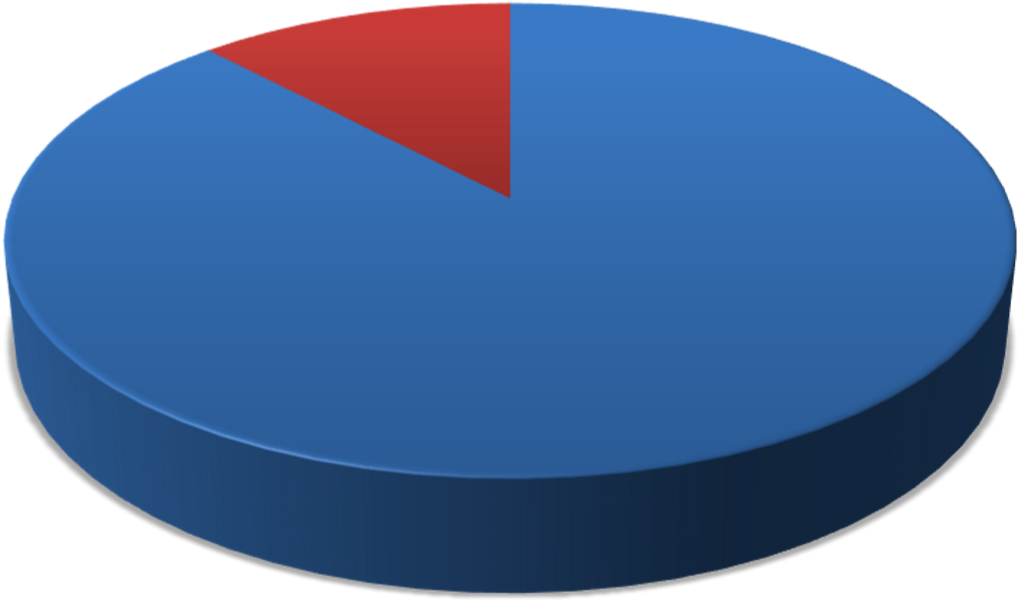

Yes
88
%
No
12
%
Benefits of Internet banking
Poll Out of 60: Yes-88%; No-12%
Findings: It is pretty amazing to see that most of the respondents are aware of the benefits of internet banking.
Q14.What are main disadvantages of online banking?

Overall Difficulty
of using online
banking System
32
%
Lack of assistance
8
%
Security
Concerns
20
%
No
Disadvantage
40
%
Overall Difficulty of using
online banking System
Lack of assistance
Security Concerns
No Disadvantage
Poll Out of 60: Overall difficulty of using online banking System-32%; Lack of assistance-8% ; Security Concerns-20%; No Disadvantage-40%
Findings:Most of the respondents felt that no disadvantage provided by internet banking but some people also face problem like Overall difficulty of using online banking system,Lack of assistance, Security Concerns.

15Q. Are you started to use more net banking after demonetization?

Poll out of 60: Yes 12%; NO 88%
Y

%
0
10
%
%
20
30
%
40
%
50
%
%
60
%
70
%
80
%
90
%
100
yes
no

Findings:Most of the people who are not starting online Banking after demonetization

CHAPTER: 4
CONCLISION AND RECOMMENDATION
4.1 Conclusion
From all of these, we have learnt that information technology has empowered customers and businesses with information needed to make better investment decisions. At the time, technology is allowing banks to offers new products, operate more efficiently, raise productivity, expand geographically and compete globally. A more efficient, productive banking industry is providing services of greater quality and value.
E-Banking is a generic term for delivery of banking services and products through electronic channels, such as the telephone, the internet, the cell phone, etc. The concept and the scope of e-banking is still evolving. It facilitates an effective payment and accounting system thereby enhancing the speed of delivery of banking services considerably. While E-Banking has improved efficiency and convenience, it has also posed severe challenges to the regulator and supervisors. Several initiative taken by the government of India, as well as the RBI, have facilitated the development of e-banking in India. The government of India enacted the IT Act, 2000, which provides legal recognition to electronic transactions and other means of electronic commerce. The RBI has been preparing to upgrade itself as a regulator and supervisor of the technologically dominated financial system. It issued guidelines on risks and control in computer and telecommunication system to all banks, advising them to evaluate the risks inherent in the system and put in place adequate control mechanism to address the risks. The existing regulatory framework over banks has also been extended to E-Banking. It covers various issues that fall within the framework of technology, security standards, and legal and regulatory issues.

4.2 Recommendation
In order to increase the use of online banking among the customers, banks should try to strengthen the following cases :
- Simplify web design services, Internet Banking.
- Simplify and shorten the process to conduct online banking transactions.
- Bank should ensure that online is safe and secure for financial transaction like traditional banking.
- Bank must emphasize the cost saving that online banking provide to the people such as reduce transaction cost by use of online banking.
- Customers who are hindered by lack of computer skill need to be education basic skills required to conduct online banking.
- Bank should organise seminar and conference to educate the customer regarding the use of online banking as well as security and privacy of their account.

BIBLIOGRAPHY

BOOKS:
- Innovation in Banking & insurance. O.P Agarwal, Himalaya Publishing House PVT.
LTD
- International Banking & Finance. Dr. P. G. Gopalakrishnan, Himalaya Publishing
House PVT. LTD.

Websites: http://www.statebankofindia.com
http://www.onlinebanking.net/online-banking-services/ http://www.productivity501.com/choosing-onlinebank/244/ http://www.thewisdomjournal.com/Blog/pro-and--cons-of-onlinebanking/ www.internerworldstats.com http://www.onlinebanking.net/future-of-online-banking/ http://www.onlinebanking.net/how-does-online-banking/work/

ANNEXURE (Quesrtionnaire)
Dear Respondent,
I am a student of Bangabasi Morning College; I am doing this research to compare different services provided by bank to its clients.
1. In which company bank do you have your account?
(a) PNB Bank
(b) State Bank of India
(c) HDFC Bank
(d) Others Bank
2. Do you think online banking is better than traditional banking?
(a) Yes
(b) No
3. Overall, how satisfied arte you with your online banking service?
(a) Very satisfied
(b) Satisfied
(c) Neutral
(d) Unsatisfied
4. Is Bank-a-net easy to use?
(a) Yes
(b) No
5. Do you trust the security of online banking service?
(a) Yes
(b) No
6. How often do you use online banking?
(a) Weekly
(b) Monthly
(c) Regularly
(d) Rarely
7. What types of transaction do you make in online banking?
(a) Check balance
(b) Payment
(c) Transfer of fund
(d) Other
8. Are you aware of Net Banking services by the banks?
(a) Yes
(b) No
9. Are you aware of methods which can be undertaken to make any kind of fraud?
(a) Yes
(b) No
10. Does your bank educate you about the Net Banking services being offered?
(a) Yes
(b) No
11. What benefits do you see in Internet banking?
(a) Convenience
(b) Sped
(c) Transparency
(d) Time
12. Would you perfect using net banking instead of visiting your bank every now and then?
(a) Yes
(b) No
13. Are you aware of the benefits of net banking which are available?
(a) Yes
(b) No
14. What are main disadvantages of online banking?
(a) Overall difficulty to use online banking system
(b) Lack of assistance
(c) Security concern
(d) Rare disadvantages
15. Are you started to use more net banking after demonetization?
(a) Yes
(b) No

