Project Report

(Submitted for the Degree of B.Com. Honours in Accounting & Finance under the University of Calcutta)

A STUDY ON PRE AND POST MERGERS FINANCIAL PERFORMANCE OF SOME SELECTED INDIAN BANKS

Submitted by

Name of the Candidate: NEHA SAHA
Registration No.: 144-1211-0851-20
C.U Roll No.: 201144-11-0109
College Roll No.: BH0421
Name of the College: Bangabasi Morning College

Supervised by

Name of the Supervisor: Dr.Moumita Sarkar(Samanta)
Name of the College: Bangabasi Morning College

Month & Year of the Submission
May-2023
Annexure-I

Supervisor's Certificate

This is to certify that Ms. NEHA SAHA a student of B.Com. Honours in Accounting & Finance of BANGABASI MORNING COLLEGE under the University of Calcutta has worked under my supervision and guidance for her Project Work and prepared a Project Report Entitled “A STUDY ON PRE AND POST MERGERS FINANCIAL PERFORMANCE OF SOME SELECTED INDIAN BANKS” which she is submitting, is her genuine and original work to the best of my knowledge.

Place: Kolkata Signature: _________
Date :
Name: Dr. Moumita Sarkar (Samanta)
Designation: Assistant Professor
Name of the College: Bangabasi Morning
College

Annexure-II

Student's Declaration

I hereby declare that the Project Work with the title “A STUDY ON PRE AND POST MERGERS FINANCIAL PERFORMANCE OF SOME SELECTED INDIAN BANKS” submitted by me for the partial fulfillment of the degree of B.Com. Honours in Accounting & Finance under the University of Calcutta is my original work and has not been submitted earlier to any other University /Institution for the fulfillment of the requirement for any other course of study.
I also declare that no chapter of this manuscript in whole or in part has been incorporated in this report from any earlier work done by others or by me. However, extracts of any literature which has been used for this report has been duly acknowledged providing details of such literature in the references.

Place : Kolkata Signature :_______________
Date:________
Name: NEHA SAHA
Address: Nimta, Belgharia kol- 49
Section: B.Com Honours
Registration No. : 144-1211-0851-20
Roll No. : 201144-11-0109

Acknowledgement

I am Neha Saha, the student of B.Com Honours , Bangabasi Morning College, Kolkata, would like to express my sincere thankfulness to Dr. Moumita Sarkar (Samanta) who give her Valuable guidance to make the report in the best way and giving me the much needed support and full cooperation for making my project report.

I would like to extend my gratitude to Calcutta University, for giving me the opportunity to increase our practical knowledge in the field of Mergers & Acquisitions in Indian Banking Sector. I also thank all the professors and staff of the institute for their valuable guidance and help throughout the project.

Last but not least, I am also thankful to my parents, friends and all the people who helped me directly and indirectly in the making of this project.

Table of Content
CONTENTS | PAGE NO.
CHAPTER 1: INTRODUCTION……………………………………………………………………………  - BACKGROUND OF THE STUDY………………………………………  - RESEARCH OBJECTIVES OF THE STUDY…………………………  - REVIEW OF LITERATURE…………………………………….  - RESEARCH METHODOLOGY……………………………………….  - LIMITATION OF THE STUDY…………………………………..  - CHAPTER PLANNING……………………………………………………  CHAPTER 2: CONCEPTUAL FRAMEWORK…………………………………….  - MEANING OF MERGER…………………………………..  - REASON FOR BANK MERGER…………………………………….  - MERITS OF A BANK MERGER………………………………………  - DEMERITS OF A BANK MERGER………………………………….  - ANOVERVIEW OF INDIAN BANKING SECTOR…………………………….  - MEGA BANK MERGER LIST IN INDIA 2019-2020………………………..  - MERGER-1 PNB………………………………………….  - MERGER-2 CANARA BANK………………………….  - MERGER-3 UBI BANK…………………………………….  CHAPTER 3: PRESENTATION OF DATA, ANALYSIS AND FINDINGS………………..  - RATIO ANALYSIS…………………………………………………………………………..  - FINDINGS………………………………………………………………………………………  CHAPTER 4: CONCLUSION AND RECOMMENDATIONS……………………………  - CONCLUSION……………………………………………………………………  - RECOMMENDATIONS……………………………………………………………..  BIBLIOGRAPHY……………………………………………………………………………….. | 06  06  07  07-08  08-09  09-10  10  11  11  11  11-12  12  12-13  14  15-16  17  18-19  20  20-26  27  28  28-29  29  30

CHAPTER 1

INTRODUCTION

- BACKGROUND
Mergers and acquisitions have both the aspects of strategic management’ s corporate finance and management dealing with the buying of selling dividing and combining the different companies of similar entities.
After the merger the result is the transaction of the ownership and control of one firm to another.

M&A is defined as a restructuring of the result in some entity reorganization with having the aim to provide growth or positive value. The consolidation of an industry or the sector that occurs when the widespread M&A activity concentrates the resources of many small companies into a few larger ones such as occurred with the automotive industry between 1910to 1940.

Technically, a merger is the legal consolidation of two business entities into one, whereas an acquisition occurs when one entity takes ownership of another entity's share capital, equity interests or assets. A deal may be euphemistically called a "merger of equals" if both CEOs agree that joining together is in the best interest of both of their companies. From a legal and financial point of view, both mergers and acquisitions generally result in the consolidation of assets and liabilities under one entity, and the distinction between the two is not always clear.

Most histories of M&A begin in the late 19th century United States. However, mergers coincide historically with the existence of companies. In 1708, for example, the East India Company merged with an erstwhile competitor to restore its monopoly over the Indian trade. In 1784, the Italian Monte dei Paschi and Monte Pio banks were united as the Monti Reuniti. In 1821, the Hudson's Bay Company merged with the rival Northwest Company.

- RESEARCH OBJECTIVES

• To study the pre- and post-merger financial performance of Punjab National Bank.
• To study the pre- and post-merger financial performance of Canara Bank.
• To study the pre- and post-merger financial performance of Union Bank of India.

- REVIEW OF LITERATURE

- Sanjay Sharma & Sahil Sidana(2017)
In this research paper it expressed the impact of SBI merger on the financial condition of SBI. The SBI will get visibility at global level in the network increase of SBI & it is also able to provide cheaper funds more easily. The gross & net NPA of SBI will come down after merger with their associate. The efficiency & effectiveness of the business will increase because of single management.

- Kotnal Jaya Shree (2016)
In this research paper it expressed “the economic impact of merger and acquisition on
profitability of SBI” it various motives of merger in Indian Banking Industry. It was a comparison.
pre- and post-merger financial performance of merging banks with the help of financial
parameters like gross profit margin, net profit margin, operating profit margin, return on equity.and debt equity ratio. Finally, it says that the banks have been affected positively but theoverall development and financial illness of the banks can’t be solved through mergers andacquisitions.

- Prof. Ritesh Patel & Dr. Dharmesh Shah(2016)
In this research paper it compared the financial performance of before and after merger of banksthrough Economic value-added approach and through others financial parameter like net profitmargin, return on net worth, return on asserts, return on long term funds, interest earned, andtotal assets and it is not necessary that EVA approach is common for all the other banks. Theyconcluded that the financial performance of OD bank may be improved after the merger. But if itpast financial data are examined before the merger, it can make merger fruitful.

- Parveen Kumari(2014)
In this research paper it considered the merger and acquisition of banks as strategic approach
and told that the aim of the merger and acquisition of banks is increase credit creation and makeprogressive. According to the gathered post-merger data she concluded that the number ofbranches & ATM, Net Profit, Deposit, Net worth have increased.

- S. Devarajappa (2012)
This study is destined in identifying the various reasons for merger and acquisitions in India.
It also focused on pre and post-merger performance of banks from the viewpoint of return on
investment, ROCE, ROE. And this merger effects the helpful for surviving of weak banks by merging into merging into larger banks.

- Ramon, A.A.,Onaolapo and Ajala, O. Ayorinde(2012)
In this research they examined the effects of merger and acquisition on the performance of
selected commercial banks in Nigeria. on the basis of gross earning , profit after tax and depositprofit was chosen as financial efficiency parameters for the purpose of the study. The findingsindicated an enhanced financial performance leading to improved financial efficiency. Thestudy is recommended that the banks should be more aggressive in marketing financial
products and also manpower training and re-training, investment in information technology
should be emphasized.

- Azeem Ahmed Khan(2011)
In this study , the researcher focused on explain the various motives for mergers and acquisition inIndia. The results of this study showed that mergers and acquisitions helped with the declaration ofdividends to equity shareholders.

- Bhan Akhil (2009)
In this research paper it insight into the motives and benefits of the mergers in Indian banking sector.This study examined eight merger deals of the Indian banks during the period of 1999 to 2006. Theresults of the study indicate that mergers have been efficient for the merging banks and they havealso created a value for the acquiring banks. Further it was concluded that in the Indian Banking contextthe effect of mergers is not seen over a short period of time but over a considerable period of time.

- RESEARCH METHODOLOGY

- Problem statement
• The banking industry has been experiencing major Merger and Acquisition in the recent years, with the number of global players emerging through successive Merger and Acquisition in the banking sectors. Only in today’s tough environment will large organizations thrive. Government banks are in bad condition following demonetization. A lot of government banks have incurred huge losses owing to bad loans, which the lenders have not been willing to recover because they have ruined their company due to a range of factors, including demonetization. There have been discussions about the closing of certain banks because, in such a case, the general public may have withdrawn deposits from their accounts in a very risky circumstance. So, instead of shutting certain banks, the government, in consultation with RBI, has taken a brave decision to merge banks through large scale economy operations. By merging many public sector banks into few and with efficient resources development, banks can be reinforced with a focus on upgrading services and revenues, optimum utilization of staff, cost efficiencies and reduced NPAs. Therefore, the study is taken up to know more details.

- Significance of the study
• The study is significant and useful as it has given the experience and knowledge about the
merger and acquisition in Indian banking sector and what are its impact on the financial
performance of the bank.

- Sources of data collection
• The study is purely based on secondary data taken from the annual reports of selected units
and other websites.
• All the data related to history, growth and development of selected banking industries, it
has been collected mainly from the books and magazine related to the banks and published
papers, reports, articles and from the various newspapers, and other journals.

- Selection of sample
Sample size: - 3 Mega Bank Mergers List in India 2019 to 2020

ACQUIRING BANK | ACQUIRED BANK | YEAR OF A MERGER
Punjab National Bank | Oriental Bank of Commerce + United Bank of India. | April 1,2020
Canara Bank | Syndicate Bank | April 1,2020
Union Bank of India | Andhra Bank + Corporation Bank | April 1,2020

- Tools of Analysis
- This Study is based on Ratio Analysis.

- Ratio Analysis
Ratio analysis is the important technique of financial analysis which shows the arithmetical
relationship between any two figures. A ratio, in general , is a statistical yardstick by means of
which the relationship between the figures can be compared and measured.
The ratios are operating profit ratio, net profit ratio, return on assets, return on equity ratio, CASA ratio.

- LIMITATION OF THE STUDY
• This study is purely based on only 3 selected banks.
• In this study the pre and post data of the selected merger banks are used.
• All the limitations of ratio analysis affect the study
• All the limitations of secondary data make an impact in the analysis because this study is based on the data only.
• For this study before and after merger 1 year data has been comparing of selected units.

- CHAPTERS PLANNING

The Study is divided into four chapters these are: -
- Introduction
- Background
- Research Objectives
- Review of Literature
- Research of Methodology
- Limitation of the Study

- Conceptual Framework
- Meaning of Merger
- Reasons for Bank Merger
- Merits of a Bank Merger
- Demerits of a Bank Merger
- An overview of Indian Banking Sectors
- Mega Bank Merger list in India 2019-2020
- Merger-1 PNB
- Merger-2 CANARA BANK
- Merger-3 UBI BANK
- Analysis of the Study
- Pre& Post merger of PNB, Canara Bank, UBI Bank by using Ratios of
the F.Y 2019-2020 & F.Y 2020-2021
- The Studied Ratios are followings:-
- CASA
- OPERATING PROFIT
- NET PROFIT
- ROA
- ROE
- EPS
- ROCE
- Conclusion of the Study
- Conclusion
- Recommendations

CHAPTER 2

CONCEPTUAL FRAMEWORK

- What is merger?
• A merger is an agreement that unites two existing companies into one new company.
• Mergers are commonly done to expand a company’s reach, expand into new
segments, or gain market share.
• All of these are done to please shareholders and create value.
• Merger is covered regulated or covered by the companies Act, 1856.
• Mergers are being referred to by finding an acceptable partner, determining upon how to pay each other and ultimately creating a new company, which is a combination of both the companies.
- Mergers are of five types, and they are Conglomerate merger, Market extension merger, Horizontal merger, Vertical merger and Product extension merger.

- Reasons For Bank Merger
- A key reason for a bank merger is the weight of mounting bad loans over the years.
- It's creating globally stronger banks that are doing away with needless overlaps in the operations and infrastructure.
- In economies of scale to be bring down costs that have always been at the heart of any consolidation drive.
- They aimed at improving operating efficiency, accountability, governance and facilitating effective monitoring.
- They also aimed at creating next generation banks with a strong national presence amid the global outreach accompanied to enhanced capacity to increase the credit to the various important sectors of the economy.

- Merits of A Bank Merger
• A large capital base would help the acquirer banks to offer large loans amount.
• This merger will make RBI have better control of the system and the implementation of policies will become easy.
• It will be easy to penetrate the market.
• Technological up gradation can be considered.
• Recapitalization need from the government to reduce.
• The cost of operation has been reduced with the help of merger.
• It helps in improving risk management.
• The geographically concentrated regionally present the banks to expand their coverage with the help of merger.
• It provides better efficiency ratio for the business of operations as well as the banking
operation which is beneficial for the economy.
• RBI will watch banks on its performance, especially in the terms of NPA (Non-
Performing Asset) otherwise loans which are not recovered.
• Customers will have a wide range of products like mutual funds and insurance to choose from in addition to the traditional loans and deposits.
• It NPA percentage of the bank is above prescribed norms, it will ask to merge with a
bigger bank to the case the situation as to combined capital of banks that will be higher and thereby reducing the NPA percentage.

- Demerits of A Bank Merger
• All different banks have different culture, systems, processes, procedures and that
merger will lead to a clash of organizational cultures.
• Bank officials and unions of PSBs are against the merger due to the issues with the
employment, security, tenure, etc.
• There are few large inter-linked banks that can expose the broader economy to
enhanced financial risks.
• The local identity of small banks are not that big.
• There is materialized and that the customers feel harassed initially that the banks are
working on it.
• It will take some time for the customers to know that their banks are merged. Even though it’s mandatory for the banks to inform to all their customer about the merger some customer may miss the communication and get panic to see their branch board is
replaced with a new one.
• Acquiring banks must handle the burden of weaker banks, resulting in risk exposure.
• It is difficult to manage the culture and people of different banks

- INTRODUCTION OF INDIAN BANKING SECTORS

In the modern economy the importance of banks cannot be neglected. The banking sector plays a vital role in the economic development of the country. The banking sector is a financial institution, which performs various functions like accepting deposits, lending loans to agricultural & industrial concerns.

The banking industry worldwide to be transformed concomitant with a paradigm shift in the Indian economy from manufacturing sector to nascent service sector. Indian Banking is in the undergoing changes. Indian banks have always proved beyond the doubt that adaptability to themselves into an agile and resilient organization.

The Banking sector has seen ongoing mergers & amalgamation in recent years. The Reserve Bank Of India (RBI), the Central Government can create a scheme for the
amalgamation of any nationalized bank with any other nationalized bank or banking sector in accordance with the banking companies Acts 1970 and 1980 (Acquisition and Transfer of undertaking).

From the past three decades India’s banking system that has several outstanding
achievements to its credit. The most striking is its extensive reach. Indian banking system has reached even to the remote corners of the country. One of the main reasons of India’s growth process is that the Indian banking system has reached even to the remote corners of the country.

Previously an account holder had to wait for hours and hours at the bank counters for
getting a draft or withdrawing his own money. But today they have a choice. Further the most efficient bank transferred money from one branch to another branch in two days. But now a days it is simple as instant messaging or dialing a pizza. Money has become the order of the day.

In India banks are playing a crucial role in the socio-economic progress of the country after the independence. Indian banks have been going through a fascinating phase through the rapid changes that brought about by the financial sector reforms, which have been implemented in a phased manner.

The current process of the transformation that should be viewed as an opportunity to convert into a Indian banking that sound, strong and vibrant system capable of playing its role efficiently and effectively on its own without imposing any burden on government.

The government has announced after the liberalization of the Indian economy that a number of reforms is measures on the basis of the recommendation of the Narasimham Committee to make a banking sector economically viable and competitively strong.

- Mega Bank Mergers List in India 2019 to 2020

ACQUIRING BANK | ACQUIRED BANK | YEAR OF A MERGER
Bank of Baroda | Vijaya Bank + Dena Bank | April 1 ,2019
Punjab National Bank | Oriental Bank of Commerce + United Bank of India | April 1, 2020
Canara Bank | Syndicate Bank | April 1, 2020
Union Bank of India | Andhra Bank + Corporation Bank | April 1, 2020
Indian Bank | Allahabad Bank | April 1, 2020

• Union Finance Minister Nirmala Sitharaman on 30th August 2019 announced the consolidation of the State-owned banks (PSBs) in which 10 PSBs are being merged to form 4 bigger lenders to strengthen the banking sector struggling with a bad loan.
• The aim is to cleanup of the bank balance sheets and create lenders of global scale that can support the economy’s surge to$5 trillion by 2024.
• Done with two rounds of bank consolidation earlier, this is what we want to do for the robust banking system and a $5 trillion economy.
• FM Sitharaman said that they are trying to build next generation banks, big banks with the capacity to enhance credit.
• The key factors for mergers are the technological platform, cultural similarities, customer reach, competitiveness, finance secretary Rajiv Kumar added.

MERGER- 1

- HISTORY OF PUNJAB NATIONAL BANK, ORIENTAL BANK OF COMMERCE & UNITED BANK OF INDIA

- Punjab National Bank
• Punjab National Bank was founded on 19th May 1894. It is an Indian Multinational
Banking and financial services company.
• The several leaders are included the state-owned corporation of Punjab National Bank was based in New Delhi, India.
• It covered over 80 million customers, 6937 branches & 10681 ATMs across 764 cities. According to RBI, among state run banks in India, Punjab National Bank topped in the number of loan fraud cases across India.

- Oriental Bank of Commerce
• Oriental Bank of Commerce was established on 19th Feb 1943 in Lahore, and it was
founded by Late Rai Bahadur Lala Sohan Lal, the first chairman of the bank.
• On 15th April 1980 it was nationalized.
• The bank newly branches were formed in Pakistan that had to be closed and the registered office was shifted from Lahore to Amritsar.
• The bank has a network of 530 branches and 505 ATMs spread throughout India, and out of which 490 branches offer centralized banking solutions.

- United Bank of India
• United Bank of India was established in 1950.
• It was nationalized in the year 1969.
• Union Bank was merged as United Bank.
• It has more than 1300 branches and it has 15 overseas branches.
• United Bank of India has a good track record of 56 years.
• United Bank of India has over all assets of Rs. 300 billion.

AFTER MERGER OF PUNJAB NATIONAL BANK , ORIENTED BANK OF
COMMERCE & UNITED BANK OF INDIA

• On 1st April 2020 Punjab National Bank(PNB) will take over Oriental Bank Of
Commerce (OBC) and United Bank of India (UBI) and to become the country’s second largest lender after State Bank of India (SBI) in terms of business and branch network.

• The biggest chunk of recapitalization that will go to PNB at Rs 16,000 crore, followed by Union Bank at Rs 11,700 crore these two anchor banks for the merger.
• The synergy after the amalgamation will create a globally competitive in the next
generation bank, PNB 2.0 the bank said that in a release and the added that all
customers, including depositors, will be treated as PNB customers.
• PNB 2.0 will be offering specified interoperable services through all the branches and all the platforms including mobile and internet banking it added.
• The amalgamated bank will be a wider geographical reach through 11,000 plus
branches, more than 13,000 ATMs, 1 lakh employees and a business mix of over Rs 18 lakhs crore.
• SS Mallikarjuna Rao, MD & CEO of Punjab National Bank that “The bigger
geographical footprint will help us to serve our customers more effectively and
efficiently”.
• The lender said that it has appointed ‘Bank Sathi’ at all the branches, zones, head office that will address the customer concerns and assist them in choosing the right products and services.
• It will also smoothen the customer transition, it added. A robust risk governance
mechanism has been set up to mitigate risks and to make the banking experience secure and safe, PNB noted,
• PNB has unveiled a new logo following the merger of United Bank of India and
Oriental Bank of Commerce with it.
• The new logo will bear distinct identification of all the three public sector lenders.

MERGER- 2

- HISTORY OF CANARA BANK & SYNDICATE BANK

- Canara Bank
• Canara Bank was established on July,1906 by Subba Rao Pai and it was known Canara Hindu Parliament fund in Mangalore.
• In 1910 the bank changed its name to Canara Bank.
• In 1969 this bank was nationalized.
• In 1976 Canara Bank inaugurated its 1000th branch.
• Canara Bank became the 1st Indian Bank to get ISO certificate in 1996 for the ‘Total Branch Banking’ for its Seshadripuram Branch in Bangalore.

- Syndicate Bank
• Syndicate Bank was established in 1925 in Udupi, Karnataka it is the oldest and
major commercial banks of India. During the time of it established the bank was
known as Canara Industrial and Banking Syndicate Ltd.
• By the three visionaries Shri Upendra Ananth Pai. A businessman, Shri Vaman
Kudva, an engineer and Dr.T M A Pai, a physician with a intention to provide
financial support to the local weavers.
• Syndicate Bank was nationalized on 19 July 1969 by the government of India.
• The headquartered of this bank was in the university town of Manipal India.
• It has 13 major commercial banks of India.
• The bank objective was to primarily to extend financial assistance to the local local
Weavers.
AFTER MERGEROF CANARA BANK &SYNDICATE BANK
• On 1th April 2020, the Syndicate Bank was merged with Canara Bank.
• After the merger Canara Bank has become the India’s fourth largest public sector bank.
• Canara Bank has taken over Syndicate Bank by which the shareholders pf Syndicate
Bank gets 158 shares for every 1000 shares of Canara Bank.
• After merger the banks will have 10,342 branches and 12,829 ATMs and Canara Bank also worth 15.20 lakh crore.
• They have a combined strength of 91,685 employees.
• The merger of these banks shall massively enhance the reach of the banking sector to the larger public and the financial inclusion activities currently underway.
• The integration would lower operating costs because of network overlap.
• After the merger these two banks have identical work cultures, and it is possible seamless integration.
MERGER- 3

- HISTORY OF UNION BANK OF INDIA, ANDHRA BANK & CORPORATION BANK

- Union Bank Of India
• Union bank of India was registered on 11th November 1919, and it has limited company
in Mumbai and it was inaugurated by Mahatma Gandhi.
• ATMs was introduced firstly in India by union bank of India.

- Andhra Bank
• Andhra bank is an Indian public sector bank.
• Andhra bank was registered on 20th November 1923.
• Andhra bank was founded by the eminent freedom fighter and the multifaceted genius,Dr. BhogarajuPattabhi Sitaramayya.
• It has more than 1900 branches, 15 extension counters and more than 1100
automated teller machines.
• It has operated in 25 states and three Union Territories.
• Andhra bank has its headquarters in Hyderabad, India.
• Andhra bank has pioneer in introducing credit cards in the country in 1981.

- Corporation Bank
• Corporation bank was founded in the year 12 March,1906 in Udupi in a small town of South India.
• In 1980 Corporation Bank was Nationalized and been public in 1998.
• Corporation Bank holds a unique record of posting profits right from inception.
• FY 2010-11 uninterrupted dividend payment track record since inception and declared highest ever dividend of 200%.

AFTER MERGER OF UNION BANK OF INDIA , ANDHRA BANK &
CORPORATION BANK

• on 1st April 2020 Andhra Bank, Corporation Bank merge into Union Bank Of India.
• The central government is in exercise of the powers conferred by section 9 in the
banking companies Act 1970/1980 after consultation with RBI notified the
amalgamation of Andhra Bank and Corporation Bank into Union Bank of India
Scheme 2020.
• Union Bank has become the country’s fifth largest public sector lender after
amalgamating Andhra Bank and Corporation Bank into Union Bank.
• From Wednesday the merger effective with harness rich individual legacies and forge a dynamic shared future.
• After the merger all the employees, customers, and branches of Andhra Bank and
Corporation Bank will become the part of the Union Bank of India.
• The merger is also expected to generate cost and revenue synergies to the tune of INR 2,500 crores over the next three years.
• The customers get the benefit of wider access to branches, ATMs, digital services and credit facilities and are now in a much stronger position as a bank.
• The banks also offer a wide range of products and services to more than 120 million customers across its over 9,500 branches and more than 13,500 ATMs.
• After combined they becomes the India’s fourth largest banking network and fifth
largest public sector bank.
• In order to minimize disruption, the account numbers, IFSC codes, debit/credit cards and internet / mobile banking portals and login credentials will remain the same.

CHAPTER- 3

PRESENTATION OF DATA, ANALYSIS AND FINDINGS

1.CASA RATIO:
CASA ratio means current account and saving account.
• Current Account are those account in which it is specially for customers those who must
carry out business and the large number of transactions in the account every day.
• In current accounts there is no restriction on the number of transactions.
• Savings bank accounts are specially for the individual persons or jointly individual (joint
account), which has a limit of transaction at every day.
• For example, when the cash withdrawn once a day and 100 times deposit at every year.
• This account is the bank pay interest for example currency 4.25% interest rate on saving account.
• CASA Ratio = Deposits in Current & Saving Account / Total Deposits.
Table 1
CASA Ratio in selected units

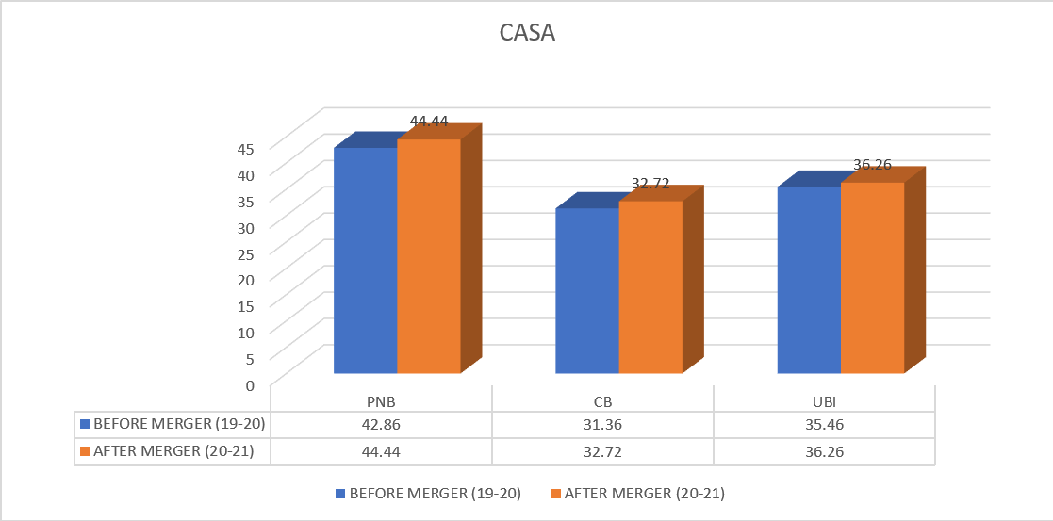
(Source: Moneycontrol.com)

- Analysis:
In the above chart of CASA Ratio in which :-
• Punjab National Bank is having lowest ratio (42.86) before the merger and it has highest ratio (44.44) after the merger.
• Canara Bank is having lowest ratio (31.36) before the merger and it has highest ratio (32.72) after the merger.
• Union Bank Of India has lowest ratio (35.46) before the merger and it has highest ratio (36.26) after the merger.
2.OPERATING PROFIT RATIO:
Operating Profit Ratio = Operating Profit/Net Sales x 100
• Operating Profit Ratio is calculated by adding non-operating expenses anddeducting non- operating income from net profit.
• It typically measuring the operating performance and the efficiency of thecompany.
• The poor operational performance of the company has been analysis in which there is higher net profit ratio but the lower operating profit ratio.
• The profit is been increased because of other income and not the due.
Table 2
Operating Profit Ratio in selected units

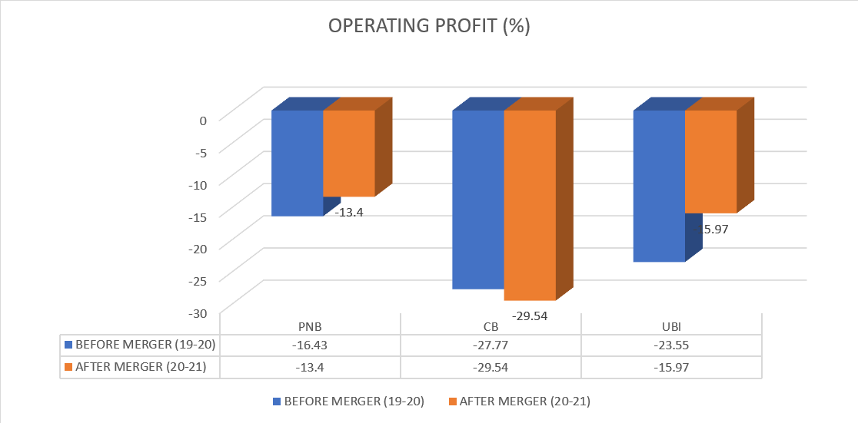
(Source : Moneycontrol.com)

- Analysis:
In the above chart of Net Profit Ratio in which :-
• Punjab National Bank has lowest ratio (-16.43) before merger and it has highest ratio (-13.4) after merger.
• Canara Bank has lowest ratio (-29.54) after merger and it has highest ratio (-27.77) before merger.
• Union Bank Of India has lowest ratio (-23.55) before merger and it has lower ratio ( -15.97) after merger.

3. NET PROFIT RATIO:
Net Profit Ratio = Net Profit / Net Sales x 100
• This could be measured by modified for a use by nonprofit entity and it can change the net assets where it is to be used in the formula instead of net profits.
• Net Profit percentage after the tax profits to net sales. The remaining profit after all costs of production, administration and financing have been deducted from the sales, and income taxes recognized.
• This is the best measure of the overall result of a firm, especially when there is combined with an evaluation of how well it is using its working capital.
• This ratio is commonly measured reported on a trend line, to be judged performance over all time.
• And it is also used to compare the results of a business with their competitors.
• Net Profit is not an indicator of cash flows, and since the net profit incorporates a number of non-cash expenses such as a accrued expenses, amortization and depreciation.
Table 3
Net Profit Ratio in selected units

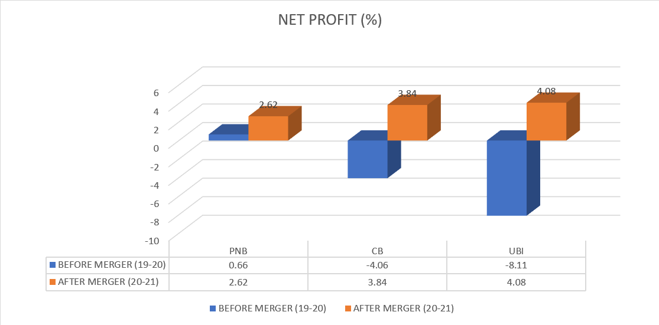
(Source : Moneycontrol.com)

- Analysis:
In the above chart of Net Profit Ratio in which :-
• Punjab National Bank has lowest ratio (0.66) before the merger and it has highest ratio (2.62) after the merger.
• Canara Bank has lowest ratio (-4.06) before the merger and it has highest ratio (3.84)
after the merger.
• Union Bank Of India has lowest ratio (-8.11) before the merger and it has highest ratio (4.08) after the merger.

4. RETURN ON ASSET RATIO:
Return on assert = Net Income / Total Assets
• The return on assets means how much contribution of assets is been for generating the return.
• If more the assets is says to be the good because by the employee than more the assets the company can be earn more return and also the ratio will be more positive.
• ROA is like return on equity, but it doesn’t reflect the impact of a bank’s leverage. Because the banks are typically leveraged by a factor of 10 to 1, in order to generate a 10% return on equity, a bank must earn the equivalent of at least 1% on its assets.
• It has long been one of the bank industry’s most cited benchmarks.
Table 4
Return on Assets Ratio in selected units.

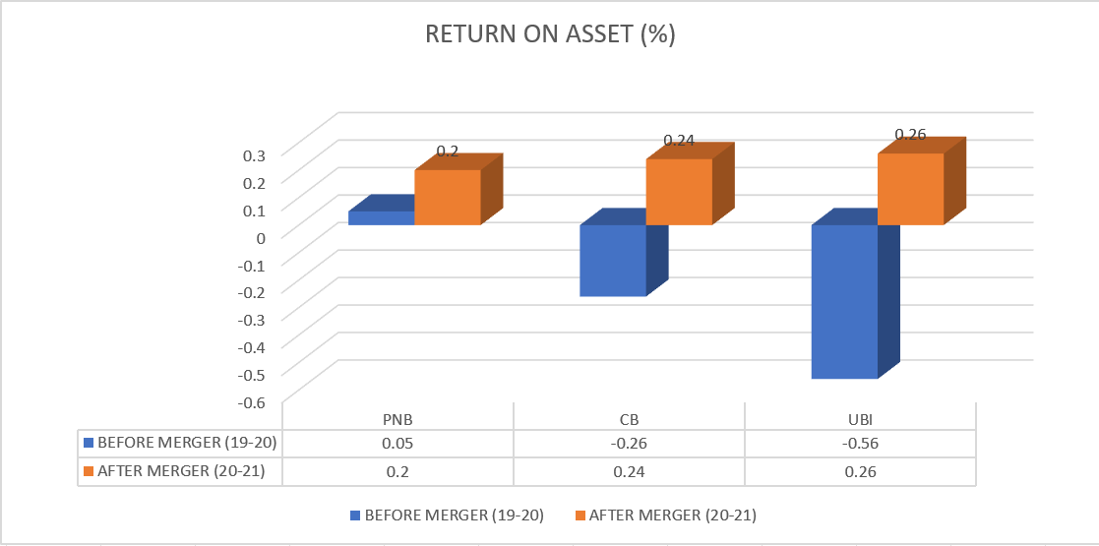
(Source : Moneycontrol.com)

- Analysis:
In the above chart of Return on Asset Ratio in which :-
• Punjab National Bank has lowest ratio (0.05) before the merger and it has highest ratio (0.2) after the merger.
• Canara Bank has lowest ratio (-0.26) before the merger and it has highest ratio (0.24) after the merger.
• Union Bank Of India has lowest ratio (-0.56) before the merger and it has highest ratio (0.26) after the merger.

5.RETURN ON EQUITY RATIO:
Return on equity = net income / shareholder’s equity.
• Return on equity is the most important metric in all the bank investing.
• It canmeasure profitability by dividing a bank’s net income by its shareholders equity, higher the number, greater the return.
• Normally if we want to see a figure in excess of 10%, which is generally to mark the threshold between long-term value creation and destruction.
Table 5
Return on Equity Ratio in selected units.

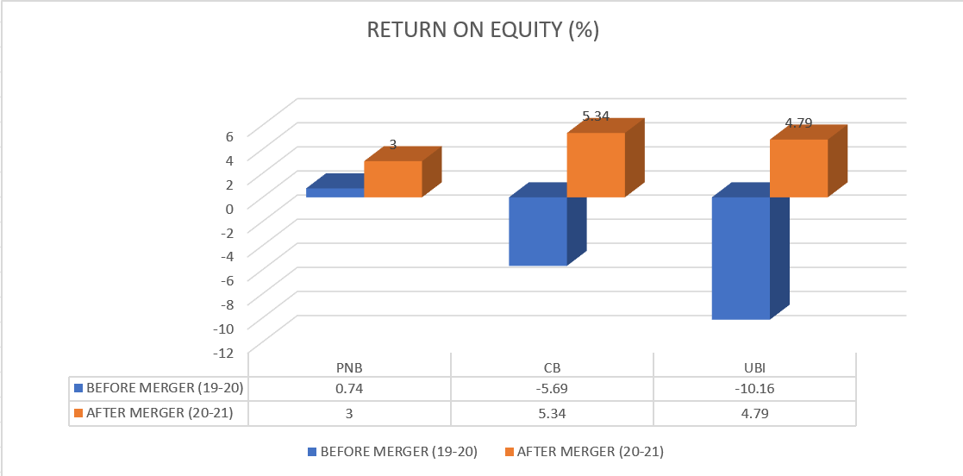
(Source : Moneycontrol.com)

- Analysis:
In the above chart of Return on Equity Ratio in which :-
• Punjab National Bank has lowest ratio (0.74) before the merger and it has highest ratio (3.00) after the merger.
• Canara Bank has lowest ratio (-5.69) before the merger and it has highest ratio (5.34) after the merger.
• Union Bank Of India has lowest ratio (-10.16) before the merger and it has highest ratio (4.79) after the merger.

6. EARNING PER SHARE RATIO:
Earningsper share = Net income of the company / weighted average number of shares outstanding.
• Earning per share means it is generally considered to be the single most important variable in determining a share’s price.
• A company’s profile allocated to each outstanding share of a common stock. Earnings per share also serve as an indicator of a company’s profitability.
• An important aspect of earnings per share that is often ignored is the capital that is required to generate the earnings (net income) in the calculation.
• The two companies could be generating the same earning per share number, but only one could do so that it will be less equity (investment) that a company would be more efficient of using its capital to be generate income and, all other things are being equal, would be a “better” company.
Table 6
Earnings Per Share Ratio in selected units

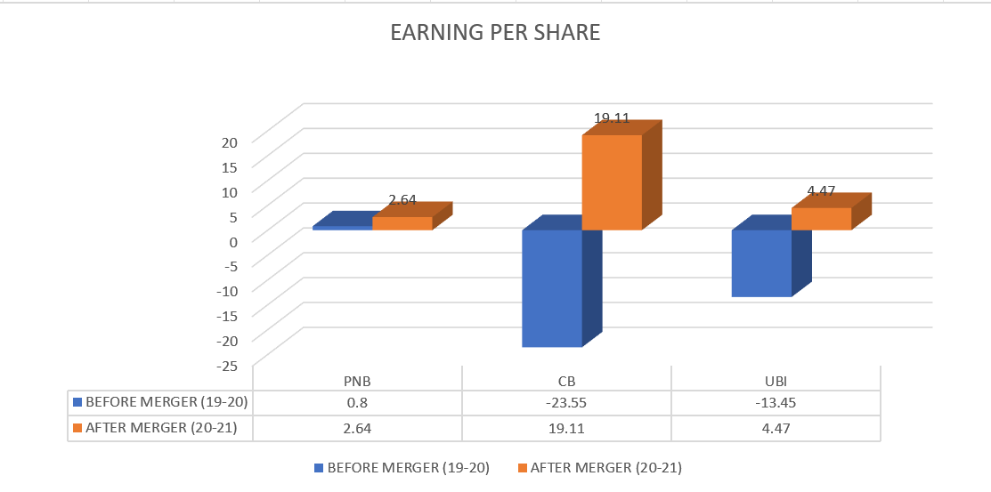
(Source : Moneycontrol.com)

- Analysis:
In the above chart of Earning Per Share Ratio in which :-
• Punjab National Bank has lowest ratio (0.8) before the merger and it has highest ratio (2.64) after the merger.
• Canara Bank has lowest ratio (-23.55) before the merger and it has highest ratio (19.11) after the merger.
• Union Bank Of India has lowest ratio (-13.45) before the merger and it has highest ratio (4.47) after the merger.
7.ROCE (%) RATIO:
Return on Capital Employed (ROCE) is used in finance as a measure of returns that a company is realizing from its capital employed.
• Capital Employed is represented as total assets minus current liabilities. In other word the value of the assets that contribute to a company’s ability to generate revenue.
• ROCE is a ratio that indicates the efficiency and the profitability of a company’s capital investments.
• ROCE = Earning / Capital Employed x100
• The numerator is earning before interest and tax. that the net revenue after all the operating expenses is deducted.
• The denominator (capital employed) that denotes the sources of the funds such as equity and short-term debt financing which is used for the day-to-day running of the company.
• It is a useful measurement for comparing the relative profitability of the companies.
Table 7
ROCE (%) Ratio in selected units

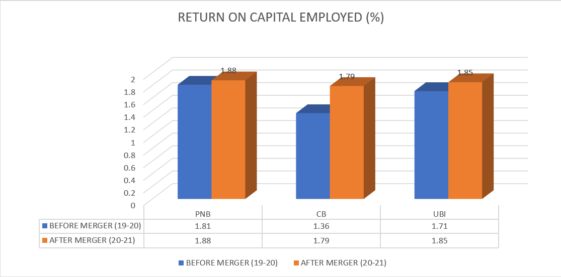
(Source : Moneycontrol.com)

- Analysis:
In the above chart of Return on Capital Employed (ROCE %) Ratio in which :-
• Punjab National Bank has lowest ratio (1.81) before the merger and it has highest ratio (1.88) after the merger.
• Canara Bank has lowest ratio (1.36) before the merger and it has highest ratio (1.79) after the merger.
• Union Bank Of India has lowest ratio (1.71) before the merger and it has highest ratio (1.85) after the merger.

- FINDINGS:

• In CASA ratio before the merger the highest ratio is (42.86) in Punjab National Bank and the lowest ratio is (31.36) in Canara Bank. After the merger the highest ratio is (44.44) in Punjab National Bank and the lowest ratio is (32.72) in Canara Bank.

• In operating profit ratio before the merger the highest ratio is (-16.43) in Punjab National Bank and the lowest ratio is (-27.77) in Canara Bank. After the merger the highest ratio is (-13.40) in Punjab National Bank and the lowest ratio is (-29.54) in Canara Bank.

• In net profit ratio before the merger the highest ratio is (0.66) in Punjab National Bank and the lowest ratio is (-8.11) in Union Bank of India. After the merger the highest ratio is (4.08) in Union Bank of India and lowest ratio is (2.62) in Punjab National Bank.

• In return on assets before the merger the highest ratio is (0.05) in Punjab National Bank and lowest ratio is (-0.26) in Canara Bank. After the merger the highest ratio is (0.26) in Union Bank of India and lowest ratio is (0.20) in Punjab National Bank.

• In return on equity ratio before the merger the highest ratio id (0.74) in Punjab National Bank and the lowest ratio is (-5.69) in Canara Bank. After the merger the highest ratio is (5.34) in Canara Bank and the lowest ratio is (3.00) in Punjab National Bank.

• In earning per share ratio before the merger the highest ratio is (0.80) in Punjab National Bank and the lowest ratio is (-23.55) in Canara Bank. After the merger the highest ratio is (19.11) in Canara Bank and the lowest ratio is (2.64) in Punjab National Bank.

• In ROCE ratio before the merger the highest ratio is (1.81) in Punjab National Bank and the lowest ratio is (1.36) in Canara Bank. After the merger the highest ratio is (1.88) in Punjab National Bank and the lowest ratio is (1.79) in Canara Bank.

CHAPTER- 4
CONCLUSION AND RECOMMENDATIONS

- CONCLUSION :
From the above study it can be concluded that :-

• The banking industry has been experiencing major Merger and Acquisition in the recent years, with the number of global players emerging through successive Merger and Acquisition in the banking sectors.

• The current study indicates that the pre and post merger and acquisition of the selected banks in India have no grater changes in profitability ratio in a few banks that are satisfactory during the study period. But in future there are robust projections of improvement in profitability. So the result is to specify that the mergers led to higher level of cost efficiencies for the merging banks.

• Merger and acquisition is leads to the financial gain and the increase in price of target banks. It is depends on the condition and the different situations that it will be increase the share and the profit of acquirer or not.

• The primary purpose of the merger and acquisition is to reduce the competition and protect in existing markets in the economy.

• Mergers are good for the growth and development of the country only when it does not give rise to the competition issues.

• The administration of the banks and the other organizations that intended to undertake merger and acquisition that should seek to evaluate and that consider how these structural factors are likely to impact on the achievement of the intended merger and acquisition.

• Mergers has improve the competition edge of the industry in order to complete with the competitors in the global market but the merger shrink the industry because of the number of firms reduces.

• Mergers help the banks to be strengthen their financial base and the access tax benefits and the direct access to cash resources.

• In banking industry its helps the weaker banks to be strengthen their position by merging with the bigger and stronger banks.

• The above study shows the impact of merger and acquisition on selected banks like Oriental Bank of Commerce and United Bank of India merged into Punjab National Bank, Syndicate Bank merged with Canara Bank , Andhra Bank and Corporation Bank merged with Union Bank Of India.

- RECOMMENDATIONS :
From the above study of Pre and Post Mergers Financial Performance of some selected Indian Banks it can be recommended that:-

Each step of the M&A workflow includes many sub-task, making the process time-consuming so they can streamline the steps , they can still complete an M&A without cutting corners and there are some ways to clear roadblocks and start streamlining the M&A process by the followings:

- Define roles and responsibilities within their M&A deal team.
- Maintain discipline during M&A deal sourcing.
- Confirm that information is up to date during the due diligence process.
- Centralize documentation and communication.
- Use technology to manage M&A transactions.

BIBLIOGRAPHY

References:
- Dr. Prashnta Atma and A. Bhavani , “ Mergers in banking sector in India ; An analysis of pre and postmerger performance of SBI & HDFC Bank”.
- CMA Jai bansal and Dr. Gurudutt kakkar (2018), “ A research on the analysis of merger of SBI with its5 associated banks and Bharathiya mahila bank”.
- Azeem Ahmed Khan (2011), “Mergers and Acquisitions in Indian Banking Sector in Post LiberalizationRegime”, International Journal of Contemporary Business Studies Vol 2, No: 11 November 20117. Devarajappa S, IRJC (2012), “Mergers in Indian Banks: A Study on Mergers of HDFC Bank Lt
- Sanjay Sharma and sahil sidana(2017), “ impact of SBI merger on condition of SBI”
- Dr. Prashnta Atma and A. Bhavani, “ Mergers in banking sector in India ; An analysis of pre and post merger performance of SBI & HDFC Bank”.
- Kuriakose Sony & Gireesh Kumar G. S (2010), “Assessing the Strategic and Financial Similarities of Merged Banks: Evidence from Voluntary Amalgamations in Indian Banking Sector”, Science & Society, Vol. 8, No. 1, 2010.
- Kotnal jaya shree (2016), “The economic impact of Merger and Acquisitions on profitability of SBI”.

Website:
- www.moneycontrol.com (Last accessed on 03-04-2023)
- www.bankofbaroda.com (Last accessed on 11-04-2023)
- www.punjabnationalbank.com (Last accessed on 21-04-2023)
- www.canarabank.com (Last accessed on 13-04-2023)
- www.unionbankofindia.com (Last accessed on 03-04-2023)
- www.indianbank.com (Last accessed on 14-04-2023)

