PROJECT REPORT

(Submitted for the degree of B.Com Honors in Accounting and Finance under the University of Calcutta)

Impact of GST on Automobile Sector

Submitted By

Name :Muskan kumari
C.U. Registration No :201144-11-0099

C.U. Roll No :144-1211-0827-20
Name of the College :BANGABASI MORNING COLLEGE

College Roll No :BH0390

Name of the the supervisor : Dr. MOUMITA SARKAR (SAMANTA)
Name of the College :BANGABASI MORNING COLLEGE

Submission of Months : MAY 2023

Annexure-1
SUPERVISOR’S CERTIFICATE

This to certify that MUSKAN KUMARI a student of B.Com (Honors) in Accounting and Finance of BANGABASI MORNING COLLEGE under the University of Calcutta has worked under my Supervision and guidance for her project work and prepared a project report with the Title Impact of GST on Automobile Sector

The project report, which she has submitted is her genuine and original work to the best of my knowledge.

PLACE : KOLKATA

DATE :

Signature :
Name : MOUMITA SARKAR(Samanta)
Designation: Assistant Professor
College Name: BANGABASI MORNING COLLEGE

ANNEXURE -2

STUDENT’S DECLARATION

I hereby declare that the project work with the title “Impact of GST on Automobile Sector”

Submitted by me for the partial fulfillment of the degree of B.COM Honors in Accounting

& Finance under the University of Calcutta is my original work and has not been not submitted earlier to any other university/ institution of the requirement for any course
of study.

I also declare that no chapter of this manuscript is whole or in part has been incorporated in this report from any earlier work done by others or by me. However, extracts of any literature which has been used in this report has been duly acknowledged by providing details of such literature in the references.

Signature:
Name: MUSKAN KUMARI
Address:7no madhav ghosh road howrah,711106
University roll no : 201144-11-0099
Registration no : 144-1211-0827-20
Collage roll no : BH0390

PLACE : KOLKATA

DATE :

ACKNOWLEDGEMENT

It is a matter of great pleasure to present this project on “GST–The New Era of Taxation System.”
I take this opportunity to thank our respected principal for giving me an opportunity to work on this field.

I am very thankful to my supervisor Prof. MOUMITA SARKAR (Samanta) for her full support in completing this project work.
Finally, I am grateful for the support of my family / friends / others and would also like to thank them for co-operating with me to carry out these research work and help me with the project work by filling up the questionnaire / report.

MUSKAN KUMARI

TABLE OF CONTENT

SI. NO PARTICULARS PAGE NO.

- Annexure - I

- Annexure - II

- Acknowledgement

- Chapter 1 - Introduction

- Chapter 2 - Conceptual Framework

- Presentation of Data Analysis

- Conclusion and Recommendation

- Bibliography
-

-

-

6 - 8

9 - 21

21 - 31

32 - 32

33 - 33

- Questionnaires 34 - 35

CHAPTER – 1

INTRODUCTION

1.1 Background

Introduction of the Value Added Tax (VAT) At the Central and the state level has been considered to be a major step -an important step forward in the globe of indirect tax reforms in India. If the VAT is a major improvement over the preexisting Central excise duty at the national level and the sales tax system at the state level, then the goods and services tax(GST) will indeed be an additional important perfection -the next logical step-towards a widespread indirect tax reforms in the country. Initially, it was conceptualized that there would be a national level goods and services tax, however, with the release of first discussion paper by the Empowered Committee of the State Finance Ministers on 10.11.2009, it has been made clear that there would be a “Dual GST” in India, taxation power-both by the center and the state to levy the taxes on the Goods and Services. Almost 150 countries have introduced GST in some from. While countries such as Singapore and New Zealand tax virtually everything at a single rate, Indonesia has five positive rates, a zero rate and over 30 categories of exemptions. In China, GST applies only to goods and the provision of repairs, replacement and processing services. Under the GST scheme, no distinction is made between goods and services for levying tax. In other words, goods and services attract the some rate of tax. GST is a multi-tier tax where ultimate burden of tax fall on the consumer of goods/services. It is called as Value Added Tax because at every stage, tax is being paid on the Value addition. Under the GST scheme, a person who was liable to pay tax on his output, whether the provision of service or sale of goods, is entitled to get input tax credit (ITC) on the tax paid on its inputs.

  - Justification of GST

The introduction of GST at the Central level will not only include comprehensively more indirect Central taxes and integrate goods and service taxes for the purpose of set-off relief, but may also lead to revenue gain for the center through widening of the dealer base by capturing value addition in the distributive trade and increased compliance. In the GST, both cascading effects of CENVAT and service tax are removed with set-off, and a constant chain of set-off from the original producer’s point and service provider's point up to the retailer's level is established which reduces the burden of all cascading effects. This is the real meaning of GST, and this is why GST is not simply VAT plus service tax but an improvement over the previous system of VAT and disjointed service tax. Moreover, with the introduction of GST, burden of central sales tax (CST) will also be removed. The GST at the state level is therefore, justified for-

    - Additional power of levy of taxation of services for the states

    - System of comprehensive set-off relief

    - subsuming of several taxes in the GST

- Removal of burden of CST.

  - Objectives:

- To understand the meaning of Goods and services Tax (GST)
- To analyze the impact of GST over Automobile Sector

  - Brief Review of Literature on GST:

Before we proceed with the finer nuances of proposed Indian GST, let us first understand the basic concept of GST. GST is a value added tax levied on manufacture, sale and consumption of goods and services. GST offers comprehensive and continues chain of tax credits from the producer’s point/service provider's point up to the retailer’s level/consumer's level thereby texting only the Value Added at each stage of supply chain. The supplier at each stage is permitted to avail credit of GST paid on the purchase of goods and/or Services and can set off this credit against GST payable on the supply of goods and/or Services to be made by him. Thus, only the final consumer bears the GST charged by last supplier in the supply chain, with set-off benefits at all the previous stages. Since, only the Value Added at each stage is taxed or cascading of taxes under GST system. Further, GST does not differentiate between goods and services and thus, the two are taxed at a single rate.
  - Research Methodology

Our study has based on the basis of secondary data collected from various books, journals, magazines, reports, newspapers, internet etc. We have also collected data from the source of “Department of Revenue” and “Ministry of Finance”. after analyzed with the help of simple statistical tools. We have used lucid language to present the Data in a more comprehensive manner. Finally some findings have been gathered to establish our objectives
  - Limitations of The Study:

The study has some limitation on its scope and interpretation of the results. It covers only the narrow concept of goods and service tax and not the whole, the present study has also the following limitation:
    - The first and most shortage of Time, in fact we have not sufficient time for in-depth analysis, international comparison and other analysis of data. this has indeed restricted our study to our mission.

    - There are few common and unavoidable general problems in collecting secondary data, which are required for our study.

  - Chapter Planning:
- INTRODUCTION
- CONCEPTURAL FRAMEWORK
- GLOBAL SCENARIO
- PRESENTATION OF DATA ANALYSIS
- CONCLUSIONS
- BIBLIOGRAPHY

CHAPTER -2

DEFINITION

It has been long pending issue to streamline all the different types of indirect taxes and implement a “single taxation” system. This system is called as goods and services tax (GST). The main expectation from this system is to abolish all indirect taxes and only GST would be levied. As the Name suggests, the GST will be levied both on Goods and Services.

GST is a tax that we need to pay on supply of Goods and Services. Any person, who is providing or supplying goods and services, is liable to charge GST. GST is a consumption based tax/levy. It is based on the “Destination Principal”.

GST was first introduced during 2007-08 budget session. On 17th December 2014, the current union cabinet ministry approved the proposal for introduction GST Constitutional Amendment bill. On 19th December 2014, the bill was presented on GST in Loksabha. The bill will be tabled and taken up for discussion during the current budget session. The current central government is very determining to implement GST Constitutional Amendment Bill.
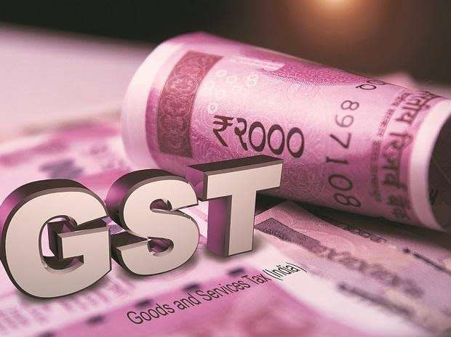

    - Applicability and Mechanism
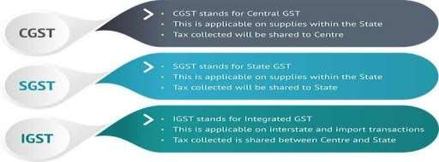
Applicability and mechanism of GST

The GST is an indirect tax which means that the tax is passed on till the last stage where in it is the customer of the goods and services who bears the tax. This is the case even today for all Indirect taxes but the difference under the GST is that with streamlining of the multiple taxes the final cost to the customer will come out to be lower on the elimination of double charging in the system.

Let us understand the above supply chain of GST with an Example:
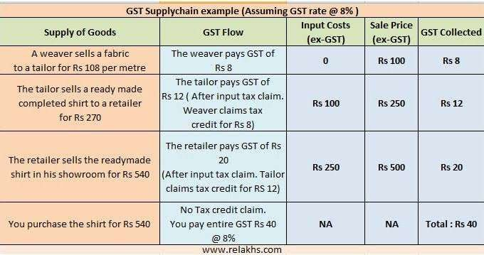

The current tax structure does not allow a business person to take tax credits. There is a lot of chances that double taxation takes place at every step of supply chain. This may set to change with the implementation of GST. Indian Government is opting for Dual system GST. This system will have two components which will be known as

Central Goods and Service Tax(CGST)
    - State Goods and Service Tax (SGST)
The current taxes like Excise duties, service tax, custom duty etc will be merged under CGST. The taxes like sales tax, entertainment tax, VAT and other state taxes will be included in SGST.
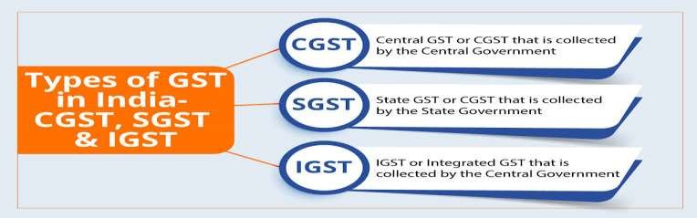

    - Salient Features of The GST Model: Salient Features of the proposed Model are as:

- The GST shall have two components: one levied by the center (referred to as central GST) and the other levied by the states (referred to as state GST). Rate for central GST and the state GST would be approved appropriately, reflecting revenue considerations and acceptability.
- The Central GST and the state GST would be applicable to all transactions of goods and services made for a consideration except the exempted goods and services.
- The Central GST and state GST are to be paid to the accounts of the Central and the states individually.
- Since the Central GST and the state GST are to be treated individually, taxes paid against the Central GST shall be allowed to be taken as input tax credit (ITC) for the Central GST and could be utilized only against the payment of central GST.
- Cross utilization of ITC between the Central GST and the state GST would not be permitted except in the case of inter-state supply of goods and services.
- Ideally, the problem related to credit accumulation on account of refund of GST should be avoided by both the Central and the states except in the cases such as exports, purchase of capital goods, input tax at higher rate than output tax etc.
    - Overview, Registration & Returns

Present System: GST
- INTRA STATE SUPPLY: CGST & SGST
- INTER STATE: IGST = CGST + SGST
- IMPORT FROM OUTSIDE INDIA: CUSTOM DUTY (CVD-SAD) & IGST

GST BASICS:

- GST is principally consumption/destination based tax.
- Tax will be payable in the state in which goods and services are consumed.
- No declaration
- No check posts
- SGST will be kept same in all states. However, a price band may be given to states for SGST rates.
- CGST & IGST rates will be same all over India.
- IGST may be sum total of SGST & CGST i.e. IGST=SGST+CGST

VAT PRINCIPLE IN GST:
- GST will be on basis of value Added Tax (VAT) concept
- VAT to avoid cascading effect of taxes
- ITC (set off) of CGST for CGST and IGST but not for SGST
- ITC (set off) of SGST and IGSST but not for CGST

- ITC (set off) of IGST for IGST, CGST and SGST in that order
- Credit on basis of Return like 26AS
RATES IN GST:
- SCHEDULE 1 : LIST OF GOODS AT NIL RATE- Meat of bovine animals fresh or chilled, Natural Honey, Live sheep, goats poultry etc.
- SCHEDULE 2 : LIST OF GOODS AT 0.25% RATES- Diamonds, precious metals, Semi precious stones etc.
- SCHEDULE 3 : LIST OF GOODS AT 3% RATES –Silver, Gold, Platinum, Beans, Coin, Imitation jewellery etc.
- SCHEDULE 4 : LIST OF GOODS AT 5% RATE- Vanilla, oats ,Soya beans, Olive oil, Cane sugar, Cocoa beans, Pizza bread etc.
- SCHEDULE 5 : LIST OF GOODS AT 12% RATE- Beverages, contacting milk, live horses, stream, Cheese, Granite Blocks, Stream, Feeding bottles etc.
- SCHEDULE 6 : LIST OF GOODS AT 18% RATE- Kajal pencil sticks, hair oil, toothpaste, Gum, Tall oil, Activated carbon, photographic plates & films etc.
- SCHEDULE 7 : LIST OF GOODS AT 28% RATE- Molasses, Chewing gum, cocoa butter, pan masala etc.

CHAPTER -3
Presentation, Analysis & Findings

- IMPACT OF GST ON AUTOMOBILE DEALER’S INDUSTRY:

The Indian auto industry is one of the largest in the world. The industry accounts for 7.1% of the largest in the world. The industry accounts for 7.1% of the country’s gross domestic product (GDP). Almost 13% of the revenue from Central excise is from this sector and claims a size 4.3% of total exports from India. Despite its contribution to the economy and growth potential, this sector has been combating the hardship of high tax rates for substantially a long period of time now with central excise duty ranging between 12.5% to 30% coupled with introduction of multiple cases ant revenues whims and fancies, most recent being infrastructure chess.

Thus, introduction of GST shall be a breather for this sector wherein taxes on vehicle are largely expected to be @ 18% in GST regime except for luxury cars where the rate may go up to 28% plus cases. However, even this rate of taxation will be beneficial of this industry. The article focuses on the supply

chain part of this industry that is the “automobile dealers”. Therefore, this article examines the intricacies of GST on automobile dealers.

BEFORE GST, DEALERS ARE PAYING FOLLOWING INDIRECT TAXES:

  - Service tax (ST) on services both as provider and also as receiver under reverse / joint Charge.
  - Value added tax (VAT) / Central sales tax (CST) / on sale of vehicles / spares /Accessories.
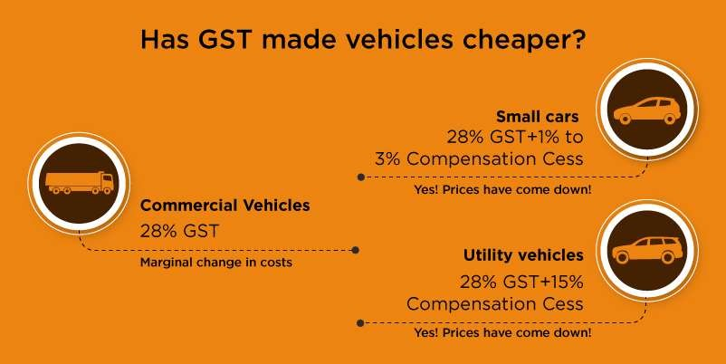

IMPACT OF GST ON VARIOUS ASPECTS IS AS EXAMINED BELOW:

- Impact on Credits:
Currently, automobile dealers are not able to avail CENVAT credit on the following indirect taxes paid by them.
  - CST paid on purchase of vehicle, Spares, consumables and accessories.
  - Excise duty paid on purchase of vehicle, spares, consumable and accessories.
  - NCCD, auto season infrastructures is paid on purchase of vehicle.
  - CVD pet on any imported spares, accessories and consumable. ❖ SBC paid on input services.
  - Reversal of proportionate CENVAT credit of service tax due to trading activity showroom rent, advertisement expenses etc.

In GST regime, all the above duties / taxes will get subsumed; therefore, dealers should be able to avail the input tax credit of all its procurement of goods and services.

IMPACT ON THE PROCUREMENT COSTS OF VEHICLES:

Since, all of the above taxes get subsumed in the GST; therefore the procurement cost to that extent will come down as explained below:

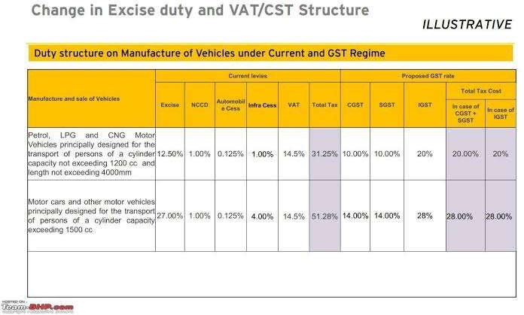

  - Since, IGST and cusses shall be fully available as credit in the GST regime, therefore they will not form part of purchase cost and can be set off from output GST payable on sale of the vehicle.
  - Procurements are assumed to be in the course of inter-state. GST rates have been assumed to be at such levels based on the various news reports and the reports issued by various committees formed by the Ministry of Finance.

As noted above, reduction in procurement Cost is substantial as cascading of taxes was just adding to the cost in this sector.
- IMPACT ON THE SALE PRICE:

Since, the procurement cost reduces in GST and if the benefit of the same is fully passed on to the customer, then is leads to reduction in sale price of the vehicle as tabulated below: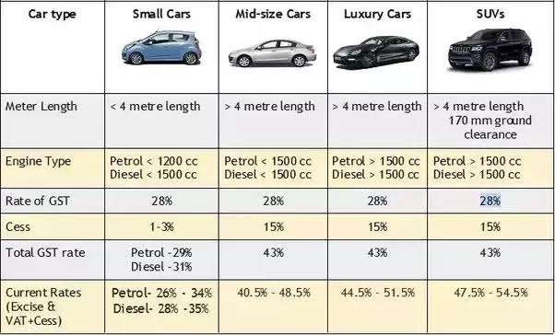

(Source: Internet)

NOTE:-

Assuming that the sale prices at 5% mark up above the purchase price. it is seen from the above calculation that overall reduction in the purchase cost of the per vehicle ranges from 16 % to 34% and if full benefit of such reduced prices is passed on to the end consumers then the sale prices of vehicles can come down in the GST regime which will boost this sectors growth and must have largely positive impact due to invasion of GST.

IMPACT ON WORKING CAPITAL:

Following aspects will impact the working capital of the automobile dealers in the GST regime:

VEHICLE TRANSFERS:

Transfer of vehicle / spares to other premises will be liable for GST if the transfer is in the course of inter-state trade. Further, if there is separate dealership of a dealer and separate GST registration number is obtained for each such dealership, then transfer of any goods or services between such dealerships will also be liable for GST. This shall be block the working capital as the taxes needs to be paid from own fund and collection of taxes will be at a later date only when such / services evenly sold.

FREE SERVICE COUPON VOUCHERS:

These coupons will be issued at the time of sale of the vehicle. As per the time of supply rule, GST on such coupons needs to be paid immediately on the date of issue of such vouchers. As per the policy of
some manufacturers, the amounts in respect of such coupons will be redeemed to the dealers only once the customer brings the vehicle for repair to the workshop. Therefore, dealer's should have to pay tax on such coupons immediately on its issue, but they said taxes can be collected from the customers only when the vehicle comes for the repair leading to unnecessary blocking of fund in taxes.

  - ❖ VEHICLE BOOKING ADVANCE: It is quite common in this sector that the vehicles will be booked in advance on payment of certain amount as token. Currently, VAT is not being paid on such advances as the same is payable at the time of sale of vehicle. However, this luxury of holding advances without payment of taxes is clipped in the GST regime and taxes need to be paid on receipt of the booking advances also. Therefore, dealers either have to pay taxes on the advances out of its pocket or collect Axis text even on the token advances.

COMMISSION, WARRANTIES AND INCENTIVES:
Currently, it is very difficult for dealers to pay service tax on accrual basis on the following incomes and thereby as a system of practice many dealers are paying service tax on receipt basis.

COMMISSION FROM BANKERS/INSURERS:

As details of the commission will be provided by bankers/insurers at a later date with constant changes involved. Therefore, generally dealers pay service tax on such receives only upon receipt of commission.

INCOME FROM MANUFACTURER:
Various commissions, incentives, reimbursements, warranty receipts etc. Are received from manufacturer. Dealer does not pay taxes on this incomes on accrual basis as the same may or may not get approved by the manufacturer at a later date. Therefore, currently Service tax is paid on receipt basis only when the amount is credited by the manufacturer and is reflected in the manufacturer’s statement.

However, the luxury of paying taxes on receipt basis will not be accepted in the GST regime as everything will be system driven. Therefore, dealers will have to either get it system connected with the bankers and manufacturers immediately to ensure smooth transition into the GST regime or else it would have to take the brunt of taxes on its own due to fault of its vendor.

- REDUCED CURRENT LITIGATIONS:

Currently this sector is facing on the following areas:

- VALUATION IN SERVICING OF VEHICLE: Complexity in bifurcation of the material and labor component is the servicing of vehicle has led to multiple disputes as both the Service tax and sales tax authorities demanded taxes on a higher component.

HANDLING CHARGES:
Weather it is liable for VAT or Service tax has led to demand of taxes from both authorities and thereby disputes.

REGISTRATION CHARGES:

Disputes were noted on Applicability of Service tax on various charges that are merely collected as pure agent such as temporary permanent Registrations etc.

INCENTIVES:
It has been a matter of disputes at a various judicial forum as to whether the incentives received by the automobile dealers from the manufacturer whether amounts to any “Service” to be liable for Service tax. Such disputes would end in the GST regime as the tax base for both CGST and SGST shall be same.

- IMPACT ON TRASITIONAL CREDITS:

To transfer the existing credits in the GST regime, condition has been kept that such credit must have been admissible in the GST regime. Therefore, the dealers should be able to transfer the following credits to the GST regime.

CREDIT OF SERVICE TAX:
The same must be properly reflected in the last Service tax returns and documentation must be in place to establish the same. Further, Service tax credit pertaining to cars, spares in stock can also be availed.

EXCISE DUTY/CVD:
Since, currently dealers are not availing the credit of excise duty & CVD. Therefore, they need to ascertain the value of stock as on the appointed day and based on the availability of the invoice, and credit can be availed. Further, even if proper excise invoice is not available with the dealers still a percentage as prescribed can be taken as credit to transit its excise credit in the GST regime.

VAT/SAD:
Similarly, if a dealer is not availing the credit of VAT/SAD current due to restriction in the state VAT law, then credit can be availed based on the ascertainment of stock as on appointed day. However, if the credit of VAT is being currently availed then the same needs to be properly reflected in the last VAT return to transfer such credits to the GST regime.

CREDIT OF CST:

The same can’t be availed subject to possession of appropriate documents for the same in states where such set off is permissible.

ENTRY TAX:

Credit of some can be availed subject to possession of appropriate documents for the same in states where such set-off is permissible.
- IMPACT DUE TO ANTI-PROFITEERING MEASURES:

Since a dealer will be able to take the credit of goods lying in stock, the tax cost would be decrease. This additional benefits accruing to a dealer is expected to be passed on to the end consumer by
way of reduction in prices etc. A separate authority will be formed in the GST regime to monitor the non-compliance of the anti-profiteering matters which could have an adverse impact on the entire industry especially when the pricing is predefined by the manufacturer. Therefore, it is imperative for the dealer to establish passing of the GST benefits to its consumers. In this times of falling prices this may not be
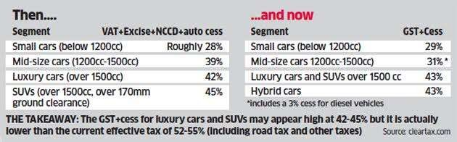
CHAPTER-4

CONCLUSION & RECOMMENDATIONS

While successfully completing this project, I have identified that GST drives for boosting up economic growth of any country. GST is the most logical steps towards the comprehensive indirect tax reform in our country since independence. GST is lovable on all supply of goods and provision of services as well combination thereof. All sectors of economic whether the industry, business including Govt.
Departments and service sector shall have to bear impact of GST. All six sense of economy viz., Big, medium, small scale units, intermediaries, importers, exporters, traders, professionals and consumers shall be directly affected by GST. One of the biggest taxation reforms in India – Goods and Service Tax (GST) is all set to integrate state economies and boost overall growth. GST bill create a single. Unified Indian market to make the economy stronger. Experts say that GST is likely to improve tax collections and boost India's economic development by breaking tax barriers between states and integrating India through a uniform tax rate. Under GST, the taxation burden will be divided equitably between manufacturing and services through a lower tax rate by increasing the tax base and minimizing exemptions.

Besides various recommendations has come to my mind while doing this project.

    - The proactive initiative if implemented properly, government can expect refund of rupees thousand core.
    - GST will simplify our indirect tax structure.
    - Government should create more items under zero rated supplies rather than exempt rate supplies.
    - In order to settle the issue, the Govt. Need to play their role by put more efforts in educating the public about tax.

BIBLIOGRAPHY

- Shefali Dani, Business and Economics Journal, Volume 7 • Issue 4 • 1000264, 2016, 7:4, An article was published regarding” A Research Paper on an Impact of Goods and Service Tax (GST) on Indian Economy”
- Amandeep kaur, International Journal of Advance Research in Science and Engineering, Volume No.7, Issue No.4, April 2018, the research paper was published on “A Research Paper on Impact of GST on Indian Economy”
- M.Sankaran & Dr.A. Sreelatha, International Journal of Pure and Applied Mathematics, Volume 120 No. 5 2018, 1371-1389, The research paper is published that “Effect of GST on Indian Economy (Agricultural and Insurance)”
- www.hindustantimes.com
- http://economictimes.indiatimes.com/topic/GST
- http;//www.gstindia.com/about

