PROJECT REPORT
(Submitted for the Degree of B.Com. Honours in Accounting & Finance / Marketing/ ........ under the University of Calcutta)

Online shopping: A case study on Flipkart

SUBMITTED BY

NAME : RAGINI SHAW REGISTRATION NO. : 144-1211-0811-20
ROLL NO. : 201144-11-0093
College Roll No:
College: Bangabasi Morning College

SUPERVISED BY

NAME OF THE SUPERVISOR : Dr. MOUMITA SARKAR (SAMANTA)

Name of the College: Bangabasi Morning College

Month & Year of Submission

May 2023

ANNEXURE – IA

Supervisor’s Certificate

This is to certify that Ragini Shaw, a student B.com Honours in Accounting & Finance of The Bangabasi Morning College under the University of Calcutta has worked under my supervision and guidance for hier project work and prepared a project with the title Online shopping: A case study on Flipkart which she is submitting, is his genuine and original work to the best of the my knowledge.

Signature:
Name : Prof. MOUMITA SARKAR (SAMANTA)
Name of the college : Bangabasi Morning College
Designation :Assistant Professor
Place :Kolkata
Date :

ANNEXURE – IB

Student’s Declaration
I hereby declare that the project work with the title Online shopping: A case study on Flipkart submitted by me for the partial fulfilment of the degree of B.com Honours in Accounting & Finance under the University of Calcutta is my original work and has not been submitted earlier to any other University of Calcutta is my original work and has not been submitted earlier to any other University for the fulfilment of the requirement of any course of study.
I also declare that no chapter of this manuscript in whole or in part has been incorporated in this report from any earlier work done by other or be me. However, extracts of any literature which has been used for this report has been duly acknowledged providing detailed of such literature in the references.

Signature :

Name : RAGINI SHAW
Address : 140, Collin Street, Kolkata – 700016
Registration No : 144-1211-0811-20
Roll No : 201144-11-0093
Place : Kolkata
Date :

Table of contents

- Chapter – 1
Introduction 4
Online shopping 5
Literature review 6
Advantages of online shopping 7
Growth of Online retailing in india 8
Methodology 10
- Chapter – 2
Conceptual framework / Notional / international scenario 13
Flipkart success story 13
Regional market 14
Factors that lead to grand success of Flipkart 16
Future marketing strategy and road map 17
- Chapter – 3
Presentation of Data & Analysis 18
Findings 27
- Chapter – 4
Recommendations 29
Conclusion 30
Bibliography / Reference 31
Questionnaires 32
Annexure I-A 35
Annexure I-B 36

ACKNOWLEDGEMENT

I take this opportunity to thank The Bangabasi Morning College for the 3 amazing years of my college life and being the best institution for pursuing the degree of B.com (Hons.).
Special thanks to our supervisor in charge prof. Moumita Sarkar Samanta for guiding me in making the whole project and complete and also in supporting me throughout the process.
Also I would to thank my friends and family members who were supportive and helpful in preparing this project work at various stages.
Will always remember making this project work and the knowledge I gained while doing. So, concluding this with a heartiest thanks to my college and its faculty members for always being there when the students needed it. Thank you.

INTRODUCTION
Electronic commerce, commonly known as E-commerce is trading in products and services using computer networks, such as the internet. Electronic commerce draws on technology such as mobile commerce, electronic fund transfer, supply chain management, internet marketing, online transaction processing, electronic data interchange (EDI), inventory management system and automated data collection systems. Modern electronic commerce topically uses the World Wide Web for at least one part of the transaction‟s life cycle, although it may also use other technologies such as e-mail.
E-Commerce businesses may some all of the following:
- Online shopping web site for retail sales direct to consumers.
- Providing and participating in online marketplace, which process third- party business to consumer or consumer to consumer sales.
- Business to business buying and selling.
- Gathering and using demographic through web contract and social media.
- Business to business electronic data interchange.
- Marketing to prospective and established consumes e-mail and fox.(for example, with slitters)
- Engaging and pertain for launching new products and services.
According to an Associated chamber of commerce and industry in India. (ASSOCHAM) survey, the online retail in India grow to Rs. 70 billion (over Rs. 1.5 billion) by 2015 Rs. 20 billion in 2011 as internet access improved.
India has always been a land of great potential. The socioeconomic condition of the country has improved many folds after independence and India is now emerging as one of the leading countries in the world. Moreover with a population over 100 crore and growth rate is above 6% , it can be compared to amarketing giant. Hence it can be well judged why online shopping in India is rise at fast pace over the day. As technology is seared to a remotest village and many job opportunities are presenting themselves to the unemployed youth

more and more people are gaining awareness and the money to purchase expensive and luxuries item over the internet.
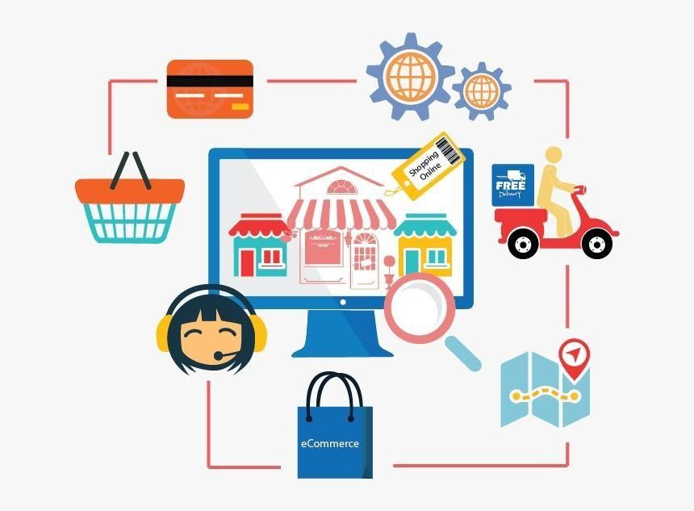

Online shopping

Which company flashes in your mind first? Flipkart, Amazon, eBay etc.
We‟ll let us talk about the home-grown India e-commerce site “flipkart”, also considers as the Amazon of India.
A company which started with just 4 lakhs is now worth is over more than 2000 crore, according to data flipkart has provided to Ministry of Corporate Affairs: the companies revenue is 2011-2012 was $77 Million (Rs. 500 crore). For the fiscal 2012-2013, their revenue is estimated to be $350 Million. With this huge success flipkart is becoming the fate of online retail in India. This paper attempt to through light and growth of online retail in business in India with special reference to flipkart (analysing the consumers feedback about the online business model of flipkart)
The invention has opened the whole new world of possibilities for us. Not only we can communicate with the we love with in moment but now a day many vital tasks like job, shopping, socializing and many others can be done easily at the convenience of the homes. The concept of online shopping is

relatively new one and it enables us to buy all our favourite goods and accessories over the internet. This will not only save the time but also we can get the product at much discounted price and that too all our homes. There are many online stores that have developed in recent times like lets shops.in, flipcart.com and many others. This stores host a wide range of products like bags, shoes, books, gadgets and many others. To purchase any product you haveto visit the site and click on the product that you would like to purchase and the product will be delivered to you with in a week maximum. It‟s that simple.

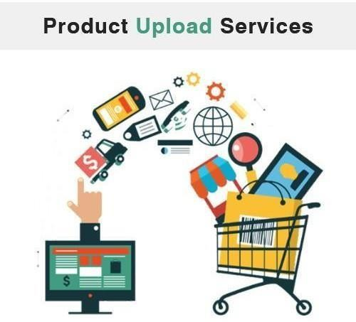

Growth of online retailing in India
India e-commerce has grown at a compounded annual growth rate of 30% since FY09, and is expected to be $18 billion (around Rs. 1,11,600 crore) opportunity by FY15. The findings part of report: Indian Ecommerce – Tip of the Iceberg, by Macquarie Equities Research back this high growth rate on rising internet population, over 300 million middle class populations, increasing mobile penetration and low level of e-commerce activity.
“Compared to the west, India‟s e-commerce industry is still in its infancy. E-commerce contributes only 0.6% of the country‟s GDP was 1-3% forother countries, with only 12% of India‟s online population transacting online vs 64% for the US and over 50% for China.” Said Atul Soni and Nitin Mohta in the report. This growth will further be accentuated by companies going in for public listing. In the Indian context, only two internet-based companies are listed on the markets, including info edge, which runs India‟s largest job portal (naukri.com), and justdial, which is India‟s largest local search site.
The nature of Indian e-commerce is also different. Travel has the lion‟s share of 71% of Indian e-commerce, but e-tailing has grown the fastest, at a 59% CAGR between FY09-13E, to reach 16% market share. Compared to the west, India‟s e-commerce industry is still in its infancy, but we believe that it may become a bigger part of the entire retail universe than in the west.

Literature Review

“In online buying, the rate of diffusion and adoption of the online buying amongst consumers is still relatively low in India. In view of above problem andempirical study of online buying behaviour was undertaken. Base on literature review, four predominant psychographic parameters namely, attitude, motivation, personality and trust were studied with respect to online buying. The online buying decision process models based on all the four parameters were designed after statistical analysis. These models were interrogated with business intelligence management and data mining to design behavioural Business intelligence framework with a cohesive view of online buyer behaviour. For better understanding the factors of internet and consumer shopping behaviour towards internet shopping, this chapter would provide academic research review and relative ideas expressed in the literature that associated with this subject. Furthermore, a number of hypotheses will be tested to answer the research questions that mentioned already in the introduction. Dueto the recent research shows the internet shopping becomes a full and effective business models, therefore there are several studies that already investigated more or less related on internet shopping and consumer behaviour. In the following chapter, some point of view will be taken from literatures, and needs careful review to achieve them as the basis of the subsequent research investigation.”

-Archana Shrivastava & Ujwal lanjewar (2011)

Objectives
  - To explore the online business of model of flipkart.
  - To analyse the customer feedback of flipkart over other available online retail stores in India.
  - To find out the mode by which the customer aware of flipkart
  - To reveal the satisfaction level of the consumer.

METHODOLOGY

Data Collection Method

Primary Data
Primary data was collected through the survey method (questionnaire observation and interview) from the respondents. Observations regarding the rise of online shopping trends. The questionnaires aimed at studying the customer’s preference and feedback for the online shopping sites flipkart. Unstructured interview was conducted for some of the respondents to find out the drawbacks of the online model of flipkart.

Secondary data
Secondary data was collected through various websites and articles available on the internet.

Sampling size
Sample size: for the research the sample size of:
    - 100 respondents were taken out of which 80% of the population are frequent users of online shopping.

    - The geographical area is limited within an area of kankurgachi, Kolkata.

Sampling procedure
To obtain the representative simple, a non-probability sample can be drawn. In this study the method of selecting samples is convenience sampling.

Tools

The tools used for analysing data are rating method; graphs, pic charts etc. questionnaires is distributed to the individual respondents and special care has been taken to make him/her feel comfortable so that, he/she could answer all the questions. This method is followed to get unbiased answers.

Technique of Analysis
The data collected from the customer are transcript to the worksheet in the form of tally bars and analysed by statistical tools by drawing tables and graphs, inferences were drawn on a maketing concept and conversation. Based on the marketing concepts findings of the research were driven and recommendations are made.

Statement of the problem
The study is being conducted for online shopping in kankurgachi area of Kolkata city only, to find out the customer preferences in choosing flipkart. It is required to find out the preferences based on certain aspects (Income, level selection of products, and satisfaction level of customers).

Scope of the Study
  - Finding out the strengths and weaknesses of flipkart
  - Finding the number of future purchases
  - Finding the customer satisfaction and their means of awareness of flipkart
  - Finding the perception among the competition
  - Finding out the perception of the customers about flipkart

Limitation of the study
It is not possible for any market study to make it accurate due to many hurdles in the collection and computation of data. Some limitations of the study are listed below.
  - The sampling frame to conduct the study has been restricted to area near kankurgachi, Kolkata.
  - Respondents show reluctance towards giving correct information.
  - Findings of the study are based on the assumption that respondents have disclosed in the questionnaire.
  - Time was a major constraint.

Chapter Planning

Conceptual Framework/ National and

International Scenario

Flipkart Success Story

When they were starting out, Sachin Bansal and Binny Bansal would get on a motorbike to make the rounds of book warehouse across Bangolore, ride back to their two – bedroom apartment and packageorders for online customers.
It was a humble beginning for two former software developers for Amazon.com who set out in 2007 to beat their one-time employer at its own game long before Amazon entered India.
The firm‟s success mantra: employing technology for speedy and accurate delivery to customers.
Sachin and Binny Bansal co-founder the e-commerce site in 2007 after resigning from their jobs at Amazon India. With Rs. 4 lakh in seed capital and just the two of them as employees, they were pouncing on a demand-supply relationships and book procurement to logistics, packing and shipping. “Sachin recalls. We started earning customer goodwill, and what followed was phenomenal word-of-mouth publicity. We become profitable in six months.”
In 2007, flipkart started by offering 50,000 titles. Today, it offers four million. It has 5,00,000 registered users, and has sold 7,50,000 books so far. Half the buyers have returned to buy a second book.
There are website that offer better discounts, but flipkart plans to focus on expanding logistics and adding value. “For now, we are not joining the pricing game. The discounts and free shipping are possible because of our sales volumes, and low expenses on overheads like rent-all of which we are passing on to the customer.” The cash-on-delivery (COD) scheme for those who hesitateto pay online owing to security fears now brings in 30 per cent of the revenue.

Flipkart also continually tweaks its website, for that is where customer satisfaction first meets the technology. A preview of select pages from books will soon be up. Users have been demanding a loyalty scheme, and that too is being worked out. A better search engine, a simple payment mechanism…the wish list stretches.
When you browse the website, and items to the shopping cart, and confirm your order, you trigger flipkart‟s automated communication system. It reads your postal address code and routes the purchase order to one of the company‟s four warehouse – in Mumbai, Delhi, Kolkata and Bangalore. If the book is not in stock, the nearest supplier is automatically queried. When the book is available, it is packed and picked up by a courier company within four to 24 hours. The book arrives at your address within one to three days. According to Sachin, the company is “aiming at 24 hours delivery of most books because that‟s what the customer seeks. In the future, a customer can order a book in the morning and get it by evening.”

Regional Market
The company is also switching to selling music, movies, mobile phones and game, besides books. Flipkart is also depending its presence in books selling by targeting the regional languages book market, which has largely been untapped “More books are read in regional languages. It is tough to get a book supplier on board, but once that is in place, this business will further explode,” says Sachin.
Things are easier said than done! To realize our dreams and that also in such a grand manner is really a tough task. The founders of flipkart have probably conquered their dream with the amazing success of flipkart. Flipkart issomething which has really opened up the Indian e-commerce market and that also in a big way.

Flipkart began with selling books, since books are easy to procure, target market which reads books is in abundance, books provide more margin, are easy to pack and deliver, do not get damaged in transit and importantly books are not very expensive, so the amount of money a customer has to spend to try out one‟s service for one time is very minimal. Flipkart sold only books for the first two years. Flipkart started with the consignment model (procurement based on demand) i.e. they had ties with 2 distributors in Bangalore, whenever a

customer order a book, they used to personally procure the book from the dealer, pack the book in their office and then courier the same. In the initial months the founder‟s personal cell number used to be the customer support numbers. So, in the start they tried their best to provide good service focus on the website – easy to browse and order and hassle-free and stove hart to resolve any customer issues. Since there were not any they did in fact grow, grew very rapidly.
The company stared from 2 employees and now has around 4500 employees. Flipkart started with consignment model as discussed above, since most of the customer issues like delivery delays etc. result from procurement model, the company started opening its own warehouses as it started getting more investments. The company opened its first warehouse in Bangalore and later on opened warehouses in Delhi, Kolkata and Mumbai. Today the company works with more than 500 suppliers. As on date more than 80% orders of flipkart are handled via warehouse which helps in quick and efficient service.
A humble beginning from books, flipkart now has a gamut of products ranging from: cell phones, laptops, computers, cameras, games, music, audio players, TV‟s, healthcare products, washing machines etc. still, flipkart derives around 50% of its revenue from selling books online. Flipkart is the Indian market leader in selling books both offline and online, it enjoys an online share of around of 80%. The electronic items have a large number of players like Naaptol, letsbuy, Indiaplaza, Tradus, Infibeam, Yebhi etc. The electronic market share is distributed among them in different unknown properties.
India has around 13.5 crore internet users today as the number of homes with cable and satellite (C&S) television is 10.5 crore. The expected internet users will reach a figure of 30 crore by 2014 and C&S homes are expected to be14 crore by 2014. Thus India has a tremendous internet growth and with the customers getting accustomed to e-commerce, the future of e-commerce sectoris definitely rosy. An approximately 25 lacks people have transacted online this year, the number is all set to increase with time. Also to mention most of the flipkart customers use internet from PC‟s /laptops to order goods. The use of mobile internet is very less at the moment, but with the advent of smart phones the use of mobile internet for e-commerce transactions will soar with time. Indiahas 8 crore mobile net users at the users at the moment, the number is expected to swell to 22.5 crore by 2014.

Factors that lead to the grand success of flipkart
- They always stove to provide great customer services. Flipkart customers are happier than with some of their competitions like Tradus.in, Indiaplaza.com; I have myself experienced this couple of times.
- Their website is great, easy to use, and easy to browse through theproducts, add products to wish list or to a cart get product reviews and opinions,pre-order products, make payments using different methods, in short hassle-free and convenient.
- A very important point is that they introduced the option of cash on delivery and card on delivery, this way people demonstrated more confidence inbuying products. An interesting is that fact, today flipkart‟ sells 20 product/min and has a massive customer base, still more than 60% of the flipkart‟s customers use cash on delivery and card on delivery methods. This is because oftwo reasons, one is many people do not know how to make payment online. And secondly people do not have immense trust in e-commerce in India.Flipkart also provides a 30 day replacement on its products and EMI options to its customers for making payments.
- Flipkart‟s reason of success is that it has a great customer retention rate, it has around 15 lacks. Individual customers and more than 70% customers base of 1 crore by 2015.

Flipkart Marketing Strategy
Flipkart has been mostly marketed by word of mouth advertising. Customer satisfaction has been their best marketing medium. Flipkart verywisely used SEO (Search Engine Optimization) and Google Ad-words as the marketing tools to have a far reach in the online world. Flipkart.com official Facebook page has close to 9 lac „likes‟ – Flipkart recently launched a series of 3 ads with the tag line – “No kidding No worries”. Kids were used to create the adverts to send out the message – if a kid can do it, you can also do it. The message is very clear to make people more comfortable with flipkart, to generate a great customer relationship and loyalty on the basis of great products prices and excellent customer service. All in all to create a great customer experience.

Future Road Map
Going forward electronics will be given more focus. Flipkart has recently added a string of electronic item like calculators, water purifier, mobile phones, microwave ovens, washing machines, dish washes, vacuum cleaners etc.
Flipkart has opened a music store which sells CD and DVD‟s of movies music releases and music albums. Flipkart has also acquired Bollywood movie content from chakpak. Since digital media in going to rise in near future, flipkart is geared up for the same. Soon it will start offering digital content like movies and songs online, as in the customers can pay and stream online digital content. Flipkart will also provide e-books very soon.

Presentation of Data & Analysis
On the basis of the answers received from the annexed questionnaire the following analysis has been made.

Figure 1
40.00%

35.00%

30.00%

25.00%

20.00%
Male
Female
15.00%

10.00%

5.00%

0.00%
Age 16-24
Age 25-34
Age 35-49
Age 50+0

The above figure 1, shows the Age Group and Gender of the number of customers who were taken as simples for the sample study. By analysis the same we could conclude the following:-
- 65% of the samples belonged to the age group of 16-24 years, which contained 35% male samples and 30% female samples.
- 20% of the samples belonged to the age group of 25-34 years, which contained 12% male samples and 8% female samples.
- 14% of the samples belonged to the age group of 35-49 years, which contained 9% male samples and 5% female samples.
- 1% of the samples belonged to the age group of 50+ years, which contained 1% male sampled and 0% female samples.

Figure 2
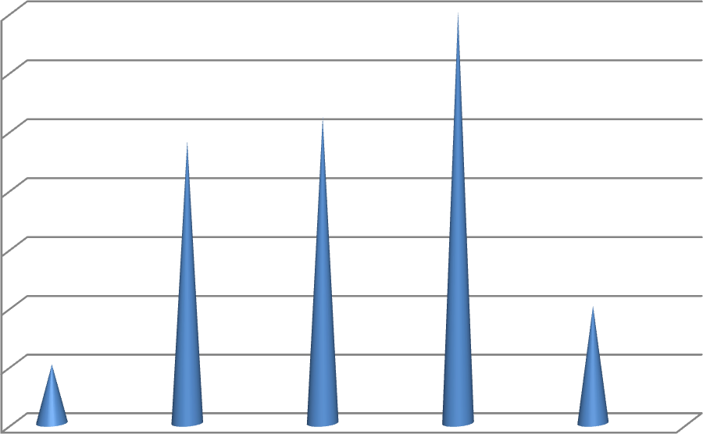
35%

30%

25%

20%

15%
Series 1
Series 2
Series 3
10%

5%

0%
Professional
self
Employed
serviecs
student
others

The above Figure 2, show the occupation of customers who were taken as samples for the sample study. By analysing the same we could conclude the following:-
- 5% of samples were professionals
- 24% of samples were self Employed
- 26% of samples were from services Sector
- 35% of samples were students
- 10% of samples were others

Figure 3
20
18
16
14
12
10
<200000
200000-500000
500000-1000000
1000000>
More than Once Once in 1-2
a month months
Once in 3-6
months
Once in 7-12
months

The above figure 3, line graph shows the frequency of visit by the number of customers who was taken as samples for the samples study with their monthly income. The following table will show us the frequency of visit of customers belonging to various income groups.

Frequency of visits | Monthly Income of the customers |  |  |  | Total Number of Frequency of visit
 | <200000 | 200000-  500000 | 500000-  1000000 | 1000000>
More than once a month | 11 | 3 | 3 | 3 | 20
Once in 1-2 months | 7 | 4 | 3 | 3 | 17
Once in 1-2 months | 18 | 12 | 5 | 5 | 40
Once in 7-  12 months | 6 | 9 | 5 | 3 | 23

Figure 4
Are you aware of Flipkart an e-commerce website ?

Yes No

From the above Figure 4, it can be analysed that:-
- 95% of the respondents are aware of Flipkart
- Only 5% do not know about it

Figure 5
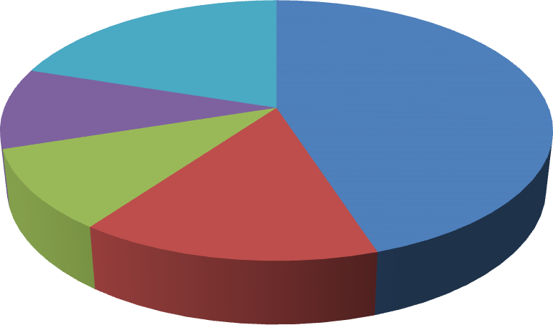
Which Online Shopping website do you
prefer ?

Flipkart Amazon Snapdeal other
I do not use e-commerce
websites

The above Figure 5, shows the analysis of consumer‟s choice of e-commerce website of which:-
- 45% respondents prefer Flipkart
- 15% respondents prefer Amazon
- 10% respondents prefer Snapdeal
- 10% respondents prefer others
- While 20% do not use e-commerce websites

Figure 6

Do you prefer online shopping ?

Yes No
From the above Figure 6, it can be concluded that
- 85% of the population prefer online shopping
- While remaining 15% do not prefer online shopping, they prefer retail shopping.

Figure 7
Do you consider online shopping safe ?

Yes
No
The above Figure 7, clearly shows that:-
- 90% of the respondents feel that shopping online is a safe affair
- While 10% among them are still conservative and avoid shopping online due to fear of quality and payment options.

Figure 8
First Experience with Flipkart
90%
80%
70%
60%
50%
40%
First Experience with Flipkart
30%
20%
10%
0%
Excilient
Good
Average
Bad

The above Figure 8, shows that:-

- 80% of the respondents show that they have excellent first time experience with flipkart
- While 15% said they have overall good experience.
- The remaining said that they have average and bad experience while shopping first time with flipkart.

Flipkart 9
Why do you prefer Flipkart over it's
competitors ?
60%

50%

40%

30%
why do you prefer
20%

10%

0%
Wide varitey Price Efficient Better service Better Quality

Above Figure 9, shows that when the respondents were asked that why they prefer shopping on flipkart over other shopping sites:-
- 50% said that Flipkart provided them better and prompt service
- While 30% among them said that they get wide variety of option on flipkart.
- Another 15% said that they get products in right price
- While remaining 5% said that they get better quality products.

Figure 10
Will you recoment Flipkart to your friends
and family ?

Yes No

Above figure 10, shows that:-
- 90% among the respondents will recommend their friends and family members to shop with flipkart.
- While 10% among them said that they will not.

Figure 11
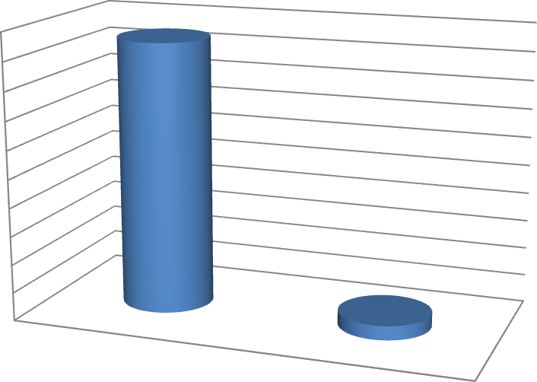
Any Drawbacks
100%
90%
80%
70%
60%
50%
40%
30%
20%
10%
0%
Any Drawbacks
Yes
No

Above Figure 11, shows that when they were asked to suggest any drawback:-

- 95% of the respondents said they feel no drawbacks in the functioning of Flipkart
- While 5% felt that there are still some drawbacks in Flipkart

Figure 12
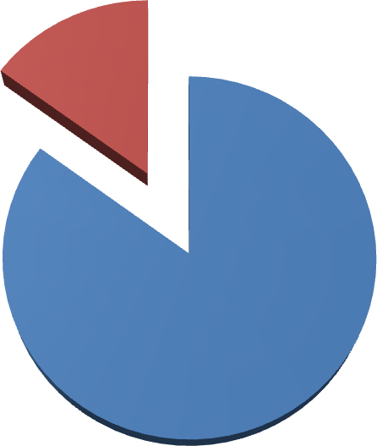
Sales

Yes No

The above Figure 12, show how many respondents are satisfied with Flipkart, out of which:-
- 85% are satisfied
- Remaining 15% are not

FINDINGS
- 90% of respondents feel safe in online shopping they have no fear and have started shopping online while still 10% are hesitant of shopping online they are the late majority type of customers who adopt the technology and advancement in later stage.
- 85% of respondents prefer online shopping as they get variety of products of good quality at one place while remaining respondents feel that they prefer shopping in stores in which they get opportunity to physically observe the products and then buy.
- Even though flipkart doesn‟t have a big list of competitions but there are stores which have grabbed attention of buyers namely jabong, eBay, Myntra, Amazon, Zovi.
- 80% of the respondents said that they have excellent first time experience with flipkart while 15% said they have overall good and remaining said that they have average experience while shopping first time with flipkart.
- More than majority of respondents had an amazing first experience with the site and prefer flipkart over its competitions due to the quick service, wide variety safety reasons, cash on delivery facility, low prices and most importantly being an Indian venture which as wide availability of products.
- Respondents are satisfied by the business model of flipkart it is a very systematic organisation.
- Flipkart is a very price efficient company because offers the products directly from the manufacture and eliminates the profit margin of the mediator‟s products at prices lower than the market price.
- The respondents are very satisfied with the homogeneous list and option flipkart offers to its customers.
- More than 50% of the consumers feel that products of by flipkart are of excellent quality, durable and worth the cost.
- Flipkart is a consumer friendly site and offers special offers sale services which include replacement of goods in 7 days.
- Flipkart offers warranty for its goods, depending on the type of product. Flipkart is very punctual in delivery their goods on time but a small percentage of respondents have faced problems regarding the timely delivery of goods. Similarly regarding the return policy a small percentage of the respondents have faced delays but the larger section of the respondents had a great experience regarding the regarding the returns policy of the goods.
- On a scale of 10, Flipkart users have rated its behaviour 6 points to 9.5 points depending on their personal experience.
- Flipkart users are not hesitant in recommending the site to any friends.
- 2% of customers had a bad experience with flipkart, regarding the timely delivery and the delay in return of goods, which is not a bad ratio and can be improved further.

RECOMMENDATIONS
- As still in India large segment of population is untapped regarding the online shopping the available online shopping stores can widen their market by getting into expansion strategies.
- There is also need to remove the fear in the minds the customers regarding the products quality, durability and payments etc. in online shopping.
- Wide expansion of internet facilities in rural area can bring the more customers for the online shopping sites.
- Through prompt service, wide variety and easy accessibility even consumers from the remote area can be tapped.
- As Indian consumers are much more cautious about shopping online as compared to the west. They are reluctant to divulge credit card details the cash on delivery service has will help a lot of traditional consumers turn to online shopping.
- India‟s e-commerce companies have far too often concentrated on the bells and whistles instead of focusing on deploying and customizing technology to serve customer needs, so their need more customer centric approach.
- Calling facility to make an order and change an order as well as, Urgent delivery with no extra cost service can add a cherry on the cake and would help flipkart to perform even better than its competitors.

CONCLUSION
Online shopping is the new mantra of this age and the people of India are applying this in their lives to a great extent nowadays. As we progress further, the growth rate of online marketing in our country will leap to the stars. According to a research report – state of e-commerce in India by Commerce for ASSOCHAM, “India‟s Internet base, is already the third highest in the world after china and US, is growing by nearly 40% every years”. Hence, the rise of online shopping in the Indian subcontinent has been meteoric in the recent year. The number of shopping websites has increased and so has the total number of persons who prefer shopping online.
At the end it can be said that Flipkart has become the fate of online business in India. The company is currently valued at around I billion dollars
i.e. 5000 crore. More importantly Flipkart has ushered in the e-commerce in India. This has generated massive interest in e-commerce sector, people are opening website to sell anything from shoes to apparels to jewels to baby care products etc. This has helped in creating a lot of job opportunities and thus helps the Indian Inc. growth story as well.

BIBLIOGRAPHY / REFERENCES
- Bagozzi, R.P. (1974) Marketing as an Organized Behavioral System of Exchange. Journal of Marketing, 38, 77-81.
- Bauer, R. A. (1960), "Consumer Behavior as Risk Taking", in R. S. Hancock (ed.), Dynamic Marketing for a Changing World, Proceedings of the 43rd Conference of the American Marketing Association, 389B400.
- Mitra, A. (2013), E-Commerce in India-A Review, International Journal of Marketing, Financial Services & Management Research
- Nigam, P., E- commerce challenges: a case study of Flipkart.com versus Amazon. in
- Sharma and Mittal (2009), Prospects of e-commerce in India
- www.Flipkart.com/about-us(Last accessed on 11-04-23)
- www.scribd.com/doc/172706499/Questioneries -Flipkart#scribd (Last accessed on 03-04-23)
- www.surveymokey.com/s/K2VVBZY(Last accessed on 23-04-23)
- www.sxccal.edu/msccs/ecommerce 1. pdf (Last accessed on 03-04-23)
- www.wikipedia.org/wiki/E-commerce(Last accessed on 23-04-23)

Respected Sir/Madam,

QUESTIONNAIRE

I am a student, pursuing B.com from the Bangabasi Morning college. I am doing project on “Rise of E-Commerce – The Indian Scenario” about the success story of flipkart and online shopping. I kindly request you to co-operate in my research study by kindly filling up the following questionnaire.
- Please tick the age group you belong to 16-24[ ] 25-35[ ] 35-49[ ] 50 or above [ ]
- Gender

Male [ ] Female [ ]

- Please tick your occupation Professional [ ]
Self Employed [ ] Service [ ] Student [ ] Others [ ]
- Please tick your income range

Less than Rs. 2 Lakhs per annum [ ] Rs. 2 to Rs. 5 lakhs per annum [ ] Rs. 5 to Rs. 10 lakhs per annum [ ]
More than 10 lakhs per annum [ ]
- Please tick your education as relevant Post graduate [ ]
Graduate [ ]

Higher secondary school certificate [ ] Higher School certificate [ ]
Less than 12 years in school [ ]

- How frequently do you shop through e-commerce websites More than once a month [ ]
Once in 1-2 Months [ ] Once in 3-6 Months [ ] Once in 7-12 Months [ ]
- Are you aware of Flipkart – an e-commerce website Yes [ ] No [ ]
- Which is your most preferred e-commerce website Flipkart [ ]
Amazon [ ] Snapdeal [ ] Other [ ]
I do not use e-commerce website [ ]

- How frequently have you used the ecommerce website for getting information before shopping at a physical store.
Always [ ] Most Often [ ] Often [ ]
Quite rarely [ ] Rarely [ ] Never [ ]
Product specification [ ]

Price comparison among products [ ]

- Tick all the product varieties that you generally prefer buying online Clothing [ ]
Personal products (perfumes, beauty cream, razors, toothbrush) [ ] Mobile/ Tablets [ ]

Laptops and accessories [ ] Cameras [ ]
Books [ ]

Digital products [ ]
- Do you prefer online shopping ? Yes [ ] No [ ]
- Do you consider online shopping is safe ? Yes [ ] No [ ]
- How was your first experience with Flipkart ? Excellent [ ]
Good [ ] Average [ ] Bad [ ]
- Why do you prefer Flipkart over its competitors? Wide variety [ ]
Price Efficient [ ] Better service [ ] Better Quality [ ]
- Will you recommend Flipkart to your friends and family members? Yes [ ]
No [ ]

- Are you satisfied with Flipkart? Yes [ ]
No [ ]

- Do you find any draw backs in Flipkart? Yes [ ]
No [ ]

