Project Report
(Submitted for the Degree of B. Com Honours in Accounting & Finance under the University of Calcutta)

“Working Capital Management"- A Case Study of CEAT Company Ltd.

Submitted by:
Name of Candidate: NISHA SHAW
Registration no: 144-1211-0808-20
Roll no: 201144-11-0092
College Roll No:
Name of College: BANGABASI MORNING COLLEGE

Supervised by:
Name of the Supervisor: Dr. Moumita Sarkar (Samanta)
Name of the College: BANGABASI MORNING COLLEGE

Month & Year Of Submission: May, 2023
Annexure-I

Supervisor's Certificate

This is to certify that Miss. NISHA SHAW a student of B.Com Honours in Accounting & Finance of BANGABASI MORNING COLLEGE under the University of Calcutta has worked under my supervision and guidance for his Project Work and prepared a Project Report with the title “Working Capital Management”- A Case Study of CEAT Company Ltd.

The Project Report, which he is submitted, is his genuine and original work to the best of my knowledge.

Place: Kolkata Signature:

Date: Name: Dr. MOUMITA SARKAR (SAMANTA) Designation: Assistant Professor

Name of the college: BANGABASI MORNING COLLEGE

Annexure-II

Student's Declaration

I hereby declare that the project work with the title, “Working Capital Management”- A Case Study of CEAT Company Ltd. submitted by me for the partial fulfillment of the degree of B. Com Honours in Accounting & Finance under the University of Calcutta is my Original work and has not been submitted earlier to any other University/institution for the fulfillment of the requirement for any course of study.

I also declare that no chapter if this manuscript in whole or in part has been incorporated in this report from any earlier work done by others of by me. However, extracts of any literature which has been used for this report has been duly acknowledged providing details of such literature in the references.

Place: Kolkata Signature:

Date: Name: NISHA SHAW
Address: 49/1 SN Banerjee road Kolkata, 700014
Reg. No: 144-1211-0808-20
Roll No: 201144-11-0092

Acknowledgement

It is a matter of great pleasure for me in submitting the project report on “Working Capital Management”- A Case Study of CEAT Company Ltd. for the fulfillment of the degree of B. Com Honours in Accounting & Finance under the University of Calcutta.

I am thankful to and owe a deep dept gratitude to all those who have helped me in preparing this report. Words seem to be inadequate to express my sincere thanks to our honorable principal Dr. AMITAVA DUTTA as well as our head of department honorable CMA MUSTAK AHMAD and finally my supervisor Dr. MOUMITA SARKAR (SAMANTA) for his valuable guidance, constructive criticism, untiring efforts and immense encouragement during the entire course of the study due to which my efforts have been rewarded.

I want to thank all who have supported me and gave their timely guidance. Last but not the least I am very grateful to all those who helped me in one-way or the other way at every stage of my work.

Name of the Student: NISHA SHAW
6th Semester B.Com(H⁾

TABLE OF CONTENT
SL. No. | Particulars | Page No.
1 | Introduction
 | 1.1 Background of Study | 6
 | 1.2 Literature review | 6-7
 | 1.3 Research Gap | 7
 | 1.4Objective of Study | 7-8
 | 1.5 Research Methodology | 8
 | 1.6 Limitations of Study | 8-9
 | 1.7 Chapter Planning | 9
2 | Conceptual Framework
 | 2.1 Concept | 10-11
 | 2.2 Company Profile | 11-12
 | 2.3 Industry Profile | 12-13
 | 2.4 National Scenario | 13-14
 | 2.5 International Scenario | 14
3 | Presentation & Analysis of Data
 | 3.1 Current Ratio | 15-16
 | 3.2 Quick/Liquid/Acid Test Ratio | 16-17
 | 3.3 Inventory Turnover Ratio | 17-19
 | 3.4 Debtors/Receivables Turnover Ratio | 19-20
 | 3.5 Creditors/Payables Turnover Ratio | 21-22
 | 3.6 Cash/Super Quick Ratio | 22-23
 | 3.7 Working Capital Turnover Ratio | 23-24
4 | Findings & Conclusion | 25-27
 | BIBLIOGRAPHY | 28
 | Annexure-1 | 29-30
 | Annexure-2 | 31-32

CHAPTER 1: INTRODUCTION

1.1 Background of Study

In this project we have studies the performance of Working Capital Management of CEAT Company Ltd. We find that performance of Working Capital may be measured from two view point, such as- (i) Measurement of efficiency of overall management and (ii) Measurement of efficiency of management of each component of working capital.
For that, we have prepared different ratios and analysis them to check how efficiently working capital has been used in the business.

1.2 Literature review

Working capital management plays an important role in financial management of the industry. Numbers of researcher has been done the research on different components of working capital and subjects on. Here, I have included the relevant articles as well research work on the same topic. And this is a part of my research work on the same title the working capital management of selected tyre companies of India. The main aim of this paper is to identify the gaps in current body of my research work which gives the direction towards forward attention to be given.

(a)NCEAR (1966):-

The National Council of applied Economic Research (NCEAR) in 1966 first time formal study was conducted on working capital management in India. The council published a structure of working capital" which was limited analysis of the creation of working capital with special attention to the fertilizers, and cement and sugar industries the main objective of this study was emphasized on come out with findings that working capital management practices were extremely unplanned and hence need to develop proper accounting policies like inventory management, debtors management as above. And the study suggested developing suitable working capital policies required in the success of business.

(b)Kushwah, Mathur&Ball(2009):-

The study undergone to evaluate the working capital management and direction in selected five major cement companies i.e. ACC, Grasim, Ambuja, Prism and Ultra- Tech.. For the research purpose secondary data are used like authors collected the financial statement of selected cements companies for the years from 2007 to 2009. There is liquidity ratios and activities ratios are used to analyse the condition of working capital of the companies. The study revealed the truth of study is that, most companies not maintain their working capital in a systematic way while overall ACC shows appropriate management of working capital.

(c)Madhavi K. (2014):-

She has done research based on empirical study of co relation among liquidity position an profitability of the paper mills in Andhra Pradesh. That has been evaluated ineffective working capital negatively effect on profitability of the paper mills.

1.3 Research Gap

From the above it is seen that previously no one has reviewed on this topic “Working Capital
Management” of my selected company “CEAT Company Ltd.” since last five years(March 2017 to March 2021).
So, I have choose this above mentioned topic and Company with last five years data to done my project work.

1.4 Objective of Study
The researcher has prepared this project to analyse some positions of the company, so the purposes are-
- To study the changes in the different components in the working capital of the company over the study period.
- To analyse the liquidity position of the company.
- To study the activity ratios in order to analyse the movement of stock, pattern of collection from debtors & the pattern of payment to the creditors.

1.5 Research Methodology

Nature of the study- It is an empirical study.

- Sample- We have used CEAT Company for this analysis and we use last 5 years data(i.e. from March 2017 to March 2021).

- Data source- It is secondary data based analysis.

- Tools used- The different tools used for analysis are tables charts & diagrams.
1.6Limitations of Study

Following limitations were faced during preparing this project-

- Limited Data- This project depends on only secondary data. Due to lack of time it is impossible to collect the primary data.
- Limited Period- This project is based on five year annual reports. Conclusions are based on such limited data.

- Cost Involved- Due to cost involved is carrying out a project we could not carry out intensive analysis as well as collection for data this might restrict our study to same extent.

1.7 Chapter Planning

This project report has been divided in four logical parts-

- Chapter 1: Introduction
This chapter includes Background of Study, Literature review, Research gap, Objective of Study, Research Methodology, Limitations of Study, Chapter Planning.

- Chapter 2: Conceptual Framework
This chapter includes Concept, Company Profile, Industry Profile, National Scenario, International Scenario.

- Chapter 3: Presentation & Analysis of Data
This chapter shows the analysis of financial data using the following ratios
Current Ratio, Quick/Liquid/Acid Test Ratio, Inventory Turnover Ratio, Debtors/Receivables Turnover Ratio, Creditors/Payables Turnover Ratio, Cash/Super Quick Ratio, Working Capital Turnover Ratio.

- Chapter 4: Findings & Conclusion
This chapter is divide into two parts. The first part shows the findings of the study & the second part shows the concluding portion of the study.

CHAPTER 2: CONCEPTUALFRAMEWORK

2.1 Concept

- What is Working Capital?

  - Working capital, also known as net working capital (NWC), is the difference between a company’s current assets, such as cash, accounts receivable (customers’ unpaid bills), and inventories of raw materials and finished goods, and its current liabilities, such as accounts payable. NWC is a measure of a company's liquidity and refers to the difference between operating current assets and operating current liabilities. In many cases, these calculations are the same and are derived from company cash plus accounts receivable plus inventories, less accounts payable, and less accrued expenses.
- What is Working Capital Management?

  - Working capital management is a business tool that helps companies effectively make use of current assets, helping companies to maintain sufficient cash flow to meet short term goals and obligations. By effectively managing working capital, companies can free up cash that would otherwise be trapped on their balance sheets. As a result, they may be able to reduce the need for external borrowing, expand their businesses, fund mergers or acquisitions, or invest in R&D.
- Objectives of Working Capital Management :-

  - To review the working capital continuously to maintain uninterrupted flow of production and sales.
  - To review current assets or current liabilities regularly in order to verify whether the liquidity position of the firm is at optimum level or not.
  - To forecast working capital for new project.
  - To forecast additional working capital for satisfying the increased demand.
  - To maintain proper control on inventories, trade receivables and cash balance.

- Importance of Working Capital Management :-

  - Helps in maintaining optimum level of working capital.
  - Helps in maintaining optimum level of liquidity.
  - Helps in proper management of current assets.
  - Co-ordination between fixed capital and working capital.

2.2 Company Profile

CEAT Limited (formerly, Cavi Elettrici e Affini Torino) is an Indian multinational tyre manufacturing company owned by the RPG Group. It was established in 1924 in Turin, Italy. As of date, CEAT is one of India's leading tyre manufacturers and has a presence in global markets. CEAT produces over 165 million tyres a year and manufactures tyres for passenger cars, twowheelers, trucks and buses, light commercial vehicles, earth-movers, forklifts, tractors, trailers, and auto-rickshaws. The current capacity of CEAT tyres' plants is over 800 tonnes per day.

▪ History
The Company was founded as Cavi Elettrici e Affini Torino (Electrical Cables and Allied Products of Turin) by Virginio Bruni Tedeschi in 1924, in Turin, Italy. On 10 March 1958, the company was incorporated as CEAT Tyres of India, in Mumbai. Initially, the company collaborated with the Tata Group. In1972, the company set up a research and development unit at Bhandup. In 1981, Deccan Fibre Glass Limited was merged with the company. In 1982, RPG Group acquired the company, and in 1990, the company was renamed as CEAT. In 1993, the company collaborated with Yokohama Rubber Company, to manufacture radial tyres at their Nashik unit. In 1999, CEAT formed a joint venture, named as CEAT Kelani, with Asia Motor Works (AMW) and Kelani Tyres, to manufacture and market CEAT tyres inSri Lanka. in 2006, CEAT Kelani commissioned their first SriLanka-based radial-tyre manufacturing unit in Kalutara.[13] In2009, AMW exited the joint-venture.

▪ Products
CEAT manufactures tyres for various types of vehicles like heavy commercial vehicle, light commercial vehicle, off-highway tryes, passenger cars, tractors, motorcycles and scooters, cycles and SUVs. It exports to countries across the Africa, Americas, Australia, and Asia.

2.3Industry Profile

The Indian Tyre Industry is an integral part of the Auto Sector – It contributes to ~3% of the manufacturing GDP of India and ~0.5% of the total GDP directly. So, let’s understand the dynamics of the Tyre Industry in India.

Indian tyre industry has almost doubled from ~Rs 30,000 crores in 2010-11 to ~Rs 59,500 crores in 2017-18 of which 90-95% came from the domestic markets. The top three companies – MRF, Apollo Tyres and JK Tyres have ~60% of the market share in terms of revenue. In terms of segmentation tyres can be divided in two ways – based on end market and based on product.

Based On End Market
Replacement, OEMs & Exports

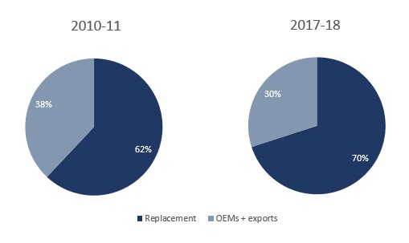

Indian tyre market is clearly skewed towards the replacement segment which contributes ~70% of total revenues. Whereas in volume (tonnage) terms the replacement segment contributes ~60% indicating realizations in the after-market are clearly higher than OEMs (Original Equipment Manufacturer) market.
Based On Products
Truck & Bus (T&B), Passenger Vehicle (PV), 2/3-Wheeler, Off-Highway Tyres (OHT) & Others

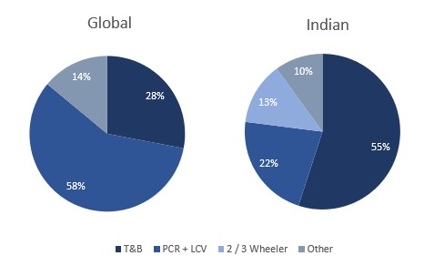

T&B tyres in India generates the major revenue i.e. 55% of total revenue whereas globally it’s the PCR (Passenger Car Radials) contribute the largest portion of the revenue. This is mainly because of very low penetration of passenger vehicles in India – below 20 per 1,000 people whereas in China the number is ~69 per 1,000 people and 786 per 1,000 people in US. In terms of volume (tonnage) T&B contributes around ~50% of the total volume.
The demand from OEM’s is widely spread across the segment where T&B contributed ~35% and PVs & 2/3 Wheeler’s contributed ~25% & ~22% respectively. In term of the replacement segment the demand was more skewed towards the T&B tyres which contributed ~61% and PVs & 2/3 Wheeler’s contributed ~14% & ~9% respectively.

2.4 National Scenario

CEAT is one of the most respected and widely renowned brands in the Indian tyre market. In
FY 20, it reported a consolidated net revenue from operations of Rs. 6,77,883 Lacs, degrowth by 2.94% Y-o-Y. Revenue contribution from 2-Wheeler, Passenger Vehicles and OffHighway tyre has increased significantly over the years, from 20% in FY 10 to 52% in FY 20. The Government announced allocation of Rs. 1,70,000 Crores for investments in transportation infrastructure in FY 21. This move is expected to improve road network, eventually benefitting automobile manufacturers and tyre suppliers.

Indian Tyre Demand is expected to grow by 6-8% between FY 20 and FY 24. On the volume growth front, the tyre industry is expected to witness a CAGR of 4.8% between 2020 and 2025, to attain the level of 245 Million units in 2025. One of the factors backing this growth would be the countervailing duty imposed in June 2019 on the import of new pneumatic radial tyres above 16 inches from China, for a period of five years.

2.5 International Scenario

CEAT is one of the major exporters among Indias’ tyre manufacturers with sales to 100+ countries worldwide.The revenues from exports have increased steadily over the past few years. CEAT has a stratified export market divided in seven clusters. This identification of clusters has helped CEAT better understand customer requirements and accordingly invest in R&D to developmarket - specific products. CEAT continues to consolidate its position in Bangladesh and Sri Lanka through Joint Ventures (JVs) with strategic partners. CEATs core focus areas and growth drivers are the Two-wheeler, Passenger Car Radial and TBR tyre segments. CEAT continues to focus on European markets to expand its footprint.
Currency fluctuation destabilising International business existing markets in FY 20, CEAT has entered the markets of Australia, UK, Belgium, Brazil, Chile and Nicaragua with its passenger car products. CEAT has also entered the US market with the products in Truck Radial segment. CEAT launched its 2-Wheeler products in Nigeria which is the worlds largest consumption market for 2-Wheeler.
CEATs product series in the Passenger Car, Winter, Summer, All-Season, Ultra High Performance (UHP) and Van categories launched in Europe have met the stringent performance requirements of European markets. CEAT is well-placed to maximise available opportunities to become one of the leading players in the global market with its high-range of premium products.

CHAPTER 3:PRESENTATION& ANALYSIS OF DATA

3.1 Current Ratio

The current ratio is a liquidity ratio that measures a company's ability to pay short-term obligations or those due within one year. It tells investors and analysts how a company can maximize the current assets on its balance sheet to satisfy its current debt and other payables.

❖ Formula of Current Ratio:-
Total Current Assets
Current Ratio =
Total Current Liabilities

- Total Current Assest= (Current Investments + Inventories + Trade Receivables + Cash & Cash Equivalent + Short Term Loans And Advances + Other Current Assets)

- Total Current Liabilities= (Short Term Borrowings + Trade Payables + Other Current Liabilities + Short Term Provisions)
Year | Mar’2017 | Mar’2018 | Mar’2019 | Mar’2020 | Mar’2021
Current Assets(Rs. in crore) (A) | 1823.57 | 1748.08 | 1964.68 | 1795.42 | 2184.08
Current Liabilities(Rs. in crore) (B) | 1337.61 | 1736.51 | 2058.95 | 2151.86 | 3009.13
Current Ratio (A/B=C) | 1.36 | 1.01 | 0.95 | 0.83 | 0.73
Source: Annual Reports of CEAT Co.
Current Ratio
Mar'17
Mar'18
Mar'19
Mar'20
Mar'21

Interpretation:-
Current Ratio indicates Company’s ability to payment short term liability. The Standard Current
Ratio is 2:1. On the basis of company’s current ratio from March 2017 to 2021, we see it does not satisfy the ideal ratio (2:1). We also see it continuously decreasing from 2018 – 2021 compared to 2017. It indicates company is unable to pay its short-term liability & day to day expenses in future.

3.2Quick/Liquid /Acid-Test Ratio

The quick ratio also known as liquid ratio is an indicator of a company’s shortterm liquidity position and measures a company’s ability to meet its short-term obligations with its most liquid assets. Since it indicates the company’s ability to instantly use its near-cash assets (assets that can be converted quickly to cash) to pay down its current liabilities, it is also called the acid test ratio. An "acid test" is a slang term for a quick test designed to produce instant results. The ideal Quick ratio is 1:1.

❖ Formula of Quick Ratio:-
Quick Assets
Quick Ratio =
Quick Liabilities

• Quick Assets= Total Current Assets – Inventories – Prepaid Expenses • Quick Liabilities= Total Current Liabilities – Bank Overdraft

Year | Mar'2017 | Mar'2018 | Mar'2019 | Mar'2020 | Mar'2021
Currrent Assets(Rs. in crore) (A) | 1823.57 | 1748.08 | 1964.68 | 1795.42 | 2184.08
Inventories(Rs. in crore) (B) | 923.44 | 754.96 | 965.15 | 879.5 | 1112.5
Prepaid Expenses(Rs. in crore) (C) | 0 | 0 | 0 | 0 | 0
Quick Assets(Rs. in crore) (A-B-C=D) | 900.13 | 993.12 | 999.53 | 915.92 | 1071.58
Current Liabilities(Rs. in crore) (E) | 1337.61 | 1736.51 | 2058.95 | 2151.86 | 3009.13
Bank Overdraft(Rs. in crore) (F) | 0 | 0 | 0 | 0 | 0
Quick Liabilities(Rs. in crore) (E-F=G) | 1337.61 | 1736.51 | 2058.95 | 2151.86 | 3009.13
Liquid Ratio (D/G=H) | 0.67 | 0.57 | 0.49 | 0.43 | 0.36
Source: Annual Reports of CEAT Co.
Quick/Liquid Ratio
Mar'2017
Mar'2018
Mar'2019
Mar'2020
Mar'2021

Interpretation:-

Quick ratio indicates company’s ability to pay immediate short term due & capacity for day to day expenses. Here we see that on the basis of company’s quick ratio from March 2017 to March
2021, it does not satisfy the ideal ratio (1:1). We also see it continuously decreasing from 2018 – 2021 compared to 2017. It indicates company is unable to pay its short term liability & day to day expenses in future.

3.3 Inventory Turnover Ratio
Inventory turnover is the rate at which a company replaces inventory in a given period due to sales. Calculating inventory turnover helps businesses make better pricing, manufacturing, marketing, and purchasing decisions. Well-managed inventory levels show that a company's sales are at the desired level, and costs are controlled. The inventory turnover ratio is a measure of how well a company generates sales from its inventory.
❖ Formula of Inventory Turnover Ratio:-
Cost of Goods Sold
Inventory Turnover Ratio =
Average Inventory
- Cost of Goods Sold= Revenue From Operations (Net) – Gross Profit
- Gross Profit= Revenue From Operations (Net) – Cost of Materials Consumed – Purchase of Stock-In-Trade – Changes In Inventories of FG, WIP and Stock-In- Trade.

- Average Inventory = Opening Inventory+Closing Inventory 2
 | Year | Mar'2017 | Mar'2018 | Mar'2019 | Mar'2020 | Mar'2021
Rs. in crore | Revenue From Operations (Net) (A) | 5658.25 | 6075.37 | 6800.06 | 6518.57 | 7572.79
 | Cost Of Materials Consumed (B) | 3308.88 | 3650.33 | 4273.64 | 3815.97 | 4173.76
 | Purchase Of Stock-In Trade (C) | 142.55 | 59.88 | 60.92 | 21.2 | 10.09
 | Changes In Inventories Of FG,WIP And Stock-In  Trade (D) | -76.15 | 93.32 | -194.25 | 14.58 | 67.43
 | Gross Profit (A-B-C-D=E) | 2282.97 | 2271.84 | 2659.75 | 2666.82 | 3321.51
 | Cost Of Goods Sold (A-E=F) | 3375.28 | 3803.53 | 4140.31 | 3851.75 | 4251.28
 | Opening Inventory (G) | 619.25 | 923.44 | 754.96 | 965.15 | 879.5
 | Closing Inventory (H) | 923.44 | 754.96 | 965.15 | 879.5 | 1112.5
 | Average Inventory (G+H/2=I) | 771.345 | 839.2 | 860.055 | 922.325 | 996
 | Inventory Turnover Ratio (Times) (F/I=J) | 4.38 | 4.53 | 4.81 | 4.18 | 4.27

Inventory Turnover Ratio
Mar'2017
Mar'2018
Mar'2019
Mar'2020
Mar'2021

Source: Annual Reports of CEAT Co.

Interpretation:-
Inventory turnover ratio indicates inventory holding period. It also indicate efficiency in inventory management. If inventory turnover ratio is high, it means inventory holding period is very low which is good for a company and vice versa. Here we see that the Inventory Turnover Ratio of the company is an increasing trend from the year March 2017 to March 2019. But in the year March 2020 there is a decreasing trend and finally in the year March 2021 there is an increasing trend.
It indicates company’s movement of the stock is quite satisfying.

3.4 Debtors/Receivables Turnover Ratio:-
The debtors turnover ratio also known as receivables turnover ratio is an accounting measure used to quantify a company's effectiveness in collecting its accounts receivable, or the money owed by customers or clients. This ratio measures how well a company uses and manages the credit it extends to customers and how quickly that short-term debt is collected or is paid. A firm that is efficient at collecting on its payments due will have a higher accounts receivable turnover ratio. It is useful to compare a firm's ratio with that of its peers in the same industry to gauge whether it is on par with its competitors. A high debtors turnover ratio may indicate an improvement in business conditions, a tightening of credit policies, or improved collection procedures. A low ratio may be an indication of long credit period or slow realisation from debtors.

❖ Formula of Debtors/Receivables Turnover Ratio:-
Net Credit Sales
Debtors/Receivables Turnover Ratio =
Average Trade Receivables
- It is assume that all sales are made on credit basis.

- Average Trade Receivables = Opening Trade Receivables+Closing Trade Receivables
2

 | Year | Mar'2017 | Mar'2018 | Mar'2019 | Mar'2020 | Mar'2021
Rs. in cro  re | Revenue From Operations (Net) (A) | 5658.25 | 6075.37 | 6800.06 | 6518.57 | 7572.79
 | Opening Trade Receivables (B) | 577.94 | 592.05 | 712.15 | 726.46 | 704.66
 | Closing Trade Receivables (C) | 592.05 | 712.15 | 726.46 | 704.66 | 922.26
 | Average Trade Receivables (B+C/2=D) | 585.00 | 652.10 | 719.31 | 715.56 | 813.46
 | Debtors/Receivables Turnover Ratio (Times) (A/D=E) | 9.67 | 9.32 | 9.45 | 9.11 | 9.31
Source: Annual Reports of CEAT Co.
Debtors/Receivables Turnover Ratio
Mar'2017
Mar'2018
Mar'2019
Mar'2020
Mar'2021

Interpretation:-
Debtors Turnover Ratio indicates the number of times per year that the average balance of debtors are collected. Here we see that the Debtors/Receivables Turnover Ratio of the company is a decreasing trend in the year March 2018 compared to the year March 2017 and after that a very low increasing trend in the year March 2019 compared to the year March 2018 and again it decreased in the next year and finally it again increasing trend it the year March 2021 compared to the year March 2020.It indicates company’s collection period from debtors are quite satisfying.

3.5 Creditors/Payables Turnover Ratio:-
The Creditors Turnover Ratio also known as accounts payable turnover ratio is a short-term liquidity measure used to quantify the rate at which a company pays off its suppliers. Accounts payable turnover shows how many times a company pays off its accounts payable during a period. Accounts payable are short-term debt that a company owes to its suppliers and creditors. The accounts payable turnover ratio shows how efficient a company is at paying its suppliers and short-term debts. A high creditors turnover ratio may indicate strict credit terms granted by the suppliers. A low ratio may be an indication of liberal credit terms granted by the suppliers.

❖ Formula of Creditors/Payables Turnover Ratio:-
Net Credit Purchase
Creditors/Payables Turnover Ratio =
AverageTradePayables
• It is assume that all purchase are made on credit basis.

Opening Trade Payables + Closing Trade Payables
Average Trade Payables =
2
 | Year | Mar'2017 | Mar'2018 | Mar'2019 | Mar'2020 | Mar'2021
R  s. in crore | Purchase Of Stock-In-Trade (A) | 142.55 | 59.88 | 60.92 | 21.2 | 10.09
 | Opening Trade Payables (B) | 630.04 | 749.58 | 848.54 | 1033.93 | 1171.37
 | Closing Trade Payables (C) | 749.58 | 848.54 | 1033.93 | 1171.37 | 1943.6
 | Average Trade Payables (B+C/2=D) | 689.81 | 799.06 | 941.24 | 1102.65 | 1557.49
 | Creditors/Payables Turnover Ratio(Times) (A/D=E) | 0.21 | 0.07 | 0.06 | 0.02 | 0.01
Source: Annual Reports of CEAT Co.
21

Creditors/Payables Turnover Ratio
Mar'2017
Mar'2018
Mar'2019
Mar'2020
Mar'2021

Interpretation:-
This ratio indicates the number of times per year that the average balance of creditors are paid. Here we see that the Creditors Turnover ratio of five consecutive year is very low (i.e., below 1). Not only that we also see that it continuously decreasing trend in every year. As the ratio is very low, so it is clear that liberal credit terms granted by the suppliers to the company.

3.6Cash/Super Quick Ratio:-

The cash ratio also known as Super Quick Ratio is a measurement of a company's liquidity, specifically the ratio of a company's total cash and cash equivalents to its current liabilities. The metric calculates a company's ability to repay its short-term debt with cash or near-cash resources, such as easily marketable securities. This information is useful to creditors when they decide how much money, if any, they would be willing to loan a company. The cash ratio is almost like an indicator of a firm’s value under the worst-case scenario—say, where the company is about to go out of business. It tells creditors and analysts the value of current assets that could quickly be turned into cash, and what percentage of the company’s current liabilities these cash and near-cash assets could cover.

❖ Formula of Cash/Super Quick Ratio:-

Cash & 𝐶𝑎𝑠ℎ 𝐸𝑞𝑢𝑖𝑣𝑎𝑙𝑒𝑛𝑡 + 𝑀𝑎𝑟𝑘𝑒𝑡𝑎𝑏𝑙𝑒 𝑆𝑒𝑐𝑢𝑟𝑖𝑡𝑖𝑒𝑠
Cash/Super Quick Ratio =
Current Liabilities

 | Year | Mar'2017 | Mar'2018 | Mar'2019 | Mar'2020 | Mar'2021
Rs. in crore | Cash & Cash Equivalent (A) | 17.47 | 73.01 | 59.74 | 26.59 | 25.51
 | Marketable Securities (B) | 0 | 0 | 0 | 0 | 0
 | Current Liabilities (C) | 1337.61 | 1736.51 | 2058.95 | 2151.86 | 3009.13
 | Cash/Super Quick Ratio (A+B/C=D) | 0.01 | 0.04 | 0.03 | 0.01 | 0.01

Source: Annual Reports of CEAT Co.
Cash/Super Quick Ratio
Mar'2017
Mar'2018
Mar'2019
Mar'2020
Mar'2021

Interpretation:-
Higher the super quick/cash ratio better the liquidity condition of a business. In the above case for every 1 unit of current liability, the company has on an average only 0.02 units of super quick assets, which is very bad for the company.

3.7 Working Capital Turnover Ratio:-
Working capital turnover is a ratio that measures how efficiently a company is using its working capital to support sales and growth. Also known as net sales to working capital, working capital turnover measures the relationship between the funds used to finance a company's operations and the revenues a company generates to continue operations and turn a profit.
A high turnover ratio shows that management is being very efficient in using a company’s shortterm assets and liabilities for supporting sales. In other words, it is generating a higher dollar amount of sales for every dollar of working capital used.
In contrast, a low ratio may indicate that a business is investing in too many accounts receivable and inventory to support its sales, which could lead to an excessive amount of bad debts or obsolete inventory.

❖ Formula of Working Capital Turnover Ratio:-
𝑁𝑒𝑡 𝑅𝑒𝑣𝑒𝑛𝑢𝑒 𝐹𝑟𝑜𝑚 𝑂𝑝𝑒𝑟𝑎𝑡𝑖𝑜𝑛𝑠
Working Capital Turnover Ratio =
Working capital
- Net Revenue From Operations= Gross Revenue From Operations – Excise/Service Tax/Other Levies
- Working Capital= Total Current Assets – Total Current Liabilities
 | Year | Mar'2017 | Mar'2018 | Mar'2019 | Mar'2020 | Mar'2021
Rs. in crore | Net Revenue From Operations (A) | 5658.25 | 6075.37 | 6800.06 | 6518.57 | 7572.79
 | Total Current Assets (B) | 1823.57 | 1748.08 | 1964.68 | 1795.42 | 2184.08
 | Total Current Liabilities (C) | 1337.61 | 1736.51 | 2058.95 | 2151.86 | 3009.13
 | Working Capital (B-C=D) | 485.96 | 11.57 | -94.27 | -356.44 | -825.05
 | Working Capital Turnover Ratio (A/D=E) | 11.64 | 525.10 | -72.13 | -18.29 | -9.18
Source: Annual Reports of CEAT Co.
Working Capital Turnover Ratio
Mar'2017
Mar'2018
Mar'2019
Mar'2020
Mar'2021

Interpretation:-
From the above we can see that the amount of sales gradually increases except in the year March 2020. But the Working Capital of the company was decreasing in a high rate and it goes to negative. We also see that the working capital turnover ratio increasing trend in the year March 2018 compared to the year March 2017 and after that there is a huge decreasing trend and it goes to a negative ratio in the year March 2019 compared to the year March 2018 but in the next two years(i.e., March 2020 & March 2021) it increases but the ratio is negative.
24

CHAPTER 4: FINDINGS & CONCLUSION

4.1 Findings:-

Working Capital is the life line of every Industry, irrespective of whether it’s a manufacturing industry or service industry. Working Capital is the prime and most important requirement for carrying out the day operations of the business. Working capital gives the much needed liquidity to the business. Working Capital finance reduces the overall fund requirement, required to build up the current assets, which in turn help you improve your turnover ratio.
In this project we have studied “Working Capital Management”- A Case Study of CEAT Company Ltd.

The major findings of the study are:-
- The ideal current ratio is 2:1. But the ratio are much below than the ideal ratio of 2:1. Even the ratio are less than one from the year March 2019 to the year March 2021. This is a negative side of the company. So we can say that the company does not have the required ability to meet its’ short-term obligation.
- The ideal quick ratio is 1:1. We find the ratio are less than one in all year. Not only that it is gradually decreasing in trend. But the higher quick ratio is much below than the ideal ratio of 1:1 understudy. So, we can surely say that the company is not able to meet its short-term liabilities or obligations.

- The inventory turnover ratio, which shows a quite good performance for the company. From the Inventory Turnover Ratio we can see that the inventory are replaced on an average 83 days interval. We can surely say that the companies having good inventories turnover ratio understudy.

- The debtor’s turnover ratio is used for efficiency of the company. A high debtors turnover ratio is good for any company. Here we can see that the Debtors Turnover ratio is much greater than 9. It indicates the company that the average collection period from the debtors is 40 days approx.

- The creditors’s turnover ratio is also used for efficiency of the company. A high creditors turnover ratio is good for any company. Here we can see that the Creditors Turnover ratio is below 1. Not only that it is gradually decreasing in trend, which is very bad for the company.

- Here we can see that the company's cash ratio is less than 1, it means there are more current liabilities than cash and cash equivalents. It means insufficient cash on hand exists to pay off short-term debt. This may not be bad news if the company has conditions that skew its balance sheets, such as lengthier-than-normal credit terms with its suppliers, efficiently-managed inventory, and very little credit extended to its customers.
- A high working capital turnover ratio shows that management is being very efficient in using a company’s short-term assets and liabilities for supporting sales. In other words, it is generating a higher dollar amount of sales for every dollar of working capital used. In contrast, a low ratio may indicate that a business is investing in too many accounts receivable and inventory to support its sales, which could lead to an excessive amount of bad debts or obsolete inventory. From the study here we can see that this ratio is in much good position for the first year (i.e., March 2017) and in very good position in the next year (i.e., March 2018) and rest years in a very bad position.

4.2 Conclusion:-
In this project “Working Capital Management”- A Case Study of CEAT Company Ltd., which is one of the most important aspects of any organization, as it deals in managing the entire current assets and current liabilities. After analyzing the financial statement and having a indepth study of various ratio of the company we conclude that the management of capital requires an evaluation of cost and benefits associated with each elements. CEAT maintains sound position of working capital its efficiency in receivable when we considered the company’s current ratio, quick ratio, debtor’s turnover ratio, creditor’s turnover ratio, cash ratio, inventory turnover ratio, working capital turnover ratio, they are not showing good situation of the company but the company make profile rigorously and they make profile by using their working capital in a tricky way, but this procedure are not followed by all kind of company. The company has primarily be non cash drawn from the market and reaping full benefits of its brand name. The company makes full utilization of its fund before making payments to outsiders. We know that the CEAT company is a biggest company and they have a very well goodwill, also we know that this company is day by day increasing all over the world. So finally, we can easily conclude that working capital management has a great effect on the profitability of the company and the managers create value for the shareholders by decreasing receivables accounts and inventory and the managers must look for the method that by means of the correct management be effective on the profitability of the companies.

BIBLIOGRAPHY

- Books
- Bhadra & Satpati, Financial Management, Kolkata, Dishari Prakashani, 2020
- Mukherjee, S. & Chandra, P., Financial Management, Kolkata, B.B.Kundu Grandsons, 2021
- Kar, S. & Bagchi, N., Financial Management, Kolkata, Dey Book Concern, 2021
- Khan, M. Y. & Jain, P.K., Financial Management, Delhi, McGraw-Hill Education (India) Pvt, 2005
- Kishore, R. M., Financial Management, Delhi, Taxmann’s, 2020
- Majumder, D., Ali, R. & Nesha, L., Financial Management, Kolkata, ABS Publishing House, 2020

- Journals
      - Kushwah Garima Mathur Shivani Bali.S, (2009) “Working Capital Management: A study on Cement sector”, (Journal of Indian Management, Vol 14 – No.4).
- Niranjana Devi.K.(Oct 2010) “Working Capital Management in Indian Corporate Sector: A Study on Policies, Structure and Efficiency”
- Sur,Debasish, (1997), “Working Capital Management in Colgate Palmolive (India) Ltd. – A Case study”’ The Management Accountant, November 1997, pp. 828 – 833.
- Sidharth.M.R., and Das.G., (March 1994), “Working capital Turnover in Pharmaceutical companies”, The Management accountant, pp 151 – 153

▪ Website:
- www.moneycontrol.com ( Last accessed on 3-04-2023)
- www.investopedia.com ( Last accessed on 3-04-2023)
- https://www.ceat.com/ ( Last accessed on 3-04-2023)

Annexure
CEAT 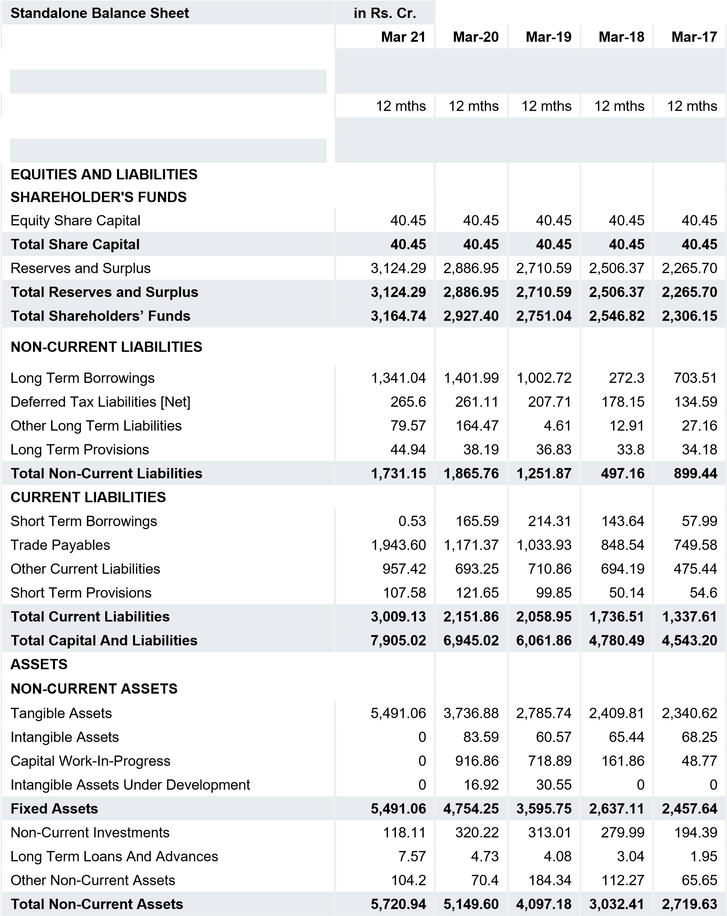
CURRENT ASSETS  Current Investments  Inventories | 0
 |  | 0  879.5 | 0  965.15 | 40.06  754.96 | 64.27  923.44
 | 1,112.50
Trade Receivables | 922.26 | 704.66 | 726.46 | 712.15 | 592.05
Cash And Cash Equivalents | 25.51 | 26.59 | 59.74 | 73.01 | 17.47
Short Term Loans And Advances | 0 | 50.32 | 58 | 49.02 | 50.02
OtherCurrentAssets | 123.81 | 134.35 | 155.33 | 118.88 | 176.32
Total Current Assets | 2,184.08 | 1,795.42 | 1,964.68 | 1,748.08 | 1,823.57
Total Assets | 7,905.02 | 6,945.02 | 6,061.86 | 4,780.49 | 4,543.20
OTHER ADDITIONAL INFORMATION  CONTINGENT LIABILITIES, COMMITMENTS |  | 1,118.98  1,797.45  - | 1,738.22  2,009.43  - | 1,459.67  1,385.56  - | 555.2  1,442.52  -
Contingent Liabilities | 0
CIF VALUE OF IMPORTS
EXPENDITURE IN FOREIGN EXCHANGE
Expenditure In Foreign Currency | 0
REMITTANCES IN FOREIGN CURRENCIES FOR DIVIDENDS
Dividend Remittance In Foreign Currency  EARNINGS IN FOREIGN EXCHANGE  FOB Value Of Goods  Other Earnings | -  -
 |  | 872.4  -  4.04  -  320.22  -  - | 847.09  -  4.04  -  313.01  -  - | 760.9  -  4.04  -  279.99  40.06  - | 775.89  -  4.04  -  194.39  64.27  -
 | -
BONUS DETAILS
Bonus Equity Share Capital | -
NON-CURRENT INVESTMENTS
Non-Current Investments Quoted Market Value  Non-Current Investments Unquoted Book Value | -
 | -
CURRENT INVESTMENTS
Current Investments Quoted Market Value  Current Investments Unquoted Book Value | -
 | -

Source : Dion Global Solutions Limited

Annexure
CEAT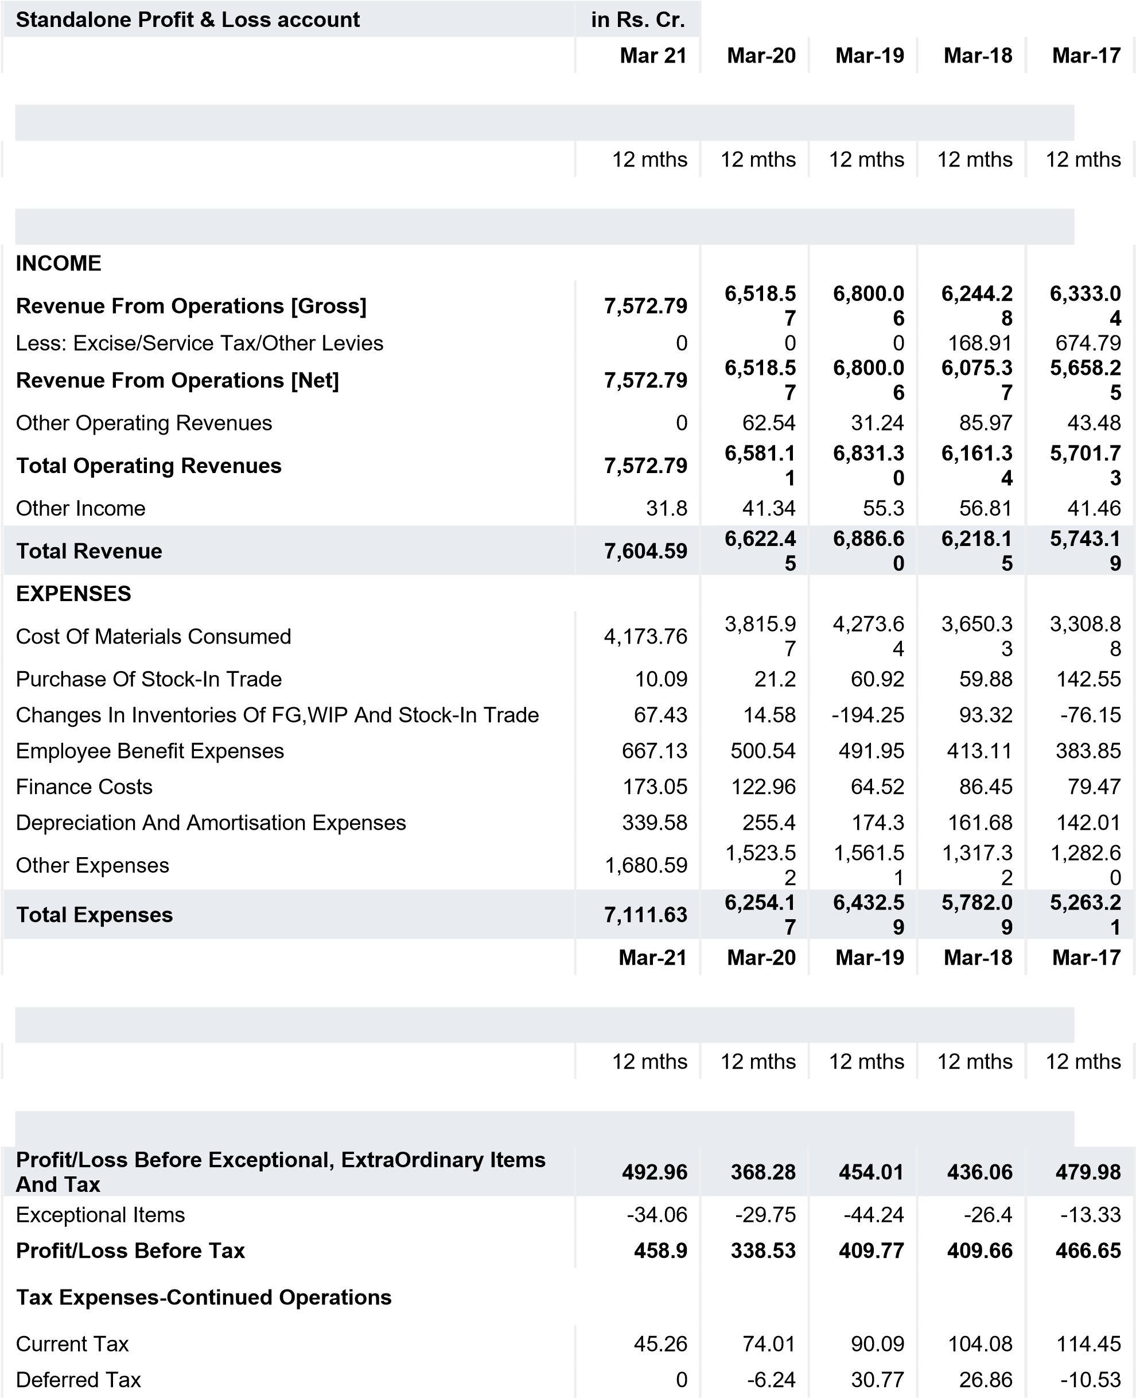
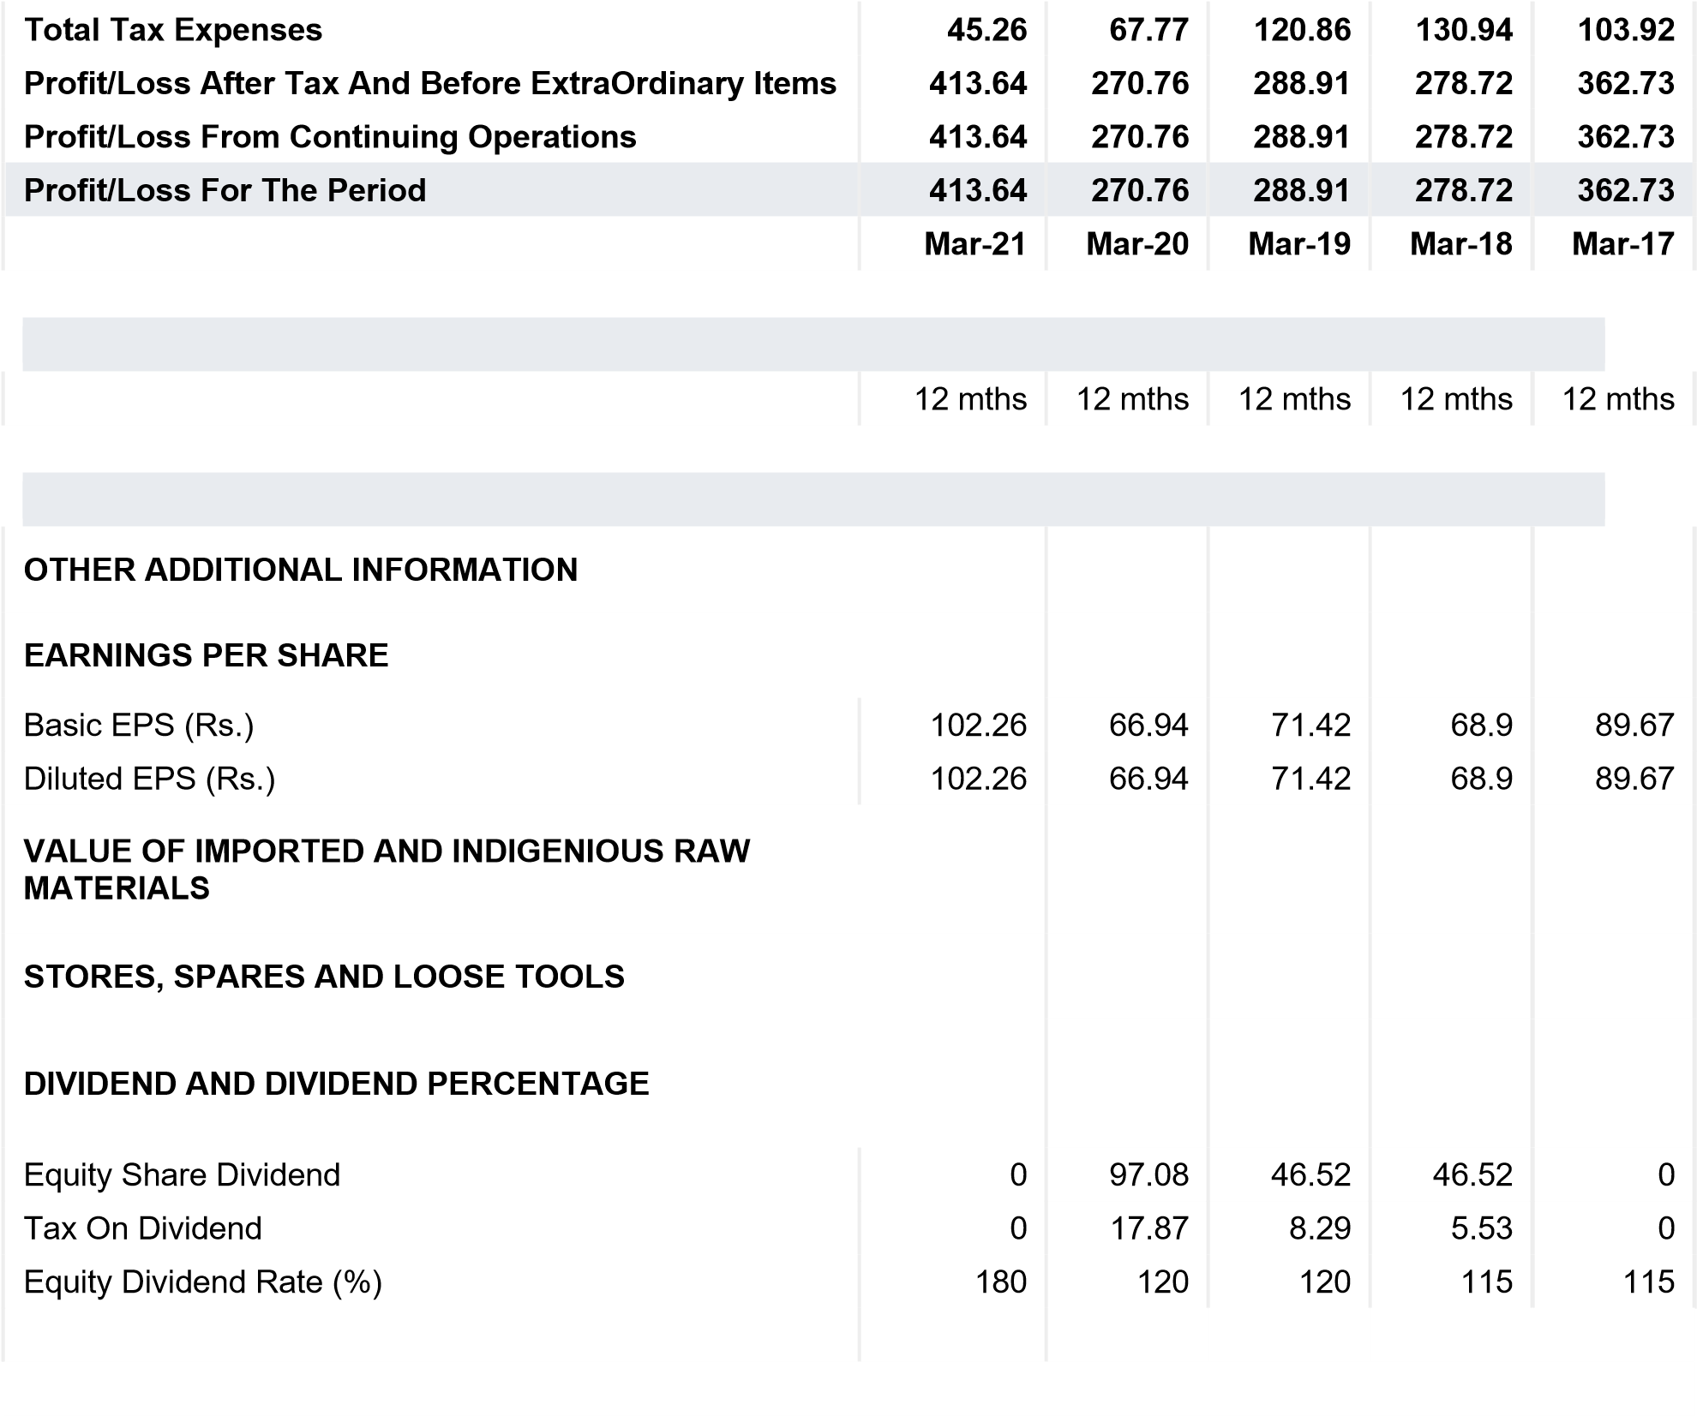

Source : Dion Global Solutions Limited

