PROJECT REPORT
(SUBMITTED FOR THE DEGREE OF B.COM. HONOURS IN ACCOUNTING &FINANCE UNDER THE UNIVERSITY OF CALCUTTA)

CREDIT RATING

SUBMITTED BY
NAME OF THE CANDIDATE: ANJALI SINGH UNIVERSITY ROLL NO: 201144-11-0085 REGISTRATION NO: 144-1211-0787-20
NAME OF THE COLLEGE: BANGABASI MORNING COLLEGE
COLLEGE ROLL NO.: BH0347

SUPERVISED BY
NAME OF THE SUPERVISOR: DR. MOUMITA SARKAR(SAMANTA)

MONTH &YEAR OF SUBMISSION: MAY, 2023

ANNEXURE- 1A

SUPERVISORS CERTIFICATE
This is to certify that Miss ANJALI SINGH a student of B. Com honours in accounting and finance of BANGABASI MORNING COLLEGE under the university of Calcutta has worked under my supervision and guidance for her project work and prepare a project with the title CREDIT RATING. The project report which she is submitting is her genuine and original work to be best of my knowledge.

SIGNATURE:
NAME: DR. MOUMITA SARKAR
(SAMANTA)
DESIGNATION: ASSISTANT PROFESSOR
NAME OF THE COLLEGE: BANGABASI MORNING COLLEGE

PLACE: KOLKATA DATE: MAY, 2023

ANNEXURE -1B
STUDENT DECLARATION
I hereby declare that the project work with the title CREDIT RATING submitted by me for the partial fulfilment of the degree of B.com (Honours) in Accounting and Finance under the university of Calcutta is my original work and has not been submitted to any other university for the fulfilment of the requirement for any course of study.
I also declare that no chapter of this manuscript in whole or in part has been incorporated in this report from any earlier work done by others or by me. However, extract of my literature which has been used for this report has been duly acknowledge providing details of such literature in the reference.

SIGNATURE:
NAME: ANJALI SINGH
ADDRESS: HOWRAH MAIDAN
NAME OF THE COLLEGE: BANGABASI MORNING COLLEGE
REGISTRATION NO.: 144-1211-0787-20
CU ROLL NO.: 201144-11-0085
COLLEGE ROLL NO.: BH0347

PLACE: HOWRAH
DATE:

It would like to express my special thanks of gratitude to our principal DR. AMITAVA DUTTA as well as our Head of Department honorable CMA MUSTAK AHMED and finally my supervisor Dr. MOUMITA SARKAR(SAMANTA) , who gave me the golden opportunity to do this wonderful project on the topic "CREDIT RATING", which also helped me in doing a lot of Research and I came to know about so many new things for which I am really thankful to them.
Secondly, I would also like to thank my parent’s and friends who have helped me a lot in finalizing this project within the limited time frame.

TABLE OF CONTENT

CHAPTER | CONTENTS | PAGE NO
1 | INTRODUCTION  1.1 Background  1.2 Understanding of credit rating  1.3 Credit rating vs. credit scores  1.4 Objective of credit rating  1.5 Importance of credit rating  1.6 History of credit rating  1.7 Advantage of credit rating  1.8 Disadvantage of credit rating | 4-14
2 | Conceptual framework  2.1 credit rating scale  2.2 Investment grade vs. speculative rating  2.3 users of credit rating  2.4 credit rating in India | 15-21
3 | Analysis & findings  Primary data analysis | 22-29
4 | Suggestions  Conclusion
 | BIBLOGRAPHY

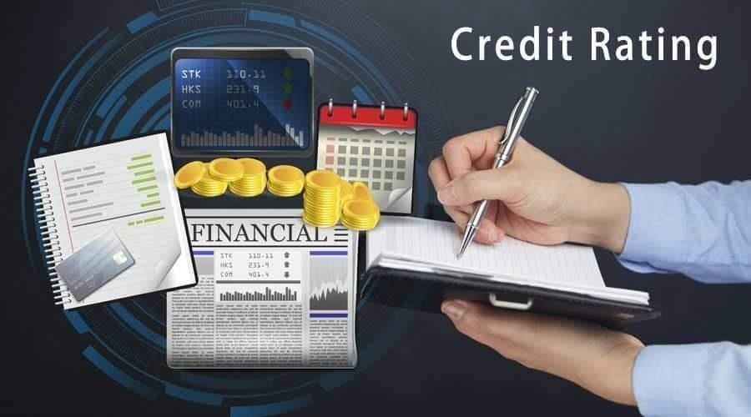

DEFINATION OF CREDIT RATING
The term credit rating refers to a quantified assessment of a borrower’s creditworthiness in general term or with respect to a
particular debt or financial obligation. A credit rating can be assigned to any entity that seeks to borrow money -an individual, a corporation, a state or provincial authority, or a sovereign government .

Individual credit scores are calculated by credit bureaus such as
Experian, Equifax, and TransUnion on a three- digit numerical scale

using a form of Fair Isaac corporation (FICO) credit scoring. Credit rating for companies and governments are calculated by a credit rating agency such as S&P Global, Moody’s, or Fitch Rating . These rating agencies are paid by the entity seeking a credit rating for itself or one of its debt issues.

- A credit rating is a quantified assessment of the creditworthiness of a borrower in general term or with respect to a financial obligation.
- Credit rating determine whether a borrower is approved for credit as well as the interest rate at which it will be repaid.
- Bonds issued by businesses and government are rated by creditagencies on letter- based system ranging AAA to D.
A loan is a debt -essentially a promise, often contractual. A credit rating determines the likelihood that the borrower will be willing and able to pay back a loan within the confines of the agreement without defaulting.
A high credit rating indicate that a borrower is likely to repay the loan in its entirety without any issues, while a poor credit rating suggests that the borrower might struggle to make their payments. Just as an individual credit score is used to evaluate the creditworthiness of a single person, businesses also use credit rating to demonstrate their creditworthiness to prospective lenders.

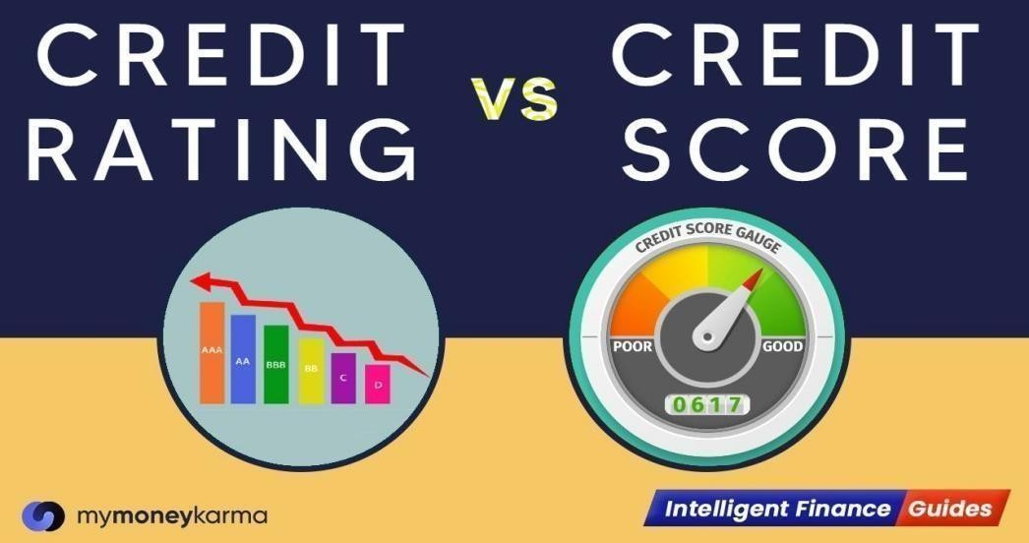
Credit rating apply to businesses and governments as well as individual. For example, sovereign credit rating apply to national governments while corporate credit apply solely to corporations. Credit scores, on the other hand, apply only to individuals.
A short -term credit rating reflects the likelihood that a borrower will default within the year. this types of credit rating has become the norm in recent years, whereas in the past, long -term credit rating were more heavily considered. Long – term credit rating predicts the borrower’s likelihood of defaulting at any given time in the extended future.

The objective of credit rating is to enable an investor to get an indication of the debt servicing capacity of a product issued by a company .
The limitation of credit rating are:
- No general evaluation .
- No recommendation.
- No guarantee about losses.

Credit rating for borrowers are based on substantial due diligence conducted by the rating agencies. Though a borrowing entity will strive to have the highest possible credit rating because it has a major impact on interest rates charged by lenders, the rating agencies must take a balanced and objective view of borrower’s financial situation and capacity to service and repay the debt.
A credit rating determines not only whether or not a borrower will be approved for a loan but also the interest rate at which the loan will need to be repaid. As companies depend on loan for many startup and other expenses, being denied a loan could spell disaster, and a high – interest – rate loan is much more difficult to pay back. A borrower’s credit rating should play a role in determining which lenders to apply to for a loan. The right lender for someone with
Credit rating are never static, which mean borrowers must remain diligent in maintaining a high credit rating. They change all the time based on the newest data, and one negative debt will bring down even the best score.
Credit also takes time to build up. An entity with good credit but a short credit history is not viewed as positively as another entity with equally good credit but a longer credit history. Debtor want to know if a borrower can maintain good consistently over time.
Credit also takes time to build up. An entity with good credit but a short credit history is not viewed as positively as another entity with equally good credit but a longer credit history. Debtor want to know if a borrower can maintain good consistently over time.
Considering how important it is to maintain a good credit rating, it’s worth looking into the best credit monitoring services and perhaps choosing one as a means of ensuring your information remain safe.

Moody’s issued publicly available credit ratings for bonds in 1909, and other agencies followed suit in the decades after. These rating didn’t have a profound effect on the market until 1936 when a new rule was passes that prohibited bank from investing in speculative bonds – that is, bonds with low credit ratings.
The aim was to avoid the risk of default, which could lead to financial losses. This practice was quickly adopted by other companies and financial institutions. Soon enough, relying on credit rating became the norm.
MOODY’S INVESTORS SERVICE

John moody and company first published moody’s manual of industrial and miscellaneous securities in 1900. The manual published basic statistics and general information about stocks and bonds of various industries.
From 1903 until the stock market crash of 1907, moody’s manual was a national publication. In 1909, moody began publishing moody’s analyses of railroad investment, which added analytical information about the value of securities.

S&P GLOBAL

In 1860, henry Varnum poor first published the history of railroad and canals in the united states, the forerunner of securities analysis and reporting that developed over the next century. The standard statistics bureau, formed in 1906, published corporate bond, sovereign debt, and municipal bond ratings. Standard statistics merged with poor’s publishing in 1941 to form standard & poor’s corporation.
Standard& poor’s corporation was acquired by the McGraw – hill companies in 1966,and in 2016, the company rebranded as S&P, introduced in 1957, a stock market index that is both a tool for investor analysis and decision – making U.S. economic indicator.

Some of the advantages are listed below which shows the importance of credit rating:
- Benefits to Investors

  - Safety of investments: credit rating gives an idea in advance to the investors about the degree of financial strength of the issuer company. Based on rating he decides about the investment. Highly rated issues gives an assurance to the investor of safety of investment and minimizes his risk.
  - Recognition of risk and return: credit rating symbols indicate both the return expected and the risk attached to a particular issue. It becomes easier for the investment to understand the worth of the issuer company just by looking at the symbol because the issue is backed by the financial strength of the company.

  - curity of a company.

Benefits of rating to the company
  - Easy to rise resources: A company with highly rated instrument finds it easy to rise resources from the public. Even though investors in different sections of the society

understand the degree of risk and uncertainty attached to a particular security but they still get attracted towards the highly rated instruments.
  - Reduced cost of borrowing: investors always like to make investment, which ensure safety and easy liquidity rather than high rate of return. A company can reduce the cost of borrowing by quoting lesser interest on those fixed deposits or debentures or bonds, which are highly rated.
  - Rating facilitates growth: rating motivates the promoters to undertake expansion of their operations or diversify their production activities thus leading to the growth of the company in future.

Benefits to intermediaries
Stock brokers have to make less efforts in persuading their clients to select an investment proposal of making investment in highly rated instruments. Thus rating enables brokers and other financial intermediaries to save time, energy costs and manpower in convincing their clients.

After having lots of advantage there are several disadvantage also of credit rating some of them are given below:

Non – disclosure of significant information
Firm being rated may not provide significant or material information, which is likely to affect the investor’s decision as toinvestment, to the investigation team of the credit ratingcompany. Thus any decisions taken in the absence of suchsignificant information may put investors at a loss.

Static study
Rating is a static study of present and past historic data of the company at one particular point of time. Number of factors including economic, political, environment, and government policies after the assignment of rating symbols may defeat thevery purpose of risk indicativeness of rating.

While each rating agency uses a slightly different scale, they each assign ratings as a letter grade for long - term debts. A rating of AAA is the highest possible credit rating, while a rating in the D’s or C’s is the lowest.
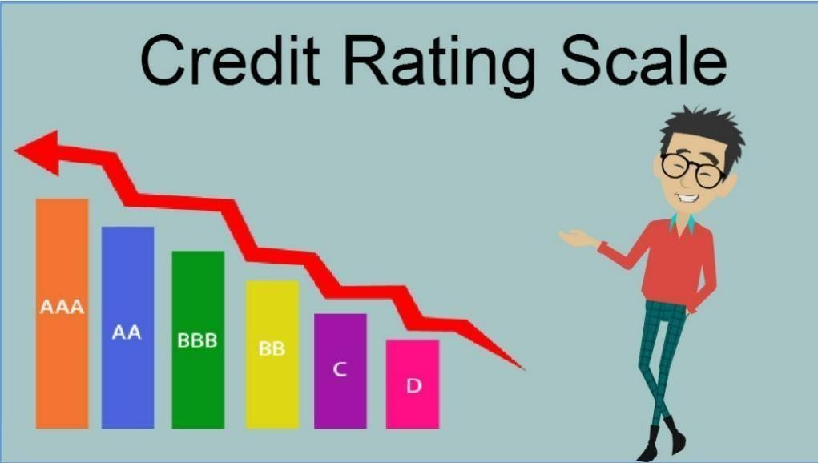

The range of possible credit ratings is divided into two categories: investment and non- investment -grade debt.

Investment -Grade Ratings
Government or corporate borrowers with a rating between BBB and AAA are considered to have investment -grade credit. These are extremely low -risk borrowers, who are considered very likely to meet all of their payment obligation. Because there is high demand for their debt, these companies or government can usually borrow money at extremely low interest rates.

Non -Investment Rating
A credit rating of BB lower indicates non -investment or speculative- grade debt. The derisive term “junk bonds” is also used for these borrowers, indicating the perceived likelihood that they are at risk of default, or have already done so. However, there is one advantage to these types of bonds: they typically pay out higher interest to the bondholder.

2.3 USERS OF CREDIT RATING

Credit ratings are used by investors, intermediaries such as investment banks, issuers of debt, and businesses and corporations.
- Debt issuers such as corporations, government, municipalities, etc., use credit ratings as an independent evaluation of their creditworthiness and credit risk associated with their debt issuance. The ratings can, to some extent, provide prospective investors with an idea of the quality of the instrument and what kind of interest rate they should be expecting from it.
- Business and corporations that are looking to evaluate the risk involved with a certain counterparty transaction also use credit rating. They can help entities that are looking to participate in partnerships or ventures with other businesses evaluate the viability of the proposition
2.4 CREDIT RATING IN INDIA

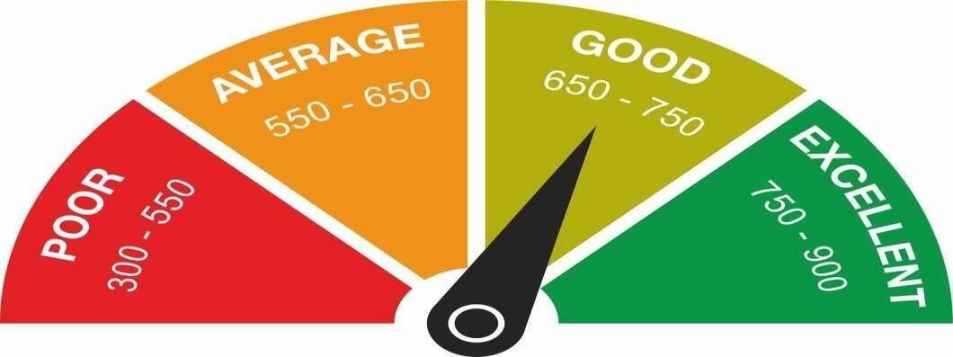

credit rating is used to determine an entity’s creditworthiness, wherein an entity could be an individual, a business, a corporation or a sovereign county. In case of a loan, the rating is used to establish whether a loan should be rendered in the first place. If the process goes further, it helps in deciding the term of the loan such as dates of repayment, interest rate, etc.
In the case of bond issuance, the credit rating indicates the
worthiness of the corporation or sovereign country’s ability to repay the bond payment in due time. It helps the investor evaluate whether to invest in the bond or not.
A credit score, however, is strictly for indicating an individual’s personal credit health. It indicates the individual’s ability to undertake a certain load and his or her ability to honor the terms and condition of the loan, including the interest rate and dates of repayment. A credit score for individuals is used by banks, credit card companies, and other lending institutions that serve individuals.

Credit scores typically range from 300 to 850. Within that range, scores can usually be placed into one of five categories: poor, fair, good, very good, and excellent.
Credit rating has garnered significant importance in the country’s financial market in the last 20 years. In simple terms, credit rating is assessing the creditworthiness of an entity. There are a number of credit agencies in the country that rate companies and organisation after measuring their ability to repay the borrowed amount.

Credit rating agencies work in India
Each rating agency has its own method to calculate credit ratings.

Credit rating agencies work in India
Each rating agency has its own method to calculate credit ratings. Agencies rate entities including companies, state governments, non- profit organisations, countries, securities, special purpose entities, and local governmental bodies. At the time of calculating the rating, credit rating agencies take into consideration several factors like the

financial statement, level and type of debt, lending and borrowing history, ability to repay the debt, and past debt of the before rating them. Once a credit rating agency rates the entities, it provides additional input to the investor following which the investor analyses and takes a sound investment decision.
Credit rating that are given to the entities serve as a benchmark for financial market regulations. However, it should be noted that the ratings should not be considered as advice for investors and instead should be used as a tool to make a sound decision.
Different credit rating scales
An individual’s creditworthiness is represented by their credit score. Similarly, a company’s creditworthiness is represented by the credit rating symbols assigned to them by the agencies. Credit rating agencies rate non convertible debentures (NCD), company deposits,and fixed deposits, among others. Let’s take a look at some of the credit rating symbols offered by rating agencies for long -term and mid -term debt instruments.

.Rating scale | India | CRISIL | Brick | CARE | ICRA
 | ratings & |  | work
 | research |  | ratings
High safety: very low credit risk | IND AA | CRISIL AA | BWR AA | CARE AA | ICRA AA
Low risk | IND A | CRISIL A | BWR A | CARE A | ICRA A
Moderate safety: moderate  credit risk | IND BBB | CRISIL BBB | BWR BBB | CARE BBB | ICRA BBB
Moderate risk: moderate risk of  default | IND BB | CRISIL BB | BWR BB | CARE BB | ICRA BB
High risk: high risk of default | IND B | CRISIL B | BWR B | CARE B | ICRA B
Very high risk: very high risk  of default | IND C | CRISIL C | BWR C | CARE C | ICRA C
Default: instrume nts are already in default or the verge  of default | IND D | CRISIL D | BWR D | CARE D | ICRA D

ICRA
ICRA was the second rating agency established in the year 1991. It is a public limited company and it has its head office in New Delhi.
Moody’s is the majority shareholder of ICRA. The long-term rating of ICRA is exactly similar to CRISIL as shown below

ICRA’s Long-Term Rating Scale
Long-Term rating Scale All Bonds, NCDs, and other debt instruments (excluding Public Deposits) with original maturity exceeding one year.
[ICRA]AAA Instruments with this rating are considered to have the highest degree of safety regarding timely servicing of financial obligations. Such instruments carry lowest credit risk.
[ICRA]BBB Instruments with this rating are considered to have moderate degree of safety regarding timely servicing of financial obligations. Such instruments carry moderate credit risk.
[ICRA]BB Instruments with this rating are considered to have moderate risk of default regarding timely servicing of financial obligations.

Credit rating by credit rating agencies
Credit rating of THE TATA POWER COMPANY LIMITED by CRISIL

Rating Rationale
January 07, 2022 | Mumbai

The Tata Power Company Limited

Rated amount enhanced

Rating Action

Total bank loan facilities rated | Rs. 17047.43 crore( enhanced from rs.14597.43 crore)
Long term rating | CRISIL AA/stable (reaffirmed)
Short term rating | CRISIL A1+(reaffirmed)

Rs.1000 crore Non convertible debentures | CRISIL AA/stable( reaffirmed)
Rs.500crore Non convertible debentures | CRISIL AA/stable( reaffirmed)
Rs.364 crore non convertible debentures | CRISIL AA/stable( reaffirmed)
Rs.1500 crore subordinated non convertible debentures | CRISIL AA/stable ( reaffirmed)

Rs.9000 crore commercial paper | CRISIL A1+( reaffirmed)
1 crore = 10 million
Refer to Annexure for Details of Instruments & Bank Facilities

Detailed Rationale
CRISIL Ratings has reaffirmed its 'CRISIL AA/Stable/CRISIL A1+' ratings on the bank facilities and debt instruments of The Tata Power Company Limited (Tata Power).
The ratings continue to reflect Tata Power's stable cash accrual from regulated businesses, which account for 45-50% of its earnings before interest, tax, depreciation and amortisation (Ebitda), its diversified business risk profile and strong financial flexibility as part of the Tata group. These strengths are partially offset by losses in Coastal Gujarat Power Ltd (CGPL; ‘CRISIL A1+ (CE)’) on account of unviable project economics, and high leverage. The ratings also factor in the management's intent to keep leverage in the form of adjusted net debt to Ebitda ratio sustainably below 3.5 times, which includes possible monetisation of the renewables portfolio.
Adjusted EBITDA for first half of current fiscal increased by 9% on- year, driven by regulated businesses, and coal companies amidst higher coal prices, while partly offset by operating losses of CGPL on account of voluntary plant shutdown.
CRISIL Ratings expects operating profitability to remain strong over the medium term given the increasing share of regulated business, healthy profitability at coal companies while partly offset by under- recoveries at CGPL and lower margins at solar EPC business due to higher raw-material prices.

Analytical Approach
CRISIL Ratings has used a combination of full and proportionate consolidation of Tata Power's companies.

CRISIL Ratings has proportionately consolidated certain joint ventures and associate companies to the extent of Tata Power’s shareholding in these entities, to reflect support to the extent of its interests in these businesses. These companies include coal-operating entities in Indonesia: 30% in PT Kaltim Prima Coal and 26% in PT Baramulti Suksessarana Tbk.

Please refer Annexure - List of entities consolidated, which captures the list of entities considered and their analytical treatment of consolidation.

Key Rating Drivers & Detailed Description Strengths:

Stable cash accrual from regulated businesses
Tata Power earns 45-50% of Ebitda from its regulated businesses, such as power generation and distribution in Mumbai, power distribution in New Delhi, the 1,050 megawatt (MW) capacity of MPL, and transmission. The PPAs for generation assets, including MPL, CGPL and the renewable portfolio, have balance life of over 15 years, thus offering strong revenue visibility. Distribution licenses for Mumbai and Delhi are valid for another 19 years and 9 years, respectively. The PPA of the power generation business for Mumbai (Trombay assets of around 930 MW) is valid till fiscal 2024, and subject to renewal risk. The proportion of cash flows from the regulated businesses could increase over the medium term, driven by the company's focus on adding licenses in the distribution sector, and regulated capex in its generation, transmission and distribution assets.

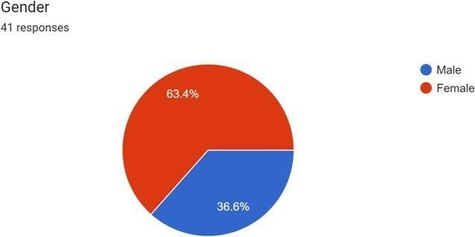

In the response form 63.4% are female and 36.6% are male .

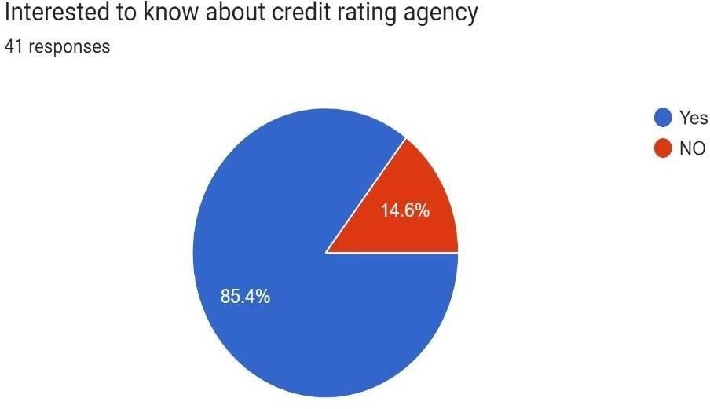
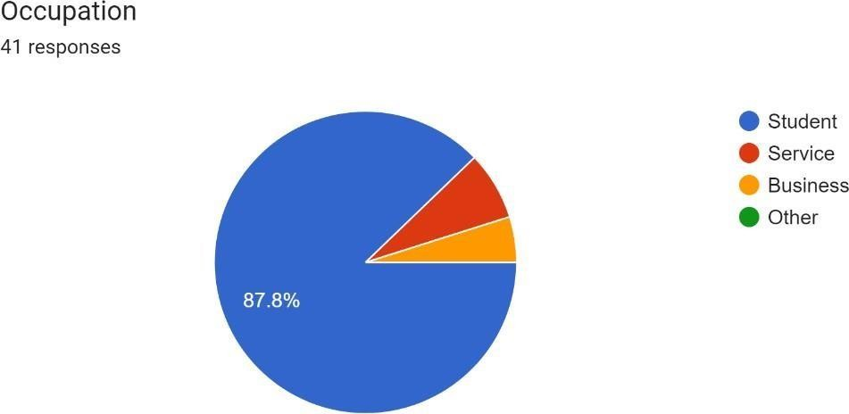

Here, 85.4% people interested to know about credit rating agency but 14.6% people not interested at all.

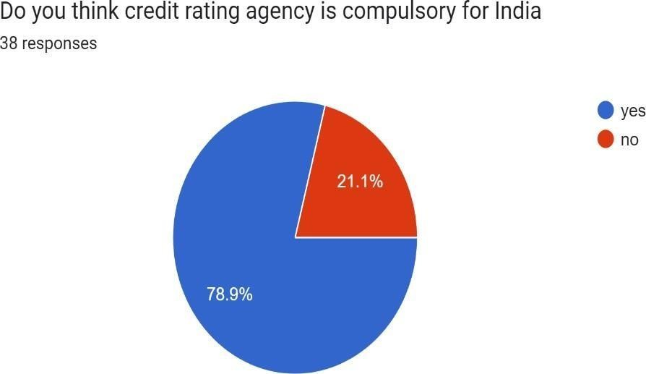

Here, 78.9% think credit rating agency Is compulsory but 21.1% think it is not compulsory
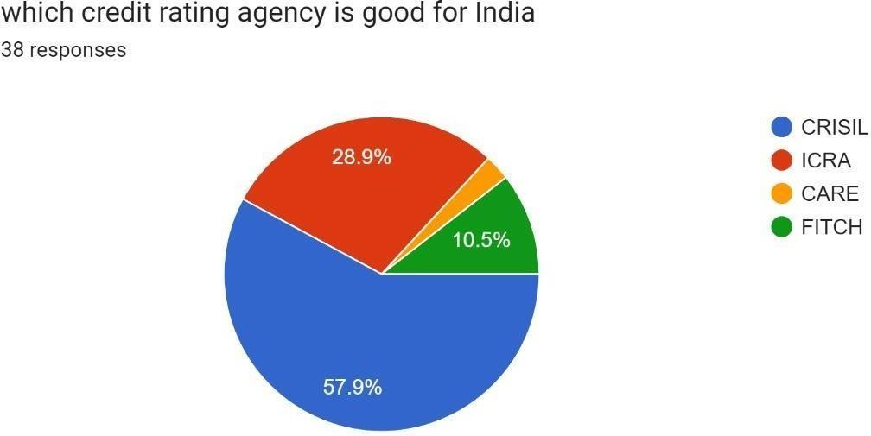

Here, 57.9% think CRISIL, 28.9% think ICRA , 10.5% think FITCH and other think CARE

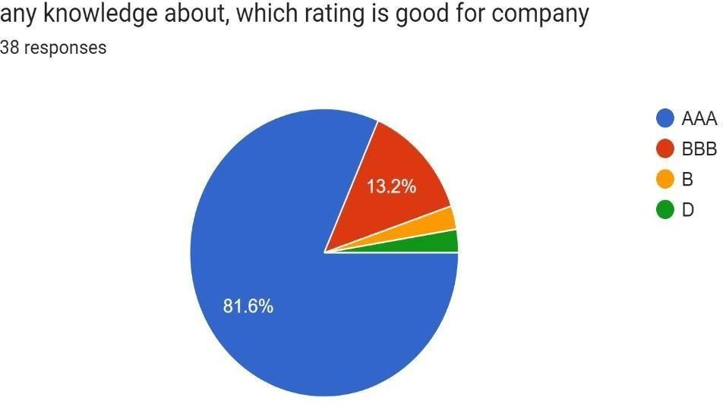

Here, 81.6% think AAA , 13.2% think BBB and rest of thing B and D

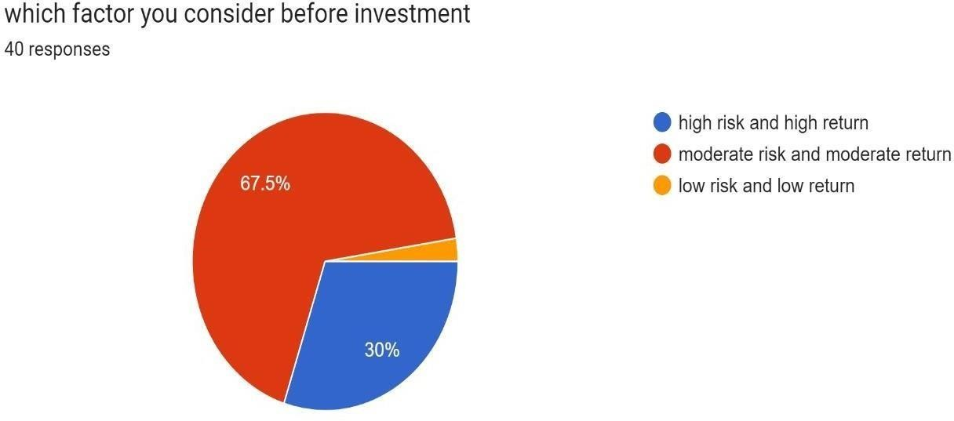

Here, 67.5% think moderate risk and moderate return , 30% think high risk and high return and rest think low risk and low return

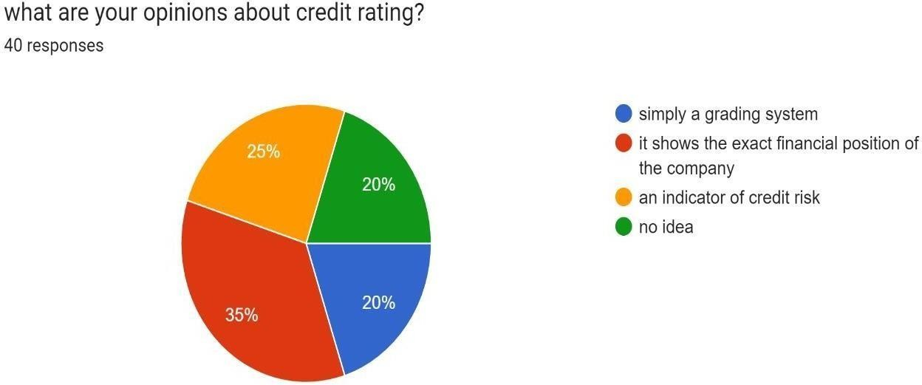

Here, 35% think it shows the exact financial position of the company
, 25% think an indicator of credit risk, 20% think simply a grading system and 20% have no idea

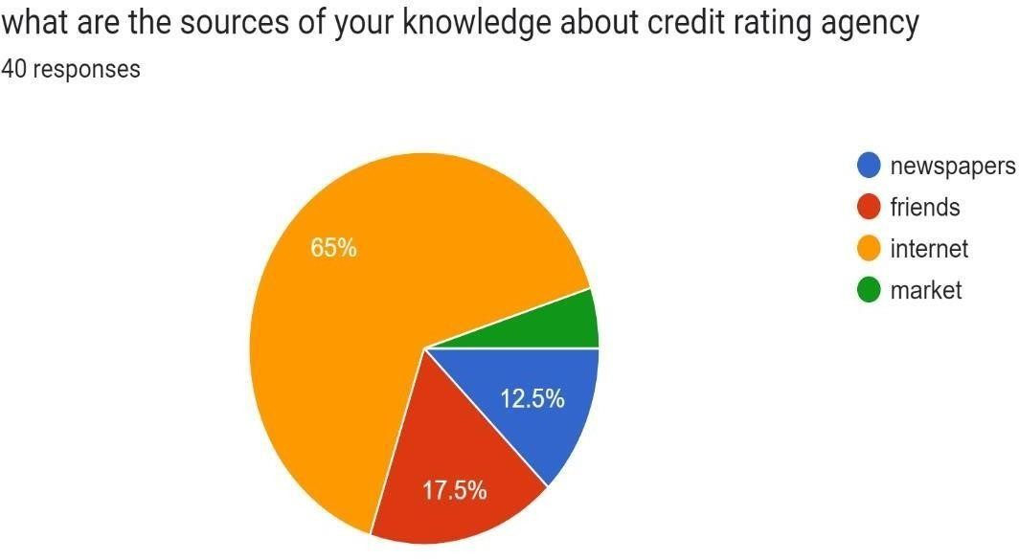

Here, 65% people sources are internet , 17.5% people from friends
,12.5% people from newspaper and rest from market

FOR INVESTORS
- An investor should always keep in mind that nothing comes along guarantee or without risk not even promised returns on Life Insurance Policies and hence should always keep in mind the principle of “Caveat Emptor” which means let the buyer beware.
- Investor themselves are to responsible for their money. Hence one should always be cautious and thoroughly examine the facts, creditworthiness before zeroing down on any investment decision and most importantly compare it with other options as well.

FOR CREDIT RATING AGENCIES
- CRISIL, ICRA & CARE, the three major rating agencies are handling 90%- 95% of the business of credit rating promoted by financial institutions who while advancing loans take the help of credit rating agencies to get the company rated. All these agencies have continued to expand their activities in recent years.
- Another aspect is regarding the procedure or the methodology that these rating agencies follow for rating. Sometimes companies not satisfied with rating of one agency approach use another rating agency for better rating. For this purpose, the rating process or procedure followed for rating must be relevant, accurate and regulated. Rating agencies should not only take into consideration past & present performance; the projected future performance must not be ignored

The credit rating system in India plays a crucial role in the financial market by providing investors with information on the creditworthiness of debt securities. It helps in determining the risk associated with investing in a particular security and aids in making informed investment decisions. Overall, the credit rating industry in India has shown steady growth and improvement in recent years, with increased regulation and transparency. However, challenges such as conflicts of interest and limited coverage of certain segments of the market remain to be addressed.

  - India Financial Systems by M Y. KHAN and BHARTI PATHAK.
  - Regulating Credit Rating Agencies by ALINE DARBELLAY.
  - The credit rating industry/An industrial organization Analysis by Lawrence J
White.
  - The Subprime Solution by ROBERT J SHILLER.
  - Credit Rating and Bank Behaviour by D. M. NACHANE and SAIBAL GHOSH.
Credit Rating Agencies and The Global Financial Crisis by ECONSTOR.

