Project Report
(Submitted for the Degree of B.Com Honours in Accounting & Finance
under the University of Calcutta)

Consumer Perceptions on Online banking

Submitted By

Name of the Candidate : Puja Bhowmik
Cu Registration no. : 144-1211-0776-20
Cu Roll no. : 201144-11-0080
Name of the college : Bangabasi Morning College
College roll no. : BH0334

Supervised By
Name of the Supervisor : Dr. Moumita Sarkar (Samanta)
Name of the College : Bangabasi Morning College

Month & year of submission
MAY,2023

ANNEXURE IA

SUPERVISOR’S CERTIFICATE

This is to certify that Mis.Puja Bhowmik, a student of B.COM Honours in Accounting & Finance in Business of Bangabasi Morning College under the University of Calcutta has worked under my supervision and guidance for her Project Work and prepared a Project Report with the title Consumer Perceptions on Online banking which she is submitting, is her genuine and original work to the best of my knowledge.

PLACE : KOLKATA SIGNATURE : ……………………
DATE : NAME : Moumita Sarkar (Samanta)
DESIGNATION : Assistant Professor
NAME OF THE COLLEGE : Bangabasi Morning College

ANNEXURE – IB

STUDENTS’ DECLARATION

I hereby declare that the Project Work with the title Consumer Perceptions on Online banking submitted by me for the partial fulfilment of the degree of B.Com. Honours in Accounting & Finance in Business under the University of Calcutta is my original work and has not been submitted earlier to any other University /Institution for the fulfilment of the requirement for any course of study.
I also declare that no chapter of this manuscript in whole or in part has been incorporated in this Report from any earlier work done by others or by me. However, extracts of any literature which has been used for this report has been duly acknowledged providing details of such literature in the references.

SIGNATURE :…………………………
NAME : JOTI KUMARI SHAW
ADDRESS : Sodpur S.M Bose road / Lahabagan,
panihati Kolkata - 700114
REGISTRATION No : 144-1211-0776-20
PLACE : KOLKATA DATE :

ACKNOWLEDGEMENT

I wish to express my deep gratitude and sincere thanks to the Principal, Amitabha Dutta for her encouragement and for all the facilities the she provided for this project work. I sincerely appreciate her magnanimity by taking me into her fold for which I shall remain indebted to.
I extend my hearty thanks to my supervisor Moumita Sarkar (Samanta) who guided me to the successful completion of this project. I take this opportunity to express my deep sense of gratitude for her invaluable guidance, constant encouragement, immense motivation, which has sustained my efforts at all the stages of this project work.
I can’t forget to offer my sincere thanks to my parents and also my friends who helped me to carry out this project work successfully and for their valuable advice and support, which I received from them time to time.

Puja Bhowmik

TABLE OF CONTENT

CHAPTER | TITLE | PAGE NO.
CHAPTER 1 | INTRODUCTION | 6-11
1.1  1.2  1.3  1.4  1.5  1.6  1.7 | Background  Need of study  Literature Review  Objective of Study  Research Methodology  Limitation Of Study Chapter Planning | 6  7  7  8  8-9  9  9-10
CHAPTER 2 | CONCEPTUAL FRAMEWORK | 10-18
2.1  2.2  2.3  2.4  2.5  2.6 | Concept  Features  Advantages  Disadvantages  National Scenario  International Scenario | 10-11  11  12  13  14  14-15
CHAPTER 3 | PRESENTATION OF DATA, ANALYSIS & FINDINGS | 16-31
CHAPTER 4 | CONCLUSION & RECOMMENDATIONS | 32-33
4.1  4.2 | Conclusion Recommendations | 32  32-33
 | BIBLIOGRAPHY | 33
 | QUESTIONNAIRES | 34

CHAPTER -1
INTRODUCTION

1.1 BACKGROUND OF THE STUDY
Online banking or e- banking ,is the term that describes all transactions that take place among companies, organizations, and individuals and their banking institutions. First conceptualized in the mid 1970s,some banks offered customers electronic banking in 1985. However the lack of internet users and cost associated with using online banking, stunted growth. The internet explosion in the late 1990s made people more comfortable with making transactions over the web. Online banking is the practice of making bank transactions or paying bills via the internet. Thanks to technology, and the internet in particular, people no longer have to leave the house to shop, communicate or even do their banking. While financial institutions took steps to implement online banking services in the mid 1990s, many customers were hesitant to conduct monetary transactions over the web. It took widespread adoption of electronic commerce , based on trailblazing companies such as America Online, Amazon.com and eBay, to make the idea of paying for items online widespread.
By 2000, 80 percent of U.S. banks offered e- banking. Customer use grew slowly. At Bank of America, for example, it took 10 years to acquire 2 million online banking customers. However, a significant cultural change took place after the Y2K scare ended. In 2001, Bank of America became the first bank to top 3 million online banking customers, more than 20% of its customer base. In comparison, larger national institutions such as Citigroup claimed 2.2 million online relationships globally, while J.P Morgan Chase estimated it had more than 7,50,000 online banking customers, including small businesses. Online customers proved more loyal and profitable than regular customers. In October 2001,Bank of America customers executed a record 3.1 million electronic bill payments, totalling more than $1 billion. In 2009, a report by Gartner group estimated that 47 percent of U.S. adults and 30 percent in the United Kingdom use online banking.

1.2 NEED OF THE STUDY
This study provides a guide to the current structure of Online Banking security and highlights the awareness level of customers for using Online banking, and their perception and satisfaction towards online banking with new technologies and its functioning. This helps to know in detail about development in the banking industry with advancement in technology. It also helps in understanding different services offered in Internet banking. Ultimately this would help in understanding the benefits of Online banking to customers as well as the banking industry.

1.3 LITERATURE REVIEW

Now a day’s contribution of Online banking towards economic development plays a crucial role in developing countries like India. Banks are no longer restricted to traditional banking rather it is shifted to the virtual banking system. Kamakodi et al.(2008) expressed that an extensive gap exists in human service and in Indian banking while IT- based facilities are beyond expectations. Qureshi T M, Zafar M K and Khan M B (2008) evaluated the customer acceptance of online banking study and concluded that the majority of customers are accepting online banking culture because of favourable factors and usefulness, security and privacy. Uppal R K (2010) expressed in his research, ATMs are the most effective while mobile banking does not hold a strong position in the public sector market, Mobile banking customers are also the highest in E-Banks which have a positive impact on net profit and business per employee. Mishra (2011) delivered useful advice to safeguard the safety of internet- based transactions (IBT). The customer of the bank should not reply to any SMS, calls or Emails, requesting for password and not to connect on any link for the bank website. E-Banking has arisen from such an advanced improvement. Zamdi et al. (2013), studying 56 countries over 2008-12, calculate that USD 983 billion were added to their cumulative real GDP because of increased card usage. Among the emerging economies, India at a lower level of 0.047%. Dhananjay B and Chandra B (2015) expressed that retail electronic payment has progressed in recent years. The creation of NCPI set the stage for the development of Electronic payments. This ratio of electronic clearing grew from one percent to three percent . Mukhopadhyay (2016) in their study of benefits from cashless society found that as more payments are directly credited to the account, cashless payment increases significantly. Dr. Karunagupta, Ravindraarya, (2017) focused on emerging trends in the banking sector in India, he focused on the banking sector with reference to digitalization. The digitalization of the banking system leads to a strong foundation in the economy and is ready to become a cashless economy to transform the Indian banking industry.

1.4 OBJECTIVE OF THE STUDY
The purpose of this research is to investigate and understand the factors affecting adoption of online banking services in Kolkata. With this intention, the report is aim to achieve the following objectives:-
⮚ To analyse the customer’s perceptions and awareness towards internet banking security;
⮚ To understand the problems faced by customers while using Online banking services and also the benefit they get from the online banking system;
⮚ To identify which are the demographic factors (Education, Income, Age and Gender) influencing the adoption of online banking and
⮚ To study an overview of Online banking services.

1.5 RESEARCH METHODOLOGY

Source of Data:-
The source of data is based on Primary data. Primary data is a type of data that is collected by researchers directly from the main source through interviews, surveys, experiments, etc. Primary data are usually collected from the source- where the data originally originates from and are regarded as the best kind of data in research.

Type of Data:-
For the purpose of case study primary data have been collected from the people of my locality of Alipore through phone calls, social network and direct interview from them. And other relevant data have been collected from different articles and websites.

Sample size:-
Sampling methodology of the Primary data has been collected through a survey with a pre-tasted structured QUESTIONNAIRE on the sample of randomly selected 40 people of my locality of Alipore.
Year of study:-
The study has been conducted during the first quarter of the current year 2023.
Time span of survey:-
April 1,2023- April 18,2023.
Area of survey:-
Alipore, Kolkata (URBAN)

1.6 LIMITATIONS OF THE STUDY:-

⮚ Due to the present pandemic situation a small size sample of 40 respondents is taken to primary data analysis.
⮚ So, I cannot draw proper inferences about the respondents from this sample size.
⮚ Due to a shortage of time, I am not able to do a deep study.
⮚ I could not collect data from outside of my locality of Alipore.
⮚ I have not used modern statistical tools to analyze the data.
⮚ This study is based on the prevailing respondents’ satisfaction. But their satisfaction may change according to time, taste, habit, age and day to day need etc.

1.7 CHAPTER PLANNING:-

- CHAPTER – 1 : INTRODUCTION includes Background of the Study, Need of the Study, Literature Review, Objective of the Study, Research Methodology, Limitations of the Study and Chapter planning.

- CHAPTER – 2 : CONCEPTUAL FRAMEWORK includes Concept, Features, Advantages, Disadvantages, National Scenario and International Scenario of Online Banking.

- CHAPTER - 3 : PRESENTATION OF DATA, ANALYSIS & FINDINGS contains various charts, diagrams, tables and graphs based on the survey done on Online Banking and their Analysis and Findings.

- CHAPTER – 4 : CONCLUSION AND RECOMMENDATION contains the
Conclusion of the Study and Recommendation.

CHAPTER – 2

CONCEPTUAL FRAMEWORK
2.1 CONCEPT
Online banking, also known as internet banking, web banking or home banking, is an electronic payment system that enables customers of a bank or other financial institution to conduct a range of financial transactions through the financial institution’s website. The online banking system will typically connect to or be part of the core banking system operated by a bank to provide customers access to banking services in place of traditional branch banking.
Online banking significantly reduces the banks’ operating cost by reducing reliance on a branch network, and offers greater convenience to customers in time saving in coming to a branch and the convenience of being able to perform banking transactions even when branches are closed. Internet banking provides personal and corporate banking services offering features such as viewing account balances, obtaining statements, checking recent transactions, transferring money between accounts and making payments.
Online banking requires a computer or other device, an internet connection, and a bank or debit card. In order to access the service, clients need to register for their bank' s online banking service. In order to register, they need to create a password. Once that’s done, they can use the service to do all their banking.
Banking transactions offered online vary by the institution. Most banks generally offer basic services such as transfers and bill payments. Some banks also allow customers to open up new accounts and apply for credit cards through online banking portals. Other functions may include ordering cheques, putting stop payment on cheques, or reporting a change of address.
Cheques can now be deposited online through a mobile app. The customer simply enters the amount before taking a photo of the front and back of the cheque to complete the deposit.

2.2 FEATURES
A bank customer can perform non- transactional tasks through online banking including:-
⮚ Viewing account balances.
⮚ Viewing recent transactions.
⮚ Downloading bank statements, for example in pdf format.
⮚ Viewing images of paid cheques.
⮚ Ordering cheque books.
⮚ Download periodic account statements.
⮚ Downloading applications for M – Banking, E- Banking etc.

Bank customers can transact banking tasks through online banking including:-
⮚ Find transfers between the customer’s linked accounts.
⮚ Paying third parties, including bill payments and third party fund transfer.
⮚ Investment purchase or sale.
⮚ Loan application and transactions, such as repayment of enrollments.
⮚ Credit Card applications.
⮚ Register utility billers and make bill payments.

Some financial institutions offer special internet banking services, for example- personal financial management support, such as importing data into personal Accounting Software.
Some online banking platforms support account Aggregation to allow the customers to monitor all of their accounts in one place where they are with their main bank or with other institutions.

2.3 ADVANTAGES OF ONLINE BANK
The key advantages of Online banking are:-
⮚ Online account opening- One can open a new account within minutes and from anywhere online.
⮚ Enhanced security- Access to banking information protected by multiple protection layers to keep the personal data private and prevent unauthorized access.
⮚ Instant access 24/7- Enjoy a full range of services from your computer, tablet, or mobile phone anytime, anywhere.
⮚ Save money- By automating your finances using the bill pay service available in online banking, one can ensure your payments are on- time.
⮚ Convenience- Skip the long lines. Easily check balances on all accounts and view records of transactions from the palm of your hand.
⮚ Pay bills- Save time and money with this free service. Schedule payments or set up autopay to automatically pay bills through our Online Banking and Mobile App.
⮚ Automate your savings- Online banking allows you to have some of your paycheck directly deposited into your savings account or funds can be scheduled to automatically transfer from your checking to your savings.
⮚ Make loan payments- Avoid late fees by scheduling all of your loan payments before the due date.
⮚ Mobile deposits- Deposit personal and business cheques safely, securely and without having to visit a branch or ATM.
⮚ Transfer money between accounts- Move your cash quickly between accounts or by sending to an external account. One can set up automatic transfers to move money into a savings account or other account to make loan payments.
⮚ Integrate with other apps- Take control of your finances with budgeting, expenses and other apps that automatically track your spending and saving habits.
⮚ View statements- Get immediate access to your bank statements for your tax or personal records.
⮚ Monitor fraud- Set up alerts to be notified by text, email or phone if your financial institution suspects fraudulent activities on your account.
⮚ Alerts and notifications- By setting up notifications on the account, one can know with the latest transaction and balance activity on your account.

2.4 DISADVANTAGES OF ONLINE BANKING

The Disadvantages of online banking are:-
⮚ Internet Requirement- An uninterrupted internet connection is a foremost requirement to use internet banking services. If you do not have access to the internet, you cannot make use of any facilities offered online. Similarly, if the bank servers are down due to any technical issues on their part, you cannot access net banking services.
⮚ Transaction Security- No matter how much precautions banks take to provide a secure network, Every internet banking account requires the password to be entered in order to access the services. Therefore, the password plays a key role in maintaining integrity. If the password is revealed to others, they may use the information to devise some fraud. Also, the chosen password must comply with the rules stated by the banks. Individuals must change the password frequently to avoid password theft which can be a hassle to remember by the account holder himself. banking transactions are still susceptible to hackers. Irrespective of the advanced encryption methods used to keep user data safe, there have been cases where transaction data is compromised. This may cause a major threat such as using the data illegally for the hacker’s benefit.
⮚ Difficult for Beginners- There are people in India who have been living lives far away from the web of the internet. It might seem a whole new deal for them to understand how internet banking works. Worse still, if there is nobody who can explain to them how internet banking works and the process flow of how to go about it. It will be very difficult for inexperienced beginners to figure it out for themselves.
⮚ Security Password- Every internet banking account requires the password to be entered in order to access the services. Therefore, the password plays a key role in maintaining integrity. If the password is revealed to others, they may use the information to devise some fraud. Also, the chosen password must comply with the rules stated by the banks. Individuals must change the password frequently to avoid password theft which can be a hassle to remember by the account holder himself.
⮚ Limited services- Online banking features a lot of services, but some of them still require business owners to go into the banks to “wet sign” documents. This includes loan and credit applications, a large cash withdrawal or large deposits. But as online banking technology continues to evolve, you may eventually be able to electronically sign for these in the future.
⮚ Lack of Personal Relationship- A personal relationship with your bank may be able to offer an advantage over online banking. If you need a business loan, a new line of credit, a waived fee or to make changes to your current banking needs, having that relationship can help.

2.5 NATIONAL SCENARIO
E- banking has become an integral part of the banking system in India. Before the 90’s, the traditional model of banking i.e. branch- based banking was prevalent, but after that non- branch banking services were started. The credit of launching internet banking in India goes to firstly ICICI Bank. After that Citibank and HDFC Bank followed with internet banking services in 1999. The government of India enacted the IT Act,2000 with effect from October 17,2000, which provided legal recognition to electronic transactions and other means of e- commerce. The Reserve Bank is monitoring and reviewing the legal and other requirements of e – banking related challenges that would not pose a threat to financial stability.
To cope with the pressure of growing competition, Indian commercial banks have adopted several initiatives and e- banking is one of them. Indian banks offer to their customers the following e- banking products and services viz. Automated Teller Machine (ATM), Internet Banking, Mobile Banking, Phone Banking, Tele Banking, Electronic Clearing Services, Electronic Clearing Cards, Door step banking and Electronic Fund Transfer.
According to RBI in its Annual Report 2020-21 stated that the payment systems recorded a robust growth of 26.2% in terms of volume on top of the expansion of 44.2% in the previous year.
Here some of the major key facts are as follows:-
⮚ Private sector banks represent about 67% of the POS terminal market while public sector banks account for 27%. Payments bank accounted for 5% market share.
⮚ The total number of cards in circulation stood at 960.25 million as of March 2021. Out of which ,there were 898.20 million debit cards and 62.05 million credit cards, up by 8% and 7% YOY respectively.
⮚ There were 2.20 billion prepaid payment instruments in the country. Out of which, 189.93 million consisted of prepaid cards and over 2.01 billion consisted of mobile wallets.
⮚ The number of transactions through mobile wallets in Q1 2021 was 1.13 billion and the value was INR 411.75 billion. This includes the purchase of goods and services and fund transfer through wallets. Transactions through wallets are growing steadily.

2.6 INTERNATIONAL SCENARIO
In early 2001, approximately 60 percent of E- business in the UK was concentrated in the financial services sector, and with the expected 10- fold increase of the British E- business market by 2005, the share of the financial services will further increase. Around one fifth of Swedish bank customers are banking online, while in the US, according to UNCTAD, online banking is growing at an annual rate of 60 percent and the number of online accounts has approximately reached 15 million by 2006.
In Asia, the major factor restricting the growth of E-banking is security, in spite of several countries being well connected via the Internet. Access to high-quality E-banking products is an issue as well. Majority of the banks in Asia are just offering basic services compared with those of developed countries. Still, E-banking seems to have a future in Asia. It is considered that E-banking will succeed if the basic features, especially bill payment, are handled well. Bill payment was the most popular feature, cited by 40 percent of respondents of the survey. However, providing this service would be difficult for banks in Asia because it requires a high level of security and involves arranging transactions with a variety of players.
In 2001, over 50 percent of the banks in the US were offering E-banking services. However, large banks appeared to have a clear advantage over small banks in the range of services they offered. Some banks in the US were targeting their Internet strategies towards business customers. Apart from affecting the way customers received banking services, E-banking was expected to influence the banking industry structure. The economics of E-banking was expected to favor large banks because of economies of scale and scope and the ability to advertise heavily. Moreover, E-banking offered entry and expansion opportunities that small banks traditionally lacked.
In Europe , the Internet is accelerating the reconfiguration of the banking industry into three separate businesses: production, distribution and advice. This reconfiguration is being further driven by the internet, due to combined impact of:
⮚ The emergence of new and more focused business models
⮚ New technology capabilities that reduces the banking relationship and transaction costs.
⮚ High degree of uncertainty over the impact that new entrants will have on current business models.
CHAPTER- 3

PRESENTATION OF DATA, ANALYSIS AND FINDINGS

Table 3.1: Gender Basis Analysis
Particulars | Respondents
Male | 18
Female | 22
Total | 40
[Source: Primary Source]

Diagram 3.1: Gender Basis Analysis

0
5
10
15
20
25
30
35
40
45
Male
Female
Total
Gender Basis Analysis
Male
Female
Total
[Source: Primary Source]
Interpretation: The survey shows that there are 40 respondents in total in which there are 8 male respondents and 22 Female respondents. This is shown with the help of a column chart.

Table 3.2: Age Basis Analysis
Age Group | Frequency | Percentage | Cumulative Frequency
Below 20 | 7 | 17.5% | 7
20-30 | 20 | 50% | 27
30-50 | 8 | 20% | 35
Above 50 | 5 | 12.5% | 40
[Source: Primary Source]

Diagram 3.2: Age Basis Analysis
17.5
%
50
%
20
%
12.5
%
Age Basis Analysis
Below 20
20-30
30-50
Above 50
[Source: Primary Source]

Interpretation: Out of 40 respondents, there are 7 people with age group below 20, 20 people with age group 20-30, 8 people with age group 30-50 and 5 people with age above 50. This is shown with the help of a pie chart.

Table 3.3: Occupation Basis Analysis
Occupation | Frequency | Cumulative Frequency | Percentage
Student | 12 | 12 | 30%
Self-Employed | 8 | 20 | 20%
Employee | 15 | 35 | 37.5%
Others | 5 | 40 | 12.5%
[Source: Primary Source]

Diagram 3.3: Occupation Basis Analysis
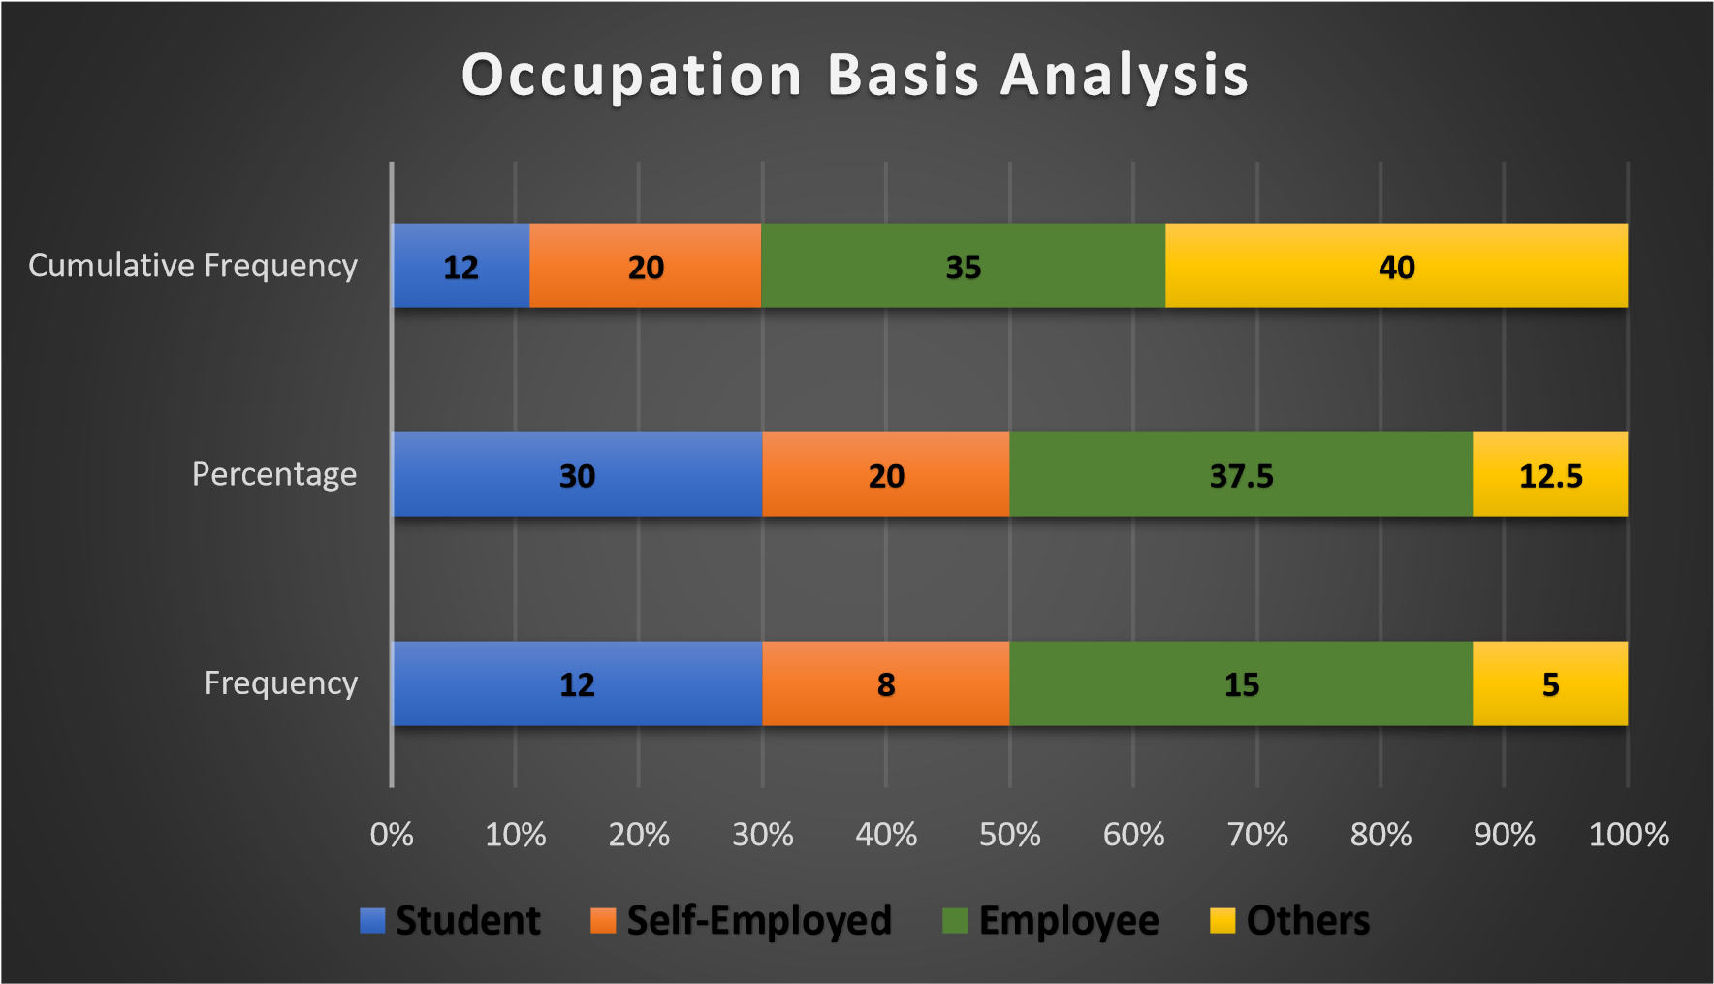
[Source: Primary Source]

Interpretation: The survey shows that out of 40 respondents, 12 respondents are students, 8 respondents are Self- employed, 15 respondents are Employees and 5 respondents come under occupation.

Table 3.4: Awareness of Online Banking
Particulars | Respondents
Yes | 36
No | 4
Total | 40
[Source: Primary Source]

Diagram 3.4: Awareness of Online Banking

36
4
Awareness of Online Banking
Yes
No
[Source: Primary Source]

Interpretation: Out of 40 respondents, only 4 respondents are unaware of online banking services while 36 respondents are aware of online banking services. This is shown in the chart given above.

Table 3.5: Use of Online banking
Use of Online Banking | Frequency | Percentage | Cumulative Frequency
Yes | 34 | 85% | 34
No | 6 | 15% | 40
[Source: Primary Source]

Diagram 3.5: Use of Online Banking
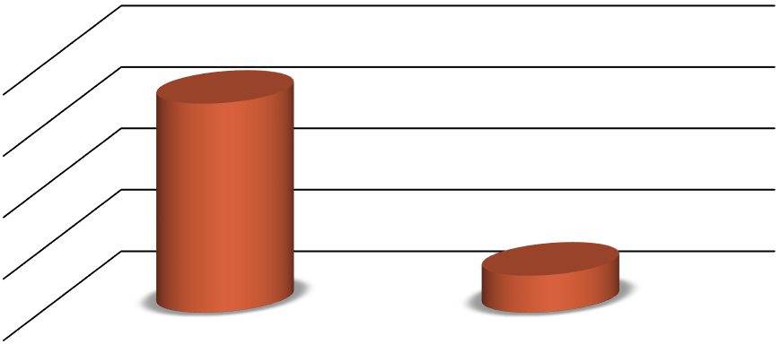
0
10
20
30
40
Yes
No
34
6
Use of Online Banking
Use of Online Banking
[Source: Primary Source]

Interpretation: It is seen that 85% of the total respondents use online banking services while 15% do not use online banking service. This shows that most of the people use online banking services.

Table 3.6: How frequently do you use Online Banking Services
Usage | Frequency | Percentage | Cumulative Frequency
Daily | 5 | 12.5% | 5
Weekly | 12 | 30% | 17
Monthly | 8 | 20% | 25
Occasionally | 7 | 17.5% | 32
Yearly | 2 | 5% | 34
Never | 6 | 15% | 40

[Source: Primary Source]
5
12
8
7
2
6
Use of Online Banking
Daily
Weekly
Monthly
Occasionally
Yearly
Never
[Source: Primary source]
Interpretation: Among 40 respondents, 5 people use online banking service on daily basis, 12 people on weekly basis, 8 people on monthly basis, 7 people use occasionally, 2 on yearly basis and 6 people have never used online banking services. This is shown in the chart given above.

Table 3.7: Advantages of Online Banking
Advantages | Frequency | Percentage | Cumulative Frequency
24/7 Accessibility | 12 | 30% | 12
Fast and Efficient | 6 | 15% | 18
Online Payment | 11 | 27.5% | 29
Easy to Use | 6 | 15% | 35
Hard to Say | 5 | 12.5% | 40
[Source: Primary Source]

Diagram 3.7: Advantages of Online Banking
12
6
11
6
5
0
2
4
6
8
10
12
14
24
/7 Accessibility
Fast and Efficient
Online Payment
Easy to Use
Hard to say
Advantages of Online Banking
Series 1
[Source: Primary Source]

Interpretation: The survey shows that the maximum respondents feel that the biggest advantage of online banking is '24/7 Accessibility’. While the others have chosen ‘online payments', ‘Fast and efficient' and ‘Easy to Use’. There are also 5 respondents who feel that it’s difficult to determine the advantages of online banking.

Table 3.8: Disadvantages of Online Banking
Particulars | Frequency | Percentage | Cumulative Frequency
Network Connectivity | 12 | 30% | 12
Security Issue | 14 | 35% | 26
Must have a device to operate | 8 | 20% | 34
Others | 3 | 7.5% | 37
Can’t Say | 3 | 7.5% | 40
[Source: Primary Source]

Diagram 3.8: Disadvantages of Online Banking
12
14
8
3
3
0
2
4
6
8
10
12
14
16
Network
Connectivity
Security Issue
Must have a
device to
operate
Others
Can’t Say
Disadvantages of Online Banking
[Source: Primary Source]

Interpretation: Out of 40 respondents, 14 respondents think that the reason for not using online banking is because of its security issues, 12 respondents have selected ‘network connectivity', 8 respondents have selected ‘must have a device to operate' . This is shown in the above graph.

Table 3.9: Which Online Service is mostly used by you?
Particulars | Frequency | Percentage | Cumulative Frequency
Fund Transfer | 11 | 27.5% | 11
Check Balance | 8 | 20% | 19
Bill Payments | 15 | 37.5% | 34
Others | 6 | 15% | 40

[Source: Primary Source]
Diagram 3.9: Which Online Service is mostly used by you?
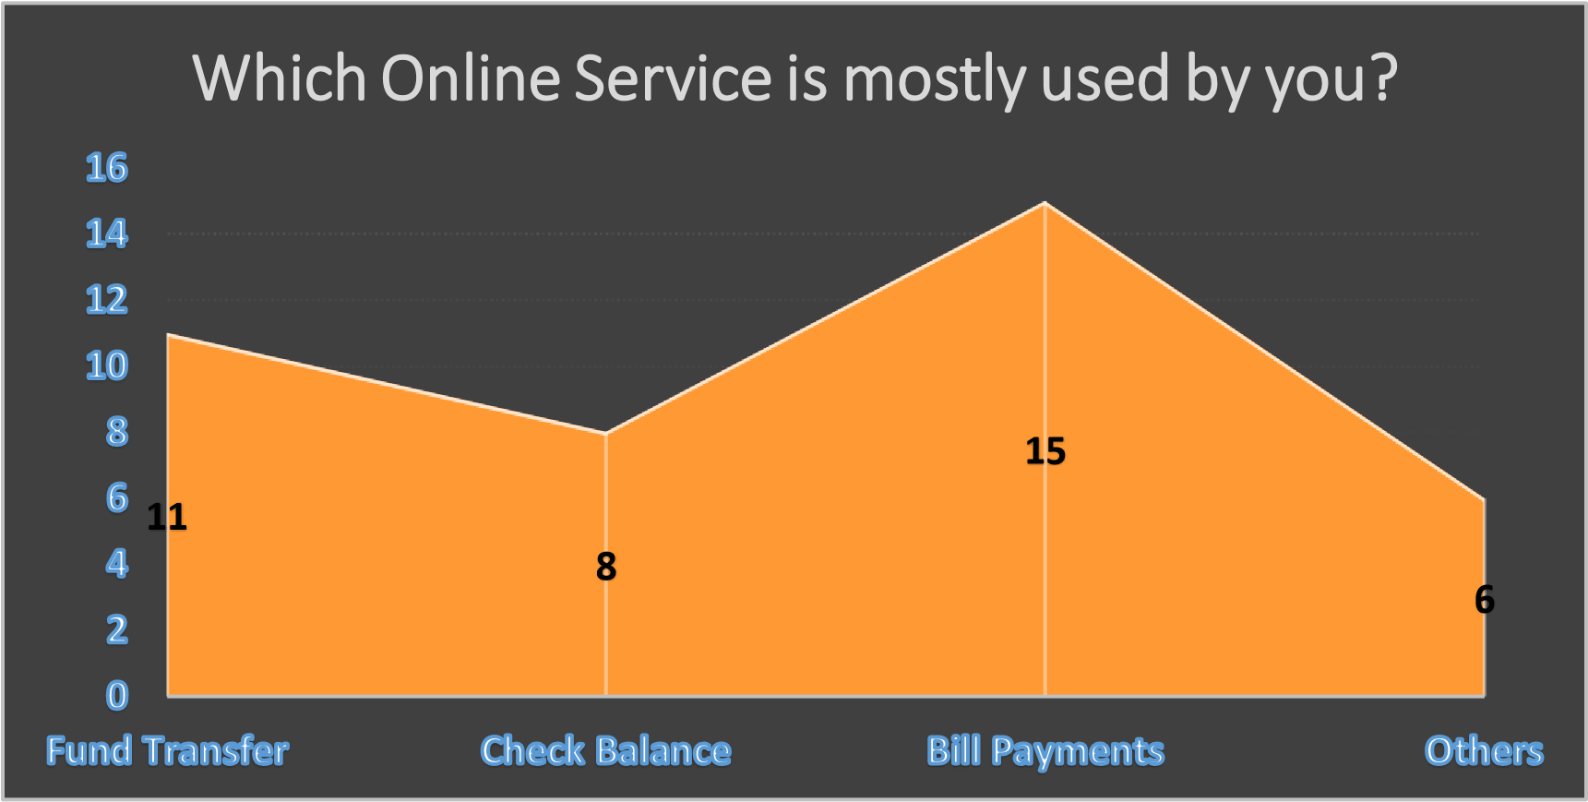
[Source: Primary Source]
Interpretation: The online service that is mostly used by the respondents is ‘Bill payment'. The others have chosen ‘Fund Transfer', ‘Check balance' and ‘others’. This is shown above with the help of a graph.

Table 3.10: Do you think that Online Banking Fraud is increasing day by day?
Particulars | Frequency
Yes | 22
No | 9
Not Sure | 9
[Source: Primary Source]

Diagram 3.10: Do you think that Online Banking Fraud is increasing day by day?
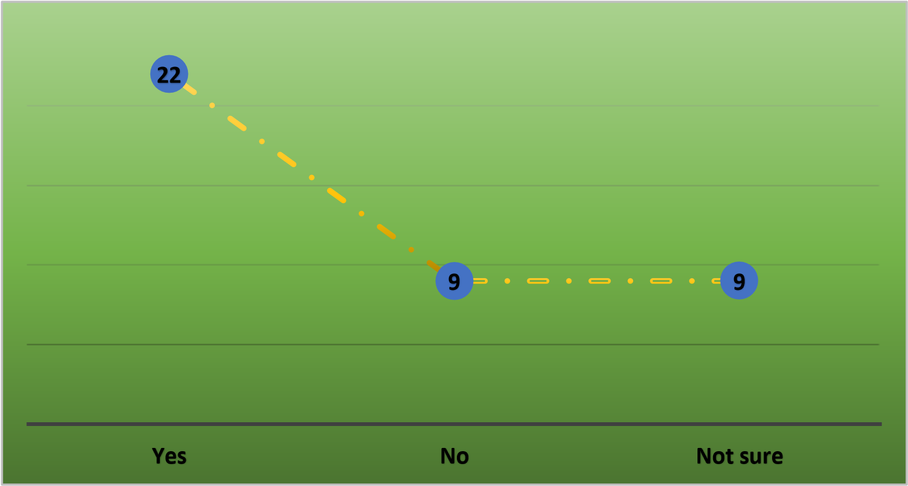
[Source: Primary Source]

Interpretation: Among 40 respondents, 22 respondents feel that the Online Banking fraud is increasing day by day while 9 respondents said ' No’ and 9 respondents are not sure about it.

Table 3.11: Do you think your account is completely secured in Online Banking?
Particulars | Frequency
Yes | 24
No | 5
Maybe | 11
[Source: Primary Source]

Diagram 3.11: Do you think your account is completely secured in Online Banking?
0
5
10
15
20
25
Yes
No
Maybe
Yes
No
Maybe
[Source: Primary Source]

Interpretation: When ‘Security in Online Banking' is taken into consideration, 24 respondents respond ‘YES’ While 5 respondents say ‘NO’ and others are not sure about it. This is presented in the above diagram.

Table 3.12: Which kind of Banking do you prefer?
Particulars | Frequency | Percentage
Online Banking | 34 | 85%
Traditional Banking | 6 | 15%
[Source: Primary Source]

Diagram 3.12: Which kind of Banking do you prefer?
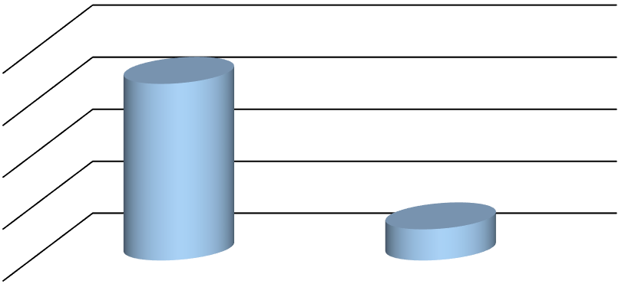
0
10
20
30
40
Online Banking
Traditional Banking
34
6
Which kind of Banking do you prefer?
Which kind of Banking do you prefer?
[Source: Primary Source]

Interpretation: Out of 40 respondents, 34 respondents have chosen online banking over traditional banking and 6 have chosen traditional banking.

Table 3.13: Which bank do you have an account with?
Particulars | Frequency | Percentage | Cumulative Frequency
SBI | 10 | 25% | 10
ICICI | 5 | 12.5% | 15
AXIS | 6 | 15% | 21
HDFC | 7 | 17.5% | 28
Others | 12 | 30% | 40
[Source: Primary Source]

Diagram 3.13: Which bank do you have an account with?
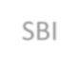
10
5
6
7
12
Which bank do you have an account?
SBI
ICICI
AXIS
HDFC
Others
[Source: Primary Source]

Interpretation: Among 40 respondents, 10 people have an account in SBI, 5 have in ICICI, 6 in AXIS, 7 in HDFC and 12 have accounts in other banks.

Table 3.14: Does your bank educate you about the online services being offered?
Particulars | Frequency | Percentage | Cumulative Frequency
Yes | 18 | 45% | 18
No | 22 | 55% | 40
[Source: Primary Source]

Diagram3.14: Does your bank educate you about the online services being offered?
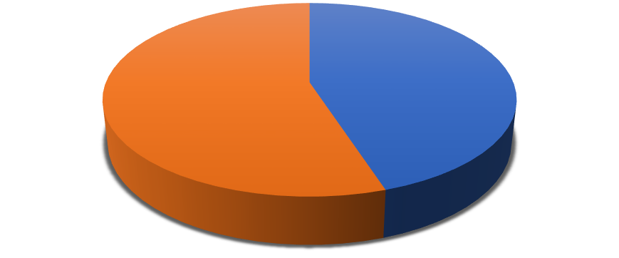
18
22
[Source: Primary Source]

Interpretation: Out of 40 respondents, 18 responded that their bank educate them about the online banking services while 22 responded that their bank have not educate them about the online banking services.

Table 3.15: Views on Online Banking Services?
Particulars | Frequency | Percentage | Cumulative Frequency
Excellent | 5 | 12.5% | 5
Good | 16 | 40% | 21
Average | 13 | 32.5% | 34
Poor | 2 | 5% | 36
Can’t Say | 4 | 10% | 40
[Source: Primary Source]

Diagram 3.15: Views on Online Banking Services?
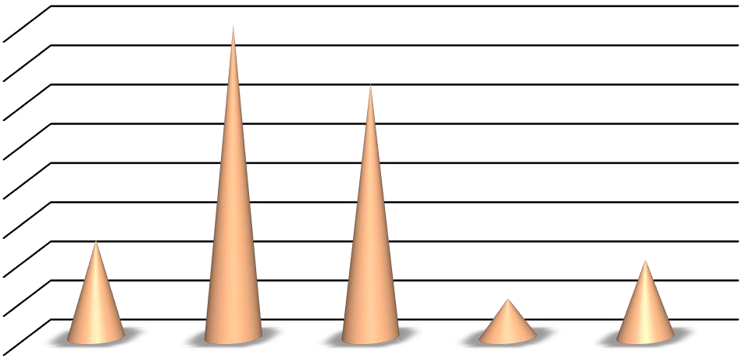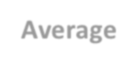
0
2
4
6
8
10
12
14
16
Excellent
Good
Average
Poor
Can't Say
Views on Online Banking Services?
[Source: Primary Source]

Interpretation: Out of 40 respondents, 5 people have chosen ‘Excellent’ service, 16 responded ‘Good’, 13 responded ‘Average’, 2 responded ‘Poor’ and 4 responded ‘Can’t say’. The graph above shows the views of 40 respondents.

FINDINGS
- Out of 40 respondents, 18 respondents are Male and 22 respondents are Female.

- There are 7 respondents who are in the age group below 20, 20 respondents who are in age group 20-30, 8 respondents are in age group 30-50 and 5 respondents are above 50.

- The survey shows the occupation basis analysis in which most of the people are Employees while others are students, Self- employed and others.

- This survey shows that most of the respondents are aware of the online banking services and only 4 out of 40 are not aware of online banking services. This shows that there are a maximum number of respondents who use online banking services.

- Since maximum respondents are aware of online banking services and have the access to use online banking services, the survey shows that 34 respondents use online banking.

- Most of the people do not use online banking services on a daily basis.They may transact with banks on weekly, monthly and occasionally basis. 2 people use online service on a yearly basis.

- There are many advantages of using online banking services. The survey shows that most of the people use online banking because of its 24/7 accessibility. Some said that they use online banking because of online payment, fast and efficient and it is easy to use.

- There are also some disadvantages of using online banking services. Those are network connectivity, security issues, devices to operate and others. Most of the respondents responded that security issues are the biggest disadvantage of using online banking while 12 respondents responded about the network connectivity and 3 respondents responded to other problems.

- The Online banking service which is mostly used by the 15 respondents is Bill payments. 11 respondents have chosen 'fund transfer’, 8 have chosen ‘check balance'.

- The survey shows that out of 40 respondents, 22 respondents think that online banking fraud is increasing day by day while 9 respondents do not think this and 9 respondents are not sure about it.

- Out of 40 respondents, 24 respondents responded that their bank account is completely secured in online banking while 11 are not sure about it and 5 respondents said ‘NO’.

- About 85% of the total respondents prefer online banking over traditional banking and the rest of the respondents prefer traditional banking.

- 10 respondents had responded that they have a bank account in SBI, 5 have in ICICI, 6 have in AXIS, 7 have in HDFC and 12 have in other banks.

- Out of 40 respondents, 18 said that their bank did educate them about the online banking services while 22 being the maximum respondents, said that their bank had not educated them about the online banking services being offered.

- The survey shows that 5 respondents have chosen ‘Excellent’, 16 have chosen ‘Good’, 13 have chosen ‘Average’, 2 have chosen ‘Poor’ as their view on online banking services.

CHAPTER-4
CONCLUSION AND RECOMMENDATION

4.1 CONCLUSION
This study consists of four chapters followed by Introduction, Conceptual, Presentation of Data, Analysis and finally found out the Findings. It gives a new insight to the online banking users and beneficiaries.
Online banking is just like normal banking, with one big exception. You don’t have to go to the bank for transactions. Instead you can access your account any time and from any part of the world, and do so when we have time, and not when the bank is open.
Based on the above findings, it can be concluded that technology has greatly influenced the bank customers' encouraging them to conduct banking in an innovative manner.
The study reveals that the users of online banking delivery channels have strong positive perception towards technology used in banking which is reflected in their adoption and usage of the same.
Those who are educated are using online services more. Online banking is more frequently used for services like bill payments, Fund transfer, checking balance etc.
The online banking system is useful for bankers as well as for customers of the bank.

4.6 RECOMMENDATION
Banks should motivate the age group of 31- 60 years to use online banking services for their banking purpose.
Banks should improve the technical and physical accessibility of online banking services.
Banks should provide more facilities like training programs and awareness camps to all types of customers.
Banks should implement an easy way to access online banking services for the people who are unaware about how to use online banking services very fluently.
Banks should improve the online banking service quality of website design, home page of bank web site and server availability.
Banks should adopt some new policies and incentives to the banking customers for making large numbers of transactions.
BIBLIOGRAPHY

Articles
- Mohammad,A.T.(2012). E- service quality strategy: Achieving customer satisfaction in online banking. Journal of theoretical and Applied Information Technology,38(1), 6-24.
- Akinyosoye, R.G.(2011). Customer preference for E- banking services: A case study of Selected banks in Sierra Leone. Australian Journal of Business and Management Research, 1(4), 108-116.

Websites
- www.bankofindia.com (Last accessed on 03-05-2023)
- www.rbi.co.in (Last accessed on 15-04-2023)
- www.Google.com (Last accessed on 03-04-2023)

Books
- Indian banking by R.Parameswaran.
- The inside story of Indian banking by Sandip Sen.

QUESTIONNAIRES

- Name- ___________________________

- Gender o Male o Female

- Age Group o Below 20 o 20- 30 o 30- 50 o Above 50

- Occupation o Student o Self-employed o Employee
  - Others

- Are you aware of online banking?
  - Yes o No

- Do you use Online Banking?
  - Yes
  - No

- How frequently do you use online banking services?
  - Daily o Weekly o Monthly o Occasionally o Yearly o Never

- What is the biggest advantage of online banking?
  - 24/7 accessibility o Fast and efficient o Online payment o Easy to use
  - Hard to say

- What is the biggest disadvantage of online banking?
  - Network connectivity o Security issues o Must have a device to operate o Others o Can’t say

- Which online service is mostly used by you?
  - Fund transfer o Check balance o Bill payments o Others

- Do you think that online banking fraud is increasing day by day? o Yes
  - No
  - Not sure

- Do you think your account is completely secured in online banking? o Yes o No
  - Maybe

- What kind of banking do you prefer?
  - Online banking o Traditional banking

- In which bank do you have an account?
  - SBI o ICICI o AXIS
  - HDFC o Others

- Does your bank educate you about the online service being offered? o Yes
  - No

- Your view on online banking services?
  - Excellent o Good o Average o Poor
  - Can’t say

