PROJECT REPORT
(Submitted for the Degree of B.Com. Honours in Accounting & Finance under the University of Calcutta)

RATIO ANALYSIS: A STUDY OF SHREE CEMENT AND AMBUJA CEMENT

Submitted by
Name of the Candidate: Pousali Maity Registration No: 144-1211-0770-20 Calcutta University Roll No: 201144-11-0077 College Roll No: BH0328
Name of the College: Bangabasi Morning College

Supervised by
Name of the Supervisor: Dr. Moumita Sarkar (Samanta)
Name of the College: Bangabasi Morning College

MONTH & YEAR OF SUBMISSION May 2023

Annexure-I

Supervisor's Certificate

This is to certify that Ms. POUSALI MAITY, a student of B.Com. Honours in Accounting & Finance in Business of Bangabasi Morning College under the University of Calcutta has worked under my supervision and guidance for her Project Work and prepared a Project Report with the title RATIO ANALYSIS: A STUDY OF SHREE CEMENT AND AMBUJA CEMENT which she is submitting, is her genuine and original work to the best of my knowledge.

Signature -
Name of Prof: Dr. Moumita Sarkar (Samanta)
Place: Kolkata Designation: Assistant Professor
Date: Name of the College: Bangabasi Morning College

Student's Declaration

I hereby declare that the Project Work with the title RATIO ANALYSIS: A STUDY OF SHREE CEMENT AND AMBUJA CEMENT submitted by me
for the partial fulfillment of the degree of B.Com. Honours in Accounting & Finance under the University of Calcutta is my original work and has not been submitted earlier to any other University/Institution for the fulfillment of the requirement for any other course of study.
I also declare that no chapter of this manuscript in whole or in part has been incorporated in this report from any earlier work done by others or by me. However, extracts of any literature which has been used for this report has been duly acknowledged providing details of such literature in the references.

Signature -
Name: Pousali Maity
Address: 163A, Baithakkhana Road,
Kolkata – 700009
Place: Kolkata Registration No.: 144-1211-0770-20
Date: CU Roll No: 201144-11-0077

ACKNOWLEDGEMENT

I would like to express my extreme gratitude to my professor, Moumita ma’am for providing her valuable time and inputs without which the completion of this project would not have been possible. I am extremely thankful to her not only for her valuable assistance but also for her moral support which motivated me from time to time to complete this project.

I would like to thank my friends and colleagues for their help and support during the making of this project. Their inputs added many colors and variety to my project.

I would like to thank my parents and siblings for having faith in me and providing me with sufficient resources which were needed for the successful completion of this project.

Lastly, I would like to thank The Almighty for giving me strength and knowledge to successfully carry out the steps required for the completion of this.

TABLE OF CONTENT

Sl. NO. | CHAPTER NAME | PAGE NO.
1. | INTRODUCTION  1.1.Background 1.2.Literature Review 1.3.Objectives of the Study 1.4.Methodology  1.5 Limitations of Study | 7-10
2. | CONCEPTUAL OVERVIEW  2.1.Concept of Ratio Analysis 2.2.National Scenario 2.3.International Scenario | 11-13
3. | ANALYSIS AND FINDINGS  3.1.Research Methodology  - Sample  - Data Type  - Data Source  - Period of Study  - Tools Used 3.2.Analysis of Findings | 14-21
4. | CONCLUSION AND RECOMMENDATION  4.1.Summary Observations 4.2.Suggestions and Recommendations | 22-23
5. | References | 24
6. | Annexure | 25-26

- INTRODUCTION

BACKGROUND OF STUDY

Ratio analysis is a technique of analyzing the financial statement of industrial concerns. Now a days, this technique is sophisticated and used in business concerns. Ratio analysis is not the end but it is only better means of understanding of financial strength and weakness of the firm.
Ratio analysis is one of the most powerful tools of financial analysis of which helps in analyzing and interpreting the health of the firm. Ratio’s are proved as a basis instrument in the control process and act as backbone in schemes of business forecast.
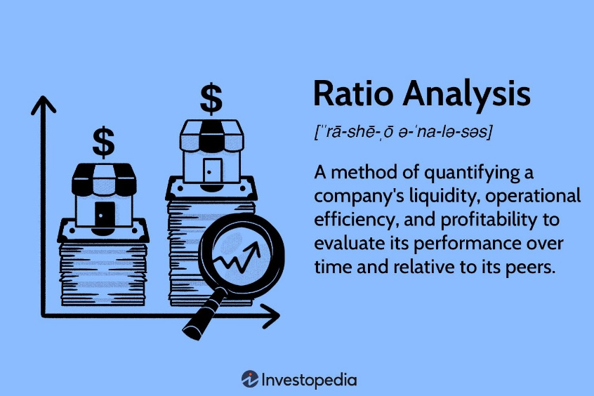
NEED FOR THE STUDY

The study has great significance and provides benefits to various parties whom directly or indirectly interact with the company.
It is beneficial to management of the company by providing crystal clear picture regarding important aspects like liquidity, leverage, activity and profitability.
The study is also beneficial to employees and offers motivation by showing how actively they are contributing for company’s growth. The investors who are interested in investing in the company’s shares will also get benefited by going through the study and can easily take a decision whether to invest or not to invest in the company’s shares.

LITERATURE REVIEW

Many researchers have studied financial ratios as a part of working capital.

In a regional study, Pandey and Parera (1997) Working capital management in Shrilanka by I. M. Pandey and K. L. W. Perera (Working Paper, No. 1997/1349) provided an empirical evidence of working capital management policies and practices of the private sector manufacturing companies in Sri Lanka. The information and data for the study were gathered through questionnaires and interviews with chief financial officers of a sample of manufacturing companies listed on the Colombo Stock Exchange. They found that most companies in Sri Lanka have informal working capital policy and company size has an influence on the overall working capital policy (formal or informal) and approach (conservative, moderate or aggressive). Moreover, company profitability has an influence on the methods of working capital planning and control.
Another aspect of working capital management has been analyzed by Morris Lamberson, (1995) "Changes in Working Capital of Small Firms in Relation to Changes in Economic Activity", American Journal of Business, Vol. 10 Iss: 2, pp.45

- 50 who studied how small firms respond to changes in economic activities by changing their working capital positions and level of current assets and liabilities. Current ratio, current assets to total assets ratio and inventory to total assets ratio were used as measure of working capital while index of annual average coincident economic indicator was used as a measure of economic activity. Contrary to the expectations, the study found that there is very small relationship between charges in economic conditions and changes in working capital.
Filbeck, G. and T. Krueger. An Analysis of Working Capital Management Results across Industries. Mid-American Journal of Business 20 (2):11-18, (2005), highlighted the importance of efficient working capital management by analyzing the working capital management policies of 32 non-financial industries in USA. According to their findings significant differences exist between industries in working capital practices over time.

OBJECTIVES OF THE STUDY

The major objectives of the recent study are to know about financial strengths and weakness of SHREE CEMENT AND AMBUJA CEMENT through RATIO ANALYSIS.
The main objectives of recent study aimed as:

- To study the financial ratios of SHREE CEMENT AND AMBUJA CEMENT.
- To know the financial performance of the company.
- Interpret the financial statement so that the strength and weakness of a firm’s performance and current financial condition can be determined.
- To analyze the liquidity, long term solvency and profitability position of the company.
- To offer appropriate suggestions for the better performance of the organization.

METHODOLOGY

This study is based on secondary data collected from literature available on this field in the forms of books, journals, published articles; authentic websites published financial reports of SHREE CEMENT AND AMBUJA CEMENT and other relevant sources.

DATA TYPE
Secondary data type is being used for making this project.

DATA SOURCE
Most of the information will be gathered through secondary sources. The data have been collected from authentic websites, journals and published financial reports of SHREE CEMENT AND AMBUJA CEMENT.

PERIOD OF STUDY
In this study the financial reports of SHREE CEMENT AND AMBUJA CEMENT for four consecutive years have been analyzed. The financial years of 2017-18, 2018-19, 2019- 20, 2020-21 has been used.

TOOLS USED

Ratio analysis of financial statements are being used for both the companies to analysis their growth and to show a comparative study of both the company and their existence in the market. The ratios used for the study are:
Liquidity or Solvency ratios Profitability ratios
Simple charts, tables, bar diagrams and structures have been used to present and explain the available data more clearly.

LIMITATIONS OF STUDY
The study is limited to few ratios because of non availability of detailed financial data.
The study is based on secondary data such as annual report of the company. The reliability and accuracy of the calculation depends on information found in profit and loss account and balance sheet of the companies.
Non monetary aspects are not considered making the results unreliable. Different accounting procedures may make results misleading.
Accounting concepts and conventions cause serious limitation to RATIO ANALYSIS.
The study is confirmed only to a period of four years.
1.6 CHAPTER PLANNING
Chapter 1 :- Introduction
- Background of Study
- Literature review
- Objective of study
- Research Methodology
- Limitations of study
Chapter 2 :- Conceptual Framework
- Concept of Ration Analysis
- National Scenario
- International Scenario
Chapter 3 :- Presentation and Analysis of Data
- Research Methodology
- Analysis of Findings
Chapter 4 :- Conclusion and Recommendation
- Summary & Suggestions

CHAPTER-2

2.CONCEPTUAL FRAMEWORK

CONCEPT OF RATIO ANALYSIS
A ratio is simple arithmetical expression of the relationship of one number to another. It may be defined as the indicated quotient of two mathematical expressions.
A financial ratio (or accounting ratio) is a relative magnitude of two selected numerical values taken from an enterprise's financial statements. Often used in accounting, there are many standard ratios used to try to evaluate the overall financial condition of a corporation or other organization.
Financial ratios may be used by managers within a firm, by current and potential shareholders (owners) of a firm, and by a firm's creditors. Security analysts use financial ratios to compare the strengths and weaknesses in various companies. If shares in a company are traded in a financial market, the market price of the shares is used in certain financial ratios.
Ratio analysis is a process of determining and interpreting relationship between the items of financial statements to provide a meaningful understanding of the performance and financial position of the enterprise. Ratios are calculated from current year numbers and are then compared to previous years, other companies, the industry, or even the economy to judge the performance of the company. Ratio analysis is predominately used by proponents of fundamental analysis.

NATIONAL SCENARIO:

AMBUJA CEMENT:
Ambuja Cements Ltd is India’s foremost cement company known for its hassle-free, home-building solutions. India is the second-largest cement producer in the world. According to Cement Manufacturers Association, the country accounts for over 8% of the overall global installed capacity. Region wise, the southern region comprises 35% of the total cement capacity, followed by the northern, eastern, western and central regions accounting for 20%, 18%, 14% and 13%, respectively. The total installed capacity of the industry stood at 509 MTPA. That said, India’s per capita cement consumption at 200-250 kg remains significantly lower than the world average of 500-580 kg and Chinas 1,650-1,750 kg. Among the end-use sectors, housing remains the largest cement consumer in the country.
The Indian cement industry is the second largest in the world after China, employing in excess of a million people throughout the country. The cement industry contributes a big deal to the Indian economy, more so because the construction industry in India relies heavily on the cement industry for natural reasons. Indian as well as foreign companies have invested billions in the Indian cement industry after regulations were lifted off in 1982. The cement industry in India is currently undergoing a turnaround phase striving hard to come at par with its global competitors in terms of safety, production and energy efficiency.

During the next four to five years, the Indian cement market is projected to witness a Compound Annual Growth Rate (CAGR) of around 8.96 percent. Approximately 67 percent of the cement consumption can be attributed to the housing sector in India, 13 percent to the infrastructure sector, 11 percent to the commercial construction and the rest to the industrial construction segment. The next two

years might see the cement industry add on 5.6 crore tonnes to its capacity due to a steep rise in the demand. The overall cement capacity in India is expected to reach 39.5 crore tonnes by the next year and 42.1 crore tonnes by the end of 2017 from the present 36.6 crore tonnes.

SHREE CEMENT:
Hari Mohan Bangur, Managing Director of the Kolkata-based Shree Cement had proved all the naysayers wrong in 2009 when he commissioned a Brownfield clinker plant in just 367 days. He was then told that the average time required to set up such a unit is 630 days. In another year, he beat his own record to set up a similar unit in 330 days.
Today, at 62, with 36 years of experience behind him, Bangur heads the company whose market value is more than Rs 29,000 crore.
In the past four years, the company's profit has increased nearly fourfold from Rs 210 crore in 2010/11 to Rs 787 crore in 2013/14 (it follows a July to June financial year).
An operating profit margin of 29.47 per cent in the quarter through June points to company's sound pricing strategy and operating efficiency. This at a time when its market peers like UltraTech and ACC, despite their market size, has been pegged at 22.2 per cent and 15.94 per cent, respectively. This is also one reason why the company's stock price has zoomed from Rs 50 to Rs 8,509 in 10 years.

"The market is giving us a right value," says Bangur. Founded in 1979, the company had a production capacity of six lakh tonnes a year. In the early 90s, the family split. Till then the joint family used to run another cement business called Digvijay Cement. Over the period, the production capacity of Shree Cement has touched 18.5 million tonnes with plants in Rajasthan, Uttarakhand and Bihar.
The Company also acquired Raipur Handling and Infrastructure Private Limited (RHIPL) for an aggregate consideration of Rs 59 crore. RHIPL is engaged in operating a Railway Siding as a Private Freight Terminal near Company's cement plant at Baloda Bazar in Chhattisgarh. The Company completed following projects during the year 2018-19:
- Integrated Cement Plant having capacity of MTPA at Kodla in Kalaburagi (erstwhile Gulbarga)
District of Karnataka
- Commissioned balance MW (3 Wind Towers) out of 21 MW Wind Power Plant at Village Kustagi District Koppal in Karnataka.

The company received Fly Ash Utilisation Award-2019 by Mission Energy Foundation. The company also received Corporate Governance and Sustainability Vision Award-2019 by Indian Chamber of Commerce. Further Company has following on-going projects: a. Clinker grinding unit of 3.0 MTPA at Athagarh Tehsil in Cuttack District of Odisha which has got delayed and is now expected to be completed in second quarter of FY 20-21 b. Clinker Grinding Unit of 3.0 MTPA at Patas in Pune District of Maharashtra which is scheduled to be completed by second quarter of FY 20-21.

  - INTERNATIONAL SCENARIO:

AMBUJA CEMENT:
Ambuja Cements Ltd, a part of the global conglomerate Lafarge Holcim, is among the leading cement companies in India. Ambuja Cement has provided hassle-free, home-building solutions with its unique sustainable development projects and environment-friendly practices since it started operations.
Currently, Ambuja Cement has a cement capacity of 29.65 million tonnes with five integrated cement manufacturing plants and eight cement grinding units across the country.
Ambuja Cement is the industry leader in responsible use of resources, both natural and man-made. The company has been certified over eight times water positive, a feat achieved through conservation efforts and increasing water efficiency in its plants. It is also plastic negative, by burning as much as over 75,000 tonnes of plastic waste in its kilns, equivalent to 2.5 times of total plastic used. The company also generated 7.1% of its power needs from renewable resources,

Ambuja Cement’s multi-pronged strategy, including triple bottom line accounting method; True Value; good corporate governance practices; overarching corporate environment policy; and sustainable supply chain policy have helped cement the company's credentials as a sustainable manufacturer. It's Sustainable Development Ambition 2030 provides strategic direction to the company's long-term sustainability vision. All Ambuja Cement plants are ISO 14001 certificate.
Ambuja's upcoming facility at Marwar Mundwa in Rajasthan will enhance clinker capacity by 3 MTPA and help improve cement sales by 5 MTPA, contributing to the long-term strategy of capacity expansion, said Chairman Martin Kriegner."The greenfield integrated plant at a total investment of Rs 2,350 crore will commence operations by Q3 2021. Ambuja is also evaluating brownfield expansions in Bhatapara and Maratha plants," he said at the company's 38th annual general meeting conducted virtually late on Friday.

Kriegner said Ambuja has a robust roadmap to become the best in industry with strategic priorities structured under key levers of growth, competitiveness, innovation, digitalisation and sustainability. The company's operating EBITDA grew by 23 per cent to Rs 2,647 crore and net profit grew by 17 per cent to Rs 1,790 crore in 2020. Operating EBITDA and net profit margin for the year stood at 23.7 and 16 per cent respectively, reporting a growth of 480 basis points and 260 basis points over 2019.

SHREE CEMENT:
Shree Cement made a bold move to buy a 93 per cent stake in Union Cement Co PSC (UCC) for an enterprise value of US$305.24m. It is a major transaction for the Indian company and sets it on a course for expansion overseas. The Economic Times notes the deal will give Shree Cement a financial lift: "Besides several operational advantages, the acquisition is expected to boost the company's earnings per share by 5-7 per cent in the very first year."

The acquisition adds a further 3.3Mta of clinker and 4Mta of cement capacity to Shree Cement, which currently has a domestic cement capacity of 29.3Mta. The price paid by Shree Cement for the additional output potential amounts to US$76/t and gives the company about 10 per cent of the UAE's cement capacity and more than 15 per cent of the country's clinker capacity. Shree Cement will also be aware that UCC has been operating at a profit margin of 22-23 per cent in the past four years, despite the overcapacity in the domestic market. The UCC plants are located close to Ras Al- Khaimah’s port, so the export markets of east Africa and the Middle East are easily served.

With the move, Shree Cement is following in the footsteps of other Indian cement producers who have looked at the UAE as the best route to make their initial bid into overseas cement operations. Star Cement, a subsidiary of UltraTech Cement, operates a clinker plant in Fujairah while the Ajman cement plant, operated by Arabian Gulf Cement Co, is also part of UltraTech Middle East Investment Ltd. UltraTech paid US$290m for Star Cement in April 2020. Binani Cement also operates a 1Mta grinding plant in Dubai and owns a limestone deposit in Fujairah.

Foreign ownership in the UAE market place has certainly been rising since the Global Economic Crisis in 2008-9. The market has readjusted to cement demand by slashing production, closing plants and cutting costs in subsequent years, but it has led to domestic producers being more vulnerable to mergers, and with overcapacity remaining in the market, Shree Cement's transaction may not be the last acquisition. Binani Cement is currently being pursued by fellow Indian player, JSW Cement, and this could mean that Binani's UAE facility also changes hands soon.

Current UAE cement demand is estimated at around 11.2Mt. The domestic cement market has been refreshed as Expo 2020 in Dubai edges nearer and as UAE exporters look to cash in on cement demand for the FIFA World Cup in Qatar in 2022,

CHAPTER-3

3. DATA ANALYSIS AND FINDINGS

The sample chosen for this study are the two renounced cement companies ‘SHREE CEMENT’ and ‘AMBUJA CEMENT’ because of their identical pattern of functioning and growth.
Shree Cement Ltd is one of India's premier cement makers. Currently its manufacturing operations are spread over North and East India across six states. Its current installed capacity stands at 34.9 million tones. The company is an energy conscious & environment friendly business organization. They have three brands under their portfolio namely Shree Ultra Jung Rodhak Cement Bangur Cement and Rockstrong Cement. Their manufacturing units are located at Beawar Ras Khushkhera Suratgarh and Jobner (Jaipur) in Rajasthan Laksar (Roorkee) in Uttarakhand Aurangabadin Bihar Panipat in Haryana Baloda Bazar in Chhattisgarh and Bulandshahr in Uttar Pradesh. The company is headquartered in Kolkata India. Shree Cement Ltd was incorporated in the
year 1979. The company was promoted by Calcutta-based industrialists P D Bangur and B G Bangur. The company is one of the largest cement producers in Rajasthan (Beawar) and is the largest single location manufacturer in Northern India.
Ambuja Cements Limited, formerly known as Gujarat Ambuja Cement Limited, is an Indian major cement producing company. The Group's market cement and clinker for both domestic and export markets. Ambuja Cements Limited is an India-based holding company, which is engaged in the manufacture of clinkers and cement. The company operates through cement and cement related products segment. The company has a range of products for the business to business and retail markets. The company's product, Ambuja Plus Roof Special, is suited for constructing roofs and slabs. The company also co-owns two brands in micro materials category. These include Alccofine, which includes a range of micro slag materials, and Dirk Pozzocrete, which includes superfine fly ash.
Alccofine Micro Materials are used in construction projects, such as metro rail, dams, roads, flyovers, bridges and tunnels.

ANALYSIS OF FINDINGS

LIQUIDITY OR SOLVENCY RATIOS
Liquidity or Solvency ratio is one of the various ratios used to measure the ability of a company to meet its short and long term debts. Moreover, the ratio quantifies the size of a company’s after tax income, not counting non-cash depreciation expenses, as contrasted to the total debt obligations of the firm. Also, it provides an assessment of the likelihood of a company to continue congregating its debt obligations. Certain ratios used under liquidity or solvency ratio for explaining the financial position of the firm are:
Current Ratio Quick Ratio
Debt Equity Ratio

CURRENT RATIO
Current Ratio indicates a company's ability to meet short-term debt obligations. The current ratio measures whether or not a firm has enough resources to pay its debts over the next 12 months. The higher the ratio, the more liquid the company is. Commonly acceptable current ratio is 2; it's a comfortable financial position for most enterprises.

FORMULA:-
Current Ratio = Current Assets / Current Liabilities Where;
Current Asset = Stock + Debtors + Bills Receivables + Cash + Bank + Marketable Securities
+ Prepaid Expense + Accrued Interest + Advance (short term).
Current Liabilities = Creditors + Bills Payable + Bank Overdraft + Outstanding Expenses + Income Received in Advance + Short term obligations.
TABLE NO: - 1 (showing a comparison of current ratio of SHREE CEMENT AND AMBUJA CEMENT in the consecutive four years)
 | 2017-18 | 2018-19 | 2019-20 | 2020-21
SHREE | 1.12 | 1.37 | 0.94 | 0.97
AMBUJA | 1.72 | 1.74 | 1.15 | 1.31

**NOTE – The figures calculated above in the table is extracted from the financial annual report of both the companies.
GRAPH NO: - 1 (showing the current ratio of both the companies as extracted from table no. 1)
2

1.8

1.6

1.4
1.2

1

0.8
2017-18
2018-19
2019-20
2020-21
0.6

0.4

0.2

0
SHREE
AMBUJA
X-axis measures the consecutive years and the company while Y-axis measures the current ratio.

COMMENT:-
By computing the current ratio of both the companies we can clearly observe that none of the company met their standard norm that’s 2:1. We can even see that SHREE CEMENT is having a average current ratio of 1.1 which shows that they may have difficulty meeting their current obligations as compared to AMBUJA CEMENT which is at a better position in meeting their current obligations with an average current ratio of 1.48.

QUICK RATIO

Quick Ratio is a measure of a company's ability to meet its short-term obligations using its most liquid assets (near cash or quick assets). Quick assets include those current assets that presumably can be quickly converted to cash at close to their book values. The commonly acceptable current ratio is 1. A company with a quick ratio of less than 1 cannot currently pay back its current liabilities; it's the bad sign for investors and partners.

FORMULA:-

Quick Ratio = Liquid Assets / Liquid Liabilities Where;
Liquid Assets = Current Assets – Stock – Prepaid Expenses. Liquid Liabilities = Current Liabilities – Bank Overdraft.

TABLE NO: - 2 (showing a comparison of quick ratio of SHREE CEMENT AND AMBUJA CEMENT in the consecutive four years)
 | 2017-18 | 2018-19 | 2019-20 | 2020-21
SHREE | 0.92 | 1.05 | 0.73 | 0.65
AMBUJA | 1.41 | 1.54 | 1.00 | 1.07
**NOTE – The figures calculated above in the table is extracted from the financial annual report of both the companies.

GRAPH NO: - 2 (showing the quick ratio of both the companies as extracted from table no.2)

1.8

1.6

1.4

1.2

1

0.8

0.6
2017-18
2018-19
2019-20
2020-21
0.4

0.2

0
SHREE
AMBUJA

Y-axis measure the Quick Ratio and X-axis measures the consecutive years for both the companies.

COMMENT:-
By computing the quick ratio of both the companies we see that AMBUJA MOTOR is at a better condition than SHREE CEMENT and can pay of its current liabilities more soon. Thus, showing a good sign to the investors. So it is better to invest in AMBUJA CEMENT than in SHREE CEMENT from the point of view of creditors, bankers, lenders etc.

DEBT EQUITY RATIO
Debt equity ratio measures the relationship between long-term debts and equity. If debts component of the total funds employed is small, outsiders feel more secure. From security point of view, capital structure with less debt and more equity is considered favorable as it reduces the chance of bankruptcy.

FORMULA:-
Debt-equity ratio = Long term debts / Shareholders fund
Where,
Long term debts = Debentures + Long-term loans.
Shareholders fund = Equity Share Capital + Reserves and Surplus – Fictitious Assets
+ Preference Share Capital.
TABLE NO: - 3 (showing a comparison of debt equity ratio of SHREE CEMENT AND AMBUJA CEMENT in the consecutive four years)
 | 2017-18 | 2018-19 | 2019-20 | 2020-21
SHREE | 0.38 | 0.29 | 0.18 | 0.12
AMBUJA | 0.00 | 0.00 | 0.01 | 0.02

**NOTE – The figures calculated above in the table is extracted from the financial annual report of both the companies.

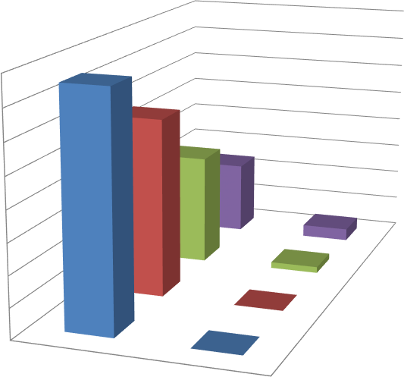
GRAPH NO: - 3 (showing the debt equity ratio of both the companies as extracted from table no. 3)
0.4
0.35
0.3
0.25
0.2
0.15
0.1
0.05
0
2020-21
2019-20
2018-19
2017-18
2018-19
2019-20
2020-21
2017-18
SHREE
AMBUJA
Y-axis measure the Debt Equity Ratio and X-axis measures the consecutive years

COMMENT:-
Lower the ratio better for the Company. Here we can clearly see that AMBUJA CEMENT is having a low debt equity ratio thus has a strong equity and long term financial position which is clearly reflected over the past four years. Hence, higher degree of protection enjoyed by the lenders. On the other hand SHREE CEMENT has a high debt equity ratio, hence, risk associated with the menders are high.
PROFITABILITY RATIO
Profitability ratios are the financial ratios which talk about the profitability of a business with respect to its sales or investments. Since the ratios measure the efficiency of operations of a business with the help of profits, they are called profitability ratios. They are quite useful tools to understand the efficiencies
/ inefficiencies of a business and thereby assist management and owners to take corrective actions. Profitability ratios are the tools for financial analysis which communicate about the final goal of a business. For all the profit oriented businesses, the final goal is none other than the profits. Profits are the life blood of any business without which a business cannot remain a going concern. Since, the profitability ratios deal with the profits, they are as important as the profits.
Gross profit margin Net profit margin

GROSS PROFIT MARGIN

Gross profit margin (gross margin) is the ratio of gross profit (gross sales less cost of sales) to sales revenue. It is the percentage by which gross profits exceed production costs. Gross margins reveal how much a company earns taking into consideration the costs that it incurs for producing its products or services. A company that boasts a higher gross margin than its competitors and industry is more efficient. FORMULA:-
Gross Profit Margin = Gross Profit / Net Sales * 100

TABLE NO: - 4 (showing a comparison of gross profit margin of SHREE CEMENT AND AMBUJA CEMENT in the consecutive four years)
 | 2017-18 | 2018-19 | 2019-20 | 2020-21
SHREE | 16.00 | 10.75 | 16.59 | 22.36
AMBUJA | 11.82 | 13.75 | 18.69 | 19.02

**NOTE – The figures calculated above in the table is extracted from the financial annual report of both the companies.

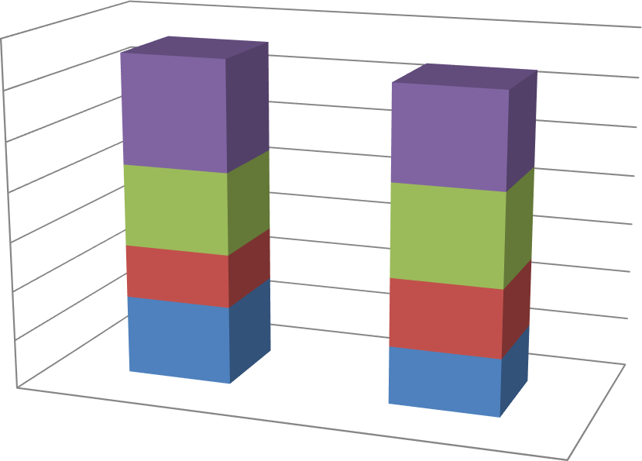
GRAPH NO: - 4 (showing the gross profit margin of both the companies as extracted from table no. 4)
70

60

50

40

30

20
2020-21
2019-20
2018-19
2017-18
10

0
SHREE
AMBUJA

Y-axis measure the Gross Profit Margin and X-axis measures the consecutive year.

COMMENT:-
It is quite obvious from the comparative graph that both the company is showing growth in its profit margin but at a very slow rate. AMBUJA CEMENT need to take necessary steps to grow in the market as its profit margin is declining at some years on the other hand we can see that SHREE CEMENT has started to grow but still in order to remain in the competitive market, it needs to take measures to improve its growth rate as soon as possible.

NET PROFIT MARGIN
Net profit margin (or profit margin, net margin, return on revenue) is a ratio of profitability calculated as after-tax net income (net profits) divided by sales (revenue). Net profit margin is displayed as a percentage. A higher net profit margin means that a company is more efficient at converting sales into actual profit.

FORMULA:-
Net Profit Margin = Net Profit / Net Sales * 100
TABLE NO :- 5 (showing a comparison of net profit margin of SHREE CEMENT AND AMBUJA CEMENT in the consecutive four years)

 | 2017-18 | 2018-19 | 2019-20 | 2020-21
SHREE | 14.07 | 8.11 | 13.19 | 18.36
AMBUJA | 13.09 | 13.10 | 15.74 | 14.89
**NOTE – The figures calculated above in the table is extracted from the financial annual report of both the companies.

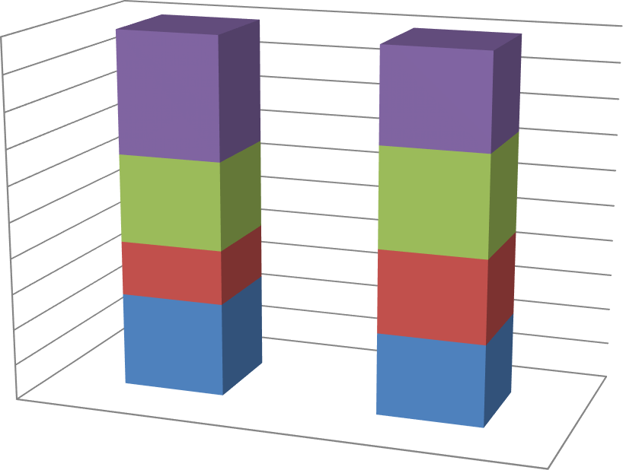
GRAPH NO: - 5 (showing the net profit margin of both the companies as extracted from table no. 5)
100%
90%
80%
70%
60%
50%
40%
30%
20%
10%
0%
2020-21
2019-20
2018-19
2017-18
SHREE
AMBUJA

Y-axis measure the Net Profit Margin and X-axis measures the consecutive years

COMMENT:-

From the graph extracted for the net profit margin we can see that AMBUJA Motor is declining from the last 4 years and there is no sign of improvement. On the other hand SHREE CEMENT is at a flourishing position with constant profit from 4 years .It should carry on its business but should take necessary measures to increase its profit .

4. CONCLUSION AND RECOMMENDATION

SUMMARY OBSERVATIONS
The purpose of the study is to investigate the impact of comparative ratio analysis of SHREE CEMENT AND AMBUJA CEMENT over a period of four consecutive years. The study aims to examine the statistical significance by way of computing accounting ratios. The accounting ratios show both increase and decrease in trend but still manages to show a stable economic position.
The statement of current ratio shows that both the companies have not mange to cover up and reach its ideal ratio at 2:1 in any of the years. SHREE CEMENT will be having difficulty in meeting their current obligations as its average current ratio is just 1 as compared to AMBUJA CEMENT which is at a better position in meeting their current obligations.
The quick ratio of SHREE CEMENT in less than 1 from the consecutive 4 years on an average basis thus limiting themselves from a quick payment to its creditors. AMBUJA CEMENT is trying to achieve its ideal position and can pay off its short term liabilities quite easily.
In the debt equity ratio we can observe that AMBUJA CEMENT is moving towards it ideal position from 2017-18 till 2020-21 on the other hand SHREE CEMENT is constantly moving away from its ideal position hence increasing the risk in investing the company.
Gross profit margin of AMBUJA CEMENT is not growing at constant rate. It is declining in alternative years. SHREE CEMENT is having a good share of profit and can grow further with proper measure.

SUGGESTIONS AND RECOMMENDATIONS

Efforts have been made in this project to fulfill the purpose of knowing the trend of both the companies in the market. The analysis made for the present financial position of SHREE CEMENT AND AMBUJA CEMENT by means of comparison of accounting ratios for the fiscal years 2017-18,2018-19,2019-20 and 2020-21 showing us a slow increasing trend in the financial position of the SHREE CEMENT and a steady growth over the years for the AMBUJA CEMENT. Though for improvement of SHREE MOTOR’S profitability, much emphasis should be given on decreasing current liabilities through reducing the unplanned overhead expenses. A stable current assets position can be ensured by recovery of all the debts on due time. The companies must give importance to unplanned and unproductive expenses and must adopt a strict credit policy.
Further, the accounting ratios computed though provide us with a continuous and stable overview on the financial position of the AMBUJA CEMENT, still in certain cases it has decreased than the previous years. Thus the company must make some extra effort to retain its increasing trend of profitability in the future years. The sales policy and procedure also must be subject to continuous change to retain the interest of consumers. The following recommendations are on the basis of the accounting ratios computed in this case study. Thus the result may or may not be accurate on which the above recommendations are made.

REFERENCES

JOURNALS
Pandey and Parera (1997) Working capital management in Shrilanka by
I. M. Pandey and K. L. W. Perera (Working Paper, No. 1997/1349)
Morris Lamberson, (1995) "Changes in Working Capital of Small Firms in Relation to Changes in Economic Activity", American Journal of Business, Vol. 10 Iss: 2, pp.45
– 50 http://www.emeraldinsight.com/journals.htm?articleid=1917723 Filbeck, G. and T. Krueger. An Analysis of Working Capital Management Results Across Industries. Mid-American Journal of Business 20 (2):11-18, (2005) http://www.bsu.edu/mcobwin/majb/?p=64

BOOKS
- Bhadra & Satpati, Financial Reporting and Financial Statement Analysis, Kolkata, Dishari Prakashani, 2020
- Kar, S. & Bagchi, N., Financial Reporting and Financial Statement Analysis, Kolkata, Dey Book Concern, 2021
- Khan, M. Y. & Jain, P.K., Financial Management, Delhi, McGraw-Hill Education (India) Pvt, 2005

WEBSITE ANNUAL REPORT
- https://www.moneycontrol.com/financials/ambujacements/balance- sheetVI/ac18#ac18 (Last Accessed on 02-04-2023)
- https://www.moneycontrol.com/financials/shreecements/balance- sheetVI/sc12#sc12 (Last Accessed on 13-04-2023)

- https://www.moneycontrol.com/financials/ambujacements/ratios/ac18 (Last Accessed on 01-05-2023)
- https://www.moneycontrol.com/financials/shreecements/ratios/sc12/1#s c12(Last Accessed on 02-04-2023)

ANNEXURES
THE FINANCIAL REPORT OF SHREE CEMENT OF 2017-18, 2018-19, 2019-20 AND 2020-21

Standalone Balance Sheet
 | Mar 21 | Mar 20 | Mar 19 | Mar 18
SHREE CEMENTS | 12 months | 12 months | 12 months | 12 months
EQUITIES & LIABILITIES
SHAREHOLDER'S FUNDS
Equity Share Capital | 36.08 | 36.08 | 34.84 | 34.84
Total Share Capital | 36.08 | 36.08 | 34.84 | 34.84
Reserves and Surplus | 15,213.99 | 12,900.34 | 9,562.55 | 8,861.99
Total Reserves and Surplus | 15,213.99 | 12,900.34 | 9,562.55 | 8,861.99
Total Shareholders’ Funds | 15,250.07 | 12,936.42 | 9,597.39 | 8,896.83
NON-CURRENT LIABILITIES
Long Term Borrowings | 1,331.55 | 1,638.70 | 2,309.04 | 2,208.13
Other Long Term Liabilities | 931.22 | 944.91 | 1,291.92 | 1,062.12
Long Term Provisions | 10.55 | 9.18 | 8.24 | 7.61
Total Non-Current Liabilities | 2,273.32 | 2,592.79 | 3,609.20 | 3,277.86
CURRENT LIABILITIES
Short Term Borrowings | 508.08 | 708.74 | 467.95 | 1,185.86
Trade Payables | 785.79 | 528.02 | 450.79 | 727.27
Other Current Liabilities | 2,219.60 | 2,570.79 | 1,066.89 | 1,053.07
Short Term Provisions | 1.91 | 1.11 | 1.03 | 0.94
Total Current Liabilities | 3,515.38 | 3,808.66 | 1,986.66 | 2,967.14
Total Capital And Liabilities | 21,038.77 | 19,337.87 | 15,193.25 | 15,141.83
ASSETS
NON-CURRENT ASSETS
Tangible Assets | 4,164.58 | 4,299.55 | 4,465.04 | 3,577.11
Intangible Assets | 26.97 | 19.37 | 10.63 | 12.07
Capital Work-In-Progress | 970.96 | 962.11 | 1,121.11 | 1,427.15
Fixed Assets | 5,162.51 | 5,281.03 | 5,596.78 | 5,016.33
Non-Current Investments | 7,271.28 | 5,829.17 | 4,411.14 | 3,123.29
Deferred Tax Assets [Net] | 785.50 | 743.78 | 612.64 | 513.05
Long Term Loans And Advances | 60.67 | 52.70 | 51.87 | 48.81
Other Non-Current Assets | 559.35 | 605.62 | 529.13 | 740.19
Total Non-Current Assets | 13,839.31 | 12,512.30 | 11,201.56 | 9,441.67
CURRENT ASSETS
Current Investments | 3,779.33 | 3,086.26 | 32.74 | 2,311.04
Inventories | 1,477.17 | 1,427.85 | 1,589.05 | 1,569.02
Trade Receivables | 485.89 | 828.45 | 732.40 | 459.25
Cash And Cash Equivalents | 209.76 | 108.16 | 307.78 | 120.90
Short Term Loans And Advances | 25.01 | 7.63 | 9.65 | 7.77

Other Current Assets | 1,222.30 | 1,367.22 | 1,320.07 | 1,232.18
Total Current Assets | 7,199.46 | 6,825.57 | 3,991.69 | 5,700.16
Total Assets | 21,038.77 | 19,337.87 | 15,193.25 | 15,141.83
THEFINANCIAL REPORT OF AMBUJA CEMENT OF 2017-18, 2018-19, 2019-20 AND 2020-21

Standalone Balance Sheet
 | Dec 21 | Dec 20 | Dec 19 | Dec 18
AMBUJA CEMENT | 12 months | 12 months | 12 months | 12 months
EQUITIES & LIABILITIES
SHAREHOLDER'S FUNDS
Equity Share Capital | 397.13 | 397.13 | 397.13 | 397.13
Total Share Capital | 397.13 | 397.13 | 397.13 | 397.13
Reserves and Surplus | 21,810.13 | 19,918.73 | 21,808.05 | 20,615.40
Total Reserves and Surplus | 21,810.13 | 19,918.73 | 21,808.05 | 20,615.40
Total Shareholders’ Funds | 22,207.26 | 20,315.86 | 22,205.18 | 21,012.53
NON-CURRENT LIABILITIES
Long Term Borrowings | 43.50 | 43.60 | 35.28 | 39.68
Deferred Tax Liabilities [Net] | 201.79 | 185.95 | 216.06 | 372.16
Other Long Term Liabilities | 298.02 | 336.82 | 36.45 | 8.35
Long Term Provisions | 65.12 | 55.62 | 50.34 | 38.53
Total Non-Current Liabilities | 608.43 | 621.99 | 338.13 | 458.72
CURRENT LIABILITIES
Trade Payables | 1,144.40 | 880.90 | 935.98 | 1,109.46
Other Current Liabilities | 4,204.43 | 3,658.78 | 3,426.07 | 2,514.92
Short Term Provisions | 8.92 | 3.85 | 85.37 | 91.05
Total Current Liabilities | 5,357.75 | 4,543.53 | 4,447.42 | 3,715.43
Total Capital And Liabilities | 28,173.44 | 25,481.38 | 26,990.73 | 25,186.68
ASSETS
NON-CURRENT ASSETS
Tangible Assets | 7,471.56 | 5,756.86 | 5,633.62 | 5,563.19
Intangible Assets | 174.15 | 174.64 | 178.83 | 100.41
Capital Work-In-Progress | 951.32 | 1,873.74 | 1,108.70 | 610.02
Intangible Assets Under Development | 0.00 | 0.00 | 0.00 | 0.00
Fixed Assets | 8,597.03 | 7,805.24 | 6,921.15 | 6,273.62
Non-Current Investments | 11,796.91 | 11,792.21 | 11,789.01 | 11,813.76
Long Term Loans And Advances | 1.52 | 76.35 | 62.90 | 60.34
Other Non-Current Assets | 1,003.31 | 1,376.77 | 1,369.57 | 1,298.66
Total Non-Current Assets | 21,398.77 | 21,050.57 | 20,142.63 | 19,446.38
CURRENT ASSETS
Inventories | 1,463.57 | 746.61 | 954.07 | 1,277.76
Trade Receivables | 293.17 | 191.51 | 513.22 | 470.26
Cash And Cash Equivalents | 4,163.07 | 2,924.34 | 4,699.49 | 3,329.97
Short Term Loans And Advances | 4.76 | 4.43 | 4.51 | 4.29
Other Current Assets | 850.10 | 563.92 | 676.81 | 658.02
Total Current Assets | 6,774.67 | 4,430.81 | 6,848.10 | 5,740.30
Total Assets | 28,173.44 | 25,481.38 | 26,990.73 | 25,186.68

