Project Report
(Submitted for the Degree of B.Com. Honours in Accounting & Finance under the University of Calcutta)

PRE AND POST EFFECTS OF PANDEMIC SITUATION ON INDIAN
TOURISM INDUSTRY

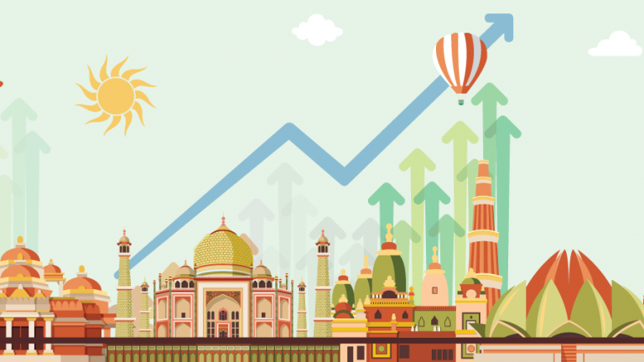

SUBMITTED BY
NAME OF THE CANDIDATE :Trisha Sen
REGISTRATION NO :144-0741-1211-20
ROLL NO :201144-11-0067
COLLEGE ROLL NO : BH0298

SUPERVISED BY
NAME OF THE SUPERVISIOR : Dr.Moumita Sarkar (Samanta)
NAME OF THE COLLEGE :Bangabasi Morning College

MONTH AND YEAR OF SUBMISSION
May2023

Annexure-I
SUPERVISOR’S CERTIFICATE

This is to certify that Miss. Trisha Sen a student of B.com Honours in Accounting & Finance of Bangabasi Morning College under University of Calcutta has worked under my supervision and guidance for the title PRE AND POST EFFECTS OF PANDEMIC SITUATION ON INDIAN TOURISM INDUSTRY which she is submitting. Her Genuine and original work to the best of my knowledge.

Place : Kolkata Signature:
Date: Name: Dr. Moumita Sarkar (Samanta)
Designation: Assistant Professor
Name of College: Bangabasi Morning College.

Annexure-II
STUDENT DECLARATION

I hereby declare that this project PRE AND POST EFFECTS OF PANDEMIC SITUATION ON INDIAN TOURISM INDUSTRY submitted by me for the partial fulfillment of the degree B.Com honours in accounting and finance under University of Calcutta is my original work and has not been submitted earlier under any other University or institution for fulfillment the requirement of other course of study.
I also declared that no chapter of this manuscript or part has been incorporated in this report from any earlier work done by others or by me.
However, extracts of any literature which has been used for this report has been duly acknowledge providing details of search literature in this reference.

Place : Kolkata Signature:
Date: Name: Trisha Sen
Address : 25 B Durga charan Doctor Road. Kolkata-700016
Name of College: Bangabasi Morning College.
CU. Reg. No.: 144-0741-1211-20
CU. Roll No.: 201144-11-0067
College Roll No.: BH0298

CONTENTS

SL. No. | TOPICS | PG. NO.
1  2  3  4  5 | Chapter:1  Introduction  - Background  - Object of Study  - Research and Methodology  - Limitation of study  - Chapter planning  Chapter:2  Conceptual Framework  - Pandemic and Indian Tourism  - Tourism Industry Economy In Normal Situation  - Tourism Industry Economy During The COVID-19 Pandemic  Chapter : 3  Presentation of Data And Analysis  - Impact of pandemic on Economy, Employment and Income  - The Indian Economy in Normal Situation  - The tourism industry during Pandemic situation  Chapter :4  Conclusion and Recommendation  - Tourism Economy Going Forward  - Recommendation of Revival of tourism in India  Bibliography | 5-6  6  7-8  8  9  10-12  12-13  13  14-15  15  15-16  17-22  22-26  27

CHAPTER – 1
INTRODUCTION

BACKGROUND
Peninsular India is one of the largest democratic countries in the world. The economic composition, civilization, culture, natural and artificial beauties, ecosystem, and local advantages attract the attention of both domestic and foreign tourists. The recent experience of the area showed that there have been amazing improvements in transportation, hotels, accommodation, restaurants and tourism related markets in India. As a vibrant segment of the economy, tourism is not only a potential source of employment generation, but also a substantial source for foreign exchange earnings. According to the World Travel and Tourism Council (WTTC), India’s tourism in 2018 was in third position out of 185 countries with respect to the contribution to the nation’s total GDP. From 2019 records, this sector obtained US$29.96 billion, reflecting a 4.8% growth when compared to the previous year; it reached US$5.40 billion in the first part of 2020. India is in 34th place in terms of tourism competitiveness (IBEF, 2020). In addition, the significance of this sector to the nation’s overall economy can be seen in Figure 1 below.

Figure1:DirectContributionofTourismandHospitalityto
GDP(US$bn)
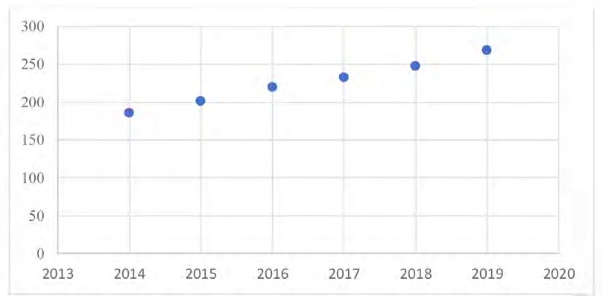

Recent trends in the tourism sector revealed that India has been blessed by digital instruments for tourism-related activities, such as tourism planning, selecting destinations and making the journey. Domestic tourists are the support system of the Indian tourism industry, and it is a stylized fact that the increasing size of the middle income group and their disposable income extends their support for the development of the tourism sector. The authentic statistics published by both governments of India and the tourism department revealed that, in2019, a total of 10.89 million foreign tourists visited India, accounting for a 3.2% growth. Mention should be made here that this sector has accommodated 4.2crore people, which is 8.1% of the nation’s total employment during the 2019. In fact, this is an incredible achievement in a populous country like India, where people are striving for employment and a higher income. Official predictions reported that this sector may generate 52.3million job opportunities by 2028 (DPIIT,2020). Unfortunately, COVID-19 entered the tourism map of India and the system collapsed.

LITERATURE REVIEW
Tourism industry in India is the backbone of the country. Tourism was affected in the past due to different disruptive events like terrorist attack of 9/11 or epidemic outbreaks of SARS, Ebola virus, Swine Flu etc. (Wen et al., 2020). But the recent outbreak of Covid 19 which originated in Wuhan, China has severely affected almost most of the industries including Tourism Industry worldwide (Yeh, 2020). The World Travel & Tourism Council projected a tourism-related loss of up to US$ 2.1 trillion in 2020 and up to 75 million jobs (WTTC, 2020). (Sigala, 2020) refers about tourism impact and transformational affordance of the COVID-19 pandemic. The study discusses how the pandemic has altered the behaviours and experiences of various tourism stakeholders in the form of tourism demand, supply and destination management, and policymaking. Covid 19 has an adverse impact on air transport and before this, aviation sector was severely affected during SARS 2003. But the worse effect on aviation sector is more in Covid 19 pandemic than that of SARS (Suau-Sanchez et.al, 2020). The global recession was provoked by the outbreak of corona virus (Ozili and Arun, 2020). The medical tourism was also disrupted due to spread of this virus, which was estimated at $28 billion in 2020 has decreased rapidly (Mehta and Jha, 2020). Outbreak of corona virus has highly damaged India’s tourism and hospitality industry.

OBJECTIVEOF STUDY

This study aims to assess the estimated loss to the economy and to the income of
households because of the COVID-19 pandemic. The key objectives of the study are:
- Quantify the sector-wise (or industry-wise) direct and indirect impacts of tourism activities on the overall economy, and especially on household income, which may be further disaggregated into different types of households like formal and informal;
- Quantify the sector-wise loss in income, and in the overall economy and of the household sector; and also the loss in jobs due to the impact of the Coronavirus pandemicon the tourism sector;
- Estimate the impact of the gradual opening up of domestic tourism activities and thesectors related to tourism;
- Estimate the likely impact of the opening of international tourism, in a phased manner; and Propose policy measures appropriate for providing relief to the tourism sector, ingeneral, and households involved in tourism-related activities, in particular, based onfeedback received from various stakeholders.

RESEARCH AND METHODOLOGY

The study captures the impact of the pandemic on the Indian tourism sector from a 360degree perspective. It looks into the sectoral activity level to understand its contribution to employment and GDP, and finally into the income loss, especially for households that are directly or indirectly involved with tourism activities. The study has also used macroeconomic modeling including the Input-Output model and Social Accounting Matrix. This facilitated capturing of the multiplier effects that reflect the economy-wide impacts emanating from the loss of tourism activities. In order to quantify the economic impact of the fall in tourism activities on Gross Value Added (GVA), the study estimated the values of Tourism Direct GVA (TDGVA) from the following perspectives:
- Tourism economy in a normal situation;
- Tourism economy due to the supply-side shock caused by the COVID-19 pandemic;
- Tourism economy due to the demand-side shock caused by the COVID-19
pandemic, which can be further dissected into:
- Inbound tourism demand-side shock; and
- Domestic tourism demand-side shock.
The TDGVA for each tourism industry has been estimated by applying the Tourism
Industry Ratios (TIRs) on the industry’s overall GVA. The TIRs indicate the part of GVA which is on account of Tourism. This has been done in the Supply and Use Table (SUT)framework of the Tourism Satellite Account (TSA). In a normal situation and in the case of an impact caused by a supply shock, the TIRs are assumed to be the same as those derived in the TSA for 2015-16.

In order to estimate the impact of the demand-side shock, the study required an
estimation of tourism demand during the study reference period, which covers the pandemic situation, that is, the first three quarters of 2020-21 [till the latest data on GDP are available from the Ministry of Statistics and Programme Implementation, (MoSPI)].This, in turn, required the estimates of inbound and domestic tourist arrival during the same period, which were provided by the Ministry of Tourism (MoT). The new TIRs were derived by applying the quarter-wise year-on-year fall in the number of inbound and domestic tourists on the inbound and domestic tourism expenditure, respectively. Further, in order to estimate the loss in jobs in the tourism sector, the key data source used in this study were the employment data obtained from the Periodic Labour Force Survey (PLFS) conducted by MoSPI. The PLFS provides annual employment estimates. In order to derive the estimates at the quarterly level, employment elasticity’s were used. The study also estimates the loss in jobs by work status, that is, employees and the self-employed.

Besides, the study estimates the impact on income of the households engaged in tourism activities. The income estimates have also been categorised into income drawn by employees (wage income) and income earned by the self-employed (non-wage income).The data for this exercise were sourced from the National Accounts Statistics, 2021, and through estimation at the sectoral level. In addition, estimation was also done at the quarterly level using the SUT framework of TSA and using the growth estimated in the number of employees and self-employed respectively.

This study also presents the expected outlook for the tourism sector in the coming years and answers questions on the time required for the revival of the sector and the expected time by which the tourism economy will reach the pre-pandemic levels. This points to the number of years lost due to the pandemic, the aftermath of which continues to be felt.

This is followed by a section on Recommendations proposed for the revival of the tourism sector in India, based on international experiences and feedback from stakeholders.

LIMITATION OF THE STUDY

As datasets and high-quality materials are very limited in this area, the present study relies mostly on Internet sources and a few published articles. Although the present study presented a broad spectrum about the impact of COVID-19 on global tourism, the main focus of the paper is to measure the impact in the Indian context.

CHAPTER PLANNING

The study is divided into four sections these are:-
1. Introduction
1.1 Background
1.2 Objective of study
1.3 Review of literature
1.4 Research methodology
1.5 Limitation of the study

2. Conceptual framework
3. Presentation and Data Analysis
4. Conclusion and Recommendation

CHAPTER – 2
CONCEPTUAL FRAMEWORK

PANDEMIC AND INDIAN TOURISM

According to UNDESA(2020), the impact of COVID-19 on the tourism industry is as follows:

“many tourism dependent countries rely heavily on tourist arrivals from a particular country–the United States, for example–as in the case of many Caribbean countries. These economies would experience sharp increases in unemployment rates affecting the livelihood of low-skilled workers and the morevulnerablesegmentsofsocietythatdependonincomefromtourism-relatedactivities”.

UNWTO (2020) reported the impact of the recent crisis on international tourism as:“the unparalleled and fast-evolving nature of the crisis, it is extremely challenging to estimate the impact of COVID-19oninternationaltourism”:theyestimatedthat“internationaltouristarrivalscoulddeclineby20% to 30% in 2020”. In addition, UNWTO (2020) computed that the monetary loss of COVID-19 wouldbeUS$300-450billionwithrespecttointernationaltourism receipts. OECD (2020a) disclosed that the impact of COVID-19 on international tourism couldbealossofbetween45%and70%, which is more pessimistic than that of the UNWTO.

ThesectoralimpactofCOVID-19 is as follows. ThemostapparentandinstantimpactofCOVID-19can be seen in the sub-segments of the tourism industry around the world. In fact, the immediateshockemergedinallthegeographicalsegmentsoftourism.Itcanbeseenthatthehotelandtourism sector in all geographical areas is strongly threatened both by the virus and the restrictions imposed by governmentstocontrolthespreadofthenovelvirus.Asaresultoftherestrictionsimposed,from global level agencies such as the WHO up to the local authorities, flights have been cancelled, conferences have been postponed, hotel booking shave been negated, and almost all restaurants and markets in tourism localities are empty. With respect
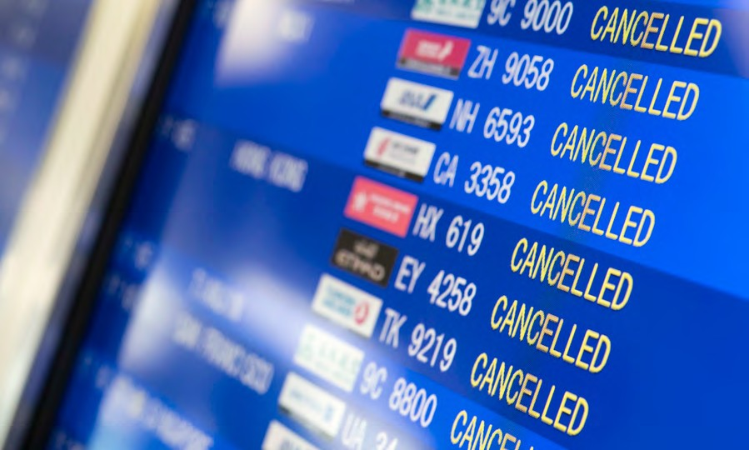

to India, the situation was worse. The Ministry of Civil Aviation of India witnessed that around 30%of international tourists immediately cancelled theirtripamidfearsoftheeffectsofCOVID-19.
Figure 2: Potential Impact of COVID-19ontheIndian Economy

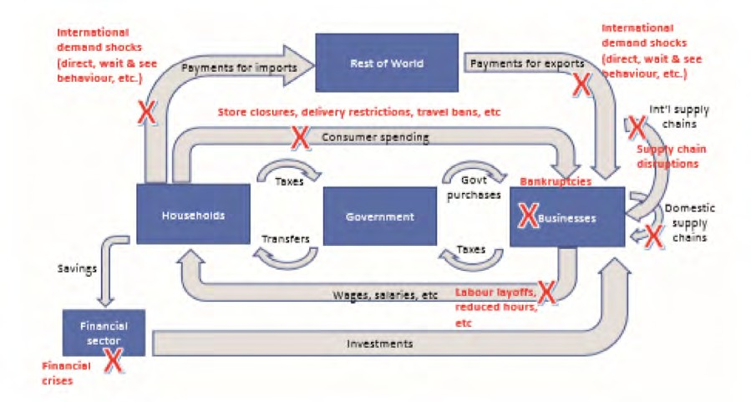
In India, the summer vacation is the suitable period for leisure tourism; the entire tourism sector uses this period to obtain temporary bromine come. However, the situation was different attend of 2019 and the first phase of 2020 in that both domestic and foreign tourists that had planned trips to attractive destinations, such as Delhi, Amritsar,Kerala, Coimbatore, Goa, Leh, Guwahati, Srinagarand Rajasthan, cancelled their holidays. The annualreportoftheMinistryofTourismrevealedthat40-50% of summer bookings have been cancelled. As a result of the restocks, business people, market places,travel industry,hotels,restaurants,andothersectorsconnectedtotourismhavebeenaffected. The statisticsavailablerevealed that the Indian tourism sector will generate a total revenue loss of Rs 1.25 trillion in 2020 as a resultof COVID-19. Further evidence revealed that the majority of people employed in the tourism sector lost their jobs and have again been pushed into aviciouscircleofpoverty.Thenetresultofallthesenegativetrendsimpactedtheoveralleconomicdevelopment of India. The impact of COVID-19 onthe whole economy can be expressed through theflowchartshowninFigure2.

The Tourism Economy in a Normal Situation

- The Tourism Satellite Account (TSA) is an important tool for estimating thecontributions of tourism to the economy. According to the second and third TSAs,the tourism sector contributed as much as 6.8 per cent and 5.2 per cent directlyand indirectly to the country’s total GDP. The direct shares for these years were 3.7 per cent and 2.7 per cent, respectively.
- For the present study, we have also derived the income multiplier to estimate theimpact of an increase in tourism demand on the overall household income of the economy through the preparation of a Social Accounting Matrix (SAM). This is because SAM constitutes not only the production account but also incorporates the household account. Hence, it presents the transactions between the production sectors and the households drawing income from these sectors. The SAM-based multiplier analysis reveals that the income multiplier of the tourism sector is 1.6332. Hence, if the tourism demand or tourism expenditure increases by, say, Rs.1 crore, then owing to the direct and indirect linkages among the sectors of theeconomy, the overall household income of the economy is expected to increase byRs. 1.63 crore.

The Tourism Economy during the COVID-19 Pandemic

The impact of the pandemic on tourism has been captured through the estimation of TDGVA for all the three quarters of 2020-21, and across the following aspects in such away that the impact of the pandemic due to different types of shocks has been captured separately.
- Impact due to the Supply-side Shock: This relates to the overall economics lowdown during 2020-21 and assumes that tourism was rather resilient and continued as before. Hence, this scenario takes into account only the supply side shock. Therefore, the TIRs are assumed to remain the same for all the quarters of 2020-21 as those for pre-pandemic years.
- Impact due to the Demand-side Shock: This refers to the impact of the pandemic on the tourism economy, with both the supply-side shock emanating from the economic slowdown and the demand-side shock resulting from the limited tourism activity in the country during the three quarters of the study. The limited tourism activity translates into a huge reduction in tourism expenditure incurred by all types of tourists— inbound, domestic, and outbound. Hence these estimates reflect the most likely loss in TDGVA.

CHAPTER – 3
PRESENTATION OF DATA AND ANALYSIS

IMPACT OF PANDAMIC ON ECONOMY, EMPLOYMENT AND INCOME

This section delineates the estimated impacts on various macro-economic parameters linked with tourism activities in the country. Since these economic parameters were estimated on the basis of different envisaged situations, their analyses and findings are presented in accordance with the relevant situations to make the study more comprehensive and reader-friendly.

THE INDIAN TOURISM IN NORMAL SITUATION

Thetourismsectorhasbeenasignificantcontributortothevaluegeneration,employment, and foreign exchange earnings of any economy. The Tourism SatelliteAccount (TSA) is an important tool for estimating these contributions to the economy.For India, the latest TSA was prepared for the reference year of 2015-16. This was theThird TSA for India. This and the previous TSA for 2009-10 were both based on theframework suggested by the United Nations World Tourism Organization (UNWTO) initspublication“TourismSatelliteAccount:RecommendedMethodologicalFramework – 2008” (TSA - RMF 2008)
6.8
3.7
5.2
2.7
2009-10
Direct
2015-16
Direct+Indirect
Source:2ndand3rdTSAofIndia,NCAER.

These TSAs estimate both the direct and indirect contributions of tourism to the country’s GDP. The indirect contributions result from the spill-over effects of an economic activity owing to it sinter-linkages with all the other
economic activities. According to the second and third TSAs, the direct and indirect contributions of the tourism sector to the country’s total GDP were 6.8 per cent and 5.2percent,respectively. The corresponding figures for the direct shares for these yearswerepercentand2.7percent,respectively.

The direct and indirect shares have been obtained through the derivation of the GVA multiplier, which stood at 1.9236, according to the Third TSA. The interpretation of this multiplier is that if the tourism demand increases by one unit, the overall GVA of theeconomyisestimatedtoincreaseby1.9236units,owing to the activities triggered in other sectors of the economy due to the increased demand for tourism.
For the present study, we have also derived the income multiplier for estimating the impact of an increase in the demand for tourism on the overall household income of the economy. For this purpose, a Social Accounting Matrix (SAM) has been prepared for thenormalyearof2018-19.The SAM issued to capture the direct as well as indirect impacts on house hold income. It may be noted here that an Input-Output(IO)TablewaspreparedaspartoftheThirdTSAinordertoderivethedirectandindirectcontributionoftourismto the overall economy. However, for the current study, the SAM has been preparedinsteadasitismoreappropriateforestimatingtheimpactonhouseholdincome.Followingarethekeydifferences between an IO Table and a SAM:

- SAM is an extension of an IO Table.
- An IO Table is a production account which presents the transactions amongthe production sectors of the economy. On the other hand, SAM not onlyconstitutestheproductionaccountbutalsoincorporatesthehouseholdaccount. Hence, it presents the transactions between the production sectors and the households drawing income from these sectors.
- An IO Table quantifies the impact of a sector, say tourism, on the overalleconomywhereasSAMalsoquantifiestheimpactonincomeearnedbydifferent types of households, thereby enabling more specific and focusedpolicyrecommendationstoassistthesectorandtheeconomyasawhole.

- For this study, SAM is based on the production sectors, as given in the SUTframework of the Third TSA. Hence, it comprises a total of 24 productionsectors, of which 11are the tourism-characteristic sectors, 8 are tourism-connectedsectors,and5arenon-tourism-specificsectors.

The SAM-based multiplier analysis reveals that the income multiplier of the tourismsector is 1.6332. Hence, if the tourism demand increases by one unit, then, owing to thedirect and indirect linkages among the sectors of the economy, the overall income isexpectedtoincreaseby1.6332 units.
As an example, if the tourism expenditure increases by just Rs. 1 crore (the originaltourism expenditure for 2018-19 is estimated at Rs. 11.8 lakh crore), then the overallhouseholdincomeoftheeconomyisexpectedtoincreasebyRs.1.63crore.Thisindicatestheimpact thatthetourismsectorhasontheincomesdrawnby households.

THE TOURISM INDUSTRY DURING COVID-19 PANDAMIC

Thissectionpresentstheestimatedimpactofthepandemic and its after-effects on the tourism sector.The pandemic not only resulted in restrictions on themovement of people, especially during the lockdownperiod, but also caused huge losses in the demand fortourism,asgeneratedbytouristswhiletheyareona
trip. The study estimates the TDGVA for the first, second, and third quarters of 2020-21,that is, the period for which the data on the overall GVA are available from MoSPI.Thesame have also been estimated for the corresponding quarters of the previous year, inordertoderive theyear-on-year fall inTDGVA during 2020-21.
According to the COVID-19 timeline for India the first quarter of 2020-21witnessed a lockdown and also a curfew in some areas of many States. The movement ofpeopleandmanyeconomicactivitieswererestrictedduringthislockdownperiod.Towardstheendofthefirstquarter(Q1),thatis,onJune8,2020,Unlock1.0wasannouncedunderwhichthegovernmentallowedre-openingofmalls,hotels,restaurants,and places of worship. In the second quarter (Q2), several Unlock measures (Unlock 2.0to Unlock 4.0) were announced, including resumption of train and flight services. WiththetaperingdownofCOVID-19newcases,onsetoffestivals,occurrenceofsocialceremonies and people getting desperate to travel, some amount of domestic tourismactivities started during the third quarter (Q3), with due Standard Operating Procedures (SOPs)and exhorting people to follow precautions.

Figure 3: COVID-19IndiaTimeline

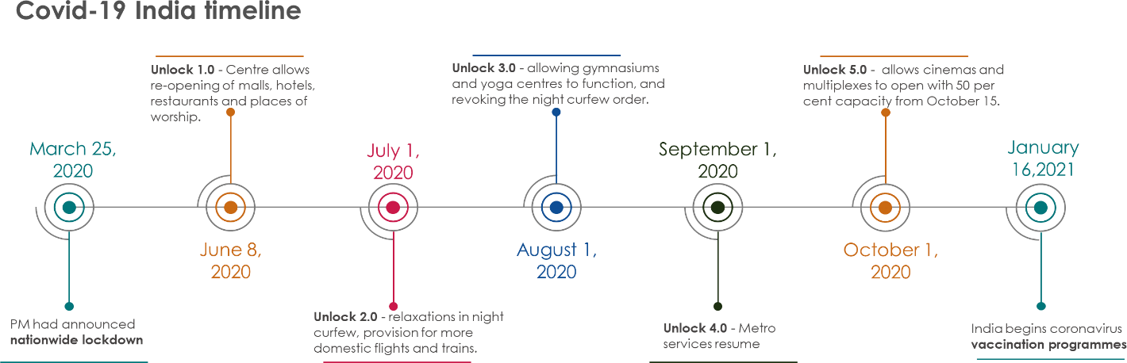

CHAPTER – 4
CONCLUSION AND RECOMMENDATION

Tourism Economy Going Forward—Future Outlook

The previous sections discussedtheimpactofthepandemiconthetourismeconomywithrespect to the TDGVA, employment, and household income, in 2020-21. This sectionpresents our outlook for the future, given the possibility of a third wave of COVID-19infectionsandalsothepossibilityofitsfadingawaywithtime,which is expected to result in a very strong rebound in tourism activity and the tourism economy, as a whole.
With the gradual opening up of international borders, revival of confidence to travel among people, success of the vaccination drive, and the lessons learnt from the previous waves of COVID-19 infection, tourism activity is expected to move towards normalcy soon. Besides, a new form of tourists are likely to emerge, that is, potential out bound tourists who will switch from international travel to domestic trips to exotic destinationsinIndialikeSrinagar,Goa,andRajasthan,amongothers.Thesetouristsarealreadybeingseeninthecountry.
In order to put forward our outlook, we have built the following three scenarios for allforms of tourism, that is, inbound, domestic, and outbound, and also outbound tourists who have switched to domestic trips:
    - Optimistic;
    - Most likely ;and
    - Pessimistic.

Starting with the most likely scenario, which is also quite realistic, the assumptions that have been taken in to account, with respect to all for most tourism are delineated below.

Assumptions for Domestic Tourism—Most likely Scenario

- The current wave reached its peak somewhere by the end of May. Hence, we considerthepeak tobein May-end.
- Considering similar trends as those noticed during the first wave, the impact of thesecondwavewillbeminimised(intermsofthedetectionofnewinfections)byaroundAugust-end.
- Inthatcase,withStategovernmentsallowingmovementwithinandacrosstheborders, and people regaining the confidence to travel, tourism activities shouldresumebyaround October2021.
- Thisleavesuswithaboutsixmonthsthatcanbeconsideredforrenewedbutrestrictedtourismactivitiesduring FY 2021-22.
- Therefore,assumingthatallotherconditionsremainthesameasin2020-21,asimilarnumberofdomestictrips/touristsorslightlylesscanbeassumedtotakeplace(itmaybenotedthatin2020also,tourismactivitystartedduringAugust/September).
- However,withthesecondwavehavinghadamuchhigherimpact,prospectivetouristswould have much lower confidence to travel as compared to the first wave. This willalsoresultintheimplementationofmorestringentmeasuresbyStategovernmentsinthewakeof thesecond wave.
- On the other hand, in case an adequate number of vaccinations are done pan India,theresponseratetotravelactivitiescouldattainthesamelevelasthatoflastyear.
- If the above scenario occurs and COVID is brought under control at the end of FY2021-22,onemay expect buoyancyintourism in FY2022-23and2023-24.
- We can assume that with the suppressed desire to travel because of restrictions andreducedconfidencelevelsduringFY2021-22,a50percentincreasecaneasilybeseeninsubsequentyearsprovided theCOVIDsituationisbroughtcompletelyundercontrol.
- Similarly FY 2023-24 can also see a significant upturn and a similar increase in thenumberoftouristscouldbeseen(intermsofabsolutenumbers).Again,theassumptionisthat COVID remainsunder control.
- From2024-25onward,weshouldexpectbuoyantyears,providedCOVIDiscontrolled(25percent growtheveryyear).

Assumptions for All Forms of Tourism—Optimistic Scenario

A figure of 5 per cent more than that in the most likely scenario is assumed for allforms of tourism except outbound tourists, for which our expectation remains thesameasin the most likelyscenario.

Assumptions for All Forms of Tourism—Pessimistic Scenario

- IfthereisathirdwaveofCOVID-19,we assume that it would start from October2021anditsimpact would last till December2021.
- However, the government will be much more prepared to face the third wave after the second wave experience. Also, it is anticipated that by that time, around 50percent of the population would have been vaccinated.
- Hence, inbound tourism activities would take place more or less for about three months in FY 2021-22 and would account for 80 per cent of the tourist activity as envisaged in the most likely scenario, for all the years after FY 2021-22.
- Domestictouristsareassumedtoconstitute60percentofthetotalnumberoftouristsinFY 2020-21.
- A rebound in domestic tourism is assumed to occur in FY 2022-23, with twice the number expected in FY2021-22.
- A similar buoyancy is assumed for the next year.
- Weassumea25percentannualgrowththereon.
- Weassumethatabout20percentoftheoutbound-turned-domestictouristsattheFY2020-21level will travel in FY 2021-22.
- A25percentannualincreasethereonisassumed.

The number of touristar rivals, based on these assumptions, across all forms of tourism, is presented in TableA10, AppendixI. The tour is expenditure for all forms of tourism has been estimated and presented in Table 1, based on the estimated per-tourist expenditure, taking into account the price escalation over the years.

With the assumptions stated above, it is expected that the tourism economy, in terms of tourism expenditure, will regain its pre-pandemic level by2024-25, primarily driven by domestic tourism As regardsinbound tourism, itsrevivalisexpected to be slower and is likely to reach thepre-pandemiclevelnotsoonerthan2026-27,evenaspertheoptimisticscenario.

However, even as per pessimistic scenario, domestic tourism (complemented by the outbound-turned domestic tourism) is likely to reach the pre-pandemic level much sooner, that is, by 2024-25.

Perspectives on the Tourism Industry Recovery Measures

It has been observed in the past that the tourism industry quickly bounces back after natural disasters or even pandemics or epidemics. The experiences from episodes of outbreak of Ebola, Severe Acute Respiratory Syndrome (SARS), or natural disasters likeearthquakesorfloodsinpastyearspointtothispattern.Governmentsatalllevelshaveaided the industry’s recovery by attracting investments through tax breaks, lenient land-use rules, and other measures (Brooder, 2020; Ioannidis and Gyimothy, 2020). The recovery strategies require effective and timely coordination, implementation of relevant crisis management techniques, responsive relationships among all the stake holders involved including Governments, recognition of risks and opportunities, and timely and scalable interventions (Alves et al., 2020; Fitriasari, 2020). Before international travel can resume, domestic tourism will boost the resumption of the tourism industry in the wake of the pandemic. Other factors, including technological resilience, local belongingness, and customer and employee confidence, may help build industry resilience, which is the need of the hour.
Four key elements relating to recovery of this industry, as identified by researchers, are essential for responding to the current situation. It is imperative to implement all these in tandem with well-crafted policy measures. The sekey elementsare:
- Government responsiveness;
- Technological innovation;
- Local belongingness; and
- Customer and employee confidence.

Promoting these elements can provide an opportunity to develop the industry from a new perspective which would fulfill the requirements of the new normal or the new economic order. The dimensions of the new normal that can be targeted through these measures are:

- Sustainable tourism;
- Well-being of the society towards lager goal;
- Mitigating climate change; and
- Engaging local communities.

Recommendations for the Revival of Tourism in India

This section discusses the recommendations proposed for the revival of the Indian tourism industry, which are based on the profile of Indian tourists and other countries’ experiences. These are also based on the feedback received from the tourism industry stakeholders like the Federation of Indian Chambers of Commerce and Industry (FICCI)Tourism Committee, Confederation of Indian Industry (CII) National Committee on Tourism and Hospitality, Associated Chambers of Commerce and Industry of India(ASSOCHAM), PHDCCI Tourism Committee, PATA (Pacific Asia Travel Association)India Chapter, Responsible Tourism Society of India(RTSOI),Indian Association of Tourism Parks and Industries (IATPI), Indian Golf Union, World Travel and Tourism Council India Initiative(WTTCII),Adventure Tour Operators Association of India(ATOAI), Association of Domestic Tour Operators of India (ADTOI), Indian Association of Tour Operators (IATO), Travel Agents Association of India (TTAI), Travel Agents Federation of India (TAFI), India Convention Promotion Bureau (ICPB), Internet and Mobile Association of India (IAMAI), Federation of Associations in Indian Tourism andHospitality(FAITH),and Association of Buddhist Tour Operators(ABTO).
The proposed recommendations are detailed below.

Promotion of Domestic Tourism
With the current restrictions on international travel to and from several countries, andtheirlikelycontinuationamidworriesofathirdwaveofCOVID-19inIndia,bothinboundand outbound tourism would be the most adversely impacted. However, if the Stateborders remain open, there is a possibility of the domestic industry holding steady.Althoughadomestictripcostsonlyaboutafractionofaninternationaltrip(bothinboundand outbound), statistics reveal that in terms of the total demand generated by all formsoftourism,domestictourismisthekeydrivingforce,givenitshugeincomparablevolume.
Figures 15 and 16 present the per-tourist expenditure and percentage distribution oftourism expenditure incurred by all forms of tourism (including expenditure incurred byoutbound tourists during their trips abroad)estimated for the pre-pandemic year of2019-20.

Figure16:Per Tourist Expenditure Incurred by All Forms of Tourism
210,015
59,933
5,429
14,286
Inbound
Domestic
OutboundPre- Outbound on-trip trip

Figure17: Percentage Distribution of Tourism Expenditure by All Forms of Tourism
2.6
25.5
71.8
Inbound Domestic
Outbound

Figure 15 and 16 indicate that while a domestic trip costs the least, at only Rs. 5429, as compared to the cost of anin bound trip(Rs.2.10lakh) and an out bound trip(Rs. 14,286as pre-trip and about Rs. 60,000 on-trip), given its huge volume in terms of the numberoftrips,thetotaltourismexpenditureincurredbydomestictouristsisover70percentofthetotalinternaltourismexpenditure.Hence,thecontributionoftourismtotheeconomyismainly on account ofdomestictourism.
Besides, domestic tourism is more resilient to natural calamities or pandemics as tripsundertakenespeciallyforsocial,health,andbusinesspurposesseldomgetseverelyimpactedunlessthere are extremesituationslike theimpositionof a curfew.
This study, therefore, recommends that domestic tourism should be promoted muchmore aggressively than inbound tourism. The Government has already launched severalinitiatives to boost domestic tourism like the ‘Dekho Apna Desh’ campaign under whichtourists are rewarded if they visit at least 15 destinations in the country in a year andsubmitpicturesofthetrips.ThereisalsoneedforState-levelpromotionsofsuchschemes.Further, given the prevalent conditions, the minimum number of trips to be taken under this scheme may be relaxed.

Diverting Outbound Tourists to Domestic Trips

IfIndiansarepreparedtospendtheirinternationaltravelbudgetsonhomesoilthisyear,individual operators may succeed by adopting bold and forward-thinking strategies that recognize and cater to the requirements of those who prefer to visit foreign countries, especially for the purpose of leisure. The tourists, especially those seeking recreational travel experiences away from home, will be driven by the following three key behavioral changes:
- Creating an enticing bucket for domestic destinations: This signifies anopportunitytoattractthoseoutboundtouristswhoprefertotravelabroadforacquiring a unique tourism experience. The adoption of a new approach from by policymakers and destination managers may alter the trend of people travelling a broad for a unique experience.
- New approach through working holidays: There accent flexible working arrangement including work-from-home during the pandemic has opened up a newhorizonoftravellingwithoutcompromisingtheproductivityoftheorganisations.Thetourismsectorwouldcertainlybenefitfrompoliciesthatcanpromotetheopportunityfor extended travel for tourists without being constrained by the need to take annual leave or adjust vacations to public holidays.
- Promoting regional or local destinations: Given the fact that much of the anticipated growth of tourism is expected to come from domestic travel, tourismpoliciesandpromotionsneedtohighlightregionalandlocaldestinationsfortravellers. It should be kept in mind that a lot of travels will be shorter in nature, entailing frequent visits to various places at short distances and also offering affordable holidays for a large segment of the tourists. Many of these will include more young professionals, older families, and backpacker schoolbook for adventure sand unique experiences through tourism.

Target Incentives to Industries Contributing Most to the Tourism Economy
Thedataontourismexpenditurerevealthatofallthetourism-characteristicproductsandservices, food and beverage providing services, road passenger transport services, andhealthcareprovidingservicesaccountforcloseto80percentofthetotaltourismexpenditureontourism-characteristicgoodsandservices.Thepercentagedistributionofalltourism-characteristicgoodsandservices,takenasanaverageoftheprevioussixyears(2015-16 to 2019-20) is presented in Figure17.
Figure17 suggest sheathe largest contributor to tourisms health care providing services(33.9 per cent), indicating the popularity of medical tourism in the country. In the after math of the pandemic, medical tourism is likely to contribute even more as people are willing to travel to other States or districts in search of better medical facilities. Food providing services, which include restaurants and dhabas, among others, account for another 25.4 per cent of the tourism activity, and road passenger transport, which is the most popular transport service among domestic tourists ,accounts for 18.5percentofthetotal tourism expenditure on characteristic goods and services.

Figure 18: Percentage Distribution of Expenditure across Tourism-characteristicGoodsandServices(%)
HealthandmedicalrelatedservicesRoadpassengertransportservices
Food and beverage serving services/RestaurantsSports and other recreational servicesRailway passenger transport servicesAccommodationservices/Hotels
Air passenger transport servicesWaterpassengertransportservices
Travelagenciesandotherreservationservices
CulturalandreligiousservicesTransportequipmentrentalservices
33.9
25.4
18.5
10.2
3.1
2.9
2.5
1.4
1.3
0.5
0.3

Hence, if the government policies are to be prioritized and targeted towards the most important industries catering to tourists, they should focus on the three key industries of healthcare providing services, food providing services, and road passenger transport services.

BIBLIOGRAPHY
- https://tourism.gov.in/sites/default/files/2021-11/Tourism-Corona%20Report_Print%20version.pdf(Last accessed on 7-04-2023)
- Kaushal, V., & Srivastava, S. (2021). Hospitality and tourism industry amid COVID-19 pandemic: Perspectives on challenges and learnings from India. International Journal of Hospitality Management, 92.
- Kumar, V. (2020). Indian Tourism Industry and COVID-19: Present Scenario. Journal of Tourism and Hospitality Education,10,179–85.
- Mehta, K., & Jha, S.S. (2020). COVID-19:A Nightmare for the Indian Economy [Internet]. SSRN Electronic Journal [Internet].
- Ozili, P.K., & Arun, T. (2020). Spillover of COVID-19: Impact on the Global Economy. SSRN Electronic Journal [Internet].
- Sharma, G.D., Thomas, A. and Paul, J. (2021), “Reviving tourism industry post-COVID-19: a resilience-based framework”, Tourism Management Perspectives, Vol. 37, p. 100786
- Sigala, M. (2020). Tourism and COVID-19: Impacts and implications for advancing and resetting industry and research. Journal of Business Research, 312-321.
- UNWTO (2020), “Tourism and COVID-19: guiding tourism's recovery”
- www.economictime.in(Last accessed on 21-04-2023)
- www.researchgate.net (Last accessed on 2-05-2023)

